1st International Conference
″Computational Mechanics and Virtual Engineering ″
COMEC 2005
20 – 22 October 2005, Brasov, Romania

The use of the Virtual Instrumentation for the analysis and synthesis of the higher coupling mechanisms

Turcu, C¹; Braun, B².; Drugă, C²
¹„RULMENTUL” High School Braşov, ROMANIA, e-mail: cturcu@unitbv.ro
² “TRANSILVANIA” University of Braşov ROMANIA, e-mail: braun@unitbv.ro, druga@unitbv.ro

Abstract: The paper presents a virtual instrument created in the LabVIEW virtual instrumentation program, which is used for the mechanism synthesis. It is supposed that the cam follower motion laws are known, these being imposed by the technological process. Basing to the motion laws, the program can establish the theoretical cam geometrical profile. The virtual instrument permits to the user to input the data which defines the radius of the cam basis circle, the cam follower displacement range and the cam rotation angle. The program shows in the Panel Window the determined values for the cam follower displacements and speeds and its graphical representations, using two distinct graphics. The program can show also (using a third graphic) the cam theoretical profile.
Keywords: virtual instrument, cam, cam follower, synthesis, analysis

I General aspects concerning the analysis and synthesis of a cam mechanism

Concerning the cam mechanism, it’s about the cinematic synthesis and analysis of the mechanism. The cinematic analysis suppose the use of some methods to establish the cam follower displacements, speeds and accelerations for different cam positions in rotation. The cam mechanism synthesis concerns to determine the cam theoretical geometric profile and also the main dimensions of each component of the mechanism, being known the cam follower law motion, imposed by the technological process.

II The problem of the mechanism analysis and synthesis for the EPDP cams

EPDP (Elevation – Pause – Descend - Pause) cam means that, during a complete rotation, it determine an elevation, followed by a pause, a descend and then a pause of the cam follower. Marking with ϕ₁ and ϕ₃ the angles which defines the cam elevation and descend ranges and ϕ₂ / ϕ₄ the angles which defines the cam pause, it can establish the displacements ranges for the linear cam. Knowing the motion law

S = k₁ϕ + k₂ (2.1)

where S represents the cam follower displacement range, ϕ - the rotation cam angle, it cant o determine the motion constants k₁ and k₂ , imposing the follow conditions:
- for a cam rotation angle ϕ = 0°, the cam follower displacement range is S = 0;
- for a cam rotation angle equal with the angle who determines the elevation cam follower displacement range, ϕ = ϕ₁, the elevation displacement is max, S = h, h being the complete displacement range of the cam follower.
Determining the constants k₁ and k₂ it can establish the motion laws for the cam follower elevation zone:
$S=\frac{h}{ϕ_{1}}ϕ$ (2.2)
$v=\frac{h}{ϕ_{1}}$ (2.3)
v represents the cam follower speed.
For the cam follower descend zone, taking the origin of these angles the begin of the displacement, the motion laws become:
$S=\frac{h}{ϕ_{3}}(ϕ_{3}−ϕ)$ (2.4)
$v=−\frac{h}{ϕ_{3}}$ (2.5)

Knowing that the linear cam rotation speed is constant, the cam follower elevation and descend speeds are constant too and, as a result, the cam follower acceleration is zero. But, the exception is about the points situated to the beginning and the ending of each zone, in this case, due to the unexpected pass from a sense displacement to an other of the cam follower, its acceleration tends theoretical to the infinity [1].

III The analysis and synthesis aided by the virtual instrumentation for a classic cam mechanism example

An example of a linear cam is the cam without pause zones (the ED cam), that means that the cam follower motion is a go – back displacement, with a constant speed. For this type of cam, it was created a virtual instrument used for the analysis and synthesis of the mechanism. The problem concerning the mechanism synthesis means to obtain the theoretical profile of this type of linear cam, knowing the basis circle radius of the cam, if the cam follower execute a go – back displacement motion with a constant speed (the acceleration is zero).
But, in order to obtain the theoretical cam profile (meaning the mechanism synthesis), first of all, is necessary to make an analysis who means to establish the cam follower displacements and speeds characteristics for both zones, using the motion laws.
To introduce the basis circle radius and the cam follower displacement, in the Panel Window must be defined two control numerical inputs:


Fig. 3.1 – Controls inputs to define the mechanism parameters

In order to establish the motion resolution, for a highly accuracy representation of the cam profile, it must to define the rotation cam angle for the first zone (the elevation zone) so that, to establish the angular step value is necessary also to specify the steps number, for the elevation zone. For example, to make 20 steps, the value fo a single angular rotation step is p_{a} = 0,05 π radian.

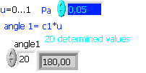
Fig. 3.2 – Defining the steps number and a single rotation step value

The angular value increase step for the elevation zone is marked with u and it take values between 0 and 1. With c₁ was marked the rotation cam angle for the elevation zone of the cam follower, so that the current rotation angle ϕ₁ can be obtained using the following relation:

ϕ₁ = c₁ u (3.1)

The lowest value of the rotation angle for the elevation zone is ϕ_{1 min} = 0° (0π radian), meaning that the increase step is u = 0.
The highest value of the rotation angle is ϕ_{1 max} = 180° (π radian), meaning that the increase step is u = 1.
The same resolution is defined also for the descending of the cam follower the lowest value of the rotation angle being ϕ_{2 min} = 180° (u = 0) and the highest value is ϕ_{2 max} = 360° (u = 1).

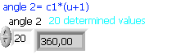
Fig. 3.3 – Defining the current cam rotation angle for the descend zone

The current rotation angle for the descend zone is obtained using the relation:

ϕ₂ = c₁ (u + 1) (3.2)

The program determines all the 20 intermediary angles values for both cam zones.
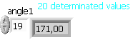
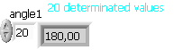
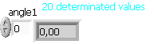
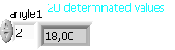
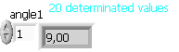
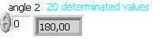
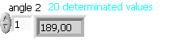
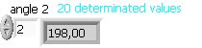

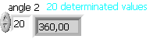

a) b)
Fig. 3.5 – The intermediary current angles values ϕ₁ and ϕ₂ for an angular rotation step p_{a} = 0,05 π radian
a) – for the elevation zone, b) – for the descend zone [2, 3]

The virtual instrument determines also the cam follower displacements for both zones, respecting the motion laws:
- for the elevation:

$S=\frac{h}{c_{1}}ϕ_{1}$ (3.3)
- for the descend:

$S=\frac{h}{c_{1}}(\text{360}−ϕ_{2})$ (3.4)

Basing to the calculus, the application permits to display in the Panel – Window, the graphic representation of the cam follower displacements.
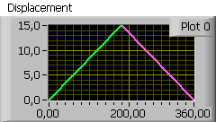

Fig. 3.6 – The representation of the displacement characteristic for a linear cam with the basic circle radius R = 5 cm and the cam follower displacement range h = 15 cm [4]

It was find that, for these conditions, the cam follower executes a linear elevation motion for a distance of 15 cm, for a cam rotation with an angle of 180°, followed by a linear descending motion for the same distance, for an other cam semi – rotation.
The program permits also to show the cam follower displacement for each rotation step of the cam, and also it shows the complete cam follower displacement.

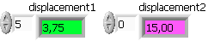
- b)
Fig. 3.7 – The values of the complete and partial displacement of the cam follower: a) – the displacement of the cam follower for a step angular cam rotation, the number of steps being 20, b) – the cam follower displacement for each zone

Respecting the same principle, the cam follower speeds were determined and represented, by derivation to the rotation angles of the displacements equations.
- the cam follower speed elevation

$v_{1}=\frac{h}{c_{1}}$ (3.5)

- the cam follower speed descend

$v_{2}=−\frac{h}{c_{1}}$ (3.6)
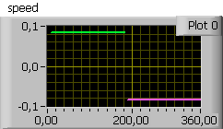

Fig. 3.8 – The graphic representation of the cam follower speeds for the elevation zone (the green trace) and for the descend zone (the magenta trace) [4]

The program shows also the cam follower speed for each zone.

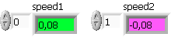
a) b)
Fig. 3.8 – The cam follower speed values a) – for the elevation zone, b) – for the descend zone

The graphic representations and the display for the cam follower displacements and speeds values concerned the main aspect about the analysis of the linear cam mechanism. The mechanism synthesis is about the graphic representation of the theoretical cam profile. For the synthesis it must to define the equations who describe the cam profile, using an orthogonal coordinate system, with the origin situated in the center of the cam. For the elevation zone, the equation who describes the distance between the center of the cam and the cam follower contact point is:

$r_{r}=r+\frac{h}{c_{1}}ϕ_{1}$ (3.7)

r_{r} being the distance between the cam center and the cam follower contact point. For the descend zone,

$r_{c}=r+\frac{h}{c_{1}}(\text{360}−ϕ_{2})$ (3.8)

For the elevation zone, the coordinates of an arbitrary point M are:
$x_{M}=(r+\frac{h}{c_{1}}ϕ_{1})\text{cos}(ϕ_{1})$
(3.9)
$$y_{M}=(r+\frac{h}{c_{1}}ϕ_{1})\text{sin}(ϕ_{1})$$

For the descend zone, the coordinates of the point M are:

$$x_{M}=(r+\frac{h}{c_{1}}(\text{360}−ϕ_{2}))\text{cos}((\text{360}−ϕ_{2}))$$
(3.10)
$$y_{M}=(r+\frac{h}{c_{1}}(\text{360}−ϕ_{2}))\text{sin}((\text{360}−ϕ_{2}))$$

Basing to the coordinates equations, the program shows the graphic representation of the theoretical cam profile.

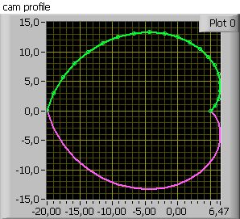

Fig. 3.9 – The graphic representation of the RC linear cam profile

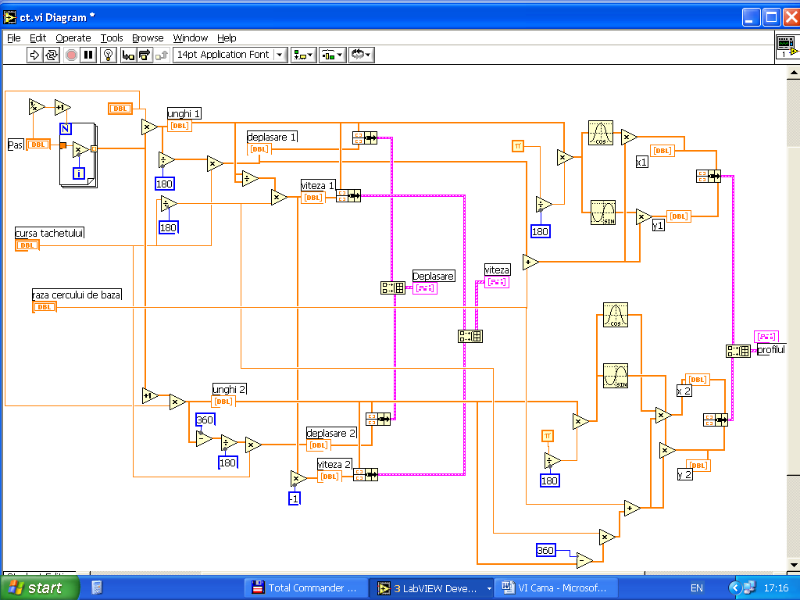

Fig. 3.10 – The Diagram Window of the virtual instrument for the analysis and synthesis of the RC linear cam
mechanism [2, 3, 4]

The Diagram Window contains a program sequence for the rotation cam angular step determination, including a FOR – LOOP structure, N being the number of steps. After the rotation angular step determination, using the relations which describe the mechanism motion laws, it was programmed the sequence to determine the displacements and speeds values of the cam follower. Based to (3.9) and (3.10) relations, describing the cam profile equations, it was programmed the sequence for the cam profile graphic representation.

IV Conclusions

The advantage of using the virtual instrumentation for the analysis and synthesis of the mechanisms is obvious, for multiples reasons: Once created the virtual instrument, in order to study the analysis and the synthesis for a particular case, as the RC linear cam mechanism, this permits to determine the cam follower displacement and speed characteristics, for different parameters, as the cam dimension, the displacement range of the cam follower or the steps of the cam angular rotation, in order to obtain the results concerning the analysis. Obvious, the program permits also the theoretical cam profile graphic representation. In order of using the virtual instrument, the principle is very simple, what is to do is to modify the parameters which define the basis circle radius of the cam, the displacement range of the cam follower and the steps number of the cam angular rotation. Running the program and entering the new values, is possible to obtain immediately the new graphical and displayed results concerning the analysis and synthesis of the mechanism.
Basing to this application for a particular mechanism case, is also possible to create more complex virtual instruments, which could make a general study about the analysis and synthesis of the cam mechanisms and so on.

References:

[1] Engineer manual – TECHNICAL Bucharest, 1980;
[2] Ursuţiu, D Initiation into the LabVIEW Program. The graphical programming in Physics and Electronics, LUX LIBRIS, 2001;
[3] Cottet, F.; Ciobanu, O. The programming basis in LabVIEW, MATRIX ROM, Bucharest, 1998;
[4] Sava, T. The LabVIEW club users – Tutorial, site: http://www.labsmn.pub.ro;

