1st International Conference
″Computational Mechanics and Virtual Engineering ″
COMEC 2005
20 – 22 October 2005, Brasov, Romania

MODELLING COMPRESSION OF WOOD INCORPORATING EARLY WOOD AND LATE WOOD USING THE FEM

Teofil Mihãilescu¹, Ioan Curtu ²
^{1, 2} TRANSILVANIA University, Braşov, ROMANIA, teomih@unitbv.ro, ioancurtu@unitbv.ro

Abstract: This paper aims to create a parametric model for wood incorporating early wood and late wood to provide data for the deformation and forces in wood compression perpendicular to the grain. Forces and displacements obtained from the finite element analysis are compared with theoretical prediction and experimental results. The theoretical displacement and stress are calculated by using Hooke’s law, and are compared with the displacement used in tests. The theoretical value of strain obtained in this way equalises the strain obtained in test.
Keywords: wood, compression, early wood, late wood, FEA

1. INTRODUCTION

Wood is a cellular composite material, having three principal directions for its material properties, characterised by its grain and growth rings. The properties and position of early and late wood within the growth ring influence the elastic properties of the wood; also the grain orientation has a great influence on the mechanical properties of the wood. The Finite Element Model should be able to simulate the proportion of early and late wood. This can be achieved by using a Cartesian or cylindrical co-ordinate system in which the elastic properties can be easily defined. Orthotropic material properties of wood can be considered in designing the models by using 3D finite elements with orthotropic capabilities and rotational degrees of freedom.

2. GROWTH RING ANALYSIS

An important factor of influence over mechanical properties is the growth ring orientation, late and early wood. Literature available on the strength in compression perpendicular to the grain as a function of the orientation of growth ring is limited. The Handbook of wood [7] explains that the proportional limit in wood during compression perpendicular to the grain varies with the angle between the growth ring and the direction of applied stress. Ethington [3] shows that compressive strength perpendicular to the grain depends on the orientation of the growth rings in the specimen.
The behaviour of wood under compression perpendicular to the grain depends on the direction of the rings. The resistance of compression is greatest in the tangential direction where the late wood and early wood share the load. In the radial direction, late wood and early wood sustain the entire load equally (early wood is weaker and therefore is compressed more). In the case of wood with semi diffuse or diffuse pores, the strength in the radial direction is stronger than in the tangential direction.
Schniewind [6] gave the following equations for calculating radial and tangential modulus of elasticity of whole section of wood:
$E_{T}=E_{\text{Te}}+(E_{\text{Tl}}−E_{\text{Te}})P_{l}$ ; $E_{R}=\frac{E_{\text{Re}}E_{\text{Rl}}}{E_{\text{Rl}}−(E_{\text{Rl}}−E_{\text{Re}})P_{l}}$ ; (1 a..b)
$E_{\text{Te}}=\frac{E_{e}E_{\text{Tr}}}{E_{\text{Tr}}−(E_{\text{Tr}}−E_{e})P_{r}}$ ; $E_{\text{Tl}}=\frac{E_{l}E_{\text{Tr}}}{E_{\text{Tr}}−(E_{\text{Tr}}−E_{l})P_{r}}$ ; (2 a..b)

$E_{\text{Re}}=E_{e}+(E_{\text{Rr}}−E_{e})P_{r}$ $E_{\text{Rl}}=E_{l}+(E_{\text{Rr}}−E_{l})P_{r}$ (3 a..b)

Substituting 2a, and b into 1a, and 3a and b into 1b, the following equation is given:

$E_{T}=\frac{E_{e}E_{\text{Tr}}(1−P_{l})}{E_{\text{Tr}}−(E_{\text{Tr}}−E_{e})P_{r}}+\frac{E_{l}E_{\text{Tr}}P_{l}}{E_{\text{Tr}}−(E_{\text{Tr}}−E_{l})P_{r}}$ $E_{R}=\frac{[E_{l}+(E_{\text{Rl}}−E_{l})P_{r}][E_{e}+(E_{\text{Rr}}−E_{e})P_{r}}{(1−P_{l})[E_{l}+(E_{\text{Rr}}−E_{l})P_{r}]+P_{l}[E_{e}+(E_{\text{Rr}}−E_{l})P_{r}]}$ (4)

where $E_{T}$, $E_{R}$ = tangential and radial modulus of elasticity of whole wood [N/mm²];
$E_{\text{Te}}$, $E_{\text{Re}}$ = tangential and radial modulus of elasticity of early wood [N/mm²];
$E_{\text{Tl}}$, $E_{\text{Rl}}$ = tangential and radial modulus of elasticity of the late wood [N/mm²];
$E_{e}$, $E_{l}$ = modulus of elasticity of the early wood and late wood prosenchyma [N/mm²];
$E_{\text{Tr}}$, $E_{\text{Rr}}$ = tangential and radial modulus of elasticity of the ray tissue [N/mm²];

$P_{r}$ = relative proportion of ray tissue and $P_{l}$ = relative proportion of late wood.

Pernestal, Johnsson, and Larsson [5] proposed a model for density distribution within the annual ring. The model originates from the concept that a tree has two growing modes, “early” and “late” wood mode, respectively. Furthermore, during a growing season there is a transition from the first to second, which describes the “slope” of the density change from early wood to late wood.
Less work has been published on late wood and early wood properties, specifically regarding the moduli of elasticity and Poisson’s ratio. Furthermore, the work reported so far is mostly restricted to some of the principal softwood species used in furniture [1].

3. EXPERIMENTAL COMPRESSION TESTS

The aim of the tests is to provide experimental data for the deformations and forces in wood compression, including early wood and late wood, which will be compared with theoretical predictions and FEA analysis.
European Beech (Fagus sylvatica) was used in all tests. All surfaces of the test specimens were free of visible flaws, scratches and other imperfections that are likely to influence the results.
The test samples were in the shape of a 20 mm cube as is shown in Figure 1 and were taken from two pieces of large timber. All machining operations were carried out such that smooth surfaces resulted and the principal directions (longitudinal, radial and tangential) were parallel to the width, thickness and length of samples respectively.
The tests were performed in the same atmosphere as used for conditioning (temperature 20 ⁰C ± 3 ⁰C and 65% ± 2% relative humidity), and where carried out using an INSTRON Model 4400 Universal Testing Machine.

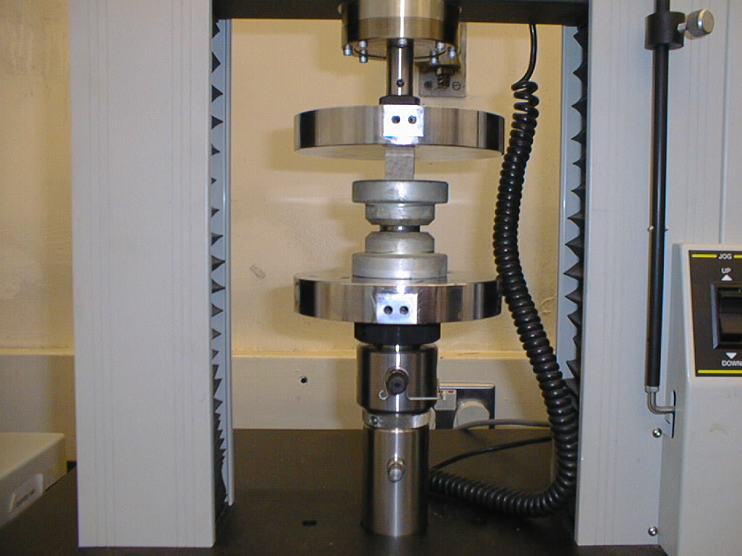
c)
Figure 1: Sample used in tests
a) Test sample b) Load and growth ring direction c) Compressive test

The dimension of the samples, forces, deflections, stresses and moduli of elasticity for each sample used in tests were recorded for radial compression and tangential compression, respectively. Using the data recorded in the files, the stresses and the corresponding strain of the specimens during the tests were determined.
All the stress-strain diagrams obtained by tests are typical empirical stress-strain curves. For example, the stress-strain diagrams of two samples (Code 13F2R and 13F2T) are shown in Figure 2. Similar results were obtained in [4].
Figure 2: Experimental stress-strain diagram in compression | It can be seen from the diagram that the stress in the radial direction is greater that in the tangential direction. Three regions of the stress-strain curve can be identified: initial curvature, linear elastic and curvilinear (a fourth region, post failure, does not exist because the imposed deflection was maintained bellow the failure limit).  Observing the lower portion of the stress-strain curve for radial and tangential direction, an upward curvilinear tendency can be found from the point of initial stress up to the point where the curves become linear, which corresponds to a strain about 0.008.  Examining the stress-strain diagram shown in Figure 2, it can be seen that a straight line follows the initial curvature. The upper end point where the curve deviates from this straight line is termed the proportional limit. The slope of the straight line between any two arbitrary points belonging to it, is the ratio of stress to strain, and is used to calculate the modulus of elasticity.
Using the values of the moduli of elasticity of each sample used in tests, the average values and standard eviation are calculated (Table 1).
Table 1: Average values of the moduli of elasticity obtained by tests
Type of  Compression | Modulus of elasticity  [N/mm²] | Standard  Deviation | Number of  samples
Radial | 429 | 43.20 | 33
Tangential | 264 | 31.52 | 28
Longitudinal | 13514 | 1017.23 | 15

It can be seen from Table 1 that the modulus of elasticity on the radial direction is greater than in the tangential direction.

4. FINITE ELEMENT MODEL INCORPORATING EARLY WOOD AND LATE WOOD

The following possibilities regarding the load of the model, the structure and the mating surface of the wood were considered in this model. The wooden structure was modelled considering two variants:
- A continuous, uniform and orthotropic material.
- A composite material incorporating growth rings consisting in two layers: early wood and late wood. Each layer is considered a continuous, uniform and orthotropic material with different material properties.

The analysis considered two different mating surfaces between wood and parallel plate:

i. As a planar surface without roughness.

ii. As a planar surface with roughness.

Appropriate macros, which ensure all these possibilities to be used in the same model, were designed. In order to validate the model, the reaction force obtained in each finite element analysis was compared with the similar force obtained in the appropriate test. Stresses in the radial and tangential direction was also analysed and compared with the theoretical prediction.
Shape and parametric dimensions of the sample used in tests and the model of wood are shown in Figure 3.

a) b)  c) | d)
Figure 3: Sample with parametric dimensions and model
a) sample; b) displacement ‘dl2’ of the upper plate;c) notations used in model; d) model with contact elements
The following assumptions were made during the design process of the initial model:
- Wood exhibits attributes of a continuous, uniform and orthotropic material with linear-elastic properties.
- The parallel plates are made of isotropic, continuous and uniform material with linear-elastic properties.
- The wood moisture content and temperature are considered constant.
To determine the forces transmitted between the parallel plates and wood, a 3-D element (CONTAC49) was chosen. This type of element is used to represent the contact and sliding between two surfaces in three dimensions. It has five nodes with three degrees of freedom at each node: translations in the nodal x, y and z directions
To enable design changes to be made easily and conveniently, the model was built using the parametric modelling facility provided by the ANSYS Parametric Design Language (APDL).
Following the most important macros are used in the model:
- HOMOGEN and RING - define the material properties considering a homogeneous structure or a structure containing growth ring with early wood and late wood. It is used in PREP7. The command to execute these macros are: *use,HOMOGEN or *use,RING.
- STEP1 and STEPS -define a single step analysis or an analysis with a number of substeps. It is used in SOLU. The commands to execute one of these macros are: *use,Step1 or *use,STEPS,arg1 (arg1 = number of substeps) .
- DISPLACE and EXPANSION -define the compression by the displacement of the upper plate. It is used in SOLU. The commands to execute one of these macros are: *use,DISPLACEMENT,arg1 (arg1 = the displacement),
- CONTACT-macro to display the contact elements status. It is used in post processor POST1.The command to execute this macro is: *use,CONTACT.
- GRAFORCE-prints the reaction forces in some nodes. It is used in all models in post processor POST26. The command to execute this macro is: *use,GRAFORCE.

All macros are included in a macro library file, which allows blocks of often used data input commands to be stacked and execute from a single file.
The following material properties were considered:

- Elastic orthotropic properties of Beech Wood
$E_{L}$ =13514 N/mm² $E_{R}$=430 N/mm² $E_{T}$=270 N/mm²
$ν_{\text{RL}}$=0.073 $ν_{\text{RT}}$=0.36 $ν_{\text{LT}}$=0.043

- Early wood and late wood are simulated by generating alternative bands of finite elements with material properties and dimensions along the y axis as a function of the type of wood (early wood or late wood).
The thickness of late wood ($t_{l}$) and early wood ($t_{e}$) are calculated considering the relative proportion of late wood ($P_{l}$) in the thickness of annual ring ($t$), which is known. A relative proportion of late wood of 0.3 mm was taken into consideration.
The material properties of late wood and early wood used in the finite element analysis are shown in Table 2.

Table 2: Material properties used in the model
Lamina | Modulus of Elasticity [N/mm²] |  |  | Poisson Ratio
 | Longitudinal | Radial | Tangential | LR | TR
Early wood | 3450 | 345 | 207 | 0.37 | 0.33
Late wood | 13802 | 1035 | 690 | 0.37 | 0.33

3. The normal contact stiffness of contact elements is used to enforce the displacement compatibility by limiting the penetration of the target base by the contact node KN=1000 N/mm
4. A displacement of 0.2 mm was modelled. The analysis was completed, and considered the mating surface between wood and parallel plate with a roughness of 0.02 mm and without roughness. The results of this analysis are presented in the following section.

Analysis was carried out considering the mating surface with roughness and without roughness. In each case, the stress distribution in the y direction, in the radial and tangential direction was obtained.
A finite element analysis of compression perpendicular to the grain in the radial direction and on similar sized specimens to those used in tests was carried out
The model with the boundary conditions and a detail of contact elements is shown in Figure 4.

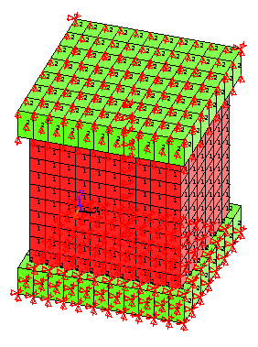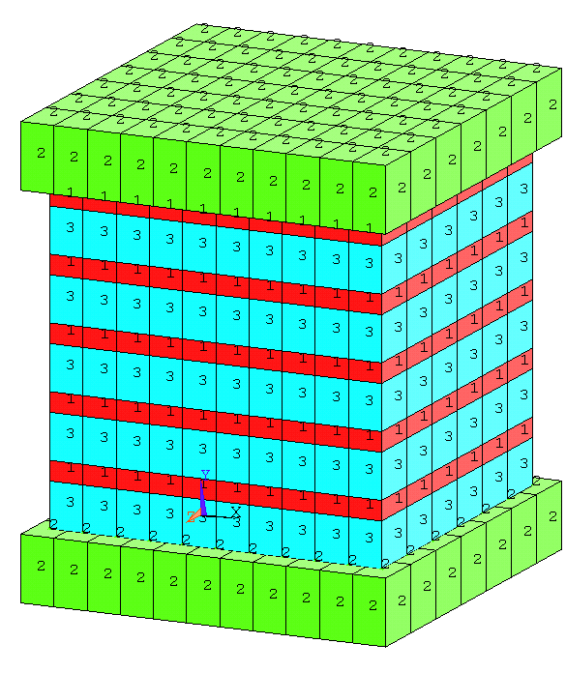  a) Boundary conditions b) Model with early wood and late wood | c) Detail with contact elements between wood and steel plate C₁,C₂-Contact; T₁,T₂-Target.

Figure 4: Model used in the finite element analysis

5. RESULTS AND DISCUSSION

Reaction force and stress in the radial and tangential direction obtained by using the theoretical prediction, tests and finite element analysis are shown in Table 3.

Table 3: Experimental and FEA results
 | Radial Direction |  | Tangential Direction
 | Force [N] | Stress [N/mm²] | Force N] | Stress N/mm²]
Tests | 1264 | 3.2 | 856 | 2.15
FEA-Model without Growth Ring Roughness = 0  Roughness = 0.02 mm | 1328  1202 | 3.07-3.51  2.78-3.19 | 924  841 | 2.20-2.35  1.99-2.13
FEA-Model with Growth Ring  Roughness = 0  Roughness = 0.02 mm | 1372  1241 | 3.42  3.1
Theoretical Model | 1252 | 3.15

It can be noted that there are no significant differences between the forces and stress values obtained by different methods. The experimental force in the radial and tangential direction has a value between reaction force obtained in the finite element models considering the mating surface without roughness and having roughness. The stress distribution in the y direction, in the radial and tangential direction is shown in Figure 5, and 6.

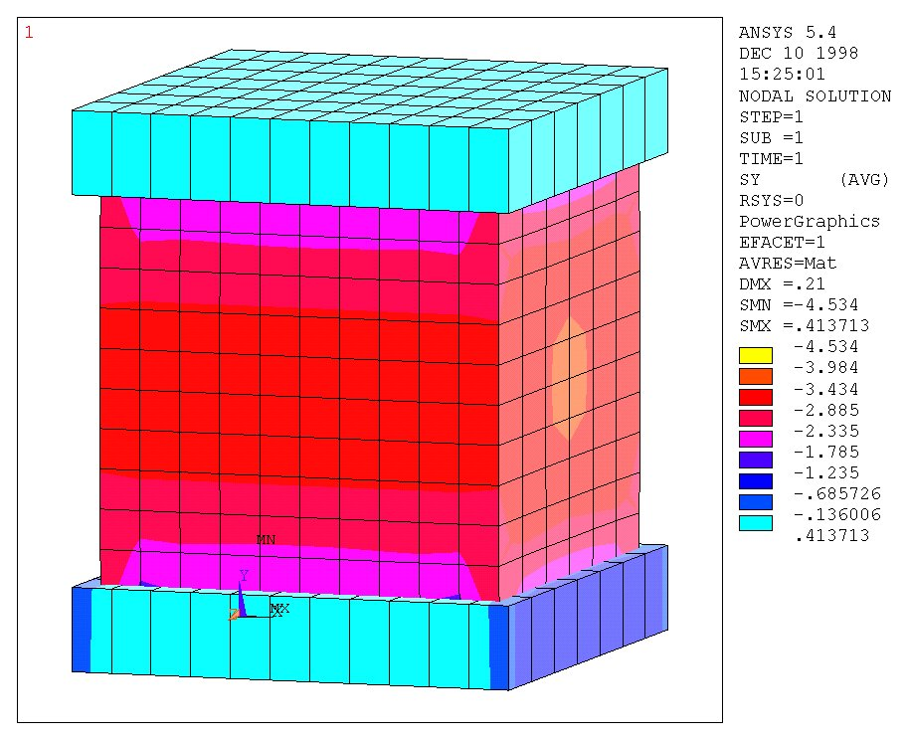  a) Radial direction | 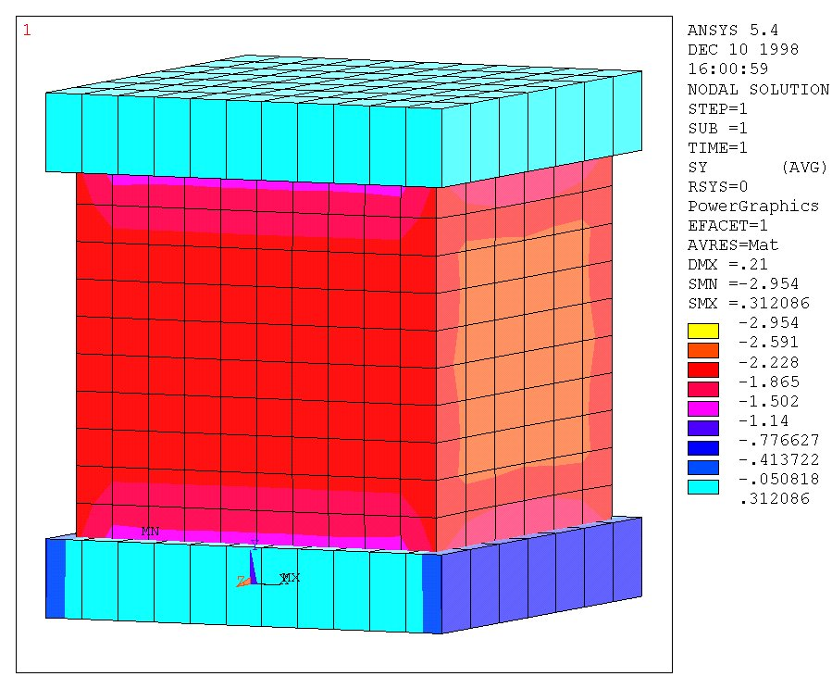  b) Tangential direction

Figure 5: Compressive stress $σ_{y}$in the radial and tangential direction (Roughness Hm = 0)
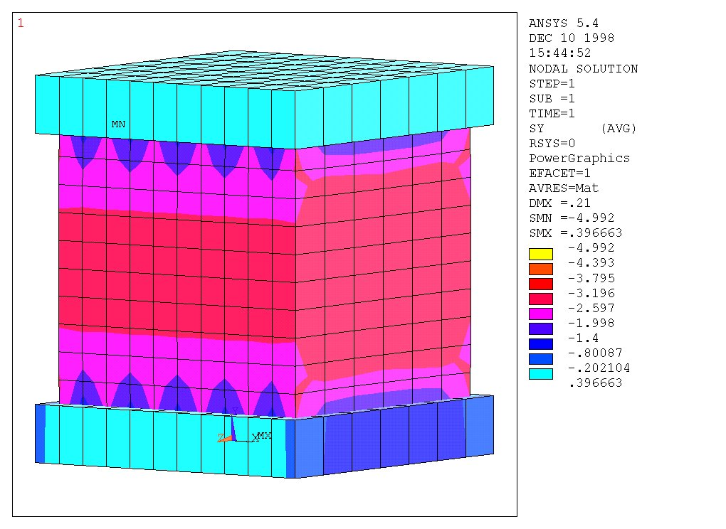  a) Radial direction | 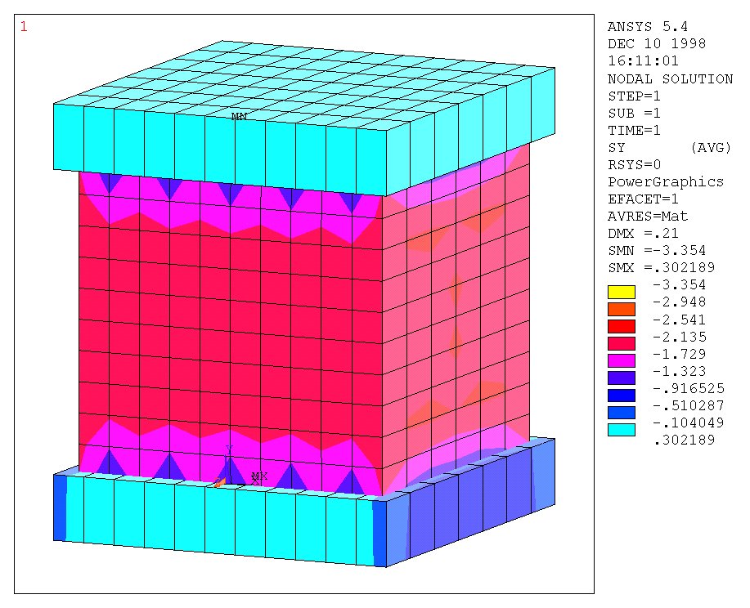  b) Tangential direction

Figure 6: Compressive stress $σ_{y}$in the radial and tangential direction (Roughness Hm = 0.02)

6. CONCLUSION

The research presented in this thesis, considered the orthotropic structure of wood, in both of homogeneous form and also incorporating early wood and late wood, mathematical methods in common use for analysing parametric finite element models.
These models provided a range of results that were compared with the results of physical tests by the author and other researches, and mathematical predictions. A good agreement between the experimental tests, and the finite element analyses was obtained and the following are a summary of findings and conclusions:
- The finite element method provides a suitable means of analysing the compression of wood when the wood is considered as a continuous, uniform, orthotropic material with linear-elastic properties, and the early wood and late wood can be modeled.
- In order to produce a well-behaved finite element model, that produces an accurate result, the finite element package used must contain the following features:
- A suitable library of finite elements with orthotropic and isotropic material properties in order to model the structure of wood, and 3-D contact elements to represent the contact and sliding between two surfaces.
- Uses the direct model generation technique, which allows controlling the models in all stages.
- An appropriate parametric design language, which provides an easy measure of means of making design changes, and also encompasses a wide range of other features such as repeating a command, the use of macros, do-loop branching, and vector and matrix operations.
- A macro library file, which allows blocks of commands to be stacked and executed from a single file by different models, obtaining a structured model easily to be controlled and modified.
- The facility to produce and manipulate local co-ordinate systems, to make model generation more convenient, for example: by modifying the orientation of the axis it is possible to change the principal directions of the element modelling the wood. In this way it is possible to study the influence of the grain and growth ring orientation upon the deflexion and state of stresses.

REFERENCES

[1] Bodig, J., Jayne, B.: Mechanics of Wood and Wood Composites, Krieger Publishing Company Malabar, Florida, 1993.
[2] Conners, T.: Segmental Model for Stress-Strain Diagrams. Wood Science and Technology, 1989
[3] Ethington, L., et al: Relationship Between Compression Strength Perpendicular to Grain and Ring Orientation, Forest Products Journal, 46 (1), 1996.
[4] Mihailescu, T., et al.: Theoretical and Experimental Aspects of Wood compression, Sesiune Stiintifica. Brasov, Casa de Stiinta si Tehnica pentru Tineret, 1981.
[5] Pernestal, K., et al: A simple model for density of Annual Rings. Wood Science and Technology, 29, 1995.
[6] Schniewind, A., P., 1959. Transverse Anisotropy of Wood: a Function of Cross Anatomic Structure. Forest Products Journal, 10 pp. 349-359.
[7] U.S. Department of Agriculture, Forest Product Laboratory, Forest Service. Handbook of Wood and Wood-Based Materials for Engineers, Architects, and Builders. London, Hemisphere Publishing Corporation, 1989.

