1st International Conference
″Computational Mechanics and Virtual Engineering ″
COMEC 2005
20 – 22 October 2005, Brasov, Romania

Vibration control using semi-active tuned
mass dampers (Part II – parametric optimization)

Dumitru D. Nicoara¹, Diana Cotoros¹
¹Transilvania University, Brasov, ROMANIA, e-mail tnicoara@unitbv.ro

Abstract: In the first part of this paper a force-excited equivalent model of a groundhook Tuned Vibration Absorbers (TVA) was developed and its closed-form solutions were obtained. In this part of the paper the optimal design parameters of groundhook equivalent TVA models are obtained based on minimization of peak transmissibility. The optimally tuned semi-active equivalent model and an optimally tuned passive model are compared. The results indicate that the peak transmissibility of that groundhook TVA is lower than that of passive, implying that the groundhook TVA s more effective in reducing vibration levels.
Keywords: groundhook control, semi-active control, vibration isolation, optimization

1. INTRODUCTION

In the early 1970s, Karnopp and Crosby [4] introduced the use of semi-active dampers in a vehicle’s primary suspension systems. Since the wellknown skyhook and control policy for semi-active dampers was developed, several other semi-active control polices, such as groundhook control, have evolved over the past two decades. A comprehensive overview of configurations, developments, and applications of passive, adaptive, and active TVAs is presented in [8]. The concept of TVAs has extended to civil structures such as floors, tall buildings, and bridges. In such applications, the goal is to attenuate the vibrations due to human excitations (i.e., walking, running, and jumping) in floors, and wind and seismic excitations in buildings and bridges [2], [3], and [9].
Conditions and parameter changes with time have led to new designs and concepts for TVAs. These designs include adaptive, semi-active, and active TVAs, which have all been actively studied recently.
The design of a passive damper involves a trade-off between the resonance amplification and the high frequency attenuation [6]. On method to eliminate the trade-off between the resonance control and high frequency isolation is to reconsider the passive configuration.
The new configuration is the groundhook TVA. The ideal structural configuration of a passive damper “hooked” between the structure and the “ground,” as shown in Figure 1.a.
On method of generating the groundhook damping force is to remove the passive suspension (i.e. both the damper and the spring) and replace it with an semi-active dampers [7].

2. mathematical models for groundhook control

The on-off groundhook semi-active TVA can be schematically represented by Figure 1.b, which shows the idealized configuration of a groundhook TVA, in the sense that it includes the effect of the off-state damping, c_{off}. Idealized configuration by Figure 1.a can be thought of as a special case of Figure 1.b, when c_{off} = 0. Although Figure 1.b represents an approximation of a on-off groundhook TVA, it provides an effective means for analytically comparing groundhook and passive TVAs.
In this section, a force-excited passive model and a force-excited “groundhook equivalent” model are formulated. The groundhook equivalent model, which emulates the actual groundhook system, is developed to have a closed-form transmissibility. For comparison purposes, closed-form solutions of both passive and semi-active models are derived first.
The transmissibility for a classical passive mount for a two-degree of freedom passive TVA model [7] is

$\frac{X_{1}}{δ_{\text{st}}}=\frac{k_{1}(m_{2}s^{2}+c_{2}s+k_{2})}{(m_{1}s^{2}+(c_{1}+c_{2})s+k_{1}+k_{2}) (m_{2}s^{2}+c_{2}s+k_{2})−(c_{2}s+k_{2})^{2}}$ (1)

where $s=iω$ and $ω$is the driving frequency and $δ_{\text{st}}$ is static deflection, $F_{0}=k_{1}δ_{\text{st}}$.
The transmissibility equation for the groundhook equivalent model is

$\frac{X_{1}}{δ_{\text{st}}}=\frac{k_{1}(m_{2}s^{2}+c_{\text{off}}s+k_{2})}{(m_{1}s^{2}+(c_{1}+c_{\text{on}})s+k_{1}+k_{2}) (m_{2}s^{2}+c_{\text{off}}s+k_{2})−(c_{\text{off}}s+k_{2})^{2}}$ (2)

The closed-form solutions derived in this section are used in the subsequent optimization and simulation sections.
k₂
F
c_{on-}c_{off}
m₂
m₁
k₁
c₁
x₁
x₂
c_{off}
k₂
C_{ground}
m₂
m₁
k₁
c₁
x₁
x₂
F

(a) Idealized groundhook configuration (b) Equivalent semiactive model

Figure 1

3. Optimization of models

This section presents optimization of the two closed-form TVA models. The purpose of optimization is to obtain the optimally tuned TVA parameters such as the damping ratios, $ς_{2} , ς_{\text{on}}$ and $ς_{\text{off}}$ and the stiffness k₂.
After the optimization, the two models can be equally evaluated. A numerical optimization technique is adopted. To this end, a multidimensional nonlinear constrained minimization function called “fmincon.m” in the Matlab optimization toolbox is used.
The optimization criterion here is the minimization of peak transmissibility. Figure 2 shows the flow chart for the optimization routine.
Running within Matlab, the execution of the optimization routine involves three steps. The main program is where the system parameters are defined along with initial values and ranges of the simulation parameters. The main program calls the closed-form transmissibility equations that are responsible for generating the peak transmissibilities. These peak transmissibilities are then input into the optimization function, fmincon.m, where the minimum values of the peak transmissibilities are returned along with the corresponding simulation parameters. When a peak transmissibility is smaller than the previous peak transmissibility, the optimization routine terminates.
Figure 3. a shows the transmissibility of each of the optimally tuned TVA models. The peak transmissibility of the semi-active TVA is lower than that of passive, indicating that the groundhook TVA is more effective in reducing vibration levels. Note that the tuning frequency ratio of the semi-active model is lower than the optimal passive frequency ratio. A tuning frequency ratio is defined as the ratio between the floor natural frequency and the TVA natural frequency.

Define system parameters:
m₁, m₂, k₁,
Set parameter range for optimization:
;

Calculate Peak Transsmisibility
Minimize

Select values of the parameters
End

Figure 2: The flow chart for the optimization routine.

Figure 3.b shows the peak transmissibility values of passive and semi-active TVAs as the floor mass m₁ ranges from -20% to 20% of its original mass.
Note that the slope of semi-active is less than that of passive, indicating that the semi-active TVA is more adaptive to changes in the mass m₁.For the simulation the values of the parameters are: m₁=1220 Kg; m₁=60 Kg; k₁=7*10⁶ N/m; ζ₁=0.01.
Note also that the slope is greater for increases in the mass m₁ than decreases in the mass m₁. This means that TVAs are less adaptive to increases in the main mass.
From these results, it is clear that the semi-active TVA is more adaptive to changes in the mass m₁ than the passive TVA. This is one of the important benefits of using a semi-active TVA.

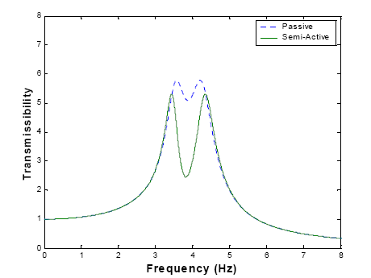  (a) | 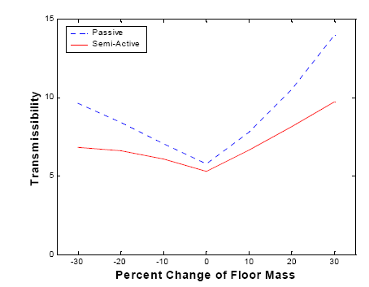  (b)

Figure 3: (a) Optimized Transmisibility
(b) Peak Transmisibility -percent change of mass m₁

4. Conclusions

In this study, the adaptability of passive and groundhook equivalent semi-active TVAs to changes in the main mass are evaluated. To this end, a groundhook equivalent semi-active TVA model was developed. After obtaining the closed-form solutions of both passive and semi-active TVA models, a numerical optimization routine was applied to both models. The optimization results show that the peak transmissibility of the groundhook equivalent TVA is lower than that of passive, implying that the semi-active TVA is more effective in reducing vibration levels. Using the optimally tuned TVA models, an adaptability analysis was performed by changing the main mass m₁. The results indicate that the groundhook semi-active TVA is more adaptive to changes in main mass than the passive TVA. The results further indicate that the TVAs are more adaptive to decreases in the main mass than increases in the main mass.

References

[1] Ahmadian, M. and Pare, C., A Quarter-Car Experimental Analysis of Alternative Semiactive Control Methods. Journal of Intelligent Material Systems and Structures, 2000, 11, 604-612.
[2] Howard, J. N., and Murray, T. M., Investigation of a Semi-active Tuned Vibration Absorbers to Mitigate Floor Vibrations, Transactions of the ASME, 2000, 117, 234-242.
[3] Hrovat, D., Barak, P., and Rabins, M., Semi- Active Versus Passive or Active Tuned Mass Dampers for Structural Control. Journal of Engineering Mechanics, 1983, 109, 691-705.
[4] Karnopp, D. C., Crosby, M. J., and Harwood, R. A., Vibration Control Using Semi-active Force Generators. American Society of Mechanical Engineers, Journal of Engineering for Industry, May 1974, 619-626.
[5] Korenev, B. G., and Reznikov, L. M., Dynamic Vibration Absorbers Theory and Technical Applications, 1993 (John Wiley & Sons, Chichester, England)
[6] Nicoara, D. D., On the vibration isolation by semi-active control strategies, Proceedings of CDM 2005, 269-272,Ed. Transilvania University, 2005.
[7] Nicoara,D.D., Vibration control using semi-active tuned mass dampers (Part I), Buletinul Universitatii “Petrol si Gaze” Ploiesti, Lucrarile a XXIX-a Conf. Nationala de Mecanica Solidelor, nov. 2005 (to apppears).
[8] Sun, J. Q., Jolly M. R., and Norris, M. A. Passive, Adaptive and Active Tuned Vibration Absorbers-A Survey.Transactions of the ASME, 1995, 117, 234-242.
[9] Soong, T. T. and Reinhorn, A. M., Observed Response of Actively Controlled Structures. Proceedings of Structural Engineering in Natural Hazards Mitigation, 1993, 187-192.

