1st International Conference
″Computational Mechanics and Virtual Engineering ″
COMEC 2005
20 – 22 October 2005, Brasov, Romania

CAE METHODOLOGY USED TO DESIGN AND SIMULATE THE BEHAVIOUR OF A MILLING MACHINE USED IN MINING INDUSTRY
PART II – the FINITE ELEMENT analysis

Ioan Călin ROŞCA, Ph.D.
Transilvania University of Braşov, Romania, icrosca@unitbv.ro

Abstract: In this paper it is presented the finite element analyse of a milling machine. The 3D model was made using technical possibilities of I-DEAS and ALGOR and the analyse was done with ABAQUS. At the end there are presented the obtained results.
Kezwords: finite element method, milling machine analyse, modeling.

1. ARM FINITE ELEMENT ANALYSIS

For a correct analysing the first part that was analysed was the arm of the milling machine. It was considered for the beginning the case of the arm as a single part and without milling cutting tool. The whole assembly of the cutting tool was substitute with a beam system with a high value of stiffness (Figure 1) and had the same geometrical dimensions as the real cutting tool.

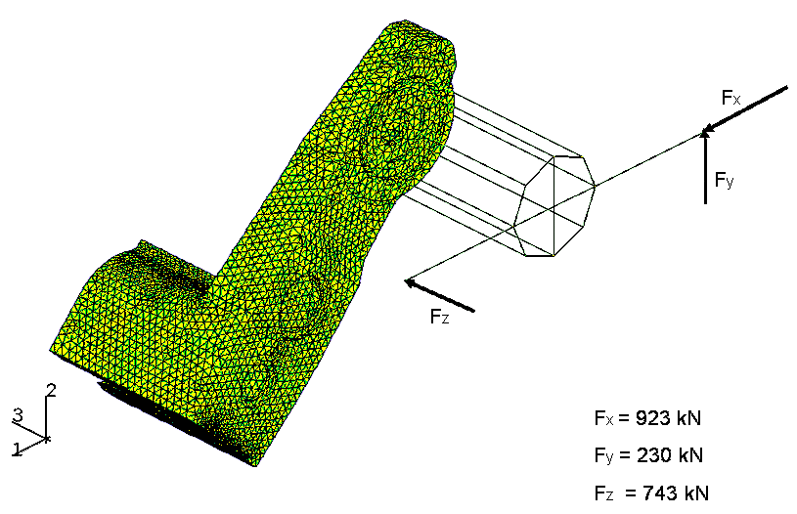
Figure 1: Simplified model of the cutting tool with beams

The loads that were applied were the same as in real case and were applied on all three directions at the ends of the beam system (Figure 1). The beams were “tied” with the arm by constrain equations written for all three spatial directions. The arm was fixed at the opposite side comparing with the beam system. This test was made to find out the values of von Mises stresses that can be considered as a basis for the future simulations. In the same time the arm is the most loaded part of the milling machine and it was necessary to find out, from the beginning, if the arm model adopted is the proper one.
As it can be seen, the obtained von Mises stresses in the arm are up to limit 360 MPa and the upper limit for the considered material (steel alloy) was 420 MPa (Figure 2,a & b). The maximum values, up to 5,000 MPa (Figure 2,b), are located in the nodes where were written the constrain equations used to link the beams with the arm.
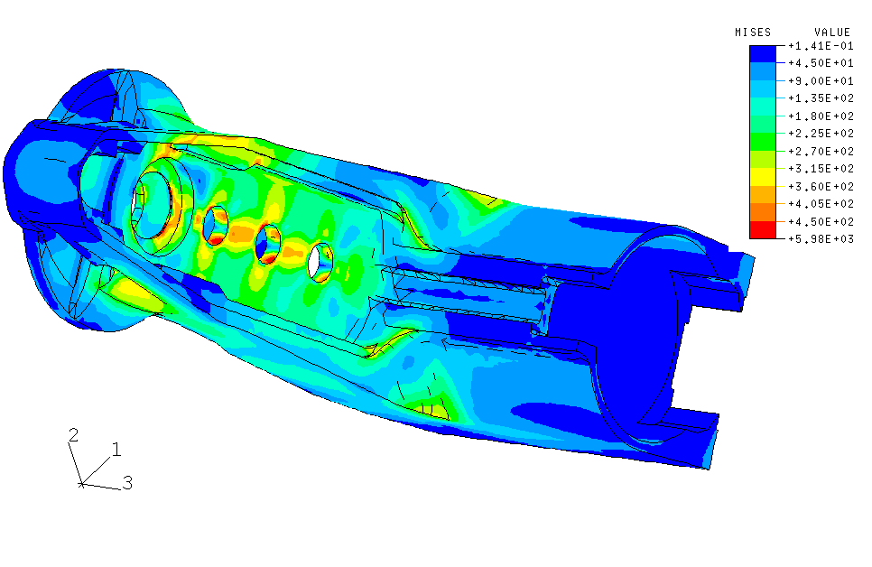  a) | 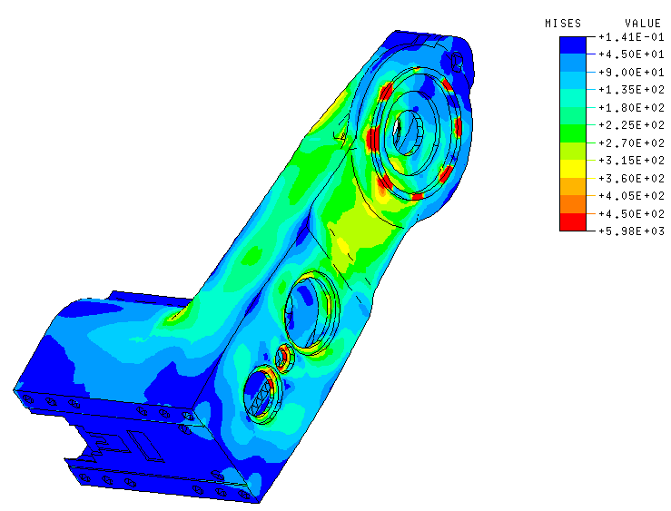  b)
Figure 2: Von Mises stresses on the left side (a) nd right side (b) of the arm.

2. assembly FINITE ELEMENT ANALYSIS - Von mises stresses.

The main boundary conditions are presented in Figure 3: the gap elements that are used to model the link of the machine with the base support and the hydraulic cylinder that push the arm.
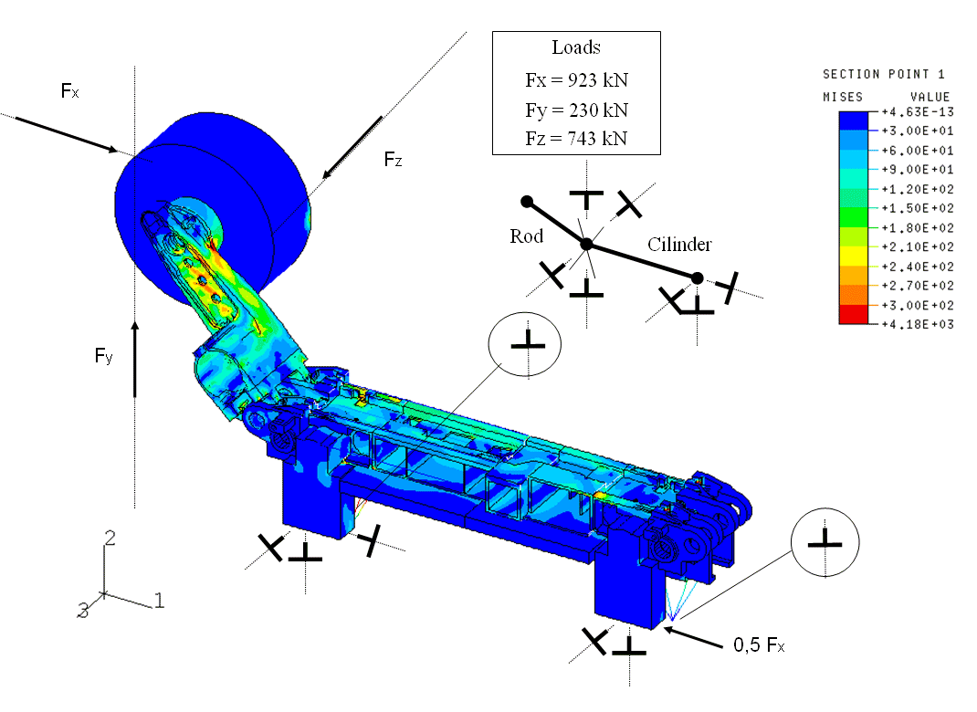
Figure 3: The milling machine with boundary conditions and von Mises stresses.

The milling machine analyse was made using ABAQUS program. The level of von Mises stresses in all parts is presented in Figures 4 ÷ 10.

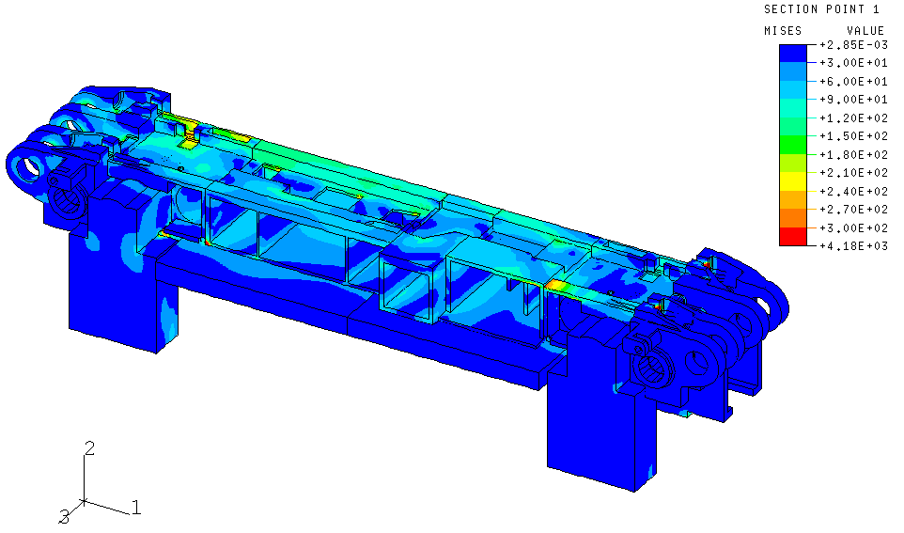  Figure 4: The middle parts of the machine | 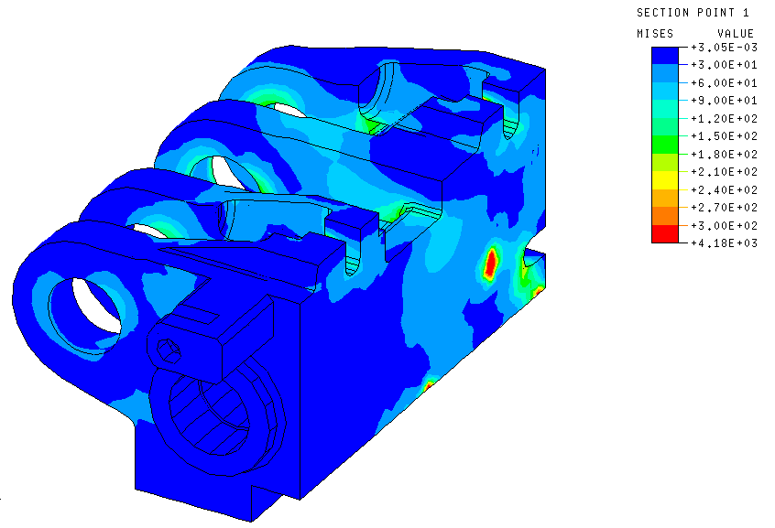  Figure 5: Rotating system base.

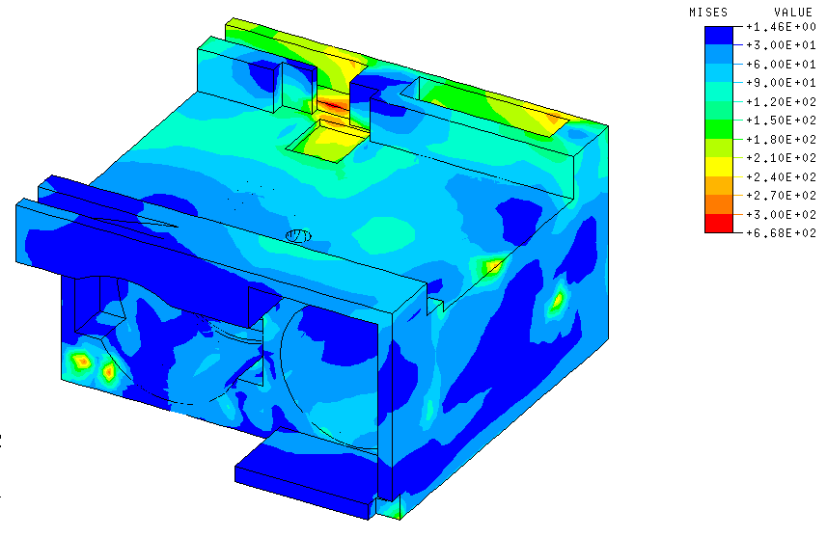  Figure 6: Gearbox. | 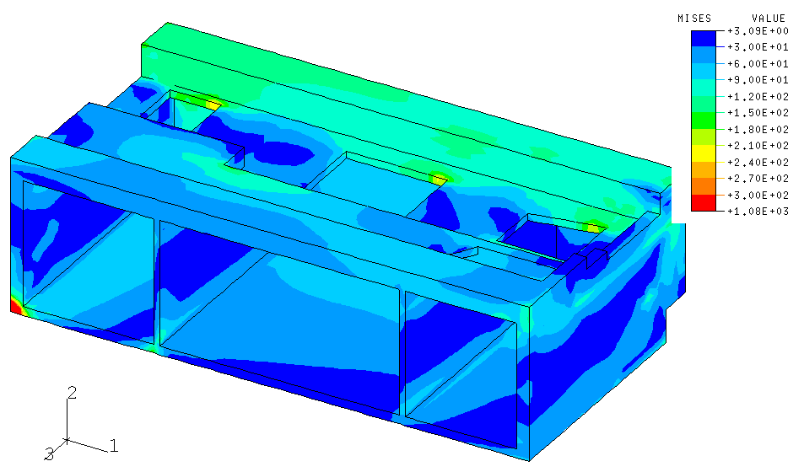  Figure 7: Electric equipment box.

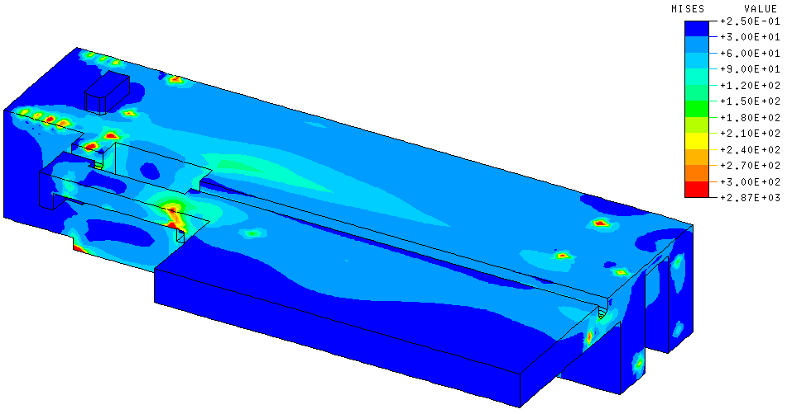 | 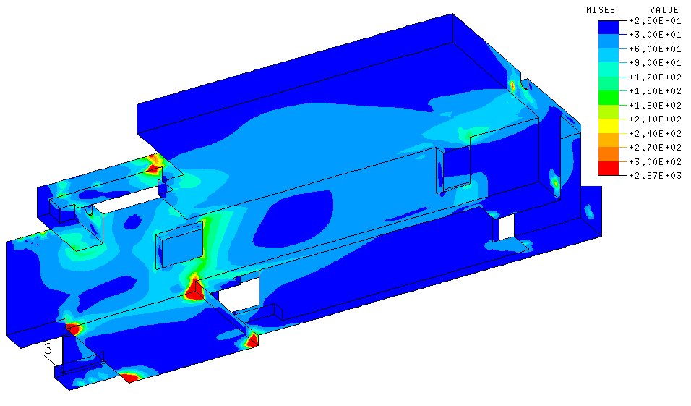
Figure 8: The milling machine platform

Along the assembly there were mounted four rods that were pre-tensioned. The level of normal stresses is presented in Figure 9.

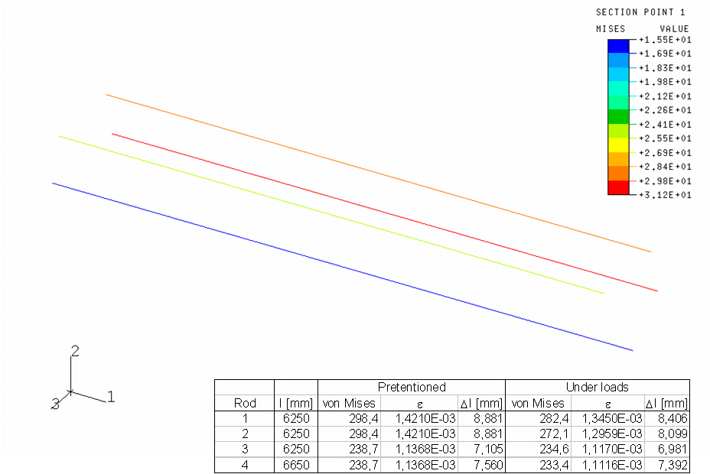  Figure 9: Normal stresses in rods. | 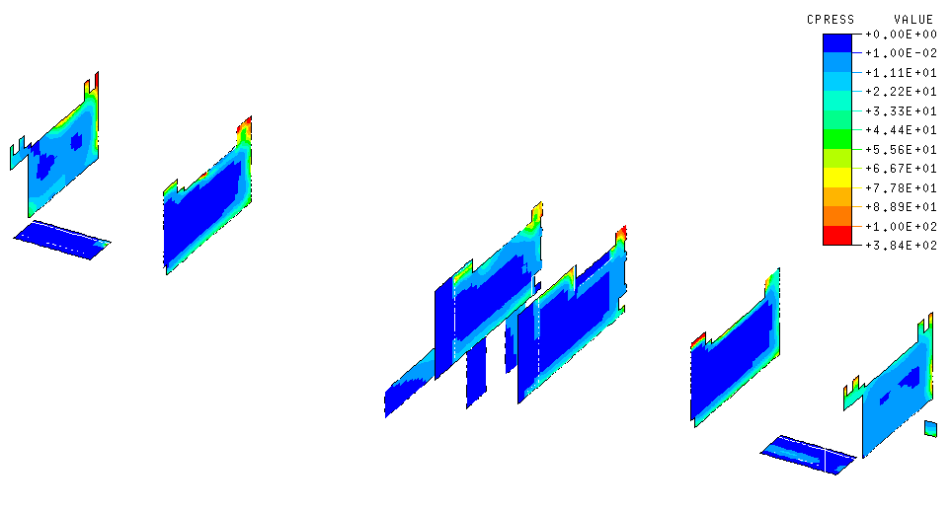  Figure 10: Contact pressure.

As it can be seen the level of von Mises stresses is up to 360 MPa in each part. In the same time the greatest contact pressure is around 300 MPa in some corner area as is presented in Figure 10. This aspect is very dangerous and in those points it is necessary to modify the geometry or the material.

3. assembly FINITE ELEMENT ANALYSIS - deformations.

Another analyse that is necessary to be done consists of deformation study of the milling machine. The construction with long beams and many screws, cotters, and pegs generate a very flexible structure that can have a large deformation during the milling process. The deformations of the assembly and of different parts there are presented in the following pictures (Figures 11 ÷ 13).

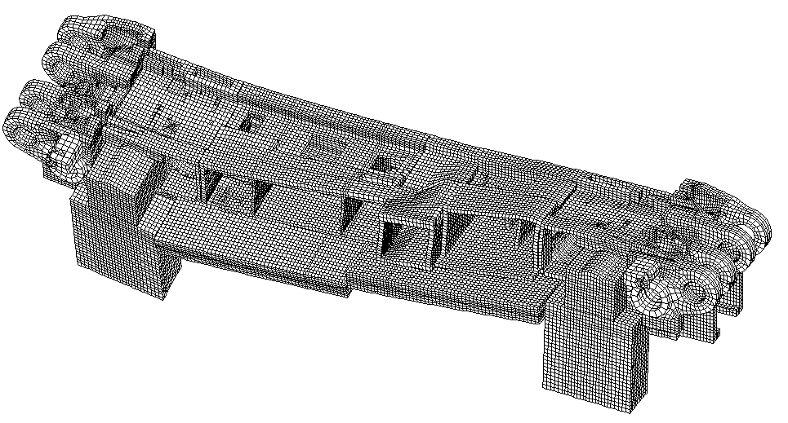  Figure 11: Deformation of the middle body of the machine (magnification coefficient 50). | 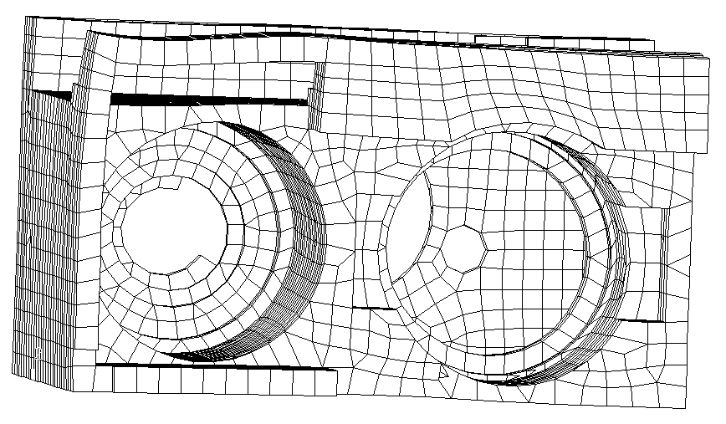  Figure 12: Deformation of the gearbox (magnification coefficient 50).

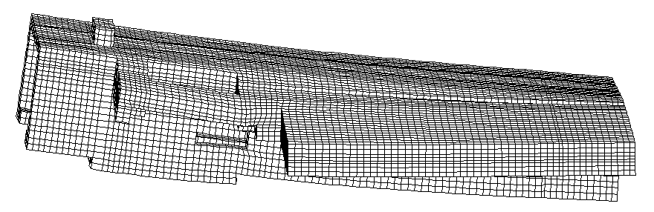
Figure 13: Deformation of the milling machine platform (magnification coefficient 50).

4. Conclusions.

Based on the obtained results presented above one can conclude that:
- The level of the von Mises stresses is situated in the limits of the material strength and from this point of view the analysis confirm that there are no problem;
- The contact pressure is in some corners a little bit greater that the admitted value and is necessary to be done some technical changes (new shapes, new material in that area, etc.);
- The deformation pictures show that some parts have a large modification of the shape during the loads and the structure is very flexible. These deformations represent an important problem for the designer and, as solution, it is necessary to introduce more screws in those regions where the contact between parts is lost and the deformations are large.
The finite element method can offer to engineer designer an image about the level of stresses and deformations and so, from the stage of designing, can take the proper decisions to solve all possible damages.

The present work is part of the activity done in the frame of the research project “Teilautomatisierte Generierung von 3D-CAD-Modellen”, developed at the Institut für Bergwerks –und Hüttenmaschinenkunde, Rheinisch-Westfälische Technische Hochschule, Aachen, Germany.

references

[1] Constantinescu N. Ioan; Dăneţ V. Georgeta: Metode noi pentru calculul de rezistenţă, Editura Tehnică, Bucureşti, ISBN 973-31-0094-3, 1989.
[2] Pascariu Ioan: Elemente-Finite. Concepte-Aplicaţii, Editura militară, Bucureşti, 1985.
[3] Rao, S., S.: The Finite Element Method in Engineering, Second Edition, Pergamon Press, ISBN 0-08-033419-9, 1989.
[4] ***: ABAQUS Reference books. User guides.
[5] ***: ALGOR Reference books. User guides.
[6] ***: I-DEAS Reference books. User guides.

