1st International Conference
″Computational Mechanics and Virtual Engineering ″
COMEC 2005
20 – 22 October 2005, Brasov, Romania

DIMENSIONING OF THE HYDRAULIC CYLINDER FOR THE REVERSING MECHANISM OF A REVERSIBLE PLOUGH BY USING THE KINEMATIC AND DYNAMIC SIMULATION OF THE REVERSING PROCESS

M.S. Eng. Niţescu Vasile¹, Math. Cârdei Petru¹, Dr. Eng. Muraru Vergil¹, Dipl. Eng. Sfâru Raluca¹, Prof. dr. Eng. Cândea Ioan²,
¹INMA, Bucharest, ROMANIA, icsit@sunu.rnc.ro
²University of Transylvania, Braşov, ROMANIA, mec@unitbv.ro

1. Introduction

In this paper the authors expose a method for selecting the characteristics of the hydraulic cylinder used at the reversing mechanism of a reversible plough, by using the kinematic and dynamic simulation on various mathematical models. For the calculus of the resistant force during reversing, inside the cylinder, there were used some analytical and structural mathematical models which gave convergent results. By using the distribution of the resisting force into the cylinder there was established the minimum pressure necessary for reversing. With these data, by using the mathematical model of the rigid solid with fixed axis, there was simulated the reversing in the plough dynamic duty. This simulation process is necessary for establishing the process control, namely the time dependence of the control pressure inside the hydraulic cylinder. Within this process various optimal criteria can be formulated. The paper has applications in the domain of design and optimizing the reversing mechanism of reversible ploughs, but it can also be applied to the optimal calculus of many similar mechanisms.

2. Determining the pressure inside the hydraulic cylinder by using structural models of the reversible plough PRS-5

For determining the pressure inside the hydraulic cylinder of the plough PRS-5 (for some other types of reversible ploughs the procedure is the same) these can be used some simple or complex structural models, their results being convergent, whether (especially for simplified models) there are considered boundary (propping) conditions which are an equivalent to real propping. A distribution of the resistant pressure inside the hydraulic cylinder determined on the most complex structural model (fig. 1) can be seen in figure 4.
We have also used the three structural models of the reversible plough PRS-5 for calculating its inertial characteristics: mass centre coordinates, inertia tensor components, gyration moments etc. The mathematical models used having this aim in view can be seen in figure 1. In order to offer the obtained results as much as possible certainly, we have used all the three structural models, according to the principle of gradual complexification, the obtained results being convergent. The inertial characteristics determined by means of these models have been used for the mathematical modeling (simulation) of the reversing process with very good results.
Consequently, the structural models which have been constructed for the plough PRS-5 have been used first for solving two problems whose results are necessary in the mathematical modeling (simulation of the reversing process: determining the resistant pressure inside the hydraulic cylinder and determining the plough inertial characteristics, both the data categories entering the mathematical model of the conversing process. But generally the structural models have as their major explanations the determining of displacement states, specific deformation and indirect (induced) stress inside the plough resistance structure. This was a third application, as important as the former ones, especially for a correct design (resistance checking) of the plough frame. Having this aim in view, a simplified model can be also used, as that in figure 2. The structural model in figure 2 is used only in order to asses the states of relative displacement, specific deformation and stress in the resistance structure when the plough is during operation. It is this reason for which there are neglected the symmetrical working parts which do not effectively operate onto the soil. The loads have been calculated according to [1] and [2].
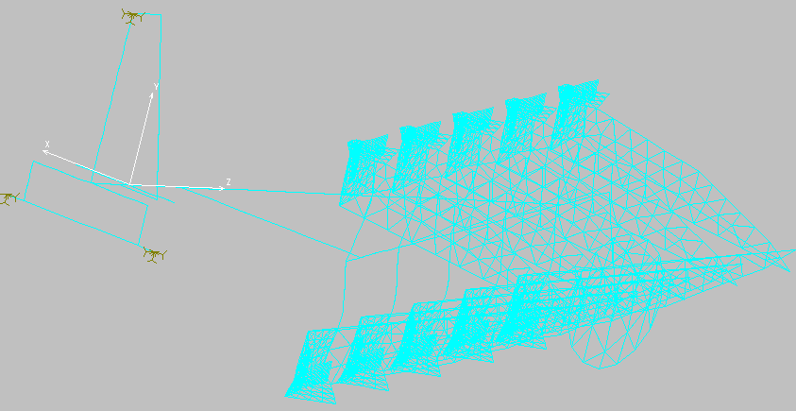
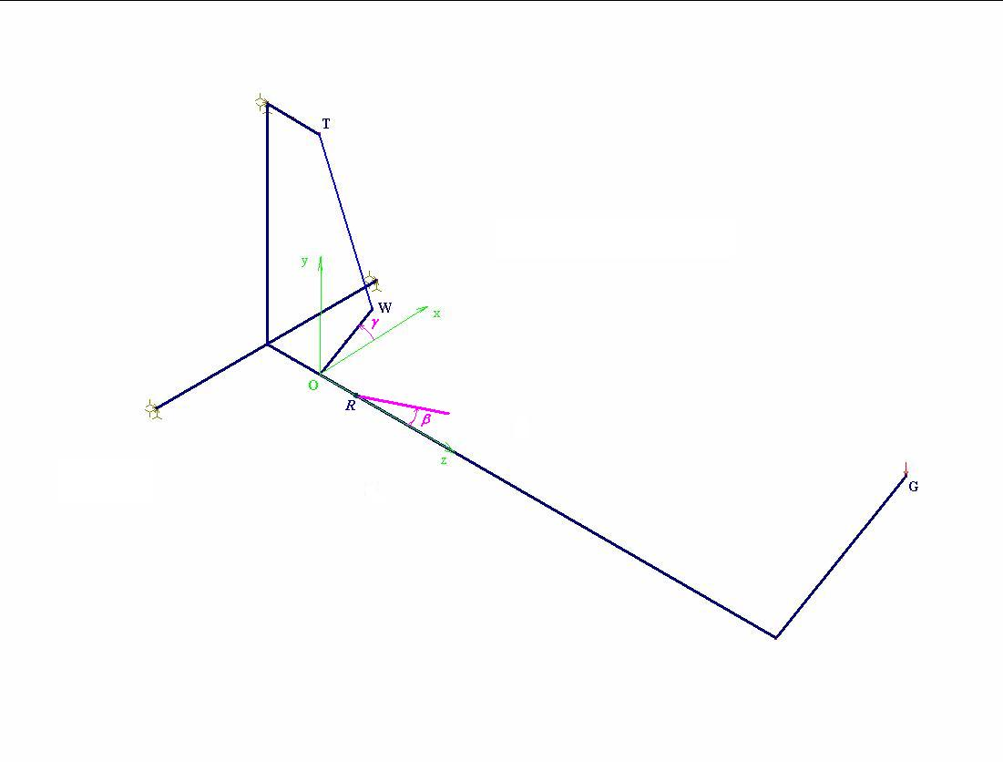
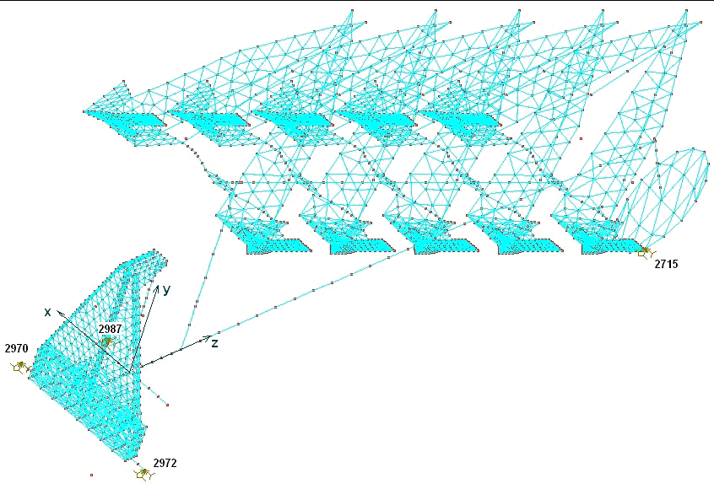

Fig. 1 Structural models of the reversible plough PRS-5.

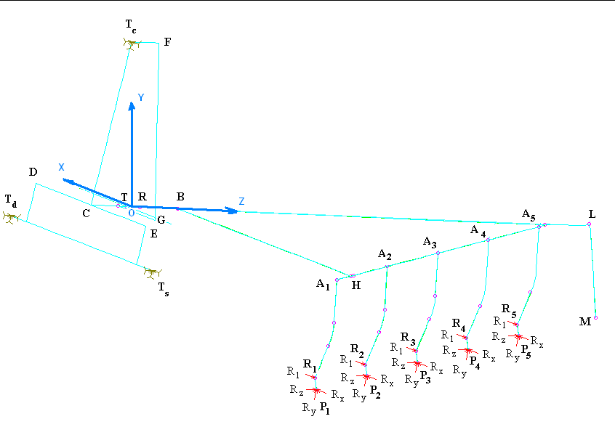
Fig. 2 Simplified model of the reversible plough, used only for assessing the behavior of the resistance frame during operation.

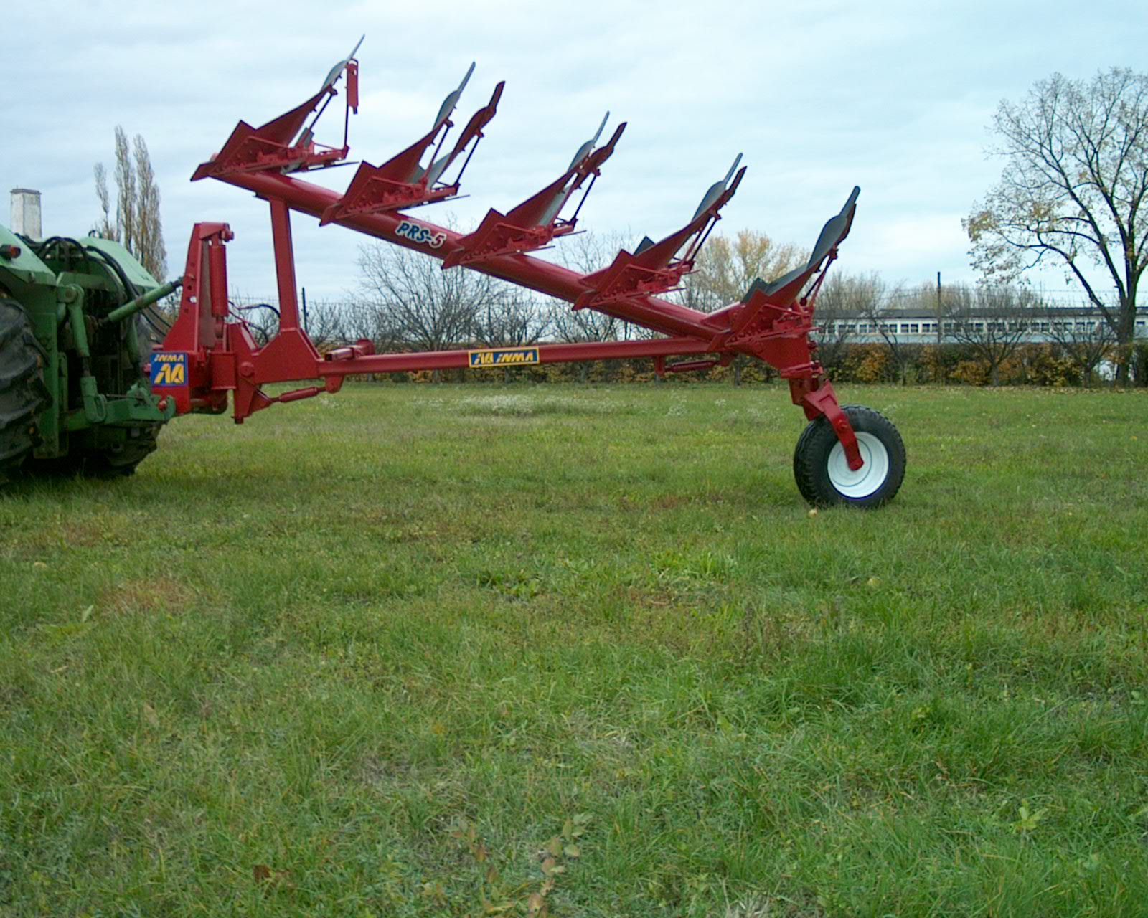
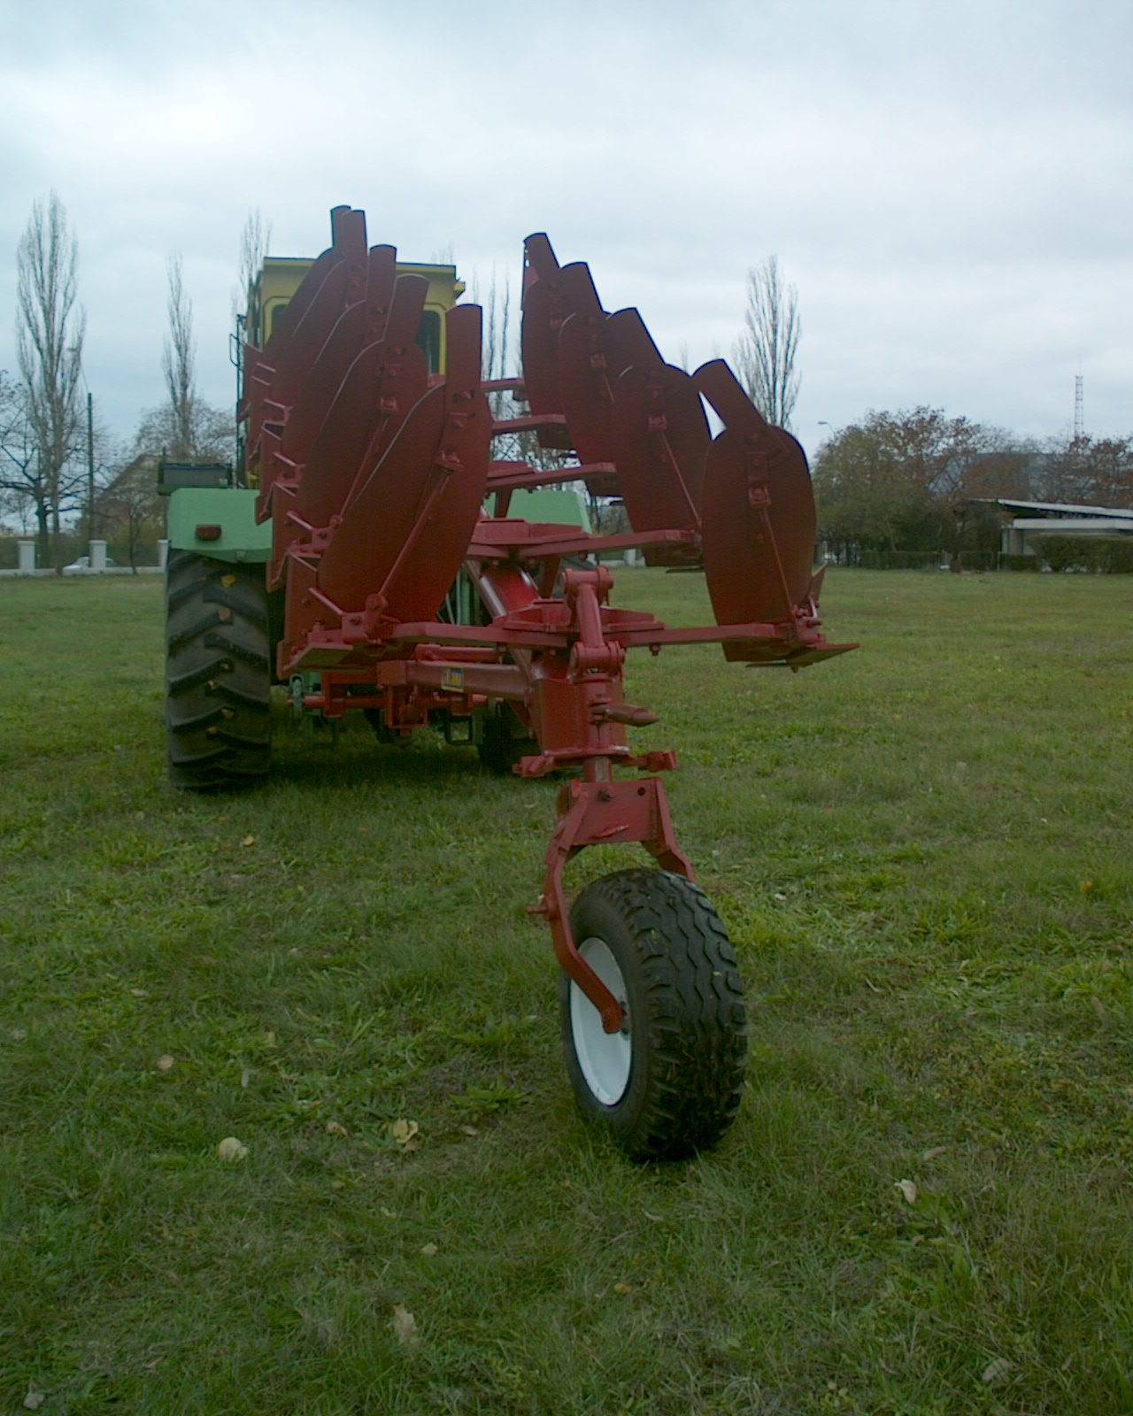

Fig. 3 Structural model of the plough PRS-5 used for assessing the behavior of the aggregate tractor A-1800 – plough PRS-5 during transport.

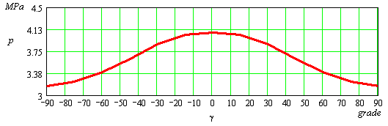
Fig. 4 Distribution of resistant pressure inside the hydraulic cylinder, depending on the reversing angle.

The last but not least, interesting application of the structural models for the reversible plough PRS-5 refers to the assessment of the structure behavior during transport. Such a study is interesting for this plough because the mass centre of the plough, in transport position, is at a relatively big height (over 1.5 m) so that, during curvatures, there can take place some skidding or overturning, or possibly some other damages of the coupling system to the tractor. In figure 3 there can be seen the structural model used in order to assess the behavior of the aggregate tractor A-1800 – plough PRS-5 during transport.
For dimensioning the hydraulic cylinder performing the reversing operation, the most suitable performance choice can be done starting from the maximum value so determined by simulation by means of the structural models. The maximum value of the resistant pressure which can be reached in the reversing processes is recorded to increase alongside with the increasing of the adjusting angle of the working width, so that the maximum value of the resistant pressure inside the hydraulic cylinder is taken as being the maximum value of its distribution for the situation when the plough is adjusted to the maximum working width (we take into consideration that the adjusting angle of the working width gets values only within the interval between 0⁰ and 12⁰, left or right). The selected hydraulic cylinder will be required with the possibility of working to a pressure at least double to the maximum accepted one for the resistant pressure.

3. Dynamic simulation of the reversing process

Having at our disposal the inertial data on the most complex structure of the reversible plough structural model there was obtained a model of the dynamics of the plough reversing process based on the model of the rigid solid with a fixed axis. The model is based on a system of six differential equations of the second rank, out of which only one leads to obtaining the time variation of the reversing angle. By using this model there are obtained the time variations both of the angle and of rotating angle speed, as in figure 5 and 6. The equations and the solutions have a non-linear character.
An analytical form of the resistant force distribution inside the hydraulic cylinder, depending on the reversing angle and the angle of adjusting the working width, can be obtained on an analytical method, too, and it has the form (1):

$F(β,γ)=m_{R}g\frac{h−δ\text{sin}γ}{\sqrt{δ^{2}−2δh\text{sin}γ+h^{2}}}\frac{x_{G0}\text{cos}β+(z_{G0}−r_{1})\text{sin}β}{δ}$, (1)

out of this being obtained pressure inside the cylinder, by the resistance dividing to the piston active surface. The significances of the variables occurring in this chapter are given in table 3.1.

Table 1 The significances of variables belonging to the dynamic models for the aggregate tractor – plough and for the plough.
Nr. | Notation | Significance | Measuring unit
1 | F | Resistance force to the action of the hydraulic cylinder | N
2 | β | Adjusting angle of working width | degrees
3 | γ | Reversing angle | radians
 |  | Reversing angular speed | Rad/s
 | $$\overset{¨}{γ}$$ | Reversing angular acceleration | Rad/sq.s.
4 | m_{R} | Mass of plough rotative part | kg
5 | g | Gravity acceleration | m/sq.s.
6 | h | Level (applicate) of the upper joint of the hydraulic cylinder in the reference system considered at structural models | m
7 | δ | Handle lenght | m
8 | x_{G0} | The mass centre abscise (x-coordinate) of the plough rotative part when the plough is during working position on the right | m
9 | y_{G0} | The mass centre y-coordinate of the plough rotative speed when the plough is during working position on the right | m
10 | z_{G0} | The mass centre height of the plough rotative part when the plough is during working position on the right | m
11 | r₁ | Distance from the origin of the fixed reference system to the point of rotation for adjusting the working width | m
12 | ℜ_{x} |  | N
13 | ℜ_{y} |  | N
14 | ℜ_{z} |  | N
15 | R_{x} | Active force component on the abscise (x-coordinate) | N
16 | R_{y} | Active force component on y-coordinate | N
17 | R_{z} | Active force component on the vertical | N
18 | R’_{x} | Reaction component on the abscise (x-coordinate) | N
19 | R’_{y} | Reaction component on y-coordinate | N
20 | R’_{z} | Reaction component on the vertical | N
21 | M_{x} | Component on the abscise (x-coordinate) of the active moment | Nm
22 | M_{y} | Component on y-coordinate of the active moment | Nm
23 | M_{z} | Component on the vertical of the active moment | Nm
M24 | i_{xx}, i_{yy}, i_{zz}, i_{xy}, i_{xz}, i_{yz}, | Components of the inertia tensor of the plough rotative part | Kg.sq.m
25 | x_{G} | Current abscise (x-coordinate) of the mass centre of the plough rotative part | m
26 | y_{G} | Current y-coordinate of the mass centre of the plough rotative part | m
27 | z_{G} | Current height of the mass centre of the plough rotative part | m
28 | S | Active surface of the hydraulic cylinder piston | sq.m.
The system of movement equations for the plough rotative part is the system of differential equations (2).
$\begin{aligned}−m_{R}(x_{G}{\overset{˙}{γ}}^{2}−y_{G}\overset{¨}{γ})=ℜ_{x}+R_{x}+R_{x}^{'}, \\ −m_{R}(y_{G}{\overset{˙}{γ}}^{2}+x_{G}\overset{¨}{γ})=ℜ_{y}+R_{y}+R_{y}^{'}, \\ 0=ℜ_{z}+R_{z}+R_{z}^{'}, \\ −i_{\text{yz}}{\overset{˙}{γ}}^{2}−i_{\text{xz}}\overset{¨}{γ}=M_{x}−r_{1}R_{y}^{'}, \\ i_{\text{xz}}{\overset{˙}{γ}}^{2}−i_{\text{yz}}\overset{¨}{γ}=M_{y}+r_{1}R_{x}^{'}, \\ −i_{\text{zz}}\overset{¨}{γ}=M_{z}\end{aligned}$ (2)

the only equation which in fact gives the movement being:

$i_{\text{zz}}\overset{¨}{γ}=\frac{Sδp(t)−m_{R}g\frac{h−δ\text{sin}γ}{\sqrt{δ^{2}−2δh\text{sin}γ+h^{2}}}\left[x_{G0}\text{cos}β+(z_{G0}−r_{1})\text{sin}β\right]}{i_{\text{zz}}}$, (3)

with the initial conditions (4):

$γ(0)=0,\overset{˙}{γ}(0)=0$. (4)

By using the equations (2) – (4) the reversing process can be simulated and a satisfactory operating duty can be calculated, as well as the maximum necessary pressure within this working duty. By simulating these can be established both the shape and the maximum values of the control function on the pressure inside the hydraulic cylinder. A complete reversing occurs in fig. 5 and 6, where there are given the time variations of the reversing angle and the reversing angular speed. In fig. 7 there can be seen the graphs of the time variations of the resistant pressure and the control pressure which should be applied inside the cylinder in order to perform reversing. In this example there is noticed that the control pressure has a bi-linear shape, with the derivative being discontinuous in the critical point. There are possible an infinity of control shapes. It can be noticed that it is not necessary that the maximum value of the control should reach the maximum value of the resistant pressure.

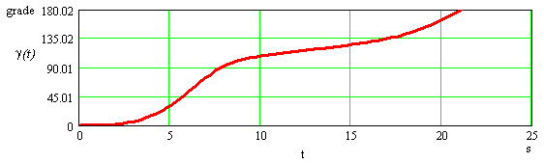
Fig. 5 Time variation of the reversing angle during a complete process of reversing according to a bi-linear law.

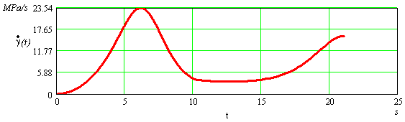
Fig. 6 Time variation of the reversing angular speed during a complete process of reversing according to a bi-linear law.

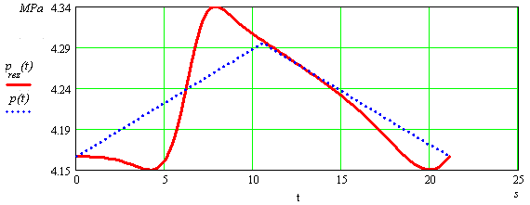
Fig. 7 Comparative time variation of the control pressures, p(t) and resistance, p_{rez} (t).

4 Conclusions

By using the results of the mathematical models shortly described in this article, some interesting conclusions can be drawn and there can be pointed a series of useful applications for the design and manufacturing the reversible ploughs, but also for their operation.
First, as a working process, the differences, as regards the interaction with the soil and the stress into the structure, the differences to the classical ploughs are minor and they do not need any complicated models.
The modeling and simulating of the transport process require an exacting structural modeling for the exact calculus of the mass centre and the structure inertial characteristics.
For the calculus of reversing dynamics there are necessary the results obtained on complex structural models. Thus some useful results are obtained for optimizing the reversing process: obtaining a short reversing time, ensuring a “silent” reversion and suitable comfort for the operator during the reversing process.
One of the important practical applications is the possibility of optimizing the reversing mechanism geometry.
The detailed results obtained during the parallel investigations on the reversible plough, performed on several models, will be made precise, each of them in separate articles which will be subsequently issued. This article is only the monitor of some articles which will precisely refer to each of the above-mentioned problems.

[1] M. N. Letoşnev, Agricultural Machines, Agriculture and Forestry Ministry, State Agro-Sylvical Printing House, Bucharest, 1959;
[2] A., V., Krasnicenko, Handbook of Agricultural Machinery Manufacturer, vol. 1 and 2, Technical Printing House, Bucharest, 1964.;

