1st International Conference
″Computational Mechanics and Virtual Engineering ″
COMEC 2005
20 – 22 October 2005, Brasov, Romania

APPLICATION OF COMPUTER GRAPHICS IN A 3D RECONSTRUCTION OF HUMAN ANKLE

Ciprian Radu¹
¹ Transylvania University, Brasov, ROMANIA, ciprian_radu@hotmail.com

Abstract: Complex parts of human skeleton are difficult to model using traditional mechanical techniques. Computational modeling techniques applied to the human body provide a possibility to analyze without interference in the human body.
The paper presents the advantages of using 3D models in biomechanics and medicine, a survey of the most important modeling techniques applied in the solid object representation and the specific modeling software.
The purpose of this paper is to perform the reconstruction of a 3D model of ankle joint using medical software, Mimics. Mimics is a software system for interfacing from a medical or technical scanner (mostly a CAT or CT scanner but also MRI) to Rapid Prototyping or CAD systems.
Keywords: computer graphics, 3D reconstruction, human ankle, topographic scanner, medical implant.

1. INTRODUCTION

The growth and the development of computer simulation has been rapid and its uses have extended from the entertainment media to the airline and automotive industries, military, different branches of science like medicine, engineering, physics and certainly to education.
To illustrate the potential that a combination of the knowledge from biology, engineering and computer graphics can have on the understanding of the development, maintenance and repair of the skeleton and on the clinical management of bone disease is the essence in the biomechanical research.
Biomechanics is the theory of how tissues, cells, muscles, bones, organs and the motion of them and their form and functions are regulated by basic mechanical proprieties.
A comparison with engineering may help us to understand the principles that presumably guide the evolution of bone strength. As in many sciences, the integration of experimental and analytical model is critical to gain and understanding of the skeletal response to mechanical factors.
Experiments provide insights and data, which can then be interpreted within the context of analytical frameworks. These investigations are greatly impacted by recent technological advances in imaging, computational mechanics, genetics and molecular biology. The integration of these techniques will provide important insight into skeletal development and disease.
In medical application, attention of researchers has now turned toward using combined 3D reconstruction and virtual environment technologies to train clinicians and to help surgeons plan patient-specific, complex procedures like plastic surgery, surgery for trauma from accidents and reconstruction surgery. The 3D models are very useful in simulation of bone fractures and internal fixations with implants. These models are also important to understand how human musculoskeletal structures adapt to external forces disturbances. Because of the complexity of these structures and because not all the biological and anatomical data about them are known, there are many possibilities for how the system might work. Computational modeling techniques applied to the human body and skeleton provide a possibility to analyze without interference in the human body.

2. DATA ACQUISITION

In medical imaging, the two most common systems used in acquiring detailed anatomical information are Computed Tomography (CT), and Magnetic Resonance Imaging (MRI). Other systems used include Ultrasound System, Mammography and X-ray. The key feature of these imaging technologies is their ability to provide detailed information about the anatomical structure and abnormalities.
CT uses radiation in the form of a highly collimated X-ray fan beam to slice a two-dimensional image or slice plane. Standard CT scanners achieve a resolution of 512 X 512 elements within a layer.
On the other hand, MRI, images are obtained based on different tissue characteristics by varying the number and sequence of pulsed radio frequency fields in order to take advantage of magnetic relaxation properties of the tissues. MRI differs from CT in at least two key aspects:
- MRI measures the density of a specific nucleus;
- The MRI measurement system is volumetric (interrogation of the entire body, within the measurement volume, is done all at one time).
CT and MRI represent the finest resolution capability available in diagnostic systems achieving volumetric resolutions. During the scanning process, the patient is stepped through the measurement plane 2-3mm at a time. The information from each plane can be put together to provide a volumetric image of the structure as well as the size and location of anatomical structures. The scanned model becomes a virtual volume that resides in a computer, representing the real volumes of the patient’s bone. The virtual volume is displayed on-screen by reformatting the data to create orthographic projections, or by a creating a pseudo 3D representation using surface-rendering algorithms.
When a series of CT images is reassembled to illustrate a 3D presentation of an anatomic structure, the medical practitioner or prosthetic designer can use this information directly and the overall shape of body structures is more clearly understood or visualized.
However, visualization requires good visualization software and so a number of dedicated software packages have been developed to enhance the visualization of such 3D computer models and enable the surgeon to grasp the particular details of individual cases. Some of these software packages include Analyze biomedical image processing package, Surgicad Template from Surgicad Corp., Intergraph corp. and Mimics from Materialise Software Company
The software packages take anatomical data from CT and MRI scans and create computer models of anatomical structures. A user can modify the image by defining various tissue densities for display. This allows separation of data of interest from the general information available from the scanner.

3. 3D VIRTUAL RECONSTRUCTION OF HUMAN ANKLE

The proposed solution is based on a method witch combine the imagine processing techniques and 3D computer graphics. For these techniques I have used a 3D reconstruction software (MIMICS).
Mimics is a software suite that performs the segmentation of the anatomy through sophisticated three-dimensional selection and editing tools. The method adopted for visualization is the conversion of 2D image slice data, as grey value images. The resolution can vary from 0.2 to 1 mm. The program also generates high-resolution 3D renderings in different colours directly from the slice information, as shown in Figure 1. Contrast enhancement can be carried out interactively to improve the model. The segmentation mask can be displayed in a different colour on top of the image.
The steps witch I have used to obtain the human ankle 3D model are:
- Import of all processor data witch are represented by 2D tomographic slice (figure 1). The number o 2D slices are 72 and the height of each one is one millimeter. These 2D slices belong to a person with a weight of 70 kg. As it can see in the picture below the bright colour zone appertain to the bone tissue whom it can be attribute a color mask to be differentiated by the soft tissue.

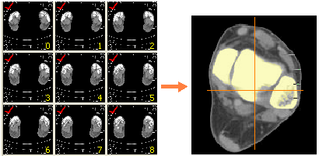
Figure 1: The input source represented by 2D tomographic slices.

- The second step is to establish the work planes. All images are loaded and displayed in three views. The view on the right shows the images as they are exported by the scanner (xy-view or axial view) (figure 2.c). The upper left corner is a reslice of these images in the xz-direction (xz-view or coronal view) (figure 2.a) and the bottom left is a reslice in the yz-direction (yz-view or sagittal view) (figure 2.b). The different colours of the intersecting lines (dashed lines) refer to the colours of the contour lines of each view so every line refers to the slice in the corresponding view.

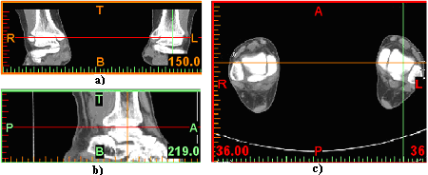
Figure 2: Establishing of work planes: a) frontal plane; b) sagittal plane; c) transversal plane.

- Thresholding means that the segmentation object (visualized by a colored mask) will contain only those pixels of the image with a value higher than or equal to the threshold value. Sometimes an upper and a lower threshold are needed, the segmentation mask contains all pixels between these two values. A low threshold value makes it possible to select the soft tissue of the scanned patient. With a high threshold, only the very dense parts remain selected. Using both an upper and a lower threshold is needed when the nerve channel needs to be selected. Defining a good threshold value also depends on the purpose of the model. The detection of bone tissue can be obtained by using the optimal gray value, established between minimum value of 2080 and maximum value of 3056 Hounstield units (figure 3).

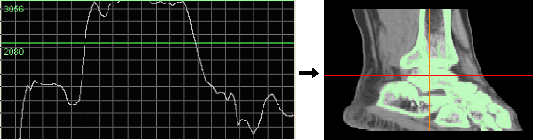
Figure 3: Establishing of the optimal gray value used for bone tissue detection.

- The 3D representation of the ankle articulation and fibular bone. As it can be seen in the picture below, the left hand said model represents the human ankle articulation and on the right hand said the fibular bone.

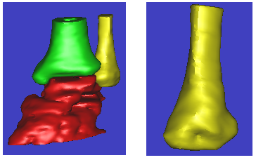
a) b)
Figure 4: 3D representation of human ankle and fibular bone.

The main problem witch can be meet is the realization of an interpolation between 2D tomographic sections. The virtual model obtained by the 2D slices, without the interpolation between them presents a roughness surface, with precipitous gaps on al three directions X, Y, Z (it is present so called “scale effect”, the size of gap is equal to the distance between two consecutive sections on the Z direction and equal to the size of the pixel on the X and Y directions. The model will always lose details and there is a possibility to provide wrong virtual and tactile informations.
The main advantage of MIMICS software is the fact that it’s possible to perform the interpolation between sections.
3. CONCLUSIONS

The potential for computer graphics to contribute to biomechanics and medicine progress is promising. It is important that not only knowledge of the natural tissue is focuses on. Also controlling and modeling mechanical stimuli will be essential to develop appropriately engineered organs and how to integrate the function with the host.

REFERENCES

- Naàji A.: Application of Computer Graphics in Biomechanics, Vasile Goldis West University, Arad.
- Nilson S.: Simulation of Bone Mechanics, Royal Institute of Technology, Stockholm, 2002.
- Radu C.: On the Design of a Prosthetic Element Using the Rapid Prototyping Technology, Transylvania University from Brasov, Romania 2005.
- Savii G.: Luchin M.: Modelare şi Simulare, Editura Eurostampa, Timişoara, 2000.
- Watt A.: 3D Computer Graphics, Addison Wesley, England, 1995.
- http://www.materialise.com.

