1st International Conference
″Computational Mechanics and Virtual Engineering ″
COMEC 2005
20 – 22 October 2005, Brasov, Romania

EFFECTS OF CONTINUOUS PRESSING WITH AND WITHOUT COOLING

MARIA LUMINITA SCUTARU
Universitatea “ Transilvania” – Facultatea , Braşov, Romania, lscutaru@unitbv.ro

Abstract: One big advantage of continuous presses for the production of wood based panels is temperature and their flexibility regarding. Both can easily be varied at different positions while the mat is running through the press.
Technically the cooling of a continuous press can only be efficient if the heat, dragged from the hot part of the press to the cooling section, can be reduced to a low level. That means that the continuous press has be divided into two sections which are unlinked on a thermal basis but still combined mechanically to keep up the pressure.
Key words: continuous presses, wood composites

1. INTRODUCTION

A major advantage of continuous hot pressing for the production of wood-based panels is the inherent flexibility to vary pressure and temperature. Both parameters can easily be controlled and changed at every position within the press during the production run. This advantage, in addition to other benefits such as heating factors, reduced sanding allowance; ability to run different products has resulted in the continuous press being considered the norm today for the wood-based panel industry.

2. TEMPERATURE WITHIN THE BOARD DURING PRESSING

To monitor the internal temperature profile while the board is running through the press a common thermocouple-testing probe was used. The thermocouple was pushed from the edge into the mat shortly before the press inlet and stayed in the board throughout its journey through the hot press, while at the same time sending the data to a connected measuring device. The exact moments when it entered and exited the press was recorded manually with the same measuring system. Before the thermocouple reached the diagonal cross cut saw, the connection was cut and its position labeled. The labeled board containing the colored mark was later separated and the thermocouple removed in order to measured its position within the board’s thickness.
The temperature profiles for a 19 mm MDF board are presented in different layers in the two following figures.
In figure 1, the press was running in a temperature mode, which is very common for continuous MDF board production- that is high temperature at the press inlet and a lower temperature at the press outlet. Because cooling was not active, the cooling platen temperature at the press outlet was $\text{180}C$.

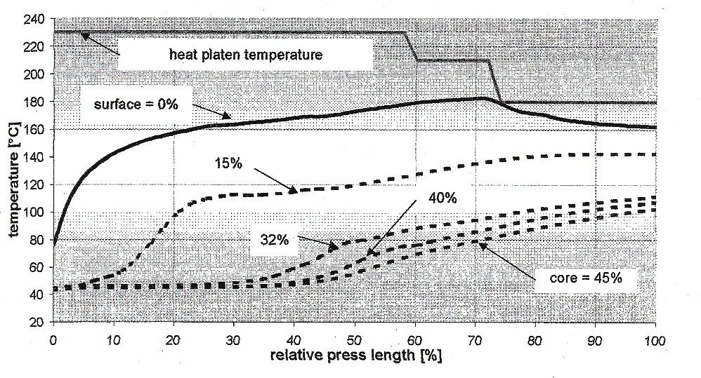

Figure 1: Temperature curves of a 19 mm MDF during continuous pressing without press cooling ( % = distance of thermocouple from board surface )

In figure 2 press cooling was active. That means, that the temperature of the press platens in the cooling zone at the press outlet was only $\text{80}C$ versus $\text{180}C$ as shown in figure 1. All other production parameters were equal to figure 1, including the initial mat moisture content.

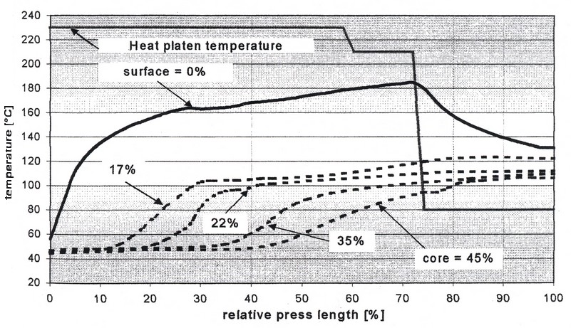

Figure 2: Temperature curves of a 19 mm MDF during continuous pressing with press cooling (% = distance of thermocouple from board surface)

As shown in figure 1 the heat transfer at the mat surfaces happens quite fast and the temperature reached more than $\text{160}C$ after the mat has passed the first third of the press length, finally reaching a maximum of approximately $\text{180}C$. At a layer close to the core (45% of the way into total board thickness) the $\text{100}C$ line gets hit prior to the press out feed.
Figure 2 shows the same temperature increase on the surface as achieved in figure 1, in the heated section of the press but the reveals a substantial temperature drop in surface temperature drop in surface temperature from the point where the cooling zone starts. The core layer in figure 2 also easily reaches $\text{100}C$ prior to exiting the press.
Figure 3 makes the effect of the press cooling very obvious. The two curves represent the temperature profiles of a 19mm, MDF board across the board thickness at the press outlet with and without cooling. As shown in figure 3, the temperature profiles with ($\text{80}C$) and without ($\text{180}C$) cooling only differs in the outer 4mm or 20% based on total board thickness. On the surface the boards are in the range of $\text{20}$to $\text{30}C$cooler with press cooling than without.
Also shown in figure 3, is the fact, that in-press cooling does not noticeably reduce the core temperature of the 19 mm board. For thicker boards this might become important, due to the fact that without thicker boards, the time available for resin cure is short in any case. Contrary to the core, the outer layers of a board usually suffer an excess of heat which I improved by cooling and the results have proven that the lower temperature imparted by product cooling are not detrimental to resin cure.

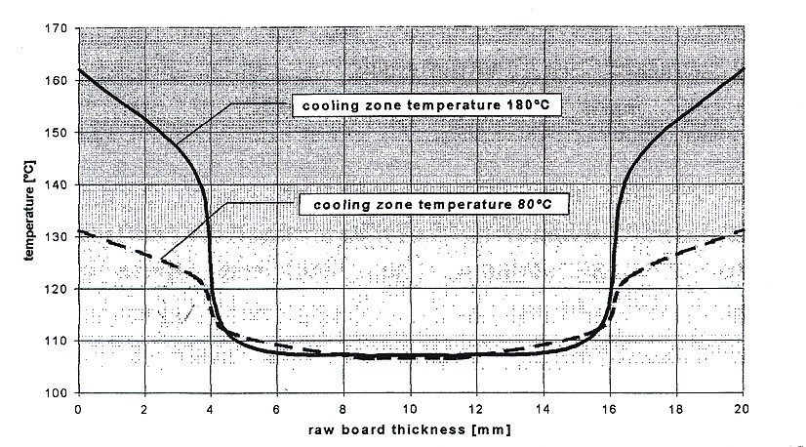

Figure 3: Temperature profile across the thickness of a 19 mm MDF board at the outlet of the continuous press without ($\text{180}C$ ) and with ( $\text{80}C$ ) press cooling.

REFERNCES:

[1] Barbu, M.: MDF - Placi din fibre de lemn. Editura Universităţii Transilvania Braşov
ISBN 973-635-027- 4

[2] Roll, H., Barbu, M.: - Continuous hot press with cooling section for MDF. Proceeding of the 5th
European Panel Products Symposium, Bangor, UK, 2001

