3rd International Conference
″Advanced Composite Materials Engineering ″
COMAT 2010
27- 29 October 2010, Brasov, Romania

THE EFFECT OF VOLUME FRACTION OF Al₂O₃ ON SYNTHESIS BEHAVIOR OF NANOSTRUCTURED Al-Al₂O₃ COMPOSITE DURING LOW TIME MILLING PROCESS

M. Alizadeh¹, M. Mirzaei Aliabadi²
¹Assistant professor, Department of Materials Science and Engineering, International Center for Science and High Technology and Environmental Sciences, Kerman, Iran, alizadeh@icst.ac.ir and mostafa_alizadeh56@yahoo.com
²Instructor, Department of Materials Science and Engineering, International Center for Science and High Technology and Environmental Sciences, Kerman, Iran

Abstract: In this work, low time mechanical milling process was employed to investigate the effect of volume fraction of Al₂O₃ on synthesis behavior of nanostructured Al-Al₂O₃ composite. Four different volume fractions of Al₂O₃ were mixed with the fine Al powder and the powder blends were milled for 5 hr. SEM analysis, particle size analysis and bulk density measurements were used to investigate the morphological changes and achieving the steady state. The results showed that increasing the Al₂O₃ content can provide the steady state particle size. X-ray mapping technique was used to investigate the uniformity of Al₂O₃ particles in the Al matrix. The results revealed that increasing the volume fraction of Al₂O₃ leads to increasing the uniformity of Al₂O₃. The XRD pattern depicted that increasing the Al₂O₃ content causes an increase in the crystal defects and micro-strain in the low time milled nanostructured composite powders while the grain size is decreased.
Keywords: Al-Al₂O₃, nanostructured composite, low time milling, synthesize behavior, steady state

1. INTRODUCTION

Al₂O₃ is known as a suitable reinforcement for the Al matrix since it is chemically inert with Al and can be also used in higher temperatures, in comparison with the un-reinforced aluminum, with accompanying benefits of resistance to creep [1]. Uniform dispersion of the Al₂O₃, particles with steady state conditions and a fine grain size of the matrix contribute to improve the mechanical properties of the composite. Recently, nanostructured composites have been found considerable attention due to their unique mechanical behavior [2]. Mechanical alloying (MA) is a simple and useful technique for achieving a uniform distribution of the fine particles within nanostructured composites [1]. During MA process, when a balance is achieved between the rate of welding and fracturing. This leads to a steady state particle size of the composite particles. The steady state can be attained only after full homogenization of the reinforcement particles in the matrix [3].
It has been reported that the time needed to reach the steady state depends on the distribution of alumina particles in the Al matrix [4–9]. In some cases, it is necessary to provide the steady state in low time milling. For example, to prevent the phase transformation in alumina particles during milling, we try to carry out the low time MA process. The main goal of the present work is to investigate the effect of volume fraction of Al₂O₃ particles on the synthesis behavior and steady state conditions of nanostructured Al-Al₂O₃ composites powders produced by low time milling process. It must be mentioned that one of the objectives during the present work is to find the volume fraction of Al₂O₃ in which the steady state of composite powders is achieved during a specified low time milling. Another aim in the present work is to ensure that after low time milling a homogeneous distribution of Al₂O₃ in the aluminum matrix is achieved. The reason behind this is the fact that a uniform distribution of reinforcements could potentially result in composites with improved mechanical properties.

2. EXPERIMENTAL

Pure Al powder and fine Al₂O₃ powder were used as starting materials for milling operation. The powder blends with composition of Al_{(100-x)}-Al₂O_{3(x)} (x =10, 20, 30 and 40 vol%) were milled using a planetary ball mill (Fritsch GmbH, model ‘Pulverisette 6’) in a hardened chromium steel vial and balls (10 mm diameter). The milling process was carried out at 300 rpm under argon atmosphere. All samples were milled for 5 hr with the ball to powder weight ratio 10:1.
The morphology of milled powders was characterized using a scanning electron microscope (SEM, S360, Cambridge, UK). The SEM was equipped with an energy dispersive spectrometer (EDS) for compositional examination. The particle size distribution of milled powders was determined using the laser particle size analyzer (Mastersizer 2000, Malvern Instruments, UK). The variation in bulk density of powders at the different volume fraction of Al₂O₃ was measured according to the standard Hall method (ASTM B417).
The microhardness test was performed to measure the hardness of specimens using the Duramin-1 microhardness tester at room temperature with a 100 gF load and a 15 second dwell time. Any microhardness value was an average of ten measurements for each specimen.
X-ray diffraction (XRD) with a D8 Bruker diffractometer (40kV and 40mA) and Cu Kα radiation (λ=0.154 nm) was used to analyze the crystal structure of the milled powders. The XRD patterns were recorded in the 2θ range of 30-120º with the step size of 0.01º. The grain size and lattice strain changes during the milling process were calculated by Williamson-Hall method for at least four peaks after removing instrumental broadening that was determined using the XRD pattern of an annealed Al powder.

2. RESULTS AND DISCUSSION

2.1. Evaluation of morphology

Figs. 1a-1d show the SEM micrographs of Al-Al₂O₃ composite particles containing various Al₂O₃ amounts. These figures depict the effect of Al₂O₃ content on the morphological changes during 5 hr milling. According to Figs. 1a-1d, increasing the volume fraction of Al₂O₃ causes an increased agglomeration in the composite powders produced during 5 hr milling. Moreover, it can be found that the composite particle size is a function of Al₂O₃ content.

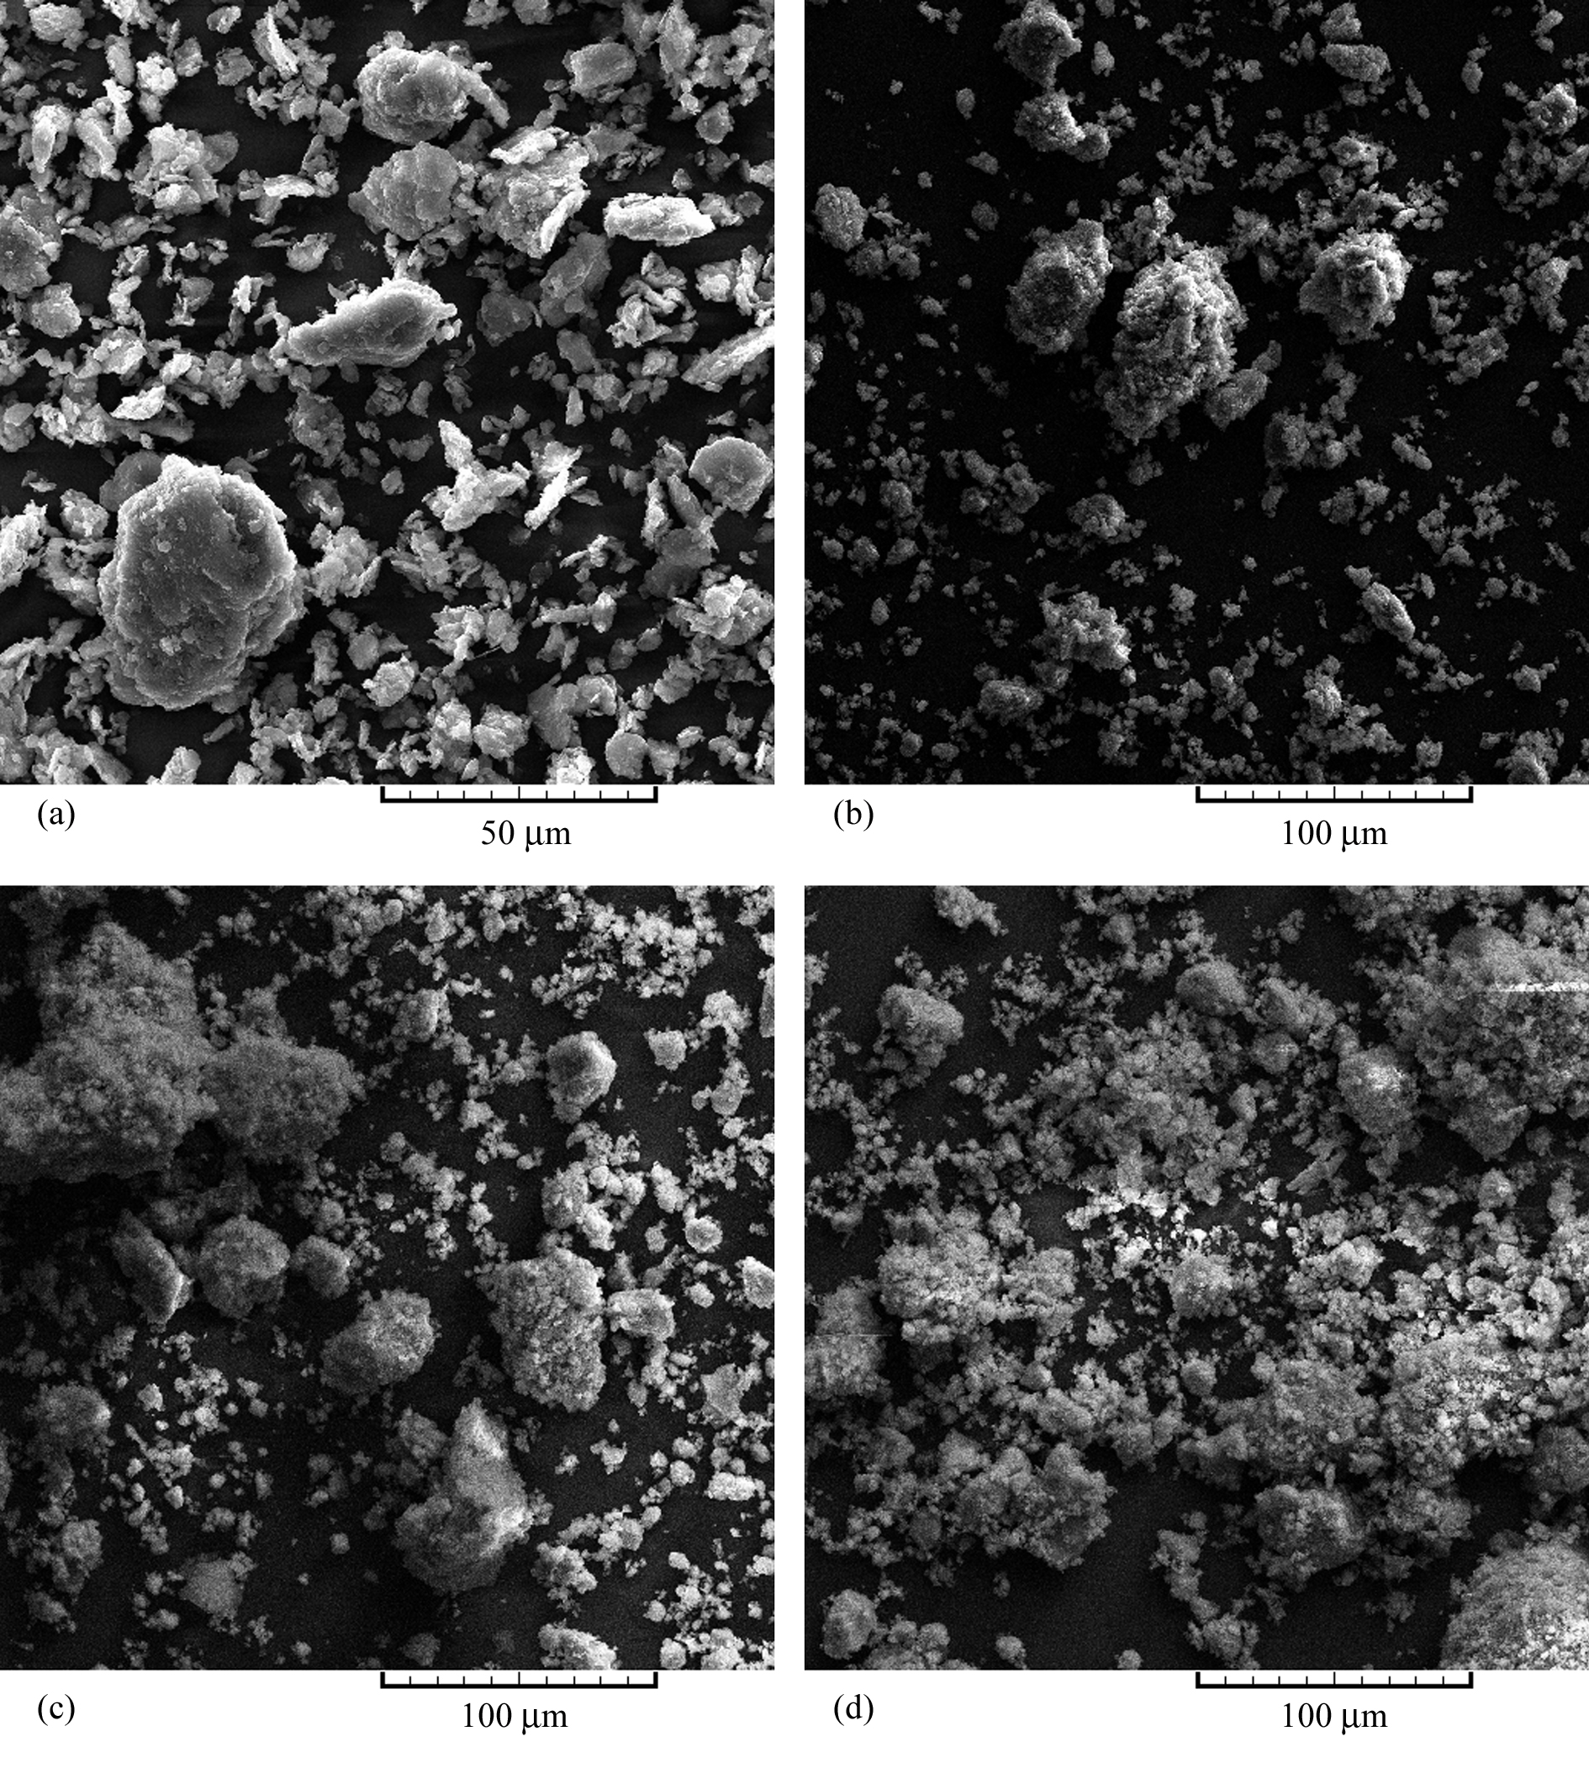
Figure 1: SEM images of composite powder after 5 hr ball milling for: (a) 10 vol.% Al₂O₃, (b) 20 vol.% ‎‎ Al₂O₃, (c) 30 vol.% Al₂O₃ and (d) 40 vol.% Al₂O₃

In order to quantify the effect of Al₂O₃ amount on the composite particle size, the median size (D₅₀) of 5 hr milled powders were determined using the laser particle size analyzer. The results of this analysis are shown by Fig. 2a. As it can be seen, increasing the Al₂O₃ amount from 0 up to 20 Vol.% causes a considerable decrease in the composite particle size while after that the composite particle size do not change with Al₂O₃ amount.
The results mentioned above may be justified as follows: during MA of this system, the Al powders with Al₂O₃ particles sticking onto them are cold welded with other surfaces. As a result, the Al₂O₃ particles are entrapped in the Al matrix and provide easier propagation of cracks in the Al matrix under cyclic loading during the milling process. This phenomenon is intensified by cold working induced during MA process [10]. Therefore, in the Al-Al₂O₃ system, particle deformation-cold welding and fracture are two mechanisms which take place through milling process. When the Al₂O₃ content is low, the Al particle deformation and cold welding are predominant mechanisms [11]. Due to this causes, the composite powders with 10 vol% Al₂O₃ include relatively large irregular (less equiaxed) particles (see Fig. 1a) compared to those with higher Al₂O₃ contents (see Fig. 1d). By increasing the Al₂O₃ content, contribution of the fracture mechanism is increased and consequently the particle size is more decreased. Moreover, the presence of Al₂O₃ particles increases the local deformation of the Al matrix enhancing the work hardening rate of the Al matrix [12]. Therefore, it is reasonable to believe that the presence of Al₂O₃ particles leads to decreasing the fracture toughness of the Al powders increasing their fracture during milling. Consequently increasing the volume fraction of Al₂O₃ particles leads to a decrease in the particle size of the composite powder during the low time milling. According to the Fig. 2a, this decreasing is continued until creation of a balance between the rate of welding and fracturing. This behavior may be related to the steady state achieving in the composite particle size.

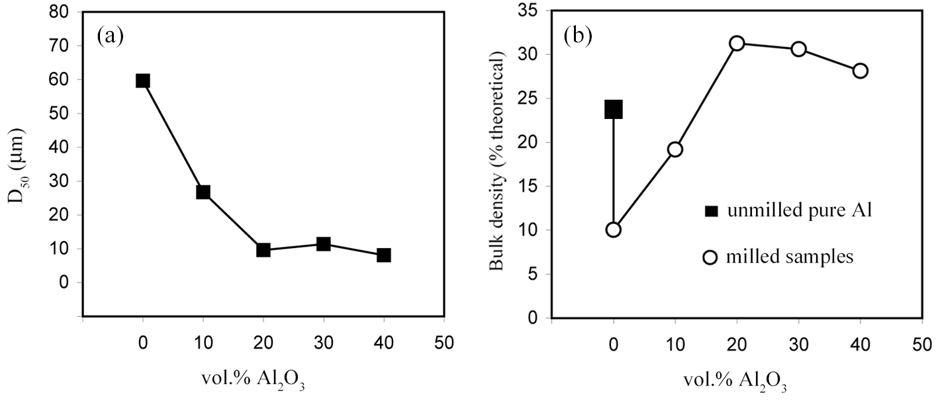
Figure 2: (a) Median size of 5 hr milled pure Al and Al-Al₂O₃ composite powders and (b) Bulk density of Al-Al₂O₃ composite powder as function of volume fraction of Al₂O₃

To study the steady state achieving, one can evaluate the variation in the bulk density of powders during the MA process [13]. It is known that the powder density depends on the size, morphology, and size distribution of its particles. Therefore, a change in the bulk density of powders during MA means that the particles morphology is changing. In other words, the steady state has not been achieved yet and vice versa, the steady state of particle size has been achieved [13, 14]. Fig. 2b shows the bulk density of unmilled pure Al powders (black square sign) and the 5 hr milled powders including 0, 10, 20, 30 and 40 Vol.% Al₂O₃ (white circle sign). This figure shows that 5 hr milling of pure Al causes a considerable decrease in the density of the powders. As it can be seen, the density from 25% of the theoretical value (for unmilled pure Al) drops to 10% of the theoretical value (for milled pure Al). This reduction is related to the morphology of pure Al after 5 hr milling process. According to Fig. 2b, when the volume fraction of Al₂O₃ is increased from 0 up to 20 Vol.%, a considerable increase is observed in the bulk density of 5 hr milled powders. After that, the density shows a slight decrease which can be related to the agglomeration of milled powders containing 30 and 40 Vol.% Al₂O₃ (see Figs. 1c and 1d). In fact, it can be resulted from Fig. 2b that the steady state is achieved in the 20 Vol.% Al₂O₃. This result confirms the result of Fig. 2a.

3.2. Embedding of Al₂O₃ particles within Al powders

One of the objectives in the present work is to ensure that after low time milling a homogeneous distribution of Al₂O₃ in the aluminum matrix is achieved. As mentioned before, the uniformity of the reinforcement influences the mechanical properties of the composite. Therefore to confirm that this distribution is uniform on an atomic scale, the microhardness test is carried out. Fig. 3 illustrates the microhardness behavior of the composites as a function of volume fraction of Al₂O₃. Each microhardness point in this diagram is an average of 10 measurements. This figure also depicts the standard deviations (SD) of microhardness measurements. As Fig. 3 shows, when the volume fraction of Al₂O₃ is increased from 10 up to 40 Vol.%, the hardness of composite is increased from 121.2 up to 164.9 HV. The noticeable point in this figure is the behavior of standard deviations versus volume fraction of Al₂O₃. As it can be seen, when the volume fraction of Al₂O₃ is increased up to 20 Vol.%, a severe decrease is observed in the SD while after that the SD of microhardness shows a slight change. Decreasing the SD means that uniformity of Al₂O₃ distribution in the Al matrix is increased. Thus it can be confirmed that increasing the Al₂O₃ content leads to increasing its uniformity.

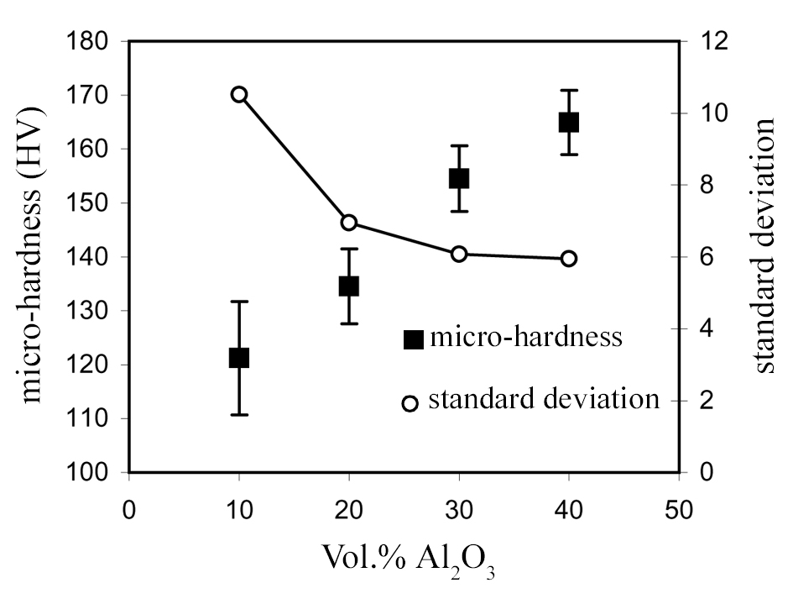
Figure 3: Variation of microhardness and standard deviation (SD) with volume fraction of Al₂O₃

3.3. Grain refinement and structural evaluation

Investigation of X-ray pattern reveals that by increasing the volume fraction of Al₂O₃, a slight shift in the position of the Al peaks is noticed and the Al peaks are also broadened. For example, Fig. 4a shows the variation of Al peak broadening and displacement for the plane of (111). This figure includes the XRD peak of unmilled pure Al (peak a) and the XRD peaks of the samples including 0, 10, 20, 30 and 40 Vol.% Al₂O₃ (peaks b-f). As it can be seen, the peak broadening is increased with increasing the volume fraction of Al₂O₃. Meanwhile, with increasing the Al₂O₃ content, the peaks show a shift towards the higher angles.

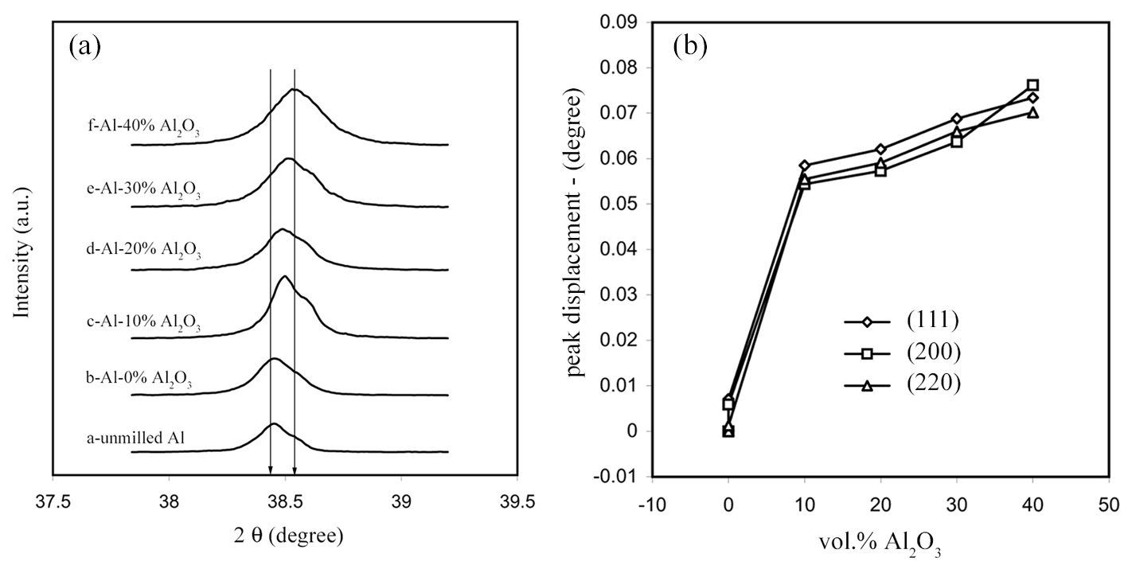
Figure 4: (a) The XRD main peak of Al representing the peak broadening and displacement versus increasing the Al₂O₃ content (b) Displacement of (111), (200) and (220) Al peaks as a function of volume fraction of Al₂O₃

Fig. 4b shows the Al peak displacement for the three main Al peaks (the planes of (111), (200) and (220)). Figs. 4a and 4b show that the peak position of the unmilled pure Al powders is near to that for the 5 hr milled pure Al (0 Vol.% Al₂O₃). On the contrary, when 10 Vol.% Al₂O₃ is added, a considerable displacement is observed. This means that the presence of Al₂O₃ has a considerable effect on the formation of crystal defects during low time milling. Also, Fig. 4b illustrates that when the Al₂O₃ content is increasing, the rate of peak displacement is decreased. This means that when the Al₂O₃ content is increased, the crystal defect formation is decreased.

In order to ensure that the low time milling process did not introduce any contamination into the milled powder, EDS analysis of the milled powders was conducted. Fig. 5 shows the EDS spectra for the Al-Al₂O₃ composition for the four different volume fractions, viz., 10, 20, 30, and 40 vol.%. The presence of only Al and oxygen in the EDS results confirms that the milled powders did not contain any additional element due to contamination from the milling media (grinding vessel and balls). Therefore, the Al peak displacement can not be due to dissolution of contamination. So it can be related to the defects created in the crystal structure during milling process. It may also be noted that the intensity of the oxygen peak is increasing with an increase in the volume fraction of Al₂O₃, as expected from the increased amount of oxygen in the powder mixes containing a higher volume fraction of Al₂O₃.

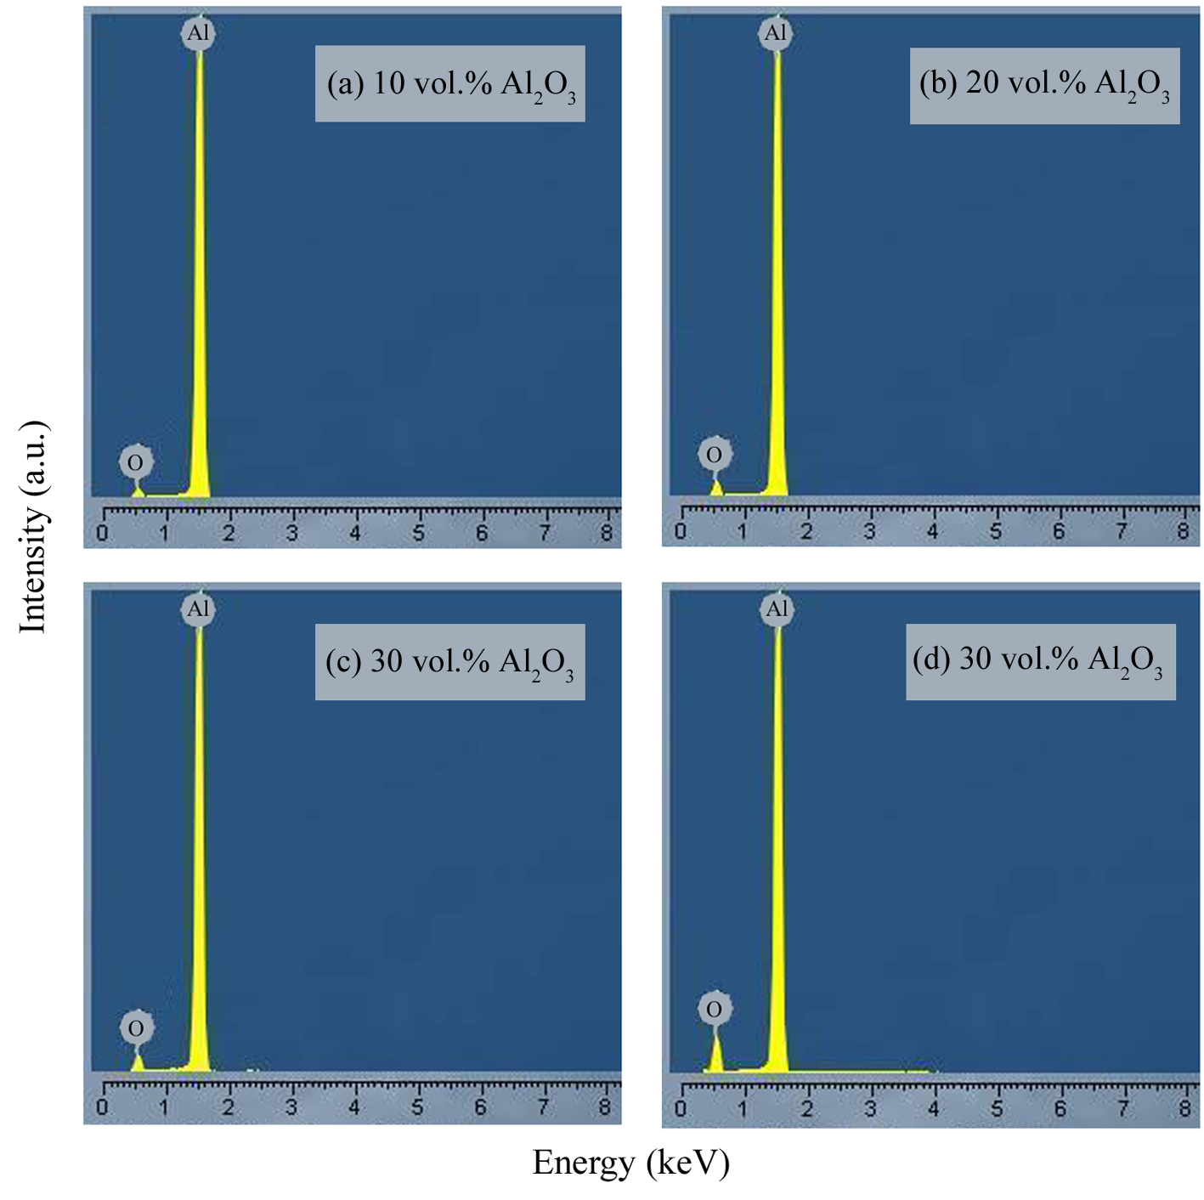
Figure 5: EDS patterns of Al-Al₂O₃ powders after 5 hr ball milling for: (a) 10 vol.% Al₂O₃, (b) 20 vol.% Al₂O₃, (c) 30 vol.% Al₂O₃ and (d) 40 vol.% Al₂O₃

The grain size of Al powders was calculated using the XRD pattern by William–Hall method [15]. Fig. 6 shows the crystallite size and lattice strain as functions of volume fraction of Al₂O₃. The results show that due to increasing the alumina from 10 vol.% up to 40 vol.%, the grain size of monolithic aluminum particles decreases from 114 nm to 93 nm at a constant milling time. Also the lattice strain increases from 0.87% to 1.1%. The interaction of the dislocations (generated during MA process) with the hard particles generates sub-boundaries which in turn results in the decomposition of the initial large grains into smaller ones. The decreased size of the Al grain when milled at the presence of the hard Al₂O₃ particles can be in part attributed to hindering the dislocation movement by Orowan bowing mechanism, leading to an increase in the dislocation density thereby accelerating the grain refining progress.

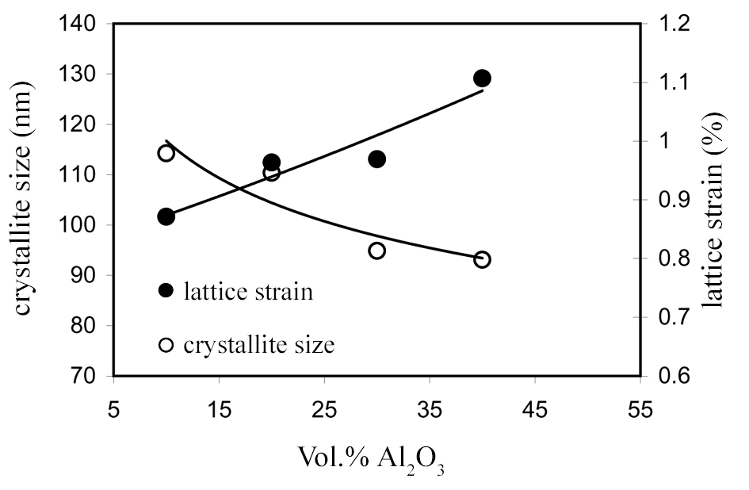
Figure 6: Crystallite size and lattice strain as functions of volume fraction of Al₂O₃

4. CONCLUSION

The low time milling process was employed to investigate the effect of Al₂O₃ content on the synthesis behavior of nanostructured Al-Al₂O₃ composite. Four different volume fractions of Al₂O₃ (10, 20, 30 and 40 vol.%) were mixed with the fine Al powder and the powder blends were milled for 5 hr. The following results can be listed briefly:
1-For 5 hr milling, as the volume fraction of Al₂O₃ is increased the particle size of nanostructured composite is decreased and the agglomeration of the particles is increased.
The particle size decreasing is continued until creation of a balance between the rate of welding and fracturing. This behavior can be related to the steady state reaching in the composite particle size.
2-As the volume fraction of Al₂O₃ is increased, the morphology of composite powders is changed from plate like to equiaxed.
3-the results of median size measurements and bulk density showed that for 5 hr milling process the steady state is achieved at 20 vol.% Al₂O₃
4-For the low time milling process (5 hr), increasing the volume fraction of Al₂O₃ improves the distribution of Al₂O₃ in the Al matrix. However, there is not a considerable nonuniformity of Al₂O₃ in the low volume fraction. Thus it can be concluded that 5 hr milling process can be suitable to produce a uniform nanostructured Al-Al₂O₃ composite.
5-At a low time milling process, increasing the volume fraction of Al₂O₃ leads to an increase in the crystal defects.
6-During 5 hr milling process, due to increasing the Al₂O₃ amount from 10 vol.% up to 40 vol.%, the grain size of monolithic Al particles decreased from 114 nm to 93 nm and also the lattice strain increased from 0.87% to 1.1%.

REFERENCES

[1] Prabhu B, Suryanarayana C, Ana L, Vaidyanathan R.: Synthesis and characterization of high volume fraction Al–Al2O3 nanocomposite powders by high-energy milling, Mater. Sci. Eng. A 425 (2006) 192–200.
[2] Lai M.O, Lu L, Laing W,: Formation of magnesium nanocomposite via mechanical milling, Compos. Struct. 66 (2004) 301–304.
[3] Benajmin J.S, Volin T.E.: The Kinetics of Composite Particle. Forming during Mechanical Alloying, Metall. Trans. 5 (1974) 1929–1934.
[4] Benjamin J.S, Bamford M.J.: Dispersion strengthened aluminum made by mechanical alloying, Metal Trans. A 8 (1997) 1301–1305.
[5] Enayati M.H, Rahmani Z.: Fabrication of nanostructured Al-Al₄C₃ alloys, Mater. Sci. Eng. A 25 (2004) 515–521.
[6] Kleiner S, Bertocco F, Khalid F.A, Beffort O.: Decomposition of process control agent during mechanical milling and its influence on displacement reactions in the Al–TiO₂ system, Mater. Chem. Phys. 89 (2005) 362–366.
[7] Ruiz-Navas E.M, Fogagnolo J.B, Velasco F, Froyn L.: One step production of aluminium matrix composite powders by mechanical alloying, Comp. Part A. 37 (2006) 2114–2120.
[8] Suryanarayana C.: Mechanical alloying and milling, Prog. Mater. Sci. 46 (2001) 1–184.
[9] Zebarjad S.M, Sajjadi S.A.: Dependency of physical and mechanical properties of mechanical alloyed Al–Al₂O₃ composite on milling time, Mater. Design 28 (2007) 2113–2120.
[10] Khakbiz M, Akhlaghi F.: Synthesis and structural characterization of Al–B₄C nano-composite powders by mechanical alloying, J. Alloys Comp. 479 (2009) 334–341.
[11] Razavi Hesabi Z, Simchi A, Seyed Reihani S.M.: Structural evolution during mechanical milling of nanometric and micrometric Al₂O₃ reinforced Al matrix composites, Mater. Sci. Eng. A 428 (2006) 159–168.
[12] Davidson D.L, in: Everett R.K, Arsenault R.J, (Eds.).: Metal Matrix Composites, Mechanisms and Properties, Academic Press, 1991, p. 217.
[13] Fogagnolo J.B, Velasco F, Robert M.H, Torralba J.M.: Effect of mechanical alloying on the morphology, microstructure and properties of aluminium matrix composite powders, Mater. Sci. Eng. A342 (2003) 131–143.
[14] Fogagnolo J.B, Ruiz-Navas E.M, Robert M.H, Torralba J.M.: The effects of mechanical alloying on the compressibility of aluminium matrix composite powder, Mater. Sci. Eng. A355 (2003) 50–55.
[15] Williamson G.K, Hall W.H.: X-ray line broadening from filed aluminium and wolfram, Acta Metall. 1 (1953) 22–31.

