Introduction in Virtual Instrumentation concept

Drugă C¹, Braun B¹, Cismaru M¹, Turcu C²
¹ „TRANSILVANIA” University of Braşov, Romania, e-mail: druga@unitbv.ro, braun@unitbv.ro,
² „RULMENTUL” High School Braşov, Romania, e-mail: cturcu@unitbv.ro

Abstract: A virtual instrumentation system is a computer software that a user would employ to develop a computerized test and measurement system, for controlling from a computer desktop an external measurement hardware device, and for displaying test or measurement data collected by the external device on instrument-like panels on a computer screen.
Virtual instrumentation extends also to computerized systems for controlling processes based on data collected and processed by a computerized instrumentation system.

Keywords: virtual instrumentation ,PC-bus, GPIB, VSI-board, DAQ board, .

1. INTRODUCTION
In these days many functions, such as the communication, data display, data output, human interface, a
memory, data processing in a measurement instruments system, and signal processing, are gradually taken in by improvement in the data-processing capability of a personal computer, and measurement system which can be customized comparatively free according to a user intention are used. As the processing of a sensor output is realized in the virtual world of a computer system, this system is known as a virtual measurement system.
The virtual measurement system is used especially by researchers or engineers as a professional
engineering tool according to the predominance realized a signal/data processing, and conversion of a measurement result on the same platform, unified operability over many functions of a measurement
system and the pliability of customization. However, this virtual measurement system is utilizable also as an educational training tool, for learning the method and principles of measurement object and operation principle and usage of measurement instruments and system by various features of the virtual world [1].
Today's virtual measurement system is a total system initialized all the functions of measurement instruments through a graphical user interface in the virtual world by the remarkable improvement in the data-processing capability in personal computers and more digitization in measurement instruments. The usage is not only as a special software for a certain measurement instrument like Multimeter, Oscilloscope and Spectrum Analyzer, but also users are able to design an original function and system, and to make a flexible system on characteristics of measurement object acquired record output by performing a measurement simulation in advance. Tools including designs, such as LabVIEW and HP-VEE, are standard used for designing of such virtual measurement system today.
The virtual measurement system, which fully employed the feature of the virtual world and a communication function efficiently, is being widely utilized as a professional engineering tool that extended the capability of conventional measurement instruments deeply and broadly.
The virtual measurement system enhances the usability by taking the operation of virtual world and employing the operation element of actual measurement instruments efficiently. This is one of the main factors that hare obtained many user’s approval for a virtual measurement system.

2. REALIZATION AND DEVELOPMENT OF VIRTUAL INSTRUMENTATION

Virtual instrumentation thus refers to the use of general purpose computers and workstations, in combination with data collection hardware devices, and virtual instrumentation software, to construct an integrated instrumentation system; in such a system the data collection hardware devices, which incorporate sensing elements for detecting changes in the conditions of test subjects, are intimately coupled to the computer, whereby the operations of the sensors are controlled by the computer software, and the output of the data collection devices is displayed on the computer screen, in a manner designed in software to be particularly useful to the user, for example by the use of displays simulating in appearance the physical dials, meters and other data visualization devices of traditional instruments [2].
Virtual instrumentation systems typically also comprise pure software instruments, such as oscilloscopes and spectrum analyzers, for processing the collected sensor data and massaging it in ways useful to the users of the data. For example, software means may be employed to analyze collected data as needed to present the user with isolated information on max or min readings, averages, standard deviations, or combinations of results from related sensing points, etc.
The development of virtual instrumentation systems faced challenging technical difficulties. Major obstacles included the many types of electronic interfaces by which external data collection devices can be coupled to a computer, and great variety in the command sets used by different hardware device vendors to control their respective products. Also, data collecting hardware devices differ in their internal structures and functions, requiring virtual instrumentation systems to take these differences into account. Thus, some data acquisition devices are so-called register-based instruments, controlled by streams of 1s and 0s sent directly to control components within the instrument; others are message-based instruments, and are controlled by strings of ASCII characters, effectively constituting written instructions that must be decoded within the instrument.
In turn, different instruments use different protocols to output data, some as electrical frequencies and others as variations in a base voltage, for example. Any virtual instrumentation system intended for connection to a typical variety of commercially available data collection hardware devices must accordingly comprise software tools capable of communicating effectively with the disparate types of hardware devices.
Until the 1990’s, the programming of virtual instrumentation systems was a task strictly for professional programmers, who wrote the required software programs using textual programming languages such as BASIC, C ++, or PASCAL. In addition to the factors previously mentioned, the great variety in possible applications also called for professional expertise, in that one customer’s measurement application was rarely suitable for another customer. For example, one customer may have needed only to collect a single value, outside temperature, once an hour, and to have all collected values stored in a file. The next customer possibly required that several related process temperatures, in a rubber-curing process, be monitored continuously, and that a shut-off valve be activated in the event that the relative temperature between two process steps should vary by more than seven degrees for a time period of three seconds or more, in any 15 minute period, and to store only data concerning such episodes.
The development of instrumentation systems software by professionals using textual programming languages such as C++ is very time consuming and tedious, and it typically results in the production of a program consisting of many pages of source code, written in a computer language that is virtually unreadable by non-programmers, and which thus cannot be modified by the typical users of such programs.
In the last ten years, there have appeared several commercial software products for the development of virtual instrumentation systems using purely graphical programming methods. Each of these products provides users, typically including users who are not skilled software programmers, with a graphical development environment within which to design a custom virtual instrumentation system. Typically, the user is presented with a design desktop environment, generally having the look-and-feel familiar to users of Windows®-based graphical applications, in which a variety of software options and tools are accessible from toolbars and dialog boxes featuring drop-down menus, and may be accessed by manipulating an on-screen cursor using a computer mouse.
However, these older software packages for developing virtual instrumentation systems, using graphical programming means, provide the user with tools for designing so-called data flow diagrams. The user of these software packages is thus required both to place icons representing desired system components onto a design desktop and then to effect wiring connections between components. In order to design a data flow diagram that corresponds to a workable measurement system application, the user is required to have comparably deep knowledge and understanding of the specific data paths and element combinations that will be required to attain
the user’s objective, which is a solution to the user’s measurement requirements.
The range of applications that may be made the subject of an instrumentation system spans the range of human activity. Therefore, a software development system that aims to provide a large cross-section of potential users with the tools to design their own customized instrumentation system must provide the user with a large range of development tools and options, including tools and options that may be or are mutually incompatible in a given application.
For many years electronic instruments have been easily identified products. Although they ranged in size and functionality, they all tended to be box-shaped objects with a control panel and a display. Stand-alone electronic instruments are very powerful, expensive and designed to perform one or more specific tasks defined by the vendor. However, the user generally cannot extend or customize them.
The knobs and buttons on the instrument, the built-in circuitry, and the functions available to the user, all of these are specific to the nature of the instrument. In addition, special technology and costly components must be developed to build these instruments, making them very expensive and hard to adapt.
Widespread adoption of the PC over the past twenty years has given rise to a new way for scientists and engineers to measure and automate the world around them. One major development resulting from the ubiquity of the PC is the concept of virtual instrumentation.
A virtual instrument consists of an industry-standard computer or workstation equipped with off-the-shelf application software, cost effective hardware such as plug-in boards, and driver software, which together perform the functions of traditional instruments.
Today, virtual instrumentation is coming of age, with engineers and scientists using virtual instruments in literally hundreds of thousands of applications around the globe, resulting in faster application development, higher quality products and lower costs. Virtual instruments represent a fundamental shift from traditional hardware-centered instrumentation systems towards software-centered systems that exploit the computing power, productivity, display and connectivity capabilities of popular desktop computers and workstations.
Although PC and integrated circuit technologies experienced significant advances in the past two decades, it is the software that makes possible building virtual instruments on this foundation. Engineers and scientists are no longer limited by traditional fixed-function instruments.
Usually instrumentation manufacturers provide specific functions to given architecture and fixed interfaces for measuring devices, and thus limit the application domain of these devices. In actual use much time is required for adjusting the measuring range and for saving and documenting the results.
The advent of microprocessors in the measurement and instrumentation fields produced rapid modifications of measuring device technology, soon followed by the appearance of computer-based measurement techniques.
The measurement process consists of three parts, as shown in figure 1, acquisition of measurement data or signals, conditioning and processing of analysis of measurement signals and presentation of data.
The concept of virtual instrument is frequently used in industrial measurement practice, but not always with precisely the same meaning. For some engineers, virtual instruments are based on standard computers and represent systems for storage, processing and presentation of means of integration of the display, control and centralization of complex measurement systems. Industrial instrumentation applications, however, require high rates, long distances, and multi-vendor instrument connectivity based on open industrial network protocols.
In order to construct a virtual instrument it is necessary to combine the hardware and software elements which should perform data acquisition and control, data processing and data presentation in a different way to take maximum advantage of the PC. It seems that in the future the restrictions of instruments will move more and more from hardware. Such a general conception of virtual instrumentation is presented in figure 2.

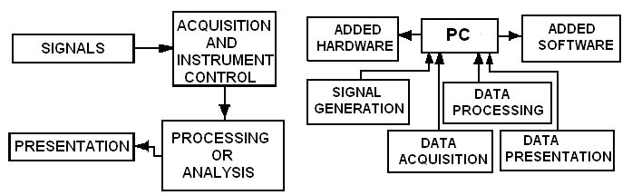

Fig. 1: Conceptual model of measurement process[2]. Fig.2: The general conception of virtual instruments[2].

The vendor of virtual instrument can use the serial communication based on RS-232 standard or the parallel communication based on GPIB standard (HP-IB, IEEE 488.1-2 or IEC 625.1-2), PC bus, or VXI-bus (VME eXtension for Instrumentation).
The main categories of virtual instruments:
- Graphical front panel on the computer screen to control the modules or instruments
  - controlled module is plug-in DAQ board,
  - controlled instrument is based on GP-IB board,
  - controlled instrument is connected via serial port,
  - controlled instrument is VXI-board (or system).
- Graphical front panel with no physical instruments at all connected to the computer. Instead, the computer acquires and analyses the data from files or from other computers on a network, or it may even calculate its data mathematically to simulate a physical process or event rather than acquiring actual real world data.
To the PC connections according to first point the following process measuring devices are attached: sensors, GP-IB instruments, Serial instruments and VXI instruments.
The main representative features of virtual instruments describing their functionality are following:
- Enhancing traditional instrument functionality with computers;
- Opening the architecture of instruments;
- Widespread recognition and adoption of virtual instrument software development frameworks.

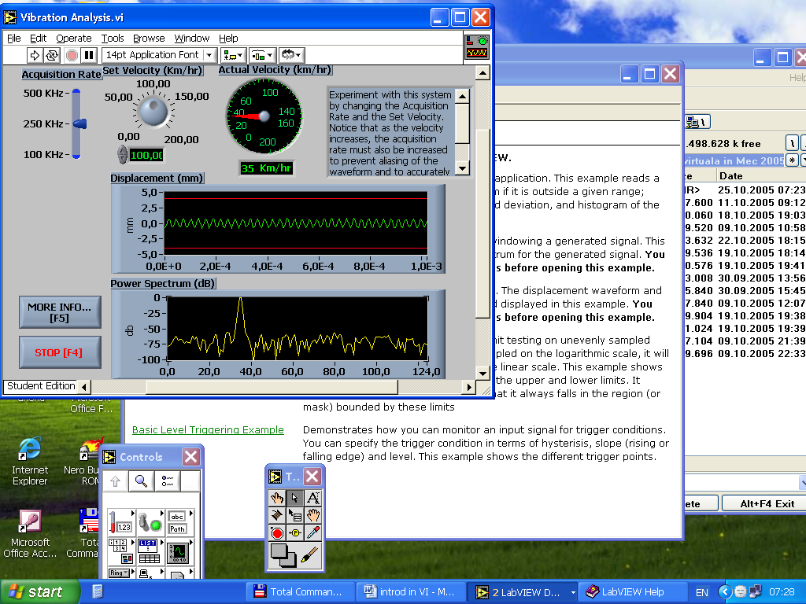

Fig. 3 Example of a virtual instrument for the vibration analysis [7].

The basic components of all virtual instruments include a computer and a display, the virtual instrument
software, a bus structure and the instrument hardware.

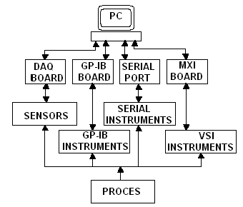

Fig.4: Structure of the PC-based instrumentation hardware [2].

The computer and the display are the heart of virtual instrument systems; these systems are typically based on a personal computer or workstation with a high-resolution monitor, a keyboard, and a mouse. It is important for the chosen computer to meet the system requirements specified by the instrumentation software packages.
Rapid technological advancements of PC technology have greatly enhanced virtual instrumentation. Moving from DOS to Windows gave to PC users the graphical user interface and made 32-bit software available for building virtual instruments. The advances in processor performance supplied the power needed to bring new applications within the scope of virtual instrumentation. Faster bus architectures (such as PCI) have eliminated the traditional data transfer bottleneck of older buses (ISA). The future of virtual instrumentation is tightly coupled with PC technology.
If the computer is the heart of the virtual instrument systems, the software is their brain. The software uniquely defines the functionality and personality of the virtual instrument system. Most software is designed to run on industry standard operating systems on personal computers and workstations.
Register-level software requires the knowledge of inner register structure of the device (DAQ board, RS 232 instrument, GP-IB instrument or VXI module) for entering the bit combination taken from the instruction manual in order to program measurement functions of the device. It is the hardest way in programming [4] The resulting program is strongly hardware dependent and it is rarely executable on systems with different hardware.
One of the most important components in measurement systems today is the device driver software. Device drivers perform the actual communication and control of the instrument hardware in the system. They provide a medium-level easy-to-use programming model that enables complete access to complex measurement capabilities of the instrument [5]
In the past programmers spent a significant amount of time writing this software from scratch for each instrument of the system. Today, instrument drivers are delivered as modular, off-the-shelf components to be used in application programs. Several leading companies formed (in 1988) the Interchangeable Virtual Instrument (IVI) Foundation; the IVI Foundation was formed to establish formal standards for instrument drivers and to address the limitations of the former approaches.
Currently the most popular way of programming is based on the high-level tool software. With easy-to-use integrated development tools, design engineers can quickly create, configure and display measurements in a user-friendly form, during product design, and verification [4].
The most known, popular tools are as follows [2]:
- LabVIEW (Laboratory Virtual Instrument Engineering Workbench) - is a highly productive graphical programming language for building data acquisition and instrumentation systems. To specify the system functionality one intuitively assembles block diagrams - a natural design notation for engineers. Its tight integration with measurement hardware facilities rapid development of data acquisition, analysis and presentation of solutions.
- LabWindows/CVI (C for Virtual Instrumentation) - is a Windows based, interactive ANSIIC programming environment designed for building virtual instrumentation applications. It delivers a drag-and-drop editor for building user interfaces, a complete ANSIIC environment for building test program logic, and a collection of automated code generation tools, as well as utilities for building automated test systems and monitoring applications of laboratory experiments.
- HP VEE (Hewlett-Packard's Visual Engineering Environment) - allows graphical programming for instrumentation applications. It is a kind of Visual Engineering Environment, an iconic programming language for solving engineering problems. It also provides an opportunity to gather, analyze and display data without conventional (text-based) programming.
- TestPoint - is a Windows based object-oriented software package that contains extensive GPIB instrument and DAQ board support. It contains a novel state-of-the art user interface that is easy to use.
Logic flow is easily established with a point and drag action list.
- Measurement Studio - is a measurement tool for data acquisition, analysis, visualization and Internet connectivity. This development tool helps you build your test system by integrating into your existing Microsoft compiler. Measurement Studio provides a collection of controls and classes designed for building virtual instrumentation systems inside Visual Basic or Visual C++. With Measurement Studio you can configure plug-in data acquisition boards, GPIB instruments, and serial devices from property pages without writing any code.

Four types of interconnect buses dominate the industry: the serial connection (serial port), the GPIB, the PC-bus and VXI bus .
GPIB- was the first industry standard bus for connecting computers with instrumentation. A major advantage of GPIB is that the interface can be embedded on the rear of a standard instrument. This allows dual use of the instrument: as a stand-alone manual instrument or as a computer-controlled instrument.
The GPIB offers a flexible cable that connects a GPIB interface card in the computer to up to 15 instruments over a distance of up to twenty meters. The interface card comes with software that allows transmission of commands to an instrument and reading of results. Each GPIB instrument comes with a documented list of commands for initiating each function. GPIB has a maximum data rate of 1 Mbytes/s and typical data transfers are between 100 and 250 Kbytes/s.
PC-bus. With the rapid acceptance of the IBM personal computer in test and measurement applications, there has been a corresponding growth of plug-in instrumentation cards that are inserted into spare slots. However, high accuracy instruments require significant circuit board space to achieve their intended precision. Because of the limited printed circuit board space and close proximity to sources of electromagnetic interference, PC-bus instruments tend to be of lower performance than GPIB instruments but also of lower cost.
Serial port. Serial communication based on RS-232 standard is the simplest way of using a computer in measurement applications and control of instruments. Serial communication is readily available via the serial port of any PC and it is limited in data transmission rate and distance (up to 19:2 Kbytes/sec, recently 115 Kbytes/sec, the associated software.
VXI bus. In the late eighties, the VME eXtension for Instrumentation (VXI) standard allowed communication among units with transfer over 20 Mbytes/second between VXI systems. VXI instruments are installed in a rack and are controlled by, and communicate directly with, a VXI computer.
These VXI instruments do not have buttons or switches for direct local control and do not have local display typical in traditional instruments. It is an open-system instrument architecture that combines many of the advantages of GPIB and computer backplane buses.
Virtual instrumentation never eliminates the instrument hardware completely; to measure the real world there will always be some sort of measurement hardware, sensor, transducer and conditioning circuit, but the physical form factor of this instrumentation may continue to evolve.

3. CONCLUSION

Ideally, such a system should also organize the software tools provided to the user in a way that enables the user to select easily the particular tools best suited for the pertinent application, and guide the user’s selection of configuration options. Older software packages lack built-in safeguards against the construction of unworkable combinations of components, and provide inadequate intuitive guidance to the user seeking to develop a measurement application.
Virtual instrumentation is fuelled by ever-advancing computer technology and it offers the power of creating and defining someone's own system based on an open framework. The combination of computer performance, graphical software, and modular instrumentation has led to the emergence of virtual instruments, which are substantially different from their physical ancestors.
Virtual instruments are manifested in different forms ranging from graphical instrument panels to complete instrument systems. Modular instrumentation building blocks are becoming more prevalent in the industry and are allowing users to develop capabilities unattainable using traditional instrument architectures.
The trend in virtual instrumentation increasingly integrates the measurement systems into more complex monitoring and control systems distributed over different (possibly geographically distant) locations. The remote instrumentation control is becoming popular since the net-works have become reliable and world wide and almost every new instrument embeds programmable capabilities.
One of the main advantages of virtual instruments is the fact that students are able to define instruments inside the software. Other characteristics of virtual instruments are [3]:
• lower costs of instrumentation;
• portability between various computer platforms;
• easy-to-use graphical user interface;
• graphical representation of program structures;
• code can be compiled to standalone.EXE or .DLL file;
• TCP/IP connectivity (Web server integrated into virtual instrument).
Texas A&M University developed remote experiments via the Internet that demonstrate the mechanics of materials taught to students who do not have access to a laboratory facility. LabVIEW was used to create virtual instruments that access a tension/compression/torsion test frame via the Internet.
Distance learning is an excellent tool to improve engineering education by providing flexibilty to students and teachers.That flexibility can be used to overcome the complexity of engineering study contrary to other fields of education. Not all disciplines are easy to be learned at the distance, since some require expensive laboratory equipment. Development of distance learning courses is costly, therefore it is a must to decrease costs to provide flexibilty in education process [6].
Virtual instruments are excellent solution, since they signifficantly decrease costs for laboratory equipment. They provide access to expensive laboratories over the LAN or even Internet.

REFERENCES

- Carlson L.: Using LabVIEW to Reform Engineering Education, National Instruments Corporation, 1996.
- Smieško V., Kováč K.: Virtual Instrumentation and distributed measurement systems, Journal of Electrical Eng. Vol.55, No.1-2, pp.50-56, 2004.
- Zaimovice-Uzumovice N., Samir Lemeś.: Virtual Instruments-A change to teach engineering at a distance, International conference on engineering Education, 6-10 August, Oslo, Norway, 2001.
[4] Cristaldi L., Ferrero A., Piuri V. : Programmable Instruments, Virtual Instruments and Distributed Measurement Systems. IEEE Instrumentation & Measurement Magazine, Sep., 20-27,1999.
[5] Goldberg H. :What is Virtual Instrumentation - IEEE Instrumentation & Measurement Mag.Dec.10-13, 2000.
[6] Takayama S., Komyo K.: Measurement Education through User Navigation Interface of Virtual Instruments, Dep.E.E.Engng., Faculty of Science and Engineering, ritsumeikan Univ. BKC, 2004.
[7] LabVIEW Student Edition – Tutorial – Demos.

