MODELING AND SIMULATION OF A HYDRAULIC SERVO SYSTEM

Hancu Olimpiu, Mătieş Vistrian, Bălan Radu

Technical University of Cluj-Napoca, Romania, ohancu@netscape.net

Technical University of Cluj-Napoca, Romania, matiesvistrian@yahoo.com

Abstract: Due to development of the nonlinear control strategies that have been registered in the last years the requirement of nonlinear models is legitimate. In this paper a nonlinear model of a hydraulic servo system is developed by means of the associated differential equations and than simulated on the computer. The model describes the behavior of a servo system FESTO TP511 (MOOG-DDV633) and includes the nonlinearities of friction forces, valve dynamics, oil compressibility and load influence. Both simulation and experimental results are provided to show the effectiveness of the proposed model.
Keywords: hydraulic servo system, nonlinear model, dynamic simulation

1. INTRODUCTION

Hydraulic actuators are widely used in industrial applications due to several advantages like large force and torque, high power to weight ratio, rapid response. On the other hand, hydraulics introduces additional nonlinearities to the control problem. The traditional and widely used approach to the control of hydraulic systems is based on the local linearization of the nonlinear dynamics about a nominal operating point. [2] proposed the use of pressure feedback to improve the performance of classical PD controller. Other papers proposed adaptive controllers based on liniarized models. The last years demonstrated that nonlinear control techniques, can deliver high performance to hydraulic systems [3], [4]. They demonstrated that nonlinear control schemes can achieve a better performance than conventional linear controllers. These control strategies use nonlinear models to design the controllers. The paper develops a nonlinear model that will be used to develop a nonlinear control strategy for a hydraulic servo system. The proposed model simulates the behavior of servo hydraulic system FESTO TP511 from Mechatronic Laboratory of UTCN and is made up of a servovalve MOOG DDV633, a pump unit with constant flow rate, a pressure relieve valve, a linear motor and sensors in order to determine the state parameters of system. The developed model includes the nonlinearities of friction forces, valve dynamics, oil compressibility and load influence. The significance of parameters and variables used in papers is describes in table 1.

Table 1: Nomenclature
Variable | Description | Variable | Description
V₀₁ , V₀₂ | lines’ volume (include dead volume) | K₁ | leakage coefficient
A₁ , A₂ | piston’s areas | Cd | valve discharge coefficient
p₁ , p₂ | pressure in cylinder chambers | x_{S} | valve spool displacement
Q_{C1} , Q_{C2} | control flow rate | w | valve area gradient
Q_{S} , Q_{T} | supply/return flow rate | F_{R} ,F_{f} | load, friction force
Q_{L1} ,Q_{L2} | leakage flow rate | F_{C} | Coulomb friction
R₁ ,… ,R₄ | hydraulic resistances | c | viscous friction coefficient
Q₁ ,…,Q₄ | flow through valve resistances | η | dynamic viscosity
y , y’ | piston displacement, velocity | U | control signal
s | piston stroke | F_{H} , F_{EM} | hydrodynamic/electromagnetic force
ε , ρ | fluid bulk modulus, mass density | F_{e} | elastic/spring force

2. PRESSURE DYNAMICS

Applying the mass conservation principle to the hydraulic actuator results the equations that describe the variation of pressure in the studied system. These equations will be used then to simulate the behavior of system in different situations. For the advance stroke (Figure 1), the pressure variation into actuator chambers is described by the follow relations:
$\begin{aligned}\left\{ \frac{V_{\text{01}}+A_{1}y}{ε}\frac{{\text{dp}}_{1}}{\text{dt}}= Q_{C1}−A_{1}\overset{˙}{y}−Q_{L1}) | \right.\end{aligned}$
(1)

(2)

where the terms significance are defined in table 1.

a) b)
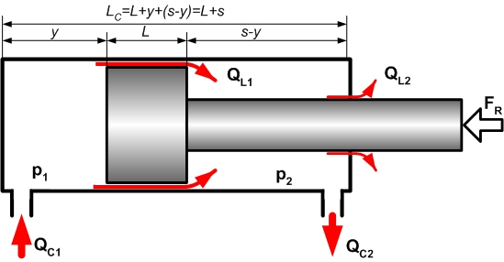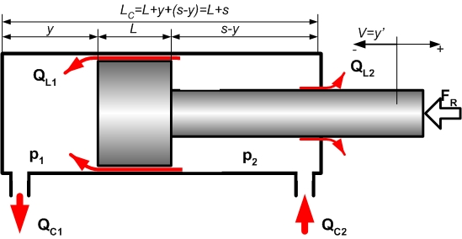
Figure 1: Actuator flow rates.
a) advance stroke, b) return stroke

Based on the conventions:
1. piston’s velocity is positive for the advance stroke and negative for the return stroke;
2. control flow rates are positive for the advance stroke and negative for the return stroke;
and, using a similar logic, the pressure variation for the return stroke is:

$\begin{aligned}\left\{ \frac{V_{\text{01}}+A_{1}y}{ε}\frac{{\text{dp}}_{1}}{\text{dt}}= Q_{C1}−A_{1}\overset{˙}{y}−Q_{L1} | \right.\end{aligned}$
(3)

(4)

The leakage flow rate Q_{L1} is supposed laminar flow rate, so it can be defined by means of the next relations:
$Q_{L1}=K_{1}(p_{1}−p_{2})$ (5)
$K_{1}|_{e≠0}=\frac{π{\text{Dj}}^{3}}{\text{12}ηL}(1+\frac{3e^{2}}{2j^{2}})$ (6)
where e is piston eccentricity.
The leakage flow rate Q_{L2} also is supposed laminar flow rate and it can be calculated using similar relations. For this application the value of Q_{L2} is insignificant and will be ignored.

Based on previous conventions and this last assumption the equations that describe the variations of pressure into the actuator chambers can be written in a unique form:
$\begin{aligned}\left\{ \frac{V_{\text{01}}+A_{1}y}{ε}\frac{{\text{dp}}_{1}}{\text{dt}}= Q_{C1}−A_{1}\overset{˙}{y}−K_{1}(p_{1}−p_{2}) | \right.\end{aligned}$

(7)

(8)

where: for advance stroke ( x_{S}>0 ): Q_{C1} > 0 and Q_{C2} > 0 ;
for return stroke ( x_{S}<0 ): Q_{C1} < 0 and Q_{C2} < 0 .
These equations are eligible (can be used) both for advance and return stroke. The differences between advance stroke and return stroke are determined by the value and sign of control flow rates Q_{C1}, Q_{C2.}

3. VALVE DYNAMICS

In this application is used a MOOG servovalve, model DDV633, with 4 ways, 3 positions and critical center, actuated by means of electromagnetic actuator with integrated closed loop spool control. The integrated controller minimizes the nonlinear perturbation effects in the spool movement and enhances the frequency response up to 70Hz/-3db for a ±10% input signal variation. The time response of valve spool varies between 5ms and 10ms. These characteristics lead to the possibility of using simple models of spool motion without the nonlinear hysteresis, friction or flow forces effects. So, the spool movement will be modeled like a first order system:
$τ{\overset{˙}{x}}_{S}+x_{S}=K_{S}U$ (9)

where K_{S} and τ are the gain and time constant. The model constants can be determined using the Bode diagrams offered by the manufacturer. Due to the low value of the valve spool response time the time constant can be ignored in the first phase of analysis.

The internal flows are modeled as the hydraulic equivalent of a Wheatstone bridge with nonlinear resistors (Figure 2). The valve spool position modulates the orifices’ area, which affects the value of hydraulic resistances and also the magnitude of control flow rates.

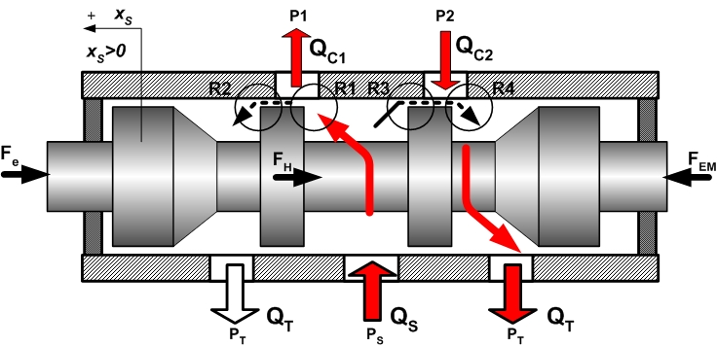
a)
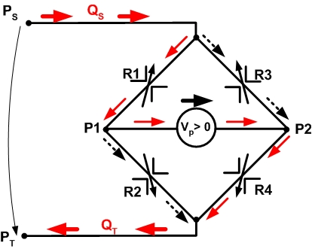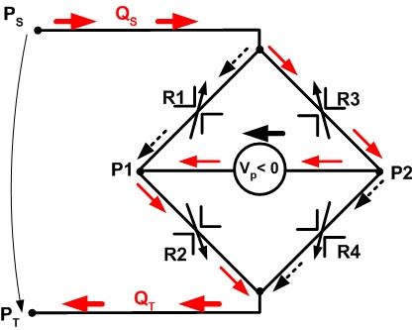
b)
main flow rate
leakage flow rate

Figure 2: a) the schematic representation of internal flows through servovalve for
advance stroke (V_{p}>0 , x_{S}>0), b) the equivalent model of internal flows
for positive (x_{S}>0) and negative (x_{S}<0) displacement of valve spool.

Q₁ ,…, Q₄ are flows through nonlinear resistance R₁ ,…,R₄. If the leakage flow rates are ignored the control flows can be defined by the next relations:
$\begin{aligned}\left\{Q_{C_{1}}=Q_{1}=C_{d}\sqrt{\frac{2}{ρ}}{\text{wx}}_{S}\sqrt{\left(p_{S}−p_{1}\right)} | \right.\end{aligned}$

(10)

(11)

$\begin{aligned}\left\{Q_{C_{1}}=Q_{2}=C_{d}\sqrt{\frac{2}{ρ}}{\text{wx}}_{S}\sqrt{\left(p_{1}\right)} | \right.\end{aligned}$

(12)

(13)
The first two relations (10), (11) describe the control flow rates for the advance stroke (x_{S} >0) and next two describe the return stroke (x_{S} <0).

4. HYDRAULIC ACTUATOR DYNAMICS

The hydraulic actuator is actuated by means of pressure forces which are applied on piston sides. In order to accelerate the piston the resultant of pressure forces must be higher than resistance forces. The ratio of these forces determines the piston movement (Figure 3).

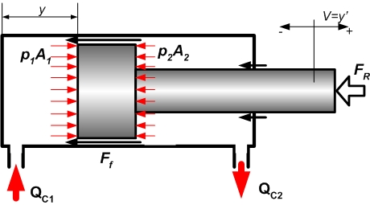

Figure 3: Hydraulic actuator

The motion equation of piston is
$m\overset{¨}{y}=(p_{1}A_{1}−p_{2}A_{2})−F_{f}−F_{R}$ (14)

where the friction force (F_{f}) is modeled as a combination between the Coulomb friction and viscous friction:
$F_{f}=F_{C}+c\overset{˙}{y}$
(15)
Although this model doesn’t include the friction’s internal dynamics like LuGre model [6], it can be used in simulations because the hysteresis and stick-slip effects are considerably reduced in practice, due to Dither signal that overlap the control signal.

5. SIMULATIONS AND EXPERIMENTAL RESULTS

The global model of hydraulic servo system is obtained by combining previous equations which describe the actuator, valve and pressure dynamics. The pump unit is considered an ideal power source that provides a constant flow rate. For the real system V₀₁ = V₀₂ =80*10⁻⁶ m³, ε = 1,5*10⁹ N/m², A₁= 200 mm², A₂ =78 mm², s =200 mm, K₁ ≈ 0, Q_{S}=3,8 l/min, p_{max}≤60 bar.

By defining y = x_{1,} y’=x_{2 ,} p₁ = x₃, p₂ = x₄, x_{S} = x₅ the state space representation of model is:

$\begin{aligned}\left\{{\overset{˙}{x}}_{1}=\overset{˙}{y}=x_{2} | \right.\left\{{\overset{˙}{x}}_{2}=\overset{¨}{y}=\frac{1}{m}[\left(p_{1}A_{1}−p_{2}A_{2}\right)−\text{sign}(\overset{˙}{y})\left(F_{C}−c\left|x_{2}\right|\right)−F_{R}] | \right.\left\{{\overset{˙}{x}}_{3}=\frac{{\text{dp}}_{1}}{\text{dt}}=\frac{ε}{V_{\text{01}}+A_{1}x_{1}}[Q_{C1} −A_{1}x_{2}−k_{1}(x_{3}−x_{4})] | \right.\left\{{\overset{˙}{x}}_{4}=\frac{{\text{dp}}_{2}}{\text{dt}}=\frac{ε}{V_{\text{02}}+A_{2}(s−x_{1})}[−Q_{C2} +A_{2}x_{2}+k_{1}(x_{3}−x_{4})] | \right.\end{aligned}$

(16)

(17)

(18)

(19)

(20)

Based on previous equations the behavior of nonlinear model is simulated using Matlab/Simulink representations. The interconnections between hydraulic subsystems are presented in figure 4. Every component has an associated submodel built upon associated differential equations.

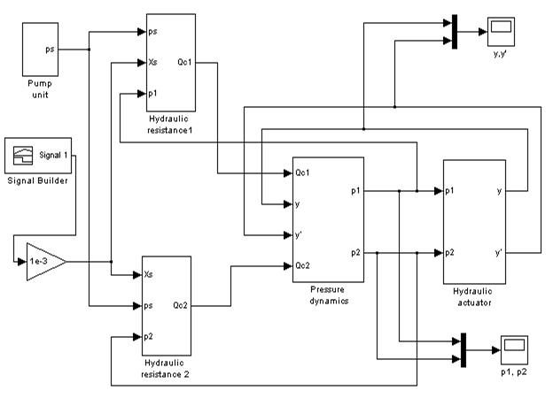

Figure 4: Nonlinear model of hydraulic servo system

In figure 5 are presented the piston position and velocity for a rectangular signal applied to valve spool and for different loads. The load rising induce oscillations for actuator piston due to oil elasticity. The simulation results demonstrate that the proposed model includes nonlinearities of oil elasticity and load influence. Similar demonstration was done to show the friction influence.

a) 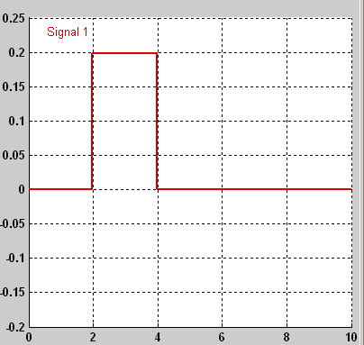 b) 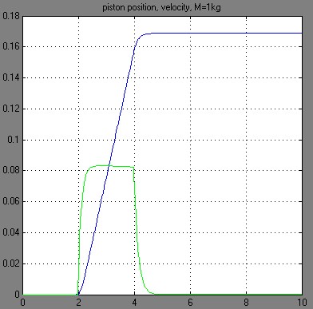
c) 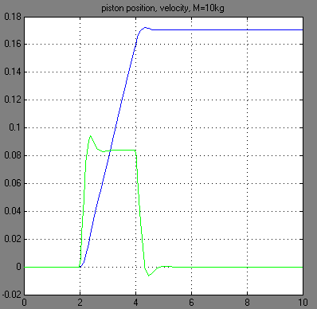 d) 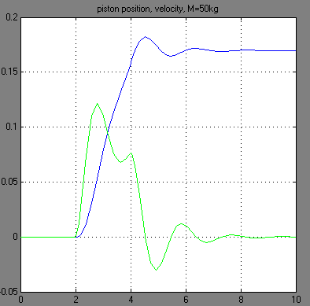

Figure 5: The system response (position and velocity) for a reference signal applied
to servovalve and different loads: a) reference signal, b) M=1kg, c) M=10kg, d) M=50kg.

The nonlinear model was tested with a PID controller and the results are presented in figure 6. For the same controller constants the load was increased from 1 kg to 20 kg. The simulated results confirm that a PID controller is not recommended for a process with large variations of load. The purpose of these simulations is to demonstrate the validity of nonlinear model and not necessary the controller design.
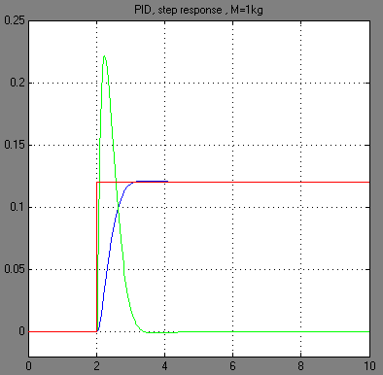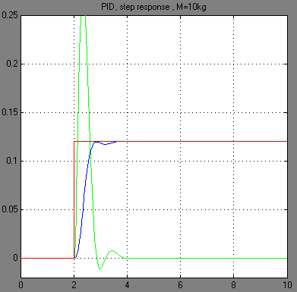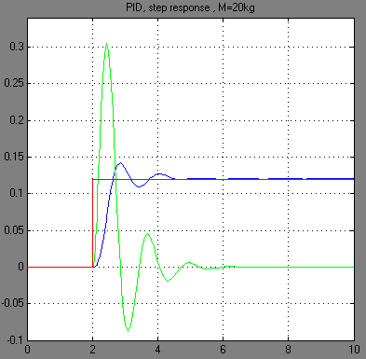
a) b) c)
Figure 6: Step response - PID controller
a) M=1kg, b) M=10kg, c) M=20kg

6. CONCLUSIONS

A nonlinear model of a hydraulic servo system is developed by means of the associated differential equations. The model describes the behavior of a servo system FESTO TP511 (MOOG-DDV633) and includes the nonlinearities of friction forces, valve dynamics, oil compressibility and load influence. The model and the methods presented in this paper can be used to study the hydraulic servo systems both in system design and dynamic analysis. Using the nonlinear model developed in this paper is possible to estimate/calculate state parameters through simulation and use these results to design a model based optimal controller.

REFERENCES

[1] P. Chatzakos , E. Papadopoulos, On model-based control of hydraulic actuators, Proceedings of RAAD’03, 12th International Workshop on Robotics in Alpe-Adria-Danube Region, Cassino May 7-10, 2003.
[2] D. Li and S. E. Salcudean, Modeling, simulation, and control of a hydraulic Stewart platform, in Proc. IEEE int.Conf. Robotics and Automat., April 1997, pp. 3360-3366.
[3] M. R. Sirouspour, S. E. Salcudean, On the Nonlinear Control of Hydraulic Servo-Systems, Proceedings of the 2000 IEEE International Conference on Robotics and Automation, April 24-28, San Francisco, CA, USA.,1276-1282, IEEE 2000.
[4] B Yao, F. Bu, J. Reedy, George T.-C. Chiu, Adaptive Robust Motion Control of Single-Rod Hydraulic Actuators: Theory and Experiments, IEEE/ASME Transactions on Mechatronics, vol. 5, no. 1, march 2000.
[5] A. J. Ferreira, F. Gomes de Almeida, M. R.Quintas, A Semi-Empirical Model for a Hydraulic Servo-Solenoid Valve, Proceedings of the IMechE, Part I: Journal of Systems and Control Engineering, Vol. 216, pp. 237-248, 2002.
[6] C. Canudas de Wit, H. Olson, K.J.Astrom, P Lischinsky, A new model for control of system with friction, IEEE Transaction on Automatic Control, vol. 40 (3), pp.419-425, 1995.
[7] M. Mihajlov, V. Nikolić, D. Antić, Position control of an electro-hydraulic servo system using sliding mode control enhanced by fuzzy PI controller, Facta Universitas, Mechanical Engineering Vol.1, No 9, pp.1217 – 1230, 2002.
[8] FESTO - MOOG DDV633 Technical Data Sheet.

