FEATURE EXTRACTION METHODS USED FOR IMAGES OF MACULAR DISEASES – PART I

Luculescu Marius ¹, Lache Simona ², Barbu Daniela ³, Barbu Ion ⁴
¹ „Transilvania” University of Braşov, Romania, lucmar@unitbv.ro
² „Transilvania” University of Braşov, Romania, slache@unitbv.ro
³ „Transilvania” University of Braşov, Romania, dbarbu@unitbv.ro
⁴ „Transilvania” University of Braşov, Romania, ibarbu@unitbv.ro

Abstract: The paper presents some methods for feature extraction of macular disease images. It is well known that a high resolution image supposes an important quantity of information. If we want to recognize it or classify it using neural networks for example, it is necessary to extract the features in a small number of values, so that these to be used as inputs in the neural network. We will see what is happening with these values when the same image is modified (rotated, scaled, translated or mirrored). For doing this we will use a Graphical User Interface (GUI) developed in MATLAB. This GUI is integrated in a Computer Aided Diagnostic (CAD) system for macular diseases.
Keywords: Image, feature, neural networks, diagnostic, MATLAB.

1. INTRODUCTION

The image recognition process is a very interesting one, being sometimes easy or sometimes difficult, depending on the type of image to be recognized. One method supposes the use of artificial neural networks. A neural network has a structure made by neuron layers. It can be trained using supervised or unsupervised methods. Each of them needs a training set of values. For the first one, the training set contains teacher inputs and desired outputs, while for the second, only the inputs are necessary. Because of the limited number of inputs, an image has to be transformed in such a way to obtain a small group of specific information that characterize and identify it. Doing this, seems to be not easy, thinking that the same image can be scaled, rotated or translated for example.

For the recognition process to be successful, it is necessary to use a set of values representing image features that are invariant. Knowing that an image is made by pixels and depending on the image format each pixel has associated a number of values, the total number of values can be a huge one. It is impossible to associate a neuron for each value in the neural network structure. It is almost impossible to find two identical images at the pixel level. That is why for the image recognition with artificial neural networks we have to use at inputs a vector of values extracted from image features. The paper presents some methods for this, methods used for recognizing some images of macular diseases. A Graphical User Interface (GUI) developed in MATLAB, integrated in a Computer Aided Diagnostic (CAD) system for macular diseases will compute all of these values.

2. FEATURE EXTRACTION METHODS

If we want to use an artficial neural network for image recognition we have to extract a set of values representing image’s features.
The values that can be used for neural network inputs are grouped in two sets, one consisting in seven 2D moment invariants and the other consisting in six descriptors based on statistical properties of the intensity histogram, namely on statistical moments.

Moments have long been used in statistical theory and classical mechanics [2]. Statisticians view moments as means, variances, skewness, and kurtosis of distributions, while classical mechanics students use moments to find centers of mass and moments of inertia. In imaging, moments have been used as feature vectors for classification as well as for image texture attributes and shape descriptors of objects. In the early 1960s, Hu developed seven invariant moments from algebraic moment theory. These seven moments are invariant under translation, rotation, and scaling. Perhaps the most important contribution of this work was the application of these seven invariant moments to the two-dimensional pattern recognition problem of character recognition. This was a crucial development, since many key problems in imaging and image recognition focus on recognizing an image even though it has been translated or rotated, or perhaps magnified by some means.

The invariants are computed for Red, Green, Blue components of the RGB image and also for the gray image and for the multidimensional image (the RGB image is transformed from 3 to 2 dimensions array using reshape Matlab function [3]).

For a digital image having a f(x,y)intensity distribution, the two dimensional moment of order p+q is defined as [1]

$m_{\text{pq}}=\sum_{x}{\sum_{y}{x^{p}y^{q}f\left(x,y\right)}}$ (1)
for p, q = 0, 1, 2,... and x, y are the values of image coordinates.

These moments in general are not invariant to any distorsions and therefore the corresponding central moments are defined as

$μ_{\text{pq}}=\sum_{x}{\sum_{y}{{\left(x−\overline{x}\right)}^{p}{\left(y−\overline{y}\right)}^{q}f\left(x,y\right)}}$ (2)
where we denoted
$\bar{x}=\frac{m_{\text{10}}}{m_{\text{00}}}$ and $\overline{y}=\frac{m_{\text{01}}}{m_{\text{00}}}$ (3)

The central moments are known to be invariant under translation. It can be demonstrated that the first four orders of central moments from equation (2) can be expressed in terms of the ordinary moments defined in equation (1).
$$μ_{\text{00}}=m_{\text{00}}$$
$$μ_{\text{10}}=μ_{\text{01}}=0$$
$$μ_{\text{11}}=m_{\text{11}}−\frac{m_{\text{10}}m_{\text{01}}}{m_{\text{00}}}$$
$$μ_{\text{20}}=m_{\text{20}}−\frac{m_{\text{10}}^{2}}{m_{\text{00}}}$$
$μ_{\text{02}}=m_{\text{02}}−\frac{m_{\text{01}}^{2}}{m_{\text{00}}}$ (4)
$$μ_{\text{12}}=m_{\text{12}}−m_{\text{02}}\bar{x}−2m_{\text{11}}\bar{y}+2m_{\text{10}}{\bar{y}}^{2}$$
$$μ_{\text{21}}=m_{\text{21}}−m_{\text{20}}\bar{y}−2m_{\text{11}}\bar{x}+2m_{\text{01}}{\bar{x}}^{2}$$
$$μ_{\text{03}}=m_{\text{03}}−3m_{\text{02}}\bar{y}+2m_{\text{01}}{\bar{y}}^{2}$$
$$μ_{\text{30}}=m_{\text{30}}−3m_{\text{20}}\bar{x}+2m_{\text{10}}{\bar{x}}^{2}$$

Often it is desirable to normalize the moments with respect to size. This may be accomplished by using the area, μ₀₀.
The normalized central moment of order (p + q) is defined as
$η_{\text{pq}}=\frac{μ_{\text{pq}}}{μ_{\text{00}}^{γ}}$ for p, q = 0, 1, 2, … (5)
and
$γ=\frac{p+q}{2}+1$ for p + q = 2, 3, … (6)
From above equations, a set of seven 2D moment invariants, insensitive to translation, change, scale, mirroring and rotation can be derived:

$φ_{{}_{1}}=η_{\text{20}}+η_{\text{02}}$
$φ_{2}={\left(η_{\text{20}}−η_{\text{02}}\right)}^{2}+4η_{\text{11}}^{2}$
$φ_{3}={\left(η_{\text{30}}−3η_{\text{12}}\right)}^{2}+{\left(3η_{\text{21}}−η_{\text{03}}\right)}^{2}$
$φ_{4}={\left(η_{\text{30}}+η_{\text{12}}\right)}^{2}+{\left(η_{\text{21}}+η_{\text{03}}\right)}^{2}$ (7)
$\begin{aligned}φ_{5}=\left(η_{\text{30}}−3η_{\text{12}}\right)\left(η_{\text{30}}+η_{\text{12}}\right)\left[{\left(η_{\text{30}}+η_{\text{12}}\right)}^{2}−3{\left(η_{\text{21}}+η_{\text{03}}\right)}^{2}\right]+ \\ +\left(3η_{\text{21}}−η_{\text{03}}\right)\left(η_{\text{21}}+η_{\text{03}}\right)\left[3{\left(η_{\text{30}}+η_{\text{12}}\right)}^{2}−{\left(η_{\text{21}}+η_{\text{03}}\right)}^{2}\right]\end{aligned}$
$φ_{6}=\left(η_{\text{20}}−η_{\text{02}}\right)\left[{\left(η_{\text{30}}+η_{\text{12}}\right)}^{2}−{\left(η_{\text{21}}+η_{\text{03}}\right)}^{2}\right]+4η_{\text{11}}\left(η_{\text{30}}+η_{\text{12}}\right)\left(η_{\text{21}}+η_{\text{03}}\right)$
$\begin{aligned}φ_{7}=\left(3η_{\text{21}}−η_{\text{03}}\right)\left(η_{\text{30}}+η_{\text{12}}\right)\left[{\left(η_{\text{30}}+η_{\text{12}}\right)}^{2}−3{\left(η_{\text{21}}+η_{\text{03}}\right)}^{2}\right]+ \\ +\left(3η_{\text{12}}−η_{\text{30}}\right)\left(η_{\text{21}}+η_{\text{03}}\right)\left[3{\left(η_{\text{30}}+η_{\text{12}}\right)}^{2}−{\left(η_{\text{21}}+η_{\text{03}}\right)}^{2}\right]\end{aligned}$

These are computed in Matlab with a user defined function. In the image processing module of the Graphical User Interface developed for diagnostic recognition, the option “Two Images Comparison” allows to compute and to compare these values of the seven moments (Figure 1).
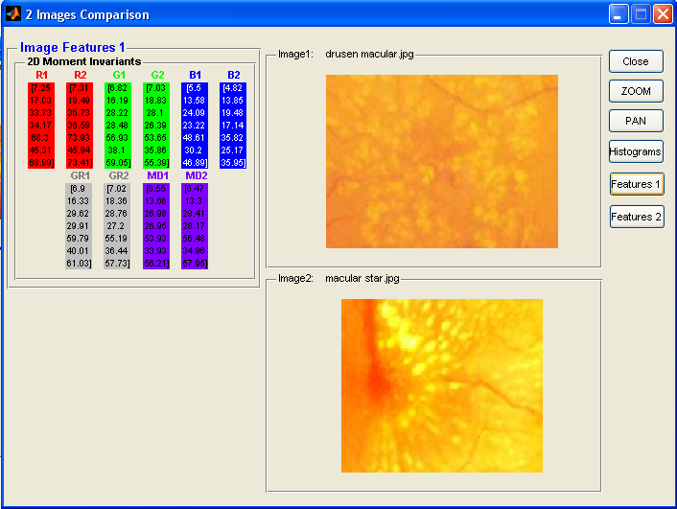

Figure 1: Option “Features 1” - computing the two dimensional moment invariants for different images

As it can be seen in Figure 1 the seven values are different for different images for the R, G, B components and also for gray and multidimensional images.

Further we will see what is happening if we want to compare the original image with the same image but rotated by 90 degrees, rotated by 30 degrees, horizontally mirrored and scaled with a 1.2 factor (Figure 2, 3, 4, 5).
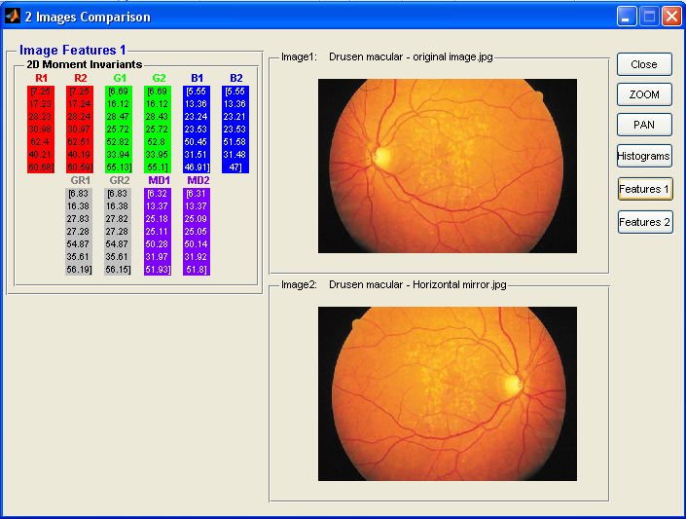

Figure 2: Comparison between original image and same image horizontally mirrored

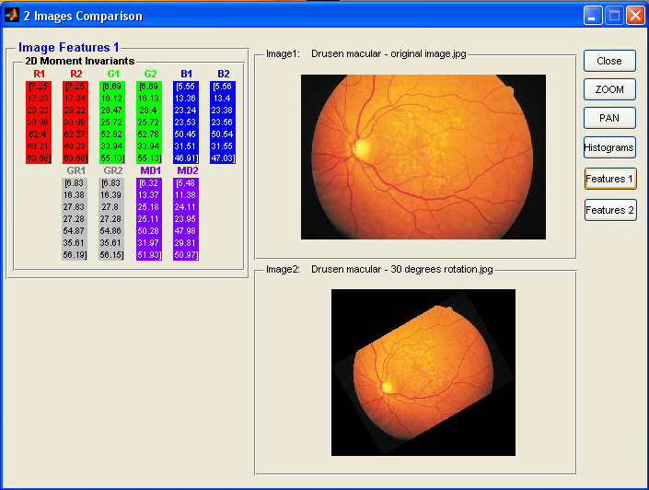

Figure 3: Comparison between original image and same image rotated with 30 degrees

As it can be seen from the figures above, the seven 2D moments are invariant at operations as mirroring and rotation and also for scaling (Figure 5).

Mirrored, rotated and scaled images were obtained using “One image analysis” option from the image processing module of the program.

The absolute value of the log was used instead of the moment invariant themselves. Use of the log reduces dynamic range and the absolute value avoids having to deal with the complex numbers that result when computing the log of negative moment invariants. Using the absolute value is a common practice because interest generally lies on the invariance of moments and not on their sign.
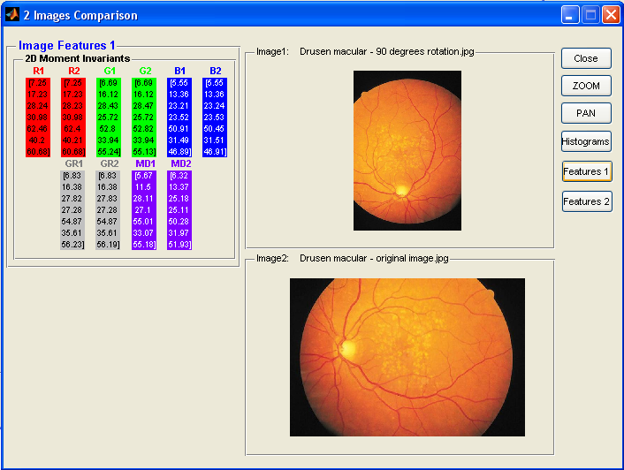

Figure 4: Comparison between original image and same image rotated with 90 degrees

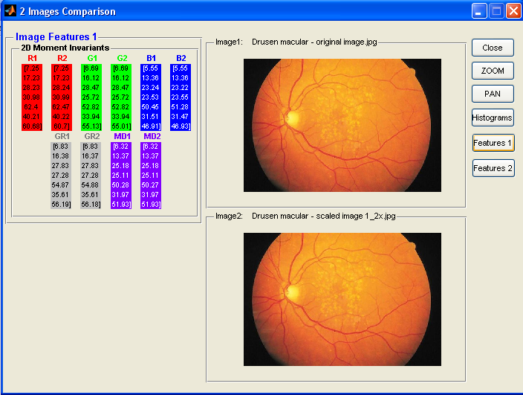
Figure 5: Comparison between original image and same image scaled by 1.2 factor (the software displays the scaled image fitted in image panel)

The values for the seven moment invariants are summarized in Table 1.

3. CONCLUSION

For image recognition using neural network it is necessary to extract some image features so these to be used as inputs values in the network. These features can be represented by a set of seven two-dimensional moment invariants that are not affected by mirroring, scaling and rotating operations.

Table 1: The seven moment invariants rounded at 2 decimals, for original, mirrored, scaled and rotated images
Image Type | 2D Moment Invariant | Original | Horizontal Mirrored | Rotated 30° | Rotated 90° | Scaled 1.2x
Red Component | Ф₁ | 7.25 | 7.25 | 7.25 | 7.25 | 7.25
Red Component | Ф₂ | 17.23 | 17.24 | 17.24 | 17.23 | 17.23
Red Component | Ф₃ | 28.23 | 28.24 | 28.22 | 28.24 | 28.24
Red Component | Ф₄ | 30.98 | 30.97 | 30.98 | 30.98 | 30.99
Red Component | Ф₅ | 62.40 | 62.51 | 62.27 | 62.46 | 62.47
Red Component | Ф₆ | 40.21 | 40.19 | 40.23 | 40.20 | 40.22
Red Component | Ф₇ | 60.68 | 60.59 | 60.68 | 60.68 | 60.70
Green Component | Ф₁ | 6.69 | 6.69 | 6.69 | 6.69 | 6.69
Green Component | Ф₂ | 16.12 | 16.12 | 16.13 | 16.12 | 16.12
Green Component | Ф₃ | 28.47 | 28.43 | 28.40 | 28.43 | 28.47
Green Component | Ф₄ | 25.72 | 25.72 | 25.72 | 25.72 | 25.72
Green Component | Ф₅ | 52.82 | 52.80 | 52.78 | 52.80 | 52.82
Green Component | Ф₆ | 33.94 | 33.95 | 33.94 | 33.94 | 33.94
Green Component | Ф₇ | 55.13 | 55.10 | 55.13 | 55.24 | 55.01
Blue Component | Ф₁ | 5.55 | 5.55 | 5.56 | 5.55 | 5.55
Blue Component | Ф₂ | 13.36 | 13.36 | 13.40 | 13.36 | 13.36
Blue Component | Ф₃ | 23.24 | 23.21 | 23.38 | 23.21 | 23.22
Blue Component | Ф₄ | 23.53 | 23.53 | 23.56 | 23.52 | 23.55
Blue Component | Ф₅ | 50.45 | 50.58 | 50.54 | 50.91 | 51.28
Blue Component | Ф₆ | 31.51 | 31.48 | 31.55 | 31.49 | 31.47
Blue Component | Ф₇ | 46.91 | 47.00 | 47.03 | 46.89 | 46.93
Gray image | Ф₁ | 6.83 | 6.83 | 6.83 | 6.83 | 6.83
Gray image | Ф₂ | 16.38 | 16.38 | 16.39 | 16.38 | 16.37
Gray image | Ф₃ | 27.83 | 27.82 | 27.80 | 27.82 | 27.83
Gray image | Ф₄ | 27.28 | 27.28 | 27.28 | 27.28 | 27.28
Gray image | Ф₅ | 54.87 | 54.87 | 54.86 | 54.87 | 54.88
Gray image | Ф₆ | 35.61 | 35.61 | 35.61 | 35.61 | 35.61
Gray image | Ф₇ | 56.19 | 56.15 | 56.15 | 56.23 | 56.18
Multidimensional Image | Ф₁ | 6.32 | 6.31 | 5.48 | 5.67 | 6.32
Multidimensional Image | Ф₂ | 13.37 | 13.37 | 11.38 | 11.50 | 13.37
Multidimensional Image | Ф₃ | 25.18 | 25.09 | 24.11 | 28.11 | 25.18
Multidimensional Image | Ф₄ | 25.11 | 25.05 | 23.95 | 27.10 | 25.11
Multidimensional Image | Ф₅ | 50.28 | 50.14 | 47.98 | 55.01 | 50.27
Multidimensional Image | Ф₆ | 31.97 | 31.92 | 29.81 | 33.07 | 31.97
Multidimensional Image | Ф₇ | 51.93 | 51.80 | 50.97 | 55.18 | 51.93

Differences between values are not significant, excepting the multidimensional image. It is normal because the multidimensional image is obtained by concatenating the 3 two dimensional arrays (of RGB image) in a 2D array. The rotated multidimensional image is made by 3 two dimensional images rotated before, not by rotating directly the entire multidimensional image. So it is better to use the RGB image or the gray one when extracting features, instead of multidimensional images.

The software developed in Matlab shows us the corresponding values and also demonstrate that R, G, B components or gray images should be better to use for image recognition. Computing procedures can be applied on the entire diagnostics database.

REFERENCES

- Gonzales R., Woods R., Eddins S.: Digital Image processing using Matlab, Pearson Prentice Hall, 2004
- Tzanakou-Micheli E.: Supervised and Unsupervised Pattern Recognition – Feature extraction and Computational Inteligence, CRC Press, 2000
- The MathWorks Inc. - Matlab – Image Processing Toolbox

