FEATURE EXTRACTION METHODS USED FOR IMAGES OF MACULAR DISEASES – PART II

Luculescu Marius ¹, Lache Simona ², Barbu Daniela ³, Barbu Ion ⁴
¹ “Transilvania” University of Braşov, Romania, lucmar@unitbv.ro
² “Transilvania” University of Braşov, Romania, slache@unitbv.ro
³ “Transilvania” University of Braşov, Romania, dbarbu@unitbv.ro
⁴ “Transilvania” University of Braşov, Romania, ibarbu@unitbv.ro

Abstract: The paper continues to present methods for feature extraction applied to macular disease images. For recognizing or classifying images using neural networks, the volume of information applied on network input should be significantly reduced. A high resolution image supposes an important quantity of information. The values representing image features have to contain specific information invariant at transformations as rotation, scaling or mirroring. For doing this, a Graphical User Interface (GUI) developed in MATLAB will be used. The GUI is integrated in a Computer Aided Diagnostic (CAD) system for macular diseases.
Keywords: Image, feature, neural networks, diagnostic, MATLAB.

1. INTRODUCTION

There are different methods to extract the features of an image. Features can be obtained by statistical measures of the intensity histogram or by spectral measures of the texture based on the Fourier spectrum, which is ideally suited for describing the directionality of periodic or almost periodic two-dimensional patterns in an image. These global texture patterns, easily distinguishable as concentrations of high-energy bursts in the spectrum, generally are quite difficult to detect with spatial methods because of the local nature of these techniques. Spectral texture is useful for discriminating between periodic and nonperiodic texture patterns and also for quantifying differences between periodic patterns.

In this paper we will present only the features obtained by statistical measures and we will compare them between original image and the same image rotated, mirrored and scaled. A vector containing a set of six values will be computed. These values are represented by the mean, the standard deviation, the smoothness, the third moment, the uniformity and the entropy.

A Graphical User Interface (GUI) developed in MATLAB, integrated in a Computer Aided Diagnostic (CAD) system for macular diseases will compute all of these values.

2. FEATURE EXTRACTION METHODS

An important approach for describing a region is to quantify its texture content. A frequently used method for texture analysis is based on statistical properties of the intensity histogram.

Let us consider z_{i} a discrete random variable that corresponds to the intensity levels of an image and let us denote p(z_{i}) the corresponding normalized histogram, with i = 0, 1, 2, … , L-1 and L – the number of possible intensity values.

One of the principal approaches for describing the shape of a histogram is via its central moments (also called moments about the mean) [1], which is defined as

$μ_{n}=\sum_{i=0}^{L−1}{(z_{i}−m)^{n}p\left(z_{i}\right)}$ (1)
where n is the moment order and m is the mean:

$m=\sum_{i=0}^{L−1}{z_{i}}p\left(z_{i}\right)$ (2)

The mean (m) is a measure of average intensity, so it can be the first image feature in a vector of such values. Due to the fact that histogram is assumed to be normalized, the sum of its all components is 1. It can be easily observed that μ₀ = 1 and μ₁ = 0.

The second moment is called the variance

$μ_{2}=\sum_{i=0}^{L−1}{(z_{i}−m)^{2}p\left(z_{i}\right)}$ (3)

Standard deviation (σ), a measure of average contrast, is used also as an image feature.

$σ=\sqrt{μ_{2}\left(z\right)}=\sqrt{σ^{2}}$ (4)

The third image feature is the smoothness (R). It measures the relative smoothness of the intensity in a region. If the region has constant intensity R = 0, and if the region has large excursions in the values of intensity level, R approaches to 1. In practice, the variance used in this measure is normalized to the range [0, 1] by dividing it by (L-1)².

$R=1−1/{\left(1+σ^{2}\right)}$ (5)

The fourth image feature in our vector is the third order moment (μ₃). It measures the skewness of a histogram. If the histogram is symmetric than μ₃ = 0, if it is skewed to the right of the mean than μ₃ > 0, and if it is skewed to the left of the mean than μ₃ < 0. Values of this measure are brought into a range of values comparable to the other five measures by dividing μ₃ by (L-1)².

(6)

The fifth image feature is uniformity (U). It is maximum when all the gray levels are equal (maximally uniform) and decreases from there.

$U=\sum_{i=0}^{L−1}{p^{2}\left(z_{i}\right)}$ (7)

The last value in our vector of features is entropy (e), a measure of randomness.

$e=\sum_{i=0}^{L−1}{p\left(z_{i}\right)}{\text{log}}_{2}p\left(z_{i}\right)$ (8)

All of these values are computed in Matlab with a user defined function. In the image processing module of the Graphical User Interface developed for diagnostic recognition, the option “Two Images Comparison” allows to compute and to compare them (Figure 1).

The computed values are scaled by the vector [1 1 10000 10000 10000 1].
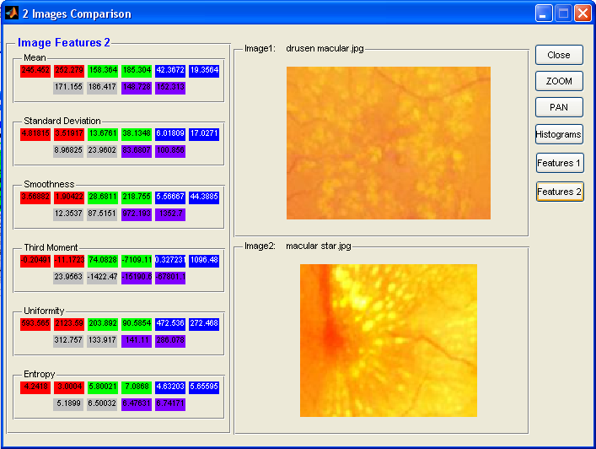

Figure 1: Option “Features 2” - computing the feature values for different images

As it can be seen in Figure 1 the six values are different for different images for the R, G, B components and also for gray and multidimensional images.

Further we will see what is happening if we want to compare the original image with the images horizontally mirrored, rotated by 30 degrees, rotated by 90 degrees and scaled with a 1.2 factor (Figure 2, 3, 4, 5).

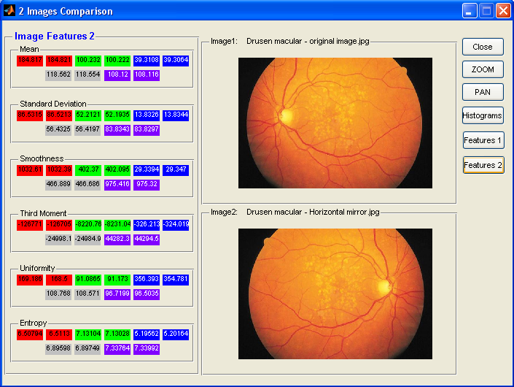

Figure 2: Comparison between original image and same image horizontally mirrored

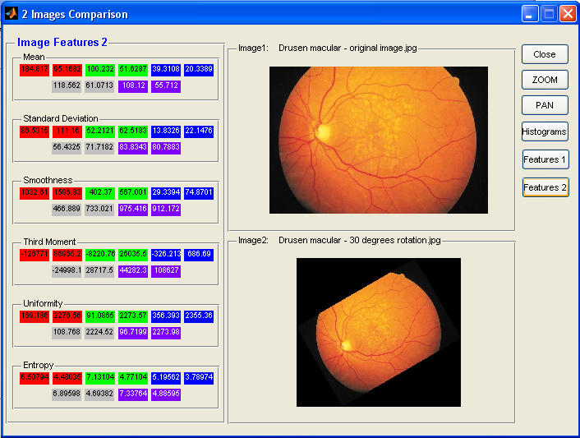

Figure 3: Comparison between original image and same image rotated with 30 degrees

As it can be seen from the figures above, the six values seem to be invariant at mirroring, but at rotation there are significant differences. It is normal for the rotated image because it contains other pixels comparing to the original one.

Mirrored, rotated and scaled images were obtained using “One image analysis” option from the image processing module of the program.

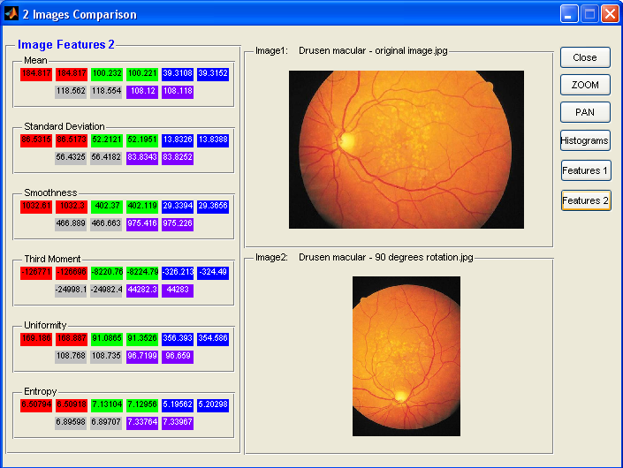

Figure 4: Comparison between original image and same image rotated with 90 degrees
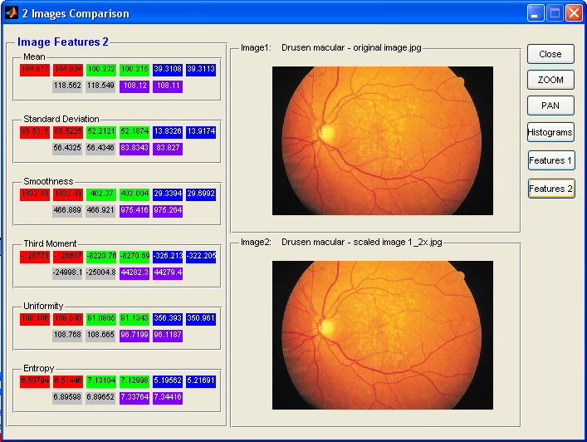

Figure 5: Comparison between original image and same image scaled by 1.2 factor

The values for the six features are summarized in Table 1.
Table 1: The seven moment invariants rounded at 2 decimals, for original, mirrored, scaled and rotated images
Image Type | Texture Descriptors | Original | Horizontal Mirrored | Rotated 30° | Rotated 90° | Scaled 1.2x
Red Component | Mean | 184.817 | 184.821 | 95.1682 | 184.817 | 184.804
Red Component | Std. dev. | 86.5315 | 86.5213 | 111.16 | 85.5173 | 86.5225
Red Component | Smoothness | 1032.61 | 1032.39 | 1596.83 | 1032.3 | 1032.41
Red Component | Third mom. | -126771 | -126705 | 86965.2 | -126696 | -126607
Red Component | Uniformity | 169.186 | 168.5 | 2276.56 | 168.887 | 168.543
Red Component | Entropy | 6.50794 | 6.5113 | 4.48035 | 6.50918 | 6.51446
Green Component | Mean | 100.232 | 100.222 | 51.6287 | 100.221 | 100.215
Green Component | Std. dev. | 52.2121 | 52.1935 | 62.5183 | 52.1951 | 52.1874
Green Component | Smoothness | 402.37 | 402.095 | 567.001 | 402.119 | 402.004
Green Component | Third mom. | -8220.76 | -8231.04 | 26035.5 | -8224.79 | -8270.69
Green Component | Uniformity | 91.0865 | 91.173 | 2273.57 | 91.3526 | 91.1343
Green Component | Entropy | 7.13104 | 7.13028 | 4.77104 | 7.12956 | 7.12998
Blue Component | Mean | 39.3108 | 39.3064 | 20.3389 | 39.3152 | 39.3113
Blue Component | Std. dev. | 13.8326 | 13.8344 | 22.1476 | 13.8388 | 13.9174
Blue Component | Smoothness | 29.3394 | 29.347 | 74.8701 | 29.3656 | 29.6992
Blue Component | Third mom. | -326.213 | -324.019 | 686.69 | -324.49 | -322.205
Blue Component | Uniformity | 356.393 | 354.781 | 2355.36 | 354.586 | 350.961
Blue Component | Entropy | 5.19562 | 5.20164 | 3.78974 | 5.20298 | 5.21691
Gray image | Mean | 118.562 | 118.554 | 61.0713 | 118.554 | 118.549
Gray image | Std. dev. | 56.4325 | 56.4197 | 71.7182 | 56.4182 | 56.4346
Gray image | Smoothness | 466.889 | 466.686 | 733.021 | 466.663 | 466.921
Gray image | Third mom. | -24998.1 | -24984.9 | 28717.5 | -24982.4 | -25004.8
Gray image | Uniformity | 108.768 | 108.571 | 2224.52 | 108.735 | 108.665
Gray image | Entropy | 6.89598 | 6.89749 | 4.69382 | 6.89707 | 6.89652
Multidimensional Image | Mean | 108.12 | 108.116 | 55.712 | 108.118 | 108.11
Multidimensional Image | Std. dev. | 83.8343 | 83.8297 | 80.7883 | 83.8252 | 83.827
Multidimensional Image | Smoothness | 975.416 | 975.32 | 912.172 | 975.226 | 975.264
Multidimensional Image | Third mom. | 44282.3 | 44294.5 | 108627 | 44283 | 44279.4
Multidimensional Image | Uniformity | 96.7199 | 96.5035 | 2273.98 | 96.659 | 96.1187
Multidimensional Image | Entropy | 7.33764 | 7.33992 | 4.88595 | 7.33967 | 7.34416

3. CONCLUSION

For image recognition using neural network it is necessary to extract some image features so these to be used as inputs values in the network. These features can be represented by a set of seven two-dimensional moment invariants that are not affected by mirroring, scaling and rotating operations and also can be used the values presented above. Differences between the last values are not significant, excepting the rotated image that has to contain different pixels.

Using the software developed in Matlab, the computing procedures can be applied on the entire diagnostics database.

REFERENCES

- Gonzales R., Woods R., Eddins S.: Digital Image processing using Matlab, Pearson Prentice Hall, 2004
- The MathWorks Inc. - Matlab – Image Processing Toolbox

