MATLAB GRAPHICAL USER INTERFACE FOR PROCESSING IMAGES OF RETINA DISEASES

Luculescu C. Marius¹
¹ “Transilvania” University of Brasov, Romania, lucmar@unitbv.ro

Abstract: The paper presents a Graphical User Interface (GUI) developed in MATLAB for processing different images. User can open, modify and save image files. The Red, Green and Blue components can be separated and the corresponding histograms can be plotted. Filters and editing tools such as rotation, mirroring, zooming, panning, cropping, enhancing contrast using histogram equalization and so on can be used. The interface offers also an option for comparing two images not only visual, but using histograms, invariant moments, entropy etc. All of these make from this GUI a very useful tool for analyze and process images. It is integrated in a Computer Aided Diagnostic (CAD) system for macular diseases.
Keywords: Image processing, diagnostic, MATLAB, computer, retina.

1. INTRODUCTION

Due to the rapid growth in the development of medical imaging technologies and the increasing availability of computing power, biomedical image processing emerged as one of the most active research areas of recent years. With their rich information content, biomedical images are opening entirely new areas of research and are posing new challenges to researchers.

For a doctor, an ophthalmologist doctor for example, images are very important. Looking to a retina’s image, on-line or off-line, the doctor may need to have access to some image manipulation and processing tools. He may want to select a certain region, to zoom in for viewing details, to pan the image, to mirror it, to rotate it or to enhance some features. Perhaps he may want to compare two images, to view their histograms, their Red, Green and Blue components or to have access to some values representing image’s features.

All of these tools have been put together in an image processing module developed in Matlab, as a Graphical User (GUI) interface [1]. This module is integrated in a Computer Aided Diagnostic (CAD) system for macular diseases, but it can be used for processing any other type of images. Let’s see what is about.

2. MATLAB GRAPHICAL USER INTERFACE FOR IMAGE PROCESSING

Matlab is very powerful programming language, offering access to a lot of functions useful for image processing, but for a doctor having to learn how to use Matlab it is not an easy task. So that, for him it is more useful to have a specialized interface from where to manipulate and to transform the image of interest corresponding to his needs. This interface will give a very simple way to choose exactly the desired operations for an image.

If we are working on-line, the image is taken into computer from a digital camera. We may shoot different interesting slides and save them.

If we are working off-line, we have to Open an image file saved before in the computer. So the GUI has first of all to offer an option for opening image files. The user can browse for the file name and file path. A default working path can be defined using “Settings” menu option. Remember that Matlab is not installed on the doctor’s computer, so all the file operations have to be implemented in GUI (Open, Save and so an).

The software offers two special menu options for image processing accessible from “Image Analysis” module, namely “One Image Analysis” and “Two Images Comparison”.

The type of image file has to be a .jpg one.

When the first one is selected, user can choose the image file he wants to open, than the image is displayed in a panel having the file name as a title. It also becomes visible a panel with many push-buttons allowing to access different image processing operations (Figure 1). A short description for all these options will be presented forwards.
- Coordinates ON/OFF – is used for displaying/hiding coordinates (the image size).
- Histograms ON/OFF – displays/hides the normalized histograms computed and plotted for R, G and B color components, if the image is a RGB one (3 x 2D matrices). If the image is a gray one (2D matrix) for example, only one histogram will be displayed. Due to different sizes of images, histograms are normalized to 1000. The number of bins can be modified by the user and the plot content can be refreshed. The maximum number of bins is 255, because image file values for the pixels are of uint8 type (8 bits unsigned integer – 0 to 255). Software verifies if the value for the number of bins is between the limits and gives a warning if not.
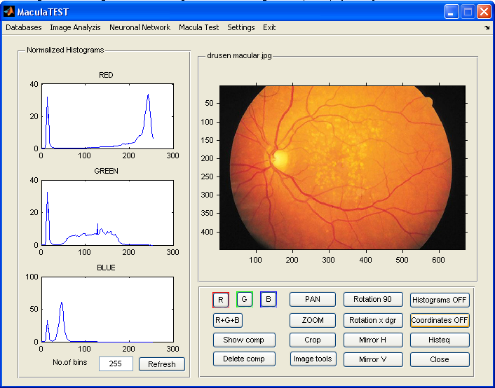

Figure 1: “One Image Analysis” menu option

- R – is used to display the Red component of the original RGB image.
- G – is used to display the Green component of the original RGB image.
- B – is used to display the Blue component of the original RGB image.
- R+G+B – displays the original RGB image.
R, G and B are visible only if the original image is a RGB one.
- PAN – it allows to pan the current image. Options as Vertical Pan, Horizontal Pan, Unconstrained Pan and Reset to Original View are available.
- ZOOM – it allows to zoom the current image. Options as Vertical Zoom, Horizontal Zoom, Unconstrained Zoom and Reset to Original View are available.
- Rotation 90 – is used to rotate the current image with 90 degrees counterclockwise.
- Rotation x dgr – is used to rotate the current image with x degrees. If x>0 the rotation is counter-clockwise, else it is clockwise.
- Mirror H – is allows to horizontally mirror the current image.
- Mirror V – is allows to vertically mirror the current image.
- Crop – is used for selecting an interest zone of the current image. After selection, user is asked if he wants to save the region. With this option, user can generate new images containing only the interest part of the image.
- Histeq – is allows to enhance the contrast of the current image using histogram equalization. This option is very useful to emphasize parts of the image with potentially problems.
- Show Comp – is an option that displays 9 views used for visual analysis of an RGB image (Figure 2). These views are: the original image, the image converted from RGB to gray scale, the enhanced contrast gray image, the R, G, B components and the enhanced contrast R, G, B components obtained using histeq Matlab function.
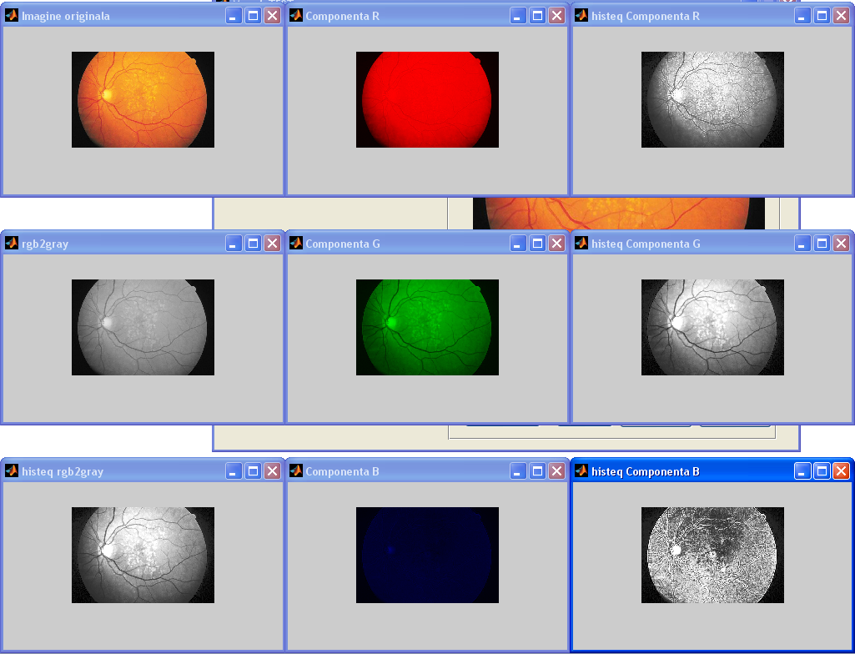

Figure 2: “Show comp” option results

This set of 9 images can be kept on the screen during other image opening. For the new image can be generated a similar set and a visual comparison can be made.

- Delete Comp – with this option all the 9 views sets displayed on the screen until that moment, can be automatically deleted
- Image tools – with this option, user has access to the powerful imtool function of Matlab [3]. Generating two windows, an overview one and a detail one, this function offers the possibility to zoom and pan, to view image information or to display the pixel region. Depending on the zoom level, a rectangle can be dragged over the image in the overview window and details are displayed in the other window (Figure 3).
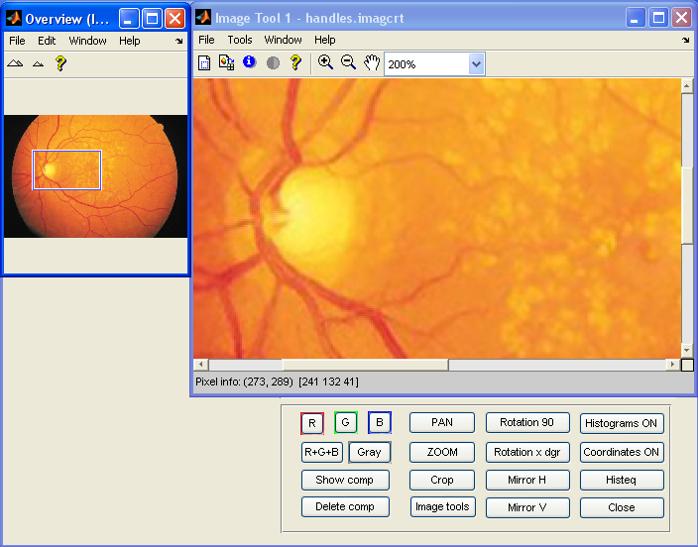

Figure 3: “Image tool” option results
All of these tools for viewing end editing an image are very useful for the user, especially for doctor, but they are very important in the design phase of the Computer Aided Diagnostic system. They give the possibility to generate a database with images of diagnostics used for training an artificial neural network in the recognition process and another will be used for testing the network We shall see if a rotated image, or a mirror one can be correctly recognized, if it is better to use gray images or RGB images or contrast enhanced images for neural network inputs.

The other option from "Image Analysis" module is the “Two Images Comparison” (Figure 4).
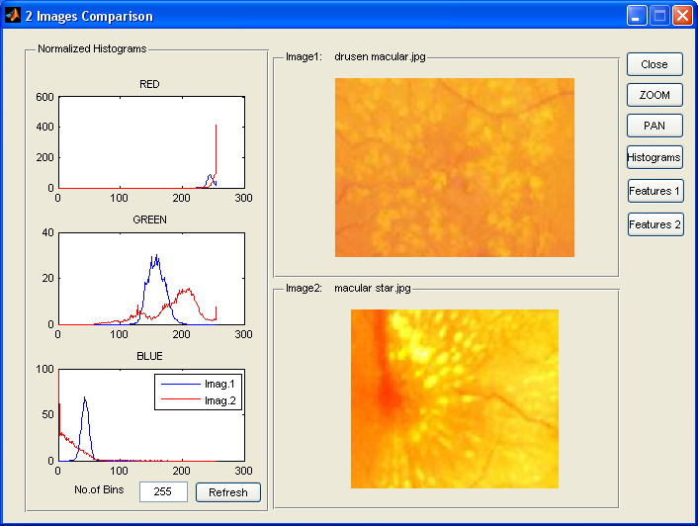

Figure 4: “Two Images Comparison” menu option

It allows opening two image files and to analyze them together, visual or using histograms or values that represent features. We can zoom and pan images and also plotted histograms. Regarding features, a set of 2D moment invariants can be computed and also a set of six values that describe a region by quantifying its texture content [2]. The six descriptors are based on statistical properties of the intensity histogram, namely on statistical moments and they are: mean – a measure of average intensity, standard deviation – a measure of average contrast, smoothness of the intensity in that region, third moment – a measure of skewness of a histogram, uniformity and entropy. These values will be used as inputs in the neural network.

3. CONCLUSION

The Graphical User Interface is important from two points of view: first for a doctor and second for a person who wants to go deeply in features extraction and image comparison. With this image processing module, doctor has a simple way for investigating an image, for editing it and save it in a database. Even the entire image or parts of it can be stored on the computer.

REFERENCES

- Marchand P, Holland T.: Graphics and GUIs with MATLAB - Third Edition, CRC Press, 2003
- Gonzales R., Woods R., Eddins S.: Digital Image processing using Matlab, Pearson Prentice Hall, 2004
- The MathWorks Inc. - Matlab – Image Processing Toolbox

