STEREOSCOPIC ANAGLYPH IMAGE RAYTRACING APPLIED TO MEDICAL BIO-MECHATRONICS ENGINEERING

Dipl.eng. Nitu Petru ¹
¹ PhD.student in Eng.Science -University TRANSILVANIA from Brasov, Brasov, Romania, ing_nitu_petru@yahoo.com

Abstract: In this paper they are presented some considerations about a virtual object design in POV-raytracing, related to virtual rigid body, regarding realistic physical model of like human organs. This model had thus to be deformable and fast enough to be used in real time tele-surgical simulations. This last point can be useful and necessary for experiments in virtual simualtion, like control of laparoscopic surgery via satelitte applications.
As the model must be fast enough, author will also work on another virtual model with adaptive morphology (Euphoria programming language, operable in Linux SO) in order to compare them and provide the best compromise between rapidity and realism of simulations. It is also presented in this paper the basic principles of the complete stereoscopic anaglyph digital process, assumed to be used into futures virtul imagistic experiments and applied in bio-mechatronics simualtions.

Keywords: stereoscopic medical image, anaglyph, laparoscopic surgery, digital raytracing.

- INTRODUCTION

Computer graphics digital animation, uses several classes of techniques for specifying object movements, by example explicit specification techniques like direct or inverse kinetic, key framing or, in a more general manner, providing rules (including physical) that allow for automatic determination of simulation according to interactions of the considered object with its environment. Using physically-based animation, it is possible to compute objects dynamic and realistic reaction to collision and all others constraint’s forms. Many models based on physical animation are proposed to simulate real object’s behavior and can be numerically simulated in the computer graphics digital area.

But this field still involves difficult points, like collision detection and response, numerical integration and mechanical simulation.

A physical model can be animated using some dedicated formalism which can be mathematical models of Newton-Euler or Lagrange. Those formalisms are equivalent from a physical point of view, but not from a computational one. This implies that models cohabitation brings many physical formalism which have to be simulated all together. Precisely speaking, contacts and constraints between heterogeneous models are often difficult to achieve in an efficient way.

Simulation including multiple models (possibly of different kinds) has been the subject of lots of study in the past and it is still a hot topic. Many solutions have been proposed that can be dispatched into two categories.
The first category proposed to simulate all objects with the same physical formalism and imposes constraints by a specific method. The second category proposed to simulate multiple objects with different mechanical formalisms and uses global constraints management to ensure constraints between objects.

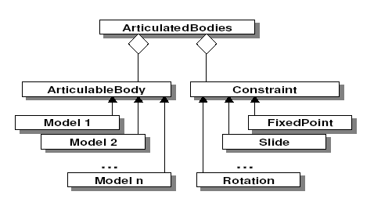
Fig.1. Logical software architecture of estimated POV-VRML real-time system

2. LAGRANGIAN SPLINE

Remion proposes an model based on the geometric spline. This geometric base is made dynamic with physical properties and material system. This dynamic system is then animated using Lagrange theory, considering the spline control points as degrees of freedom. This model has, among other advantages, the one that it is continuously deformable, which can not be achieved using Newton formalism due to its inevitable discrete form. Such model has been proposed in the past by Qin and Terzopoulos with their D-NURBS proposition, but this work is intended to variational modeling purposes and thus the resolution stage is static. The Lagrange theory only imposes to the model that it must be definable using a set of degrees of freedom called generalized coordinates. Its kinetic and potential energy must be definable only using those degrees of freedom. If the model coresponding of the condition, it can be animated by the Lagrange equations:
(1)
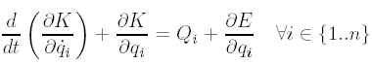
where n is the number of degrees of freedom, qi are the degrees of freedom, ÿ qi are the velocities of the degrees of freedom, K is the kinetic energy of the system, E is the energy of the conservative forces and Qi the energy of the other forces relative to the ith degree of freedom. The degrees of freedom of a spline are defined by the coordinates of its control points. Thereby, the kinetic and potential energies can be formally defined and computed to define the equation’s system. The isotropic property of the object allows, by structuring the system by x,y and z coordinates, to obtain the same data for each axis.

3. NEWTON-EULER RIGID BODY

Rigid body can be seen as the extreme case of a deformable object with very stiff internal energy. At this tage, the dynamic of the object can be reduced to the center of mass G and the orientation of the object (for instance a quaternion <q>). The geometry of the object is only taken into account by defining an inertia matrix I that gives the mass repartition in all directions. Physically speaking, the

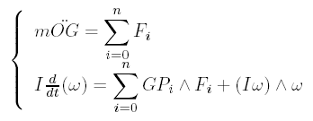

(2)

dynamics of a rigid body is given by the Newton-Euler formalism:
where n is the number of degrees of freedom, qi are the degrees of freedom, ÿ qi are the velocities of the degrees of where Fi are the forces applied to the object at point Pi, m the mass of the object and ϖ the angular velocity. The relation between the angular velocity and the quaternion of orientation, is given by the equation :
(3)

Using this physical formalism, a rigid body is defined by six degrees of freedom, three degrees in translation and three degrees in rotation. This system has to be represented into a matrix form, to be compliant with the global framework.

4. DIGITAL IMAGE PROCESSING FUNDAMENTALS

Modern digital technology for image procesing has made it possible to manipulate multi-dimensional signals with systems that range from simple digital circuits to advanced computers. The goal of this manipulation can be divided into three categories:
- Image Processing = image in -> image out
- Image Analysis = image in -> measurements out

We will focus in this paper on the fundamental concepts of image processing , and few introductory remarks about image analysis. Further, we will restrict ourselves to two-dimensional (2D) image processing although most of the concepts and techniques, that are to be described, can be extended easily to three dimensions (3D).

5. DIGITAL IMAGE - BASIC DEFINITIONS.

An image, by convention, is considered to be a function of two real variables, a(x,y) where a as the amplitude (brightness of image) at the real coordinate position (x,y), and the image may be considered to contain series of dedicated sub-images, referred to as regions-of-interest. This concept reflects the fact that images frequently contain collections of dedicated objects, each of which can be the basis for a region.

In a image processing systems it should be possible to apply specific image processing operations to selected regions. Thus one part of an image (region) might be processed to suppress motion blur while another part might be processed to improve color rendition. The amplitudes of a given image will almost always be either real numbers or integer numbers.
The latter is usually a result of a quantization process that converts a continuous range (range is between 0 and 100%) to a discrete number of levels. In certain image-forming processes, however, the signal may involve photon counting which implies that the amplitude would be inherently quantized.

In medical image forming procedures, by example such as magnetic resonance imaging (MRI), the direct physical measurement yields a complex number is related with the form of a real magnitude and a real phase. For the remainder of this paper we will consider amplitudes as reals or integers, unless otherwise indicated.


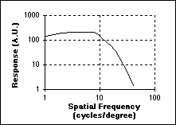

a) b)

Fig.2. Spatial frequency sensitivity (a), and sinusoidal test grating (b)

6. SPATIAL FREQUENCY SENSITIVITY

Is possible to determine the spatial frequency sensitivity (Fig.2-a) if the constant intensity (brightness) I_{o} is replaced by a sinusoidal grating with increasing spatial frequency (Fig.2-b).

But to translate these data into common terms, is recommended to consider an computer monitor at a viewing distance of 100 cm. The spatial frequency that will give maximum response is at 10 cycles per degree. (See Fig.12a.) The one degree at 100 cm translates to 100•tan(1deg.) = 1,745cm [ where tan(1deg.)=0.01745506 ] on the computer screen. Thus the spatial frequency of maximum response f_{max} = 10 cycles/1,74cm = 5,7 cycles/cm at this viewing distance. Translating this into a general formula gives:
(4)
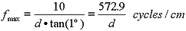
where d = viewing distance measured in cm

7. SPECTRAL SENSITIVITY OF VIRTUAL CAMERA IN VRML SCENE

Sensors, such as those found in cameras and film, are not equally sensitive to all wavelengths of light. The spectral sensitivity for the CCD-sensor is given in Fig.3:
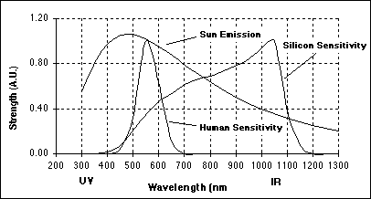

Fig. 3. Spectral characteristics of silicon, the sun, and the human visual system.
(UV = ultraviolet and IR = infra-red)

The high sensitivity of silicon in the infra-red means that, for applications where a CCD (or other silicon-based) camera is to be used as a source of images for digital image processing and analysis, consideration should be given to using an IR blocking filter. This filter blocks wavelengths above 750 nm. and thus prevents "fogging effect" of the image from the longer wavelengths found in sunlight. Alternatively, a CCD-based camera can make an excellent sensor for the near infrared wavelength range of 750nm to 1000nm

8. RESOLUTION

The pixels stored in computer memory (RAM, DDRAM) or memory of CCD-camera (SD-card,Compact-Flash) although they are derived from regions of finite area in the original scene, may be thought of as mathematical points having no physical extent.

When displayed, the space between the points must be filled in. The brightness profile of a spot is approximately Gaussian and the number of spots that can be resolved on the display depends on the quality of the system. It is relatively straightforward to obtain display systems, with a resolution of 72 spots per inch (28.3 spots/cm.) This number corresponds to standard printing conventions. If printing is not a consideration then higher resolutions, in excess of 30 spots/cm, are attainable.

9. SAMPLING DENSITY IN DIGITAL IMAGE ANALISYS

The rules for choosing the sampling density when the goal is image analysis as opposed to image processing, are different. The fundamental difference is that the digitization of objects in an image, into a collection of pixels, introduces a form of spatial quantization noise that is not band-limited. This leads to the following results for the choice of sampling density when one is interested in the measurement of area and (perimeter) length.

10. SAMPLING FOR AREA MEASUREMENTS
Assuming square sampling, X_{o} = Y_{o} and the unbiased algorithm for estimating area which involves simple pixel counting, the CV (see eq. ) of the area measurement is related to the sampling density by :
(5)

where S is the number of “samples / object diameter”. In 2D the measurement is area, and in 3D is the volume.

11. SAMPLING FOR LENGTH MEASUREMENT

Square sampling and algorithms for estimating length based upon the Freeman chain-code representation the CV (precision) of the length measurement, and is related to the sampling “density / unit length”.

The curves developed in the context of straight lines, have been found for curves and closed contours. The specific formulas for length estimation use a chain-code representation of a line and are based upon a linear combination of three numbers:
(6)
where N_{e} is the number of even chain-codes, N_{o} the number of odd chain-codes, and N_{c} the number of corners.
Length estimation formulas based on chain-code counts (N_{e}, N_{o}, N_{c}) , are based on coefficients of Pixel-Count, where [ α=1, β=1, γ=0 ]

12. CONCLUSION ON SAMPLING
If one is interested in image processing, one should choose a sampling density , based upon classical signal theory, that is the Nyquist sampling theory. If one is interested in image analysis, one should choose a sampling density based upon the desired measurement accuracy (bias) and precision (CV).

13. RAYTRACING WITH PERSISTENCE OF VISION (POV). BASIC INFORMATION.

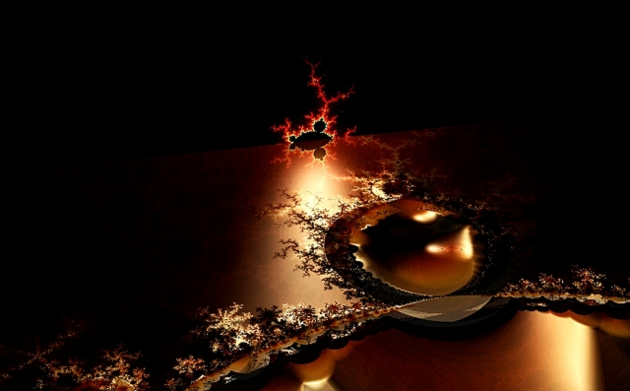
The “Persistence of Vision Raytracer” software is now able to creates three-dimensional (3D), photo-realistic images using a rendering technique called “ray tracing”, that allows any user to create professional-quality ray-traced images. It offers a sophisticated modelling and shading language that is fairly easy to learn and use, but is exceedingly flexible. It reads in, a text file, containing information describing the objects and lighting in a scene, and generates an image of that scene from the view point of a camera also described in the text file. Ray tracing is not a fast process by any means, but it produces very high quality images with realistic reflections, shading, perspective, and other special graphical effects (by example special graphics effects of movie War-Star and more other physics simulations). An example of the real power of this raytracer rendering is presented in next image:
Fig.4. Digital image of M-fractals type, rendered in “Persistence of Vision Raytracer - POV”.
(POV - official archive code sources - USA)
Digital design by Dipl.eng.Nitu Petru / 2005
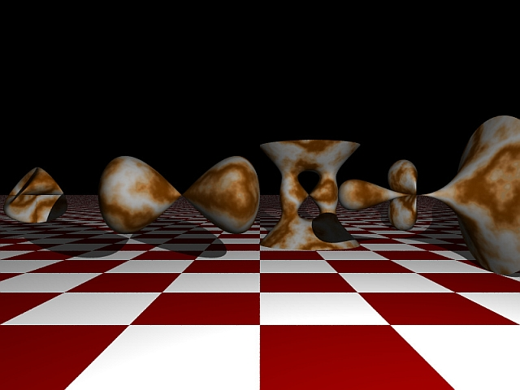
An other example is provided by the ISO-surfaces algoritms facilities, implemented on POV-raytracing:
Fig.5. Digital image of ISO-surfaces colection, rendered in “Persistence of Vision Raytracer - POV”.
(POV - official archive code sources - USA)
Digital design by Dipl.eng.Nitu Petru / 2005
14. RECONSTRUCTION OF 3-D MEDICAL DATA POINTS IN POV

Raytracing of digital design in POV-raytracing involves the generation of mathematical representations of solids from 3D data sets, a process generally referred to as object reconstruction. Object reconstruction is useful in applications where digitized information of an object is readily available ( medical DCIM images by example). The reconstruction of 3D solids from scattered data points has recently received a great deal of attention in both engineering and medical surgical laparoscopic fields, due to the emergence of relatively inexpensive 3D scanners and continued improvements in medical scanners that produce data arranged as layers of points.

In context, an aspect of this research that differs from existing reconstruction schemes is the use in POV raytracing an implicit function, f(x,y,z)=0, to represent the reconstructed object. The implicit function for computational algoritm is obtained through approximating Boolean unions of primitives.

Results from reconstructing sample objects in POV-raytracing, indicate that the reconstructed virtual models are accurate to within a few percent of the real object size dimensions. One of the advantages of using the implicit representation, is that the reconstructed object can be subjected to any regular Boolean operations in 3D digital design. The ease of generating new shapes with the implicit representation allows the user to incorporate the resulting virtual solid body, into other virtual models.

This current research paper is related to object reconstruction from data points of standard medical images and concret algebric computer-aided-design of virtual models designed in POV, stereoscopic anaglyph images manipulated in real-time processes.

15. BASIC ENHANCEMENT OF DIGITAL IMAGE RESTORATION IN POV
The process of medical image acquisition frequently leads (inadvertently) to image degradation. Due to mechanical problems, out-of-focus blur, motion, inappropriate illumination, and noise the quality of the digitized image can be inferior to the original image.
The goal of enhancement is, starting from a recorded image c[m,n], to produce the most visually pleasing image â[m,n]. The goal of restoration is, starting from a recorded image c[m,n], to produce the best possible estimate â[m,n] of the original image a[m,n]. The measure of success in restoration is usually an error measure between the original a[m,n] and the estimate â[m,n]: E{â[m,n], a[m,n]}.

The mean-square error function is commonly used because:
1. It is easy to compute;
2. It is differentiable implying that a minimum can be sought;
3. It corresponds to signal-energy in the total error;

The mean-square error is defined by relations:
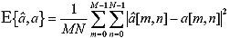
(7)

In some techniques an error measure will not be necessary, but in others it will be essential for evaluation and comparative purposes (practical example is processing of special medical images - DCIM).

16. EXPERIMENTAL RESULTS OF POV-RAYTRACING STEREOSOPIC DESIGN

The first VRML system designed with POV-raytracer is based on algoritms resulted from theory presented in this paper. Image resulted have realy high-resolusion and respect all proprieties of encapsulated virtual objects.

Rendering time obtained is acceptable, and iterations of variables, related to virtual complex objects, is very easy to programming. Design of this first virtual scene 3D, with bio-model simulation is presented in next image:

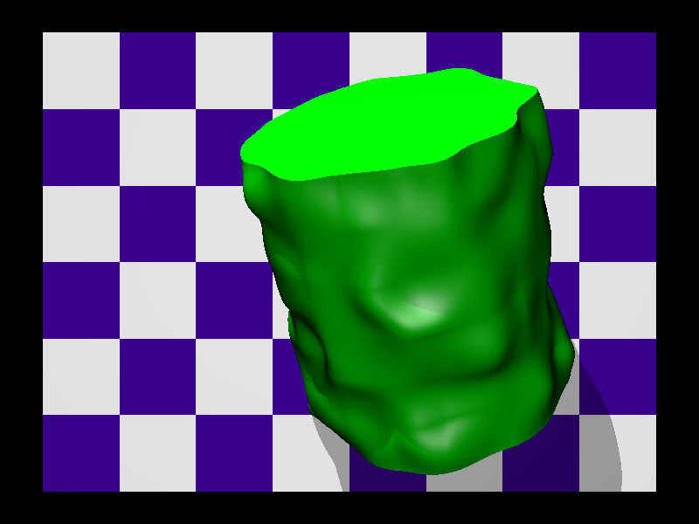

Fig.7. Static simulated-image of bio-medical rigid body, rendered with POV-raytracer.
Digital design by Dipl.eng.Nitu Petru / 2005.

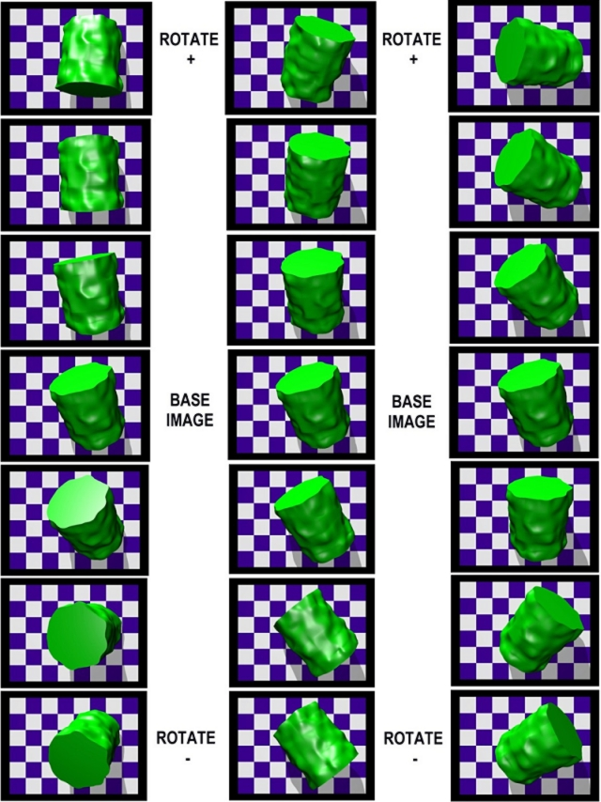

X Y Z

Fig.6. Dinamic images is related to rotations of simulated bio-medical rigid body in an experimental movie .
Rendered images have created with POV-raytracer, from dedicated external file with data-points.
Digital design by Dipl.eng.Nitu Petru / 2005.

17. DIGITAL STEREO DIGITAL IMAGE GEOMETRY
Stereo algorithms compute range information to objects by using triangulation. Two images at different viewpoints see the object at different positions: the image difference is called in digital imaging computing disparity. This section discusses the basic equations that govern the relationship between disparity and range.

18. DISPARITY AND THE H-ZONE OF STEREO DIGITAL IMAGE
The figure below displays stereo image geometry. Two images of the same object are taken from different viewpoints. The distance between the viewpoints is called the baseline (b) . The focal length of the lenses is f. The horizontal distance from the image center to the object image is named dl variable for the left image, and dr is named a variable for the right image .
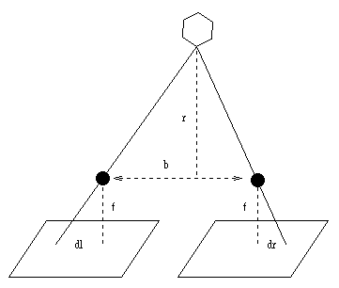
Fig.8. Digital stereo image geometry.

Normally, we set up the stereo cameras in POV algoritms, so that their image planes are embedded within the same plane. Under this condition, the difference between dl and dr variables (visual parallax distance) is called the disparity, and is directly related to the variable viewed distance r of the object normal to the image plane. The relationship in this case is:
r = bf / d , where d = (dl - dr ) (8)

Using this short equation, we can plot range as a function of disparity for display on PC-monitor ( CRT & TFT) or display on special STH digital stereo-head (in this case at their smallest baseline, the cameras are about 80 mm apart, the pixels are 14 um wide, and the standard lenses have a focal length of 6.3 mm). Using these figures, we can plot the relationship between range and disparity.
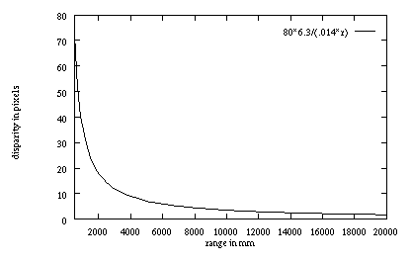
Fig.9. Relationship between range and disparity for an algoritm of rendering stereo image in POV-raytracer

The minimum range in this plot is 1/2 meter; at this point, the disparity is over 70 pixels; the maximum range is about 35 meters. Because of the real inverse relationship, most of the change in disparity takes place in the first several meters.
Stereo algorithms typically search only a window of disparities, by example 16 or 32 disparities. In this case, the range of objects that they can successfully determine is restricted to some interval, called the H-zone. The H-zone can be determined from equation (8). For example, if the disparity search window is 0-31, the H-zone (using the graph above) will be from approximately 1 meter to infinity. The search window can be moved to an offset by shifting the stereo images along the baseline. The same 32 pixel window could be moved to cover 10-41 pixel disparities, with a corresponding H-zone of 0.8 meters to 2.2 meters. The location and size of the H-zone depends on the application designed. If an object falls outside the H-zone, then its true disparity will not be found, and instead it will get some random distribution of disparities. The figure below shows what happens when the object's range falls outside the H-zone. In the left image, the disparity search window is correctly positioned so that objects from 1 meter to infinity are in view. In the right image, the window has been moved back so that objects have higher disparities. However, close objects are now outside of the H-zone, and their disparity image has been "broken up" into a random pattern. This is typical of the disparity images produced by objects outside the H-zone.

For a given application, the H-zone must be large enough to encompass the ranges of objects in the application. In most cases, this will mean positioning the upper end of the H-zone at infinity, and making the search window large enough to see the closest objects.The H-zone is influenced not only by the search window and offset, but also by the virtual-camera parameters and the baseline. The H-zone can be made larger by some combination of the following:
- Decreasing the baseline.
- Decreasing the focal length (wider angle lenses) of virtual-camera.
- Increasing pixel width.
- Increasing the disparity search window size.

As the virtual-cameras are moved together, their viewpoints come closer, and image differences like disparity are lessened. Decreasing the focal length changes the image geometry so that perceived sizes are smaller, and has a similar effect. It also makes the field of view larger, which can be beneficial in many applications.
However, very small focal length lenses often have significant distortion that must be corrected (algoritms for virtual camera calibration). Another way to change the image geometry is to make the pixels wider. This can be done by scaling the image, by example from 320x240 to 160x120, which doubles the pixel size. Note that it is only necessary to change the pixel width. Most frame grabbers have hardware scaling to arbitrary resolutions.

These first three options change the virtual-camera geometry, and thus have a corresponding effect on the range resolution, which decreases. The only way to increase the H-zone size and maintain range resolution is to increase the disparity search window size, which leads to more computation. Multi-resolution methods, which use several sizes of an image, each with its own H-zone, are one way to minimize computation.

19. RANGE RESOLUTION OF STEREO DIGITAL IMAGE
Often it's important to know the minimal change in range that stereo can differentiate, that is, the range resolution of the method. Give the discussion of stereo geometry above, it's easy to see that that range resolution is a function of the range itself. At closer ranges, the resolution is much better than farther ranges. Range resolution is governed by the following equation :
Δ r = (r²/bf) • Δ d (9)
The range resolution, Δ r, is the smallest change in range that is descernible by the stereo geometry, given a change in disparity of Δ d. The range resolution goes up (gets worse) as the square of the range. The baseline and focal length both have an inverse influence on the resolution, so that larger baselines and focal lengths (telephoto) make the range resolution better. Finally, the pixel size has a direct influence, so that smaller pixel sizes give better resolution. Typically, stereo algorithms can report disparities with sub-pixel precision, which also increases range resolution.
The figure below plots by example range resolution as a function of range for the STH special stereo-head , given a baseline of 8 cm and 6.3 mm lenses. This Stereo-Engine interpolates disparities to 1/4 pixel, so Δ d is defined by relations: 1/4 * 14 um = 3.5 um

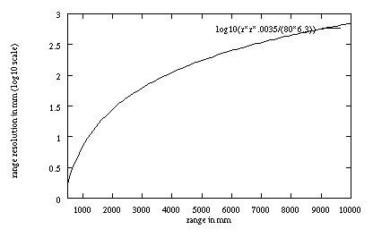

Fig.10. Plot of range resolution as a function of range

The range resolution is plotted on a log₁₀ scale to show more detail at closer ranges. At 1 meter, the range resolution is about 10 mm. At 4 meters, it has grown to 100 mm; by 10 meters, it is almost a meter.
Equation (9) shows the range resolution of a perfect stereo system. In practice, video noise, matching errors, and the spreading effect of the correlation window all contribute to degrading this resolution. Range resolution is not the same as range accuracy, which is a measure of how well the range computed by stereo compares with the actual range. Range accuracy is sensitive to errors in camera calibration, including lens distortion and camera alignment errors.

20. STEREO ANAGLYPH DIGITAL IMAGE PROCESSING

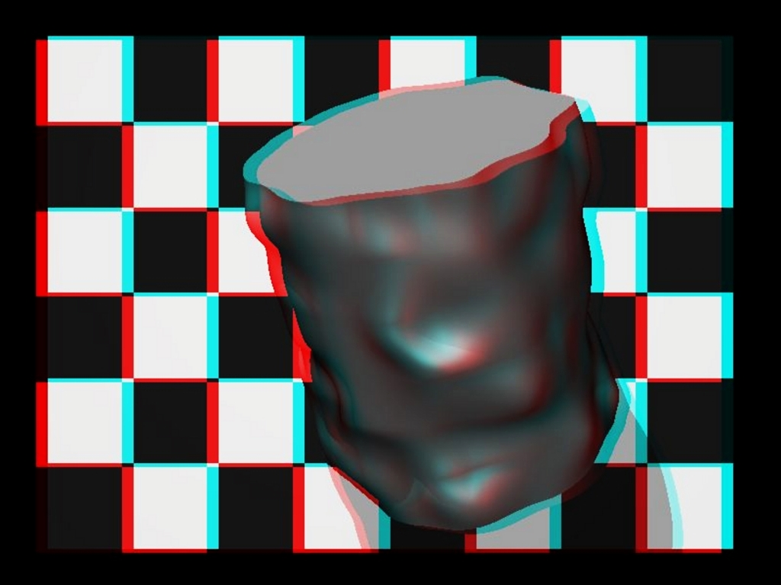
In the context of this research, we have already introduced and implemented an procedure for design stereo anaglyph digital image with an new algoritm, able to 3D mouvements analisys of of bio-medical rigid body.

Fig.11. Stereoscopic anaglyph image of simulated bio-medical rigid body, rendered with POV-raytracer.
Digital design by Dipl.eng.Nitu Petru / 2005.

NOTE: This image is viewed 3D only with special anaglyph glasses.
Rendered in POV-raytracer and after converted in a stereo anaglyph image, this model 3D is directed to deliver in real-time informations about relative position of rigid body (x,y,z coordinates) in to VRML scene. This system is tested and is very robust; can be easy implemented and used for imagistic control planing in medical micro-robotics systems or other virtual bio-mechatronical applications.

21. CONCLUSION

The contribution of this research study, as methodological and as originally, will be reported to investigations a new CAD technological computational metods (raytracing computer-aided-design type) which is able to manipulate digital images in real-time; captured and stored microscopic images of biological specimens in external data-point files, rendered later in POV (dedicated software for professional raytracing), or other dedicated design of virtual models applied to biomedical rigid body. Final result is an set of anaglyphs images (special stereoscopic red-blue images), recorded as three dimensional stereopairs static image (presented in this paper), or an stereo-animation manipulated in real-time (on work), viewed on standard computer display in 3D dimensions, with special anaglyph glasses.

NOTE: All of digital digital imaging experiments is designed and tested with POV – raytracer in diferent SO systems: MS-Windows Me, XP (Copyright of Microsoft) and Linux (Mandrake compilation, Knopix compilation & Fedora compilation , all versions of SO-Linux, GNU Free-Software Development).

Furthermore, this final results of reserch can be successfully applied to develop the field of special medical images DCIM analisys, and in other bio-medical imagistic digital aplications, or designing virtual realistic scenes (with high-resolution) for VRML bio-medical applications; and in combination with special devices, is an practical solution to simulation robotic control in real-time, in domain of laparoscopic tele-surgery via satelitte, coresponding with goal of my PhD thesis.

REFERENCES
[1] BLECHSCHMIDT, J., AND NAGASURU, D. The use of algebraic functions as a solid modeling alternative: An investigation. In ASME Advances in Design Automation (Chicago, Il, USA, 1990), pp.33-41.
[2] BLINN, J. A generalization of algebraic surface drawing. ACM Transactions on Graphics 1, 3 (July 1982), 235-256.
[3] BLOOMENTHAL, J. Polygonization of implicit surfaces. Computer-Aided Geometric Design 5, 4 (1988), 341-355.
[4] BOULT, T., AND GROSS, A. Recovery of superquadrics from depth information. In Proceedings of Workshop on Spatial Reasoning and Multi- Sensor Fusion (1987), pp. 128-137.
[5] DOI, J., AND KOEDA, K. Three-dimensional reconstruction of solid models from multi-directional images and applications to industrial measuration. In Proceedings of SPIE, Close-Range Photogrammetry Meets Machine Vision (Zurich, Switzerland, September 1990), pp. 564-571.
[6] FERRIE, F., LAGARDE, J., AND WHAITE, P. Recovery of volumetric object descriptions from laser rangefinder images. In Proceedings of Computer Vision -- ECCV '90, Antibes, France (1990), pp. 387-396.
[7] GORDON, M., AND DELOID, G. Advanced 3d image reconstruction from serial slices. In NCGA '90 Conference Proceedings (Anaheim, CA, USA, 1990), pp. 176-183.
[8] GRAY, A. Modern differential geometry of curves and surfaces. CRC Press, Boca Raton, Fl, USA, 1993, pp. 267-298.
[9] HOFFMANN, C., AND HOPCROFT, J. The potential method for blending surfaces and corners. In Geometric Modeling: Algorithms and New Trends, G. Farin, Ed. SIAM, Philadelphia, 1987, pp. 347-365.
[10 HSIEH, Y., DRAKE, S., AND RIESENFELD, R. Reconstruction of scupltured surfaces using coordinate measuring machines. In ASME Advances in Design Automation DE-Vol.65-2 (Albuquerque, NM, USA, 1993), pp. 35-46.
[11] IMSL, INC. IMSL Library: FORTRAN Subroutines for Mathematics and Statistics, 9.2 ed. Houston, Tx, USA, 1985.
[12] MIDDLEDITCH, A., AND SEARS, K. Blend surfaces for set theoretic volume modeling systems. In Computer Graphics (SIGGRAPH '85 Proceedings) (July 1985), B. A. Barsky, Ed., vol. 19, pp. 161-170.
[13] OWEN, J., AND ROCKWOOD, A. Intersection of general implicit surfaces. In Geometric Modeling: Algorithms and New Trends, G. Farin, Ed. SIAM, Philadelphia, 1987, pp. 335-345.
[14] ROCKWOOD, A. The displacement method for implicit blending surfaces in solid models. ACM Transactions on Graphics 8, 4 (1989), 279-297.

