EXPERIMENTAL RESEARCH ON ELECTRICAL PROPERTIES OF PARTICLE REINFORCED COMPOSITE MATERIALS AS CANDIDATES FOR VARIOUS INDUSTRIAL APPLICATIONS

Prof. eng. Ioan D. Oltean¹ PhD, Assoc. prof. eng. Dana I. Luca Motoc² PhD
¹ Transilvania University, Braşov, ROMANIA, oltean@unitbv.ro
²Transilvania University, Braşov, ROMANIA, danaluca@unitbv.ro

Abstract: The paper summarizes the experimental research conducted on metallic (Fe) particle reinforced polymer composite samples in order to retrieve few of their electrical properties. The particles considered were embedded into an epoxy matrix, having different dimensions and the same fraction volume (0.7). Frequency variation impedance measurements on the samples shown an unusual behavior of these types of composite materials and revealed a dielectric nature for the overall composite. Comparison with the theoretical models and statistical analysis completes the studies. Example calculation demonstrates the effect of varying filler volume fraction, intrinsic material properties, particle shape and frequency. Potential applications already identified, previously and during the studies, for this class of materials will provide enough working space for all involved and interested in developing and characterizing novel materials.
Keywords: electro-composite, particles, electrical conductivity, temperature, frequency.

1. INTRODUCTION

The paper herein belongs to a series of experimental research procedures developed by the authors to aid the characterization of metallic particles embedded into a polymer matrix (epoxy) composites samples from mechanical, thermal and electrical point of view in order to answer to few basic questions in the area of nature, behavior and manufacturing of new materials as potential candidates for various industrial applications.
As was underlined in [6], it is useful to be able to predict the bulk behavior of a composite material from knowledge of the intrinsic properties of its constituents, since this ability is a fundamental requirement in the development/characterization/optimization processes of a novel material.
The experimental results within this paper concern with the electrical behavior of a polymer based composite materials embedded with Fe particles having different dimensions (100, 160, 200 μm respectively, see [1]) and the same fraction volume (0.7), at room temperature as well as considering temperature variations measurements (up to 120 ⁰C, approximately the glass transition temperature of the epoxy resin) in order to characterize the nature of the overall material as long as its constitutive were conductive taken separately. Some of the experimental data were compared with their theoretical correspondent, and for the other experimental values were used some polynomial fitting curves to characterize the dependence.
Technical literature lacks on such experimental procedures in case of particle reinforced polymer composite materials (specifically, on their electrical conductivities values) and in such circumstances we do consider that the paper will contribute in some extent to the trends and concerns in this area.

2. EXPERIMENTAL PROCEDURE AND RESULTS

The initial experimental trials on these particle reinforced composites were carried out using 2-point impedance measurements employing a WK-4265 –Wayne & Kerr impedance analyzer (see figure 1). The results were acquired at the room temperature with the aim of impedance vs. various frequency values dependence plotting. In figure 2 is being represented the measurements scheme that reveals the significance of the R_{DC} (resistance) component over L (reactance).
Composite sample
Impedance analyzer

Figure 1: 2 points impedance analyzer experimental configuration
R_{x}
RLC bridge
Figure 2: RLC bridge measurement scheme

2.1. Frequency dependence of samples’ impedance

In figure 3 are being plotted the samples’ impedance vs. different frequency values (namely 0.1, 1, 10 and 100 kHz) whereas in figure 4 are being plotted the relative electrical conductivities for different fraction volumes of particles based on different theoretical models accompanied by the values measured for the samples involved at 50 Hz.
As can be seen, a frequency rise lead to higher values of samples’ impedance and in case of the sample having the highest particle dimensions (200 μm) the values are higher comparatively to the other 2 samples. In case of electrical conductivities values, for the same fraction volume of particles, the same ratio like those with respect of the particles’ dimensions are applied, and seems that the smaller the particles the more approaches theoretical models corresponding to the ideal spherical inclusions.

Figure 4: Theoretical models vs. experimental values (0.7 fraction volume)
Figure 3: Samples’ impedance vs. different frequency values

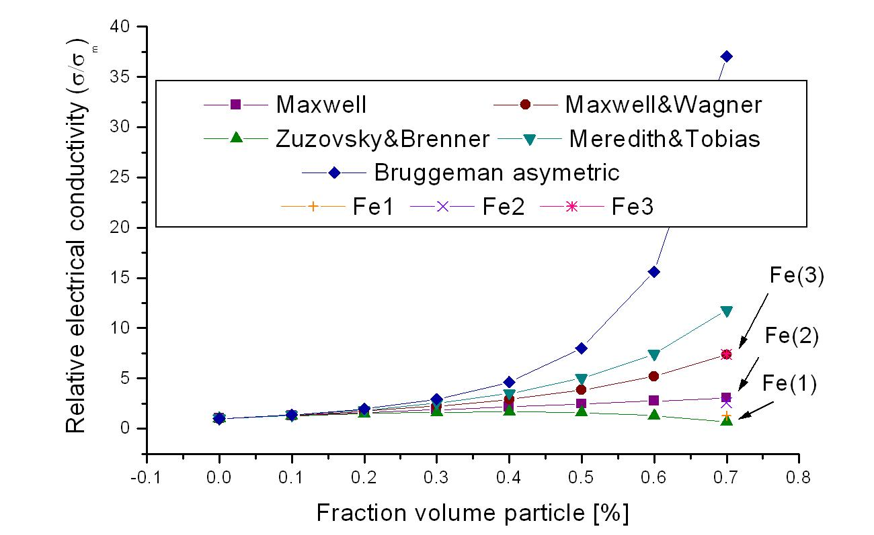

Figure 4: Theoretical models vs. experimental values (0.7 fraction volume)

2.2. Temperature dependence of samples’ resistance

In figures 5 and 6 are being plotted the temperature dependence of the measured electrical resistance of the sampled involved into the measurements. For these type of measurements was used a temperature controlled oven were the samples were introduced using the same RLC bridge to acquire the measured values. The sample having a lower particle dimension was subjected to a higher temperature comparatively with the previous one, a temperature approaching the glass temperature transition of the epoxy polymer. There were no changes in the sample’s shapes due to the temperature rise as one might expect. The reason relies on the polymerization process that was completely right from the samples’ manufacturing step.
The best polynomial fitting curve is being shown in the same plot. In both cases the curve approaches a 3rd degree polynomial curve (equation given) and around the 80 ⁰C a changing in the “behavior” can be outlined. As a general trend, the sample’s resistance decrease as temperature raises to higher values and in some extent the curves approaches the general tendencies found in dielectric materials.

Figure 5: Fe - 200 μm particle dimensions composite samples – temperature dependence of measured resistance & polynomial fitting curve

Figure 6: Fe – 160 μm particle dimensions composite samples –temperature dependence of measured resistance & polynomial fitting curve

3. CONCLUSION

The particle dimensions influence the overall behavior of the temperature dependence of the measured resistance (the highest contributions in the impedance values). There are problems, however, with high-field dc measurements in metallic particles polymer based composites. First, corrosion products are anticipated on particle surfaces if high dc currents are applied for any period of time. Second, such currents can lead to joule heating effects. The data in figures 5 and 6 were taken with delays between individual points to allow for thermal relaxation. If this procedure was not employed, the threshold voltages under negative vs. positive bias differed significantly, and the outer (high current) regimes had different slopes. Finally, the resistances in the high-current regime were found to be significantly higher than in lower frequencies measurements. One proposed explanation is that high local current densities (between particles) can result in permanent micro-structural changes in the matrix. In conclusions, impedance measurements are non-destructive and the only reliable means of assessing composite electrical properties in the "conductive" particle regime.
Acknowledgment: The paper was supported under the research grand CNCSIS no. 172/2004.

REFERENCES

- Motoc Luca D.: Contribuţii la studiul corelaţiilor dintre gradul de tensionare şi proprietăţile fizice ale unor materiale utilizând metode nedistructive (sonore, vizuale), teză de doctorat, Universitatea Transilvania din Braşov, 2002.
- Motoc Luca D.: Particle reinforced composite materials' thermal conductivity evaluation - theoretical approaches, Buletinul Universităţii din Oradea, Mai, 2004.
- Oltean I.D., Tehnologie electronică, Tehnologia dispozitivelor semiconductoare şi a circuitelor integrate, Editura MATRIX ROM, Bucureşti, 2004, ISBN 973 - 685-792-1.
- Oltean I.D.: Componente electronice pasive, Editura Lux Libris, 2000, ISBN 973-9458-04-1.
- Campo M. A., Woo L. Y., Mason T. O., Garboczi E. J.: Frequency-dependent electrical mixing law behavior in spherical particle composites, Northwestern University, Evanston, 2002.
- Motoc Luca D.: Theoretical approaches on electrical properties of particle reinforced composite materials as candidates for alternative industrial applications, 1st International Conference ″Computational Mechanics and Virtual Engineering ″ COMEC 2005, Brasov, Romania, 2005 (to be published).

