NUMERICAL METHODS FOR DETERMINATION THE ELASTIC TENSIONS
APLICATIONS ON ROLLING BEARINGS

Enescu Ioan
“Transilvania” University Brasov, ROMANIA, enescu@unitbv.ro

Abstract: The projection of the bearings elements special the rolling bearings and the roller way . It was studied the aspect in all rolling bearings with half-space method, finite elements(contact element), MathCad programmes
Key words: numerical methods, bearings

1. INTRODUCTIONS

One af the best methods to determinated the tensions are the numerical methods. In this applications we uses same different numerical methods for determination the state of bearings tensions, very importante for your projections..

2. HALF-SPACE METHOD

2.1. Uniform pressure applied to a polygonal region

We shall consider in this section a uniform pressure p applied to a region of the surface consisting of a straight-sided polygon, as shown in fig (1.a). It is required to find the depression at a general point B (x,y) on the surface and the stress components at a subsurface point A(x,y) ,BH₁, BH₂, etc, are perpendiculars of lenghts h₁,h₂, etc. onto the side of polygon DE,EF respectively. The loaded polygonal is then made up of the algebric addtion ofeight right angle triangles:
EFG=[BEH₁+BEH₂+BFH₂+BFH₃]-[BDH₁+BDH₄+BGH₃+BGH₄] (1)
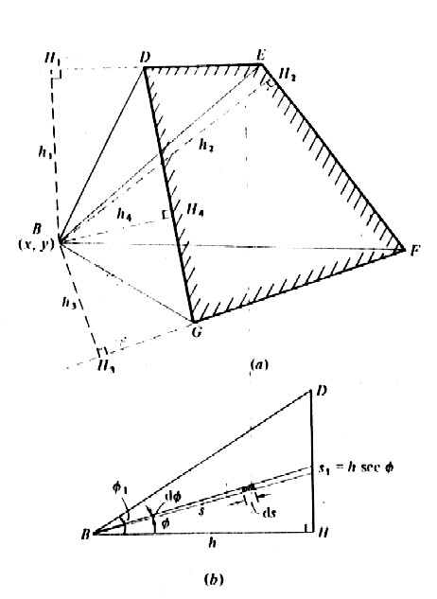
Figure 1
A similar breakdown into rectangular triangles would have been possible if B had lain inside the polygon a typical triangular area is shown in fig.(1.b)
$({\bar{u}}_{y})_{B}=\frac{1−ν^{2}}{πE}p\int_{0}^{φ_{1}}{dφ}\int_{0}^{s_{1}}{\text{ds}}=\frac{1−ν^{2}}{πE}p\int_{0}^{φ_{1}}{h\text{sec}φdφ=\frac{1−ν^{2}}{πE}}p\frac{h}{2}\text{ln}\left(\frac{1+\text{sin}φ_{1}}{1−\text{sin}φ_{1}}\right)$ (2)
The total displecement at B due to a uniforme pressure on the polygonal region DEFG can then be found by combining the results of equations (2) for the eight constitutive triangles. The stress components at an interior point A(x,y,z) beliw B can be found by integration of the stress components due to a point force given by known equation but the procedure is tedious.
The effect of a uniform pressure acting on arectangular area 2a*2b has been analysed in detail by Love (1929) . The deflexion of a general point (x,y) on the surface is given by:

D=$\frac{πE}{1−ν^{2}}\frac{{\bar{u}}_{z}}{p}=(x+a)\text{ln}\left[\frac{(y+b)+((x+a)+(x+a)^{2})^{1/2}}{(y−b)+((y−b)+(x+a)^{2})^{1/2}}\right]+$

$(y+b)\text{ln}\left[\frac{(x+a)+{\left((y+b)^{2}+(x+a)^{2}\right)}^{1/2}}{(x−a)+{\left((y+b)^{2}+(x−a)^{2}\right)}^{1/2}}\right]+$

$(x−a)\text{ln}\left[\frac{(y−b)+{\left((y−b)^{2}+(x−a)^{2}\right)}^{1/2}}{(y+b)+{\left((y+b)^{2}+(x−a)^{2}\right)}^{1/2}}\right]+$ (3)

$$(y−b)\text{ln}\left[\frac{(x−a)+{\left((y−b)^{2}+(x−a)^{2}\right)}^{1/2}}{(x+a)+{\left((y−b)^{2}+(x+a)^{2}\right)}^{1/2}}\right]$$

Expressions have been found by Love (1929) from which the stress components at ageneral point in the solid can be found. Love comments on the fact that the components of shear stress τ_{xy} has a theoretically infinite value at the corner of the rectangle. Elsewhere all stress components are finite. On the surface at the centre of the rectangle:
[σ_{x}]₀=-p{2ν+(2/π)(1-2ν)tan⁻¹(b/a)}

[σ_{y}]₀=-p{2ν+(2/π)(1-2ν)tan⁻¹(a/b)} (4)

[σ_{z}]₀=-p

These results are useful when a uniform loaded rectangle is used as a ‘boundary elements’ in the numerical solution of more general contact problems.
The elastic deformation in a point (x,y) make by the uniforme distribute pressure from the rectangulare surface (2a*2b) will be fig.(2) :
$δ'=\frac{p}{πE}\int_{−a}^{a}{\int_{−b}^{b}{\frac{\text{dxdy}}{{\left[(y−y_{1})^{2}+(x−x_{1})^{2}\right]}^{1/2}}}}$ (5)
By integrations the equation result :
$δ=\frac{\text{pD}}{{πE}^{'}}$ (6)
where the displacement D is calculated by the formule (2)
The expression δ represent the elastic deformation in the point (x,y) make by the uniforme pressure p, distribute from the rectangulare surface (2a*2b). If the contact surface is divided in a number of rectangulare equal surface, the total deformation in point (x,y) make by contribution of the diverse uniforme rectangulare surface load ,in the contact surface made by numerical evalueted.
The total deformation make by the uniform load from the rectangulare surfacein the inside of the con
$δ_{i}=\frac{1}{πE}\sum{p_{j}D_{i,j}}$ (7)
The results obtained by this method utilised for the contact of cilindrical bearings N2256 is giving in application.
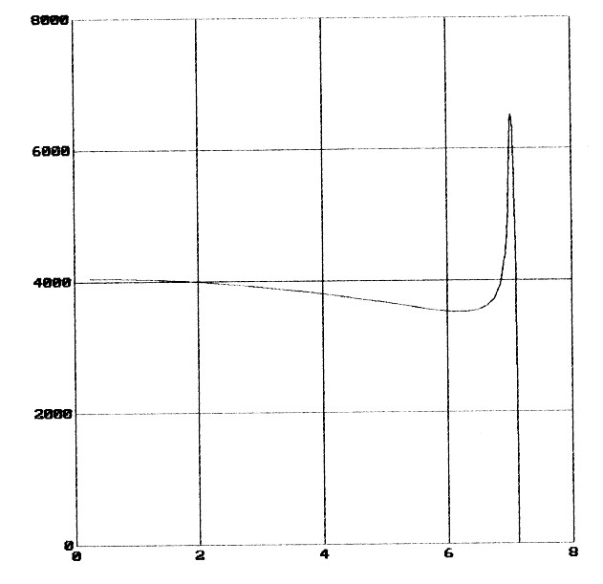
Figure 2

3. FINITE ELEMENT METHOD

The compression of a cylinder in contact “nonconformist” with two surfaces, who are in opposition at the extremity of roles, can be analyses satisfactory (fig.3).
A compression force on the unity of length we give a hertz distribution of pressure in O₁ equal with:
$p=\frac{2P}{{πa}_{1}}(1−\frac{x^{2}}{a^{2}})^{\frac{1}{2}}$ (8)
and
$a_{1}^{2}=4{\text{PR}}/{{πE}_{1}^{}}$ (9)
where $E_{1}^{}$is the Young modulus.
The tensions in A are given by the contribution:
1) the tensions given by the hertz distribution in O₁
2) the tension given by the pressure in O₂, may be considered as for a concentrate force P
3) the biaxial tension given by the equation

$σ_{1}−σ_{2}=P/{πR}$ (10)

Assembly the three contribution, we obtain:

$σ_{x}=\frac{P}{π}\left[\frac{1}{R}−\frac{2(a_{1}^{2}+2z^{2})}{a_{1}^{2(}(a_{1}^{2}+z^{2})^{\frac{1}{2}}}+\frac{4z}{a_{1}^{2}}\right]$
$σ_{z}=\frac{P}{π}\left[\frac{1}{R}−\frac{2}{2R−z}−\frac{2}{(a_{1}^{2}+z^{2})^{\frac{1}{2}}}\right]$ (11)
The real cylinders are finite length and the important deviations at the Hertz theory appear to their end.

3.1. The description of the construction solution

With the finite element program ANSYS use plane elements (triangular, rectangular and contact elements 48 we realized in the case of a cylindrical roles one other profile, a Lundberg modified profile.
The advantage of the proposed solution.
In (fig.3) and (fig.4) we can observe the distribution of tensions in two type of roles – cylindrical right roles (fig 3) and cylindrical roles with Lundberg modified profile. We can also observe that the tensions at the end of the roles are large small in the second case.

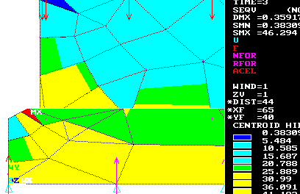

Figure 3

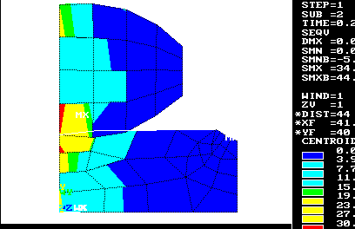
Figure 4

4. HERTZIAN CONSTANTS COMPUTER ASSISTED PROCESS DESIGN USING MATHCAD

For the understanding the hertzian models, it was study first the constituent equations for the vertical displacement u_{z} .
The hypothesis I is associate to establishment the path in a median elastic plane dependent by the curves of the conjugated surface and the elastics contacts of the two surface cylinders the account of contact verifying the consigns equations (fig.6).
$(z_{0}+u_{0})+(z_{1}+u_{1})=h,$ h=h₀+h₁ (12)
The external point of the contact, verifiable the inequation
$(z_{0}+u_{0})+(z_{1}+u_{1})$< h (13)
Take by P_{z} (x,y) ,the distribution of the contact pressure we have:
$u_{i}'\frac{1}{{πE}_{i}^{}}\iint{\frac{P_{z}(ξ,η)}{r}}dξdη$, $E^{{}_{i}}=\frac{E}{1−ν^{2}}$ I=0..n (14)
where :
E_{i} , ν_{I} is the Young and Poisson coefficients of this two materials.

4.1. The description of the construction solution

For construct an imagine of the sliding in the hertz plain I am stimulated one of two sphere by the plane structural complex by beam elements, for 7 radial level and twenty one angular (266 elements, 21*7=147 nodes).

To fix to structure embed for the contour 0,…,20,41,62,146 radial sliding for the 21,42,…,126 nodes.
The impose reshuffle of force is corresponding of flatten in the profile plane (fig.6).

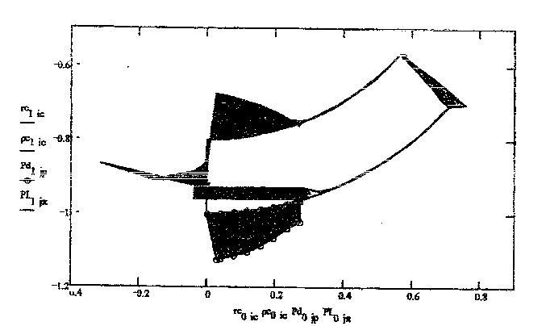
Figure 5

5. CONCLUSION

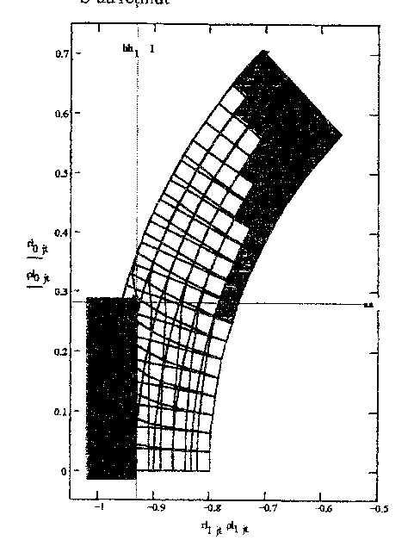
The numericals methods are one of the best methods to determinations the tensions in the rolles and rollings ways. It is very important to now, because the projects of the profile of rolle is very importante for determinations of the stade of tensions.

Figure 6
It rested that the slides for the contact plane and at the same time is making be determinates the pressure of contact distribution (fig.5).

REFERENCES

[1].Enescu I. – “ Aspecte ale mecanicii contactului la rulmenţi”, Editura Lux Libris Braşov, 1999
[2] Johnson K. L. – “Contacts mechanics”, Cambrige University Press ,1985
[3]. Tofan M.C., Ulea M., Enescu I. – “O aproximată sugestivă a alunecării în contactul Hertzian”, Buletinul celei de-a XXII-a Conferinţei Naţionale de Mecanica Solidelor Braşov, 1998.
[4].Enescu I., Ceptureanu G., Enescu D., „Rulmenti” Editura Universitatatea „Transilvania” Brasov 2005.

