POST-PROCESSING OF THE EXPERIMENTAL DATA
USING MATLAB

Mircea Cristian DUDESCU
Technical University of Cluj-Napoca, Strength of Materials Department
Str. Const. Daicoviciu, nr. 15, RO-400020, Cluj-Napoca, Romania
Mircea.Dudescu@rezi.utcluj.ro

Abstract:This paper describes a scientific toolbox created with MATLAB software designed to calculate, based on experimental data, full-field strain and stress distribution in machine parts. The input data consists of full field deformations obtained by optical measurements such as Electronic Speckle Pattern Interferometry and shadow moiré method with phase shift technique. As demonstration of the toolbox features, two practical examples are presented: strain-stress computation in a compressed ring and shear stress calculation in a bar subjected to torsion. Identification of the hot spots in these cases can easily be done and it highlights the advantages of the developed MATLAB Scientific Toolbox for Strain –Stress Analysis.
Keywords: experimental data post-processing, stress-strain calculation, speckle interferometry, shadow moiré

1. INTRODUCTION

Determination of the strain and stress states in machine parts is an essential condition in their reliability and design. Experimental methods in solid mechanics together with analytical and numerical concepts have a well-known importance. Development in the last decades of the computers has led in this field to numerous contributions in the direction of strain - stress analysis based on image processing. Most of so called optical methods of engineering analysis are today widely used due to the high speed computation, full-field information, enhanced calculus accuracy and friendly computer software. Among these, it should be reminded moiré technique, ESPI (Electronic Speckle Pattern Interferometry), or grey correlation techniques, all of these provide full-field information about the in-plane or out-of-plane deformations. In most cases, to carry out the component design, a subsequent data processing is necessary to get strain or stress distribution. Full-field information reveals rapidly the hot spots and contributes to phenomena understanding.
To complete a complex strain-stress investigation using optical methods, sophisticated equipment controlled by dedicated computer software is needed. Interaction of the researcher in the measuring process or data manipulation is restricted by system parameters. Development of commercial applications adapted to the research objectives is time consuming and very expensive. The difficulties to find a universal tool direct the researcher towards creating specific applications that can offer higher flexibility and are fully verifiable. Mathwork’s Matlab® is a software package designed, among others, for image and data processing [1]. Worldwide used in technical computing and data processing and having a high numbers of predefined numerical algorithms it is the ideal instrument for software development by researchers and engineers.

2. MATLAB SCIENTIFIC TOOLBOX FOR STRAIN-STRESS ANALYSIS

In figure 1 is presented a complex MATLAB Graphical User Interface (GUI) designed to compute different experimental data in order to get strains, stresses and their directions. The GUI is structured in two different frames (“Input data” and “Results”) according to the calculation flow. The results are presented in the plot area. Pull-down menus that accompany the graphical interface facilitate the user to access some extra features such as file operations (Open, Copy, Save, Print, Close), graphics (Profile, Point value) and settings (Filter parameters, Reset input data). The input data can be read directly from the measurement output files through an interactive menu, and three proprietary file types are recognized, “REL” [5], “TFD” [2] and ASCII format. After selection of input file containing in plane or out of plane experimentally measured object deformations and its dimensions respectively, the user can choose the corresponding problem solver: 1D strain, 2D plane stress, 2D plane strain, plates of constant thickness and torsion of bars using membrane analogy. According to the selected analysis type the object deformation can be displayed in the plot area. Material parameters necessary to calculate stresses (E-modulus, Poisson ratio and plate thickness in case of plate calculation) are necessary to fulfil the computation.
Calculation is done in seconds and then the results visualisation module becomes active. The results in terms of strain and stresses are graphically presented as colour coded images, colour contour levels or 3D plots. Visualisation mode can be chose by user and “Zoom” and “Rotate” functions increase the interface capabilities. All data displayed in the plot area can be printed, saved or copied. Two types of image filters - median and smoothing - with adjustable parameters were also included to reduce noise quantity and to improve data quality. Further analyses are possible using profile and point value functions.

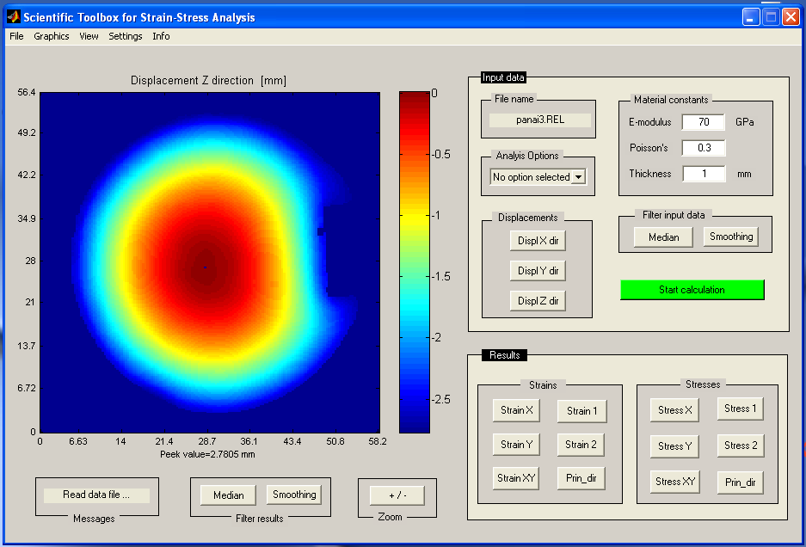

Figure1: MATLAB Graphical User Interface of the Scientific Toolbox for Strain-Stress Analysis

To check the validity of the complex MATLAB calculation algorithm, that is behind this Graphical User Interface, synthetic data were generated according to the problem type. For instance, to check the plate calculation module two out-of-plane deformations data corresponding to a plate clamped and respectively simply supported with uniform load were generated based on analytical plate equations. These kinds of data have the important advantage to be noise free. The results – strains and stresses - obtained with the Scientific Toolbox based on double differentiation of the out-of-plane deformation of plates were compared with those obtained by classical formulas. The errors were under 0.1 % [9]. In a similar manner was verified the algorithm for shear stress computation in case of bars subjected to torsion using the membrane analogy [7]. Verification of the principal direction of strain and stresses was performed by comparison with the Finite Element Method for the same problem.

3. PRACTICAL APPLICATIONS

Two applications were chosen in order to demonstrate how the Scientific Toolbox for Strain-Stress Analysis works. One is related to an ESPI measurement for a compressed ring and the second one to shadow moiré and membrane analogy to get shear stress distribution in a bar subjected to torsion.

3.1 Strain computation of a compressed ring using ESPI

The principle of speckle interferometry (ESPI) uses the ability of laser light for interference. The object to be analyzed is entirely illuminated with laser light, its image being recorded by a CCD camera. The light waves which are reflected by single points on the object’s surface interfere and produce a so called speckle pattern. This speckle pattern is stored using an image acquisition board as reference image. When the object is deformed, the speckle pattern is changing and in comparison with the reference pattern, correlation fringes are produced. These fringes represent the displacement component of the object’s surface in the measuring direction which is defined by the applied measuring technique. There are two different measuring set-ups which permit to determine in plane or out of plane deformation [6].

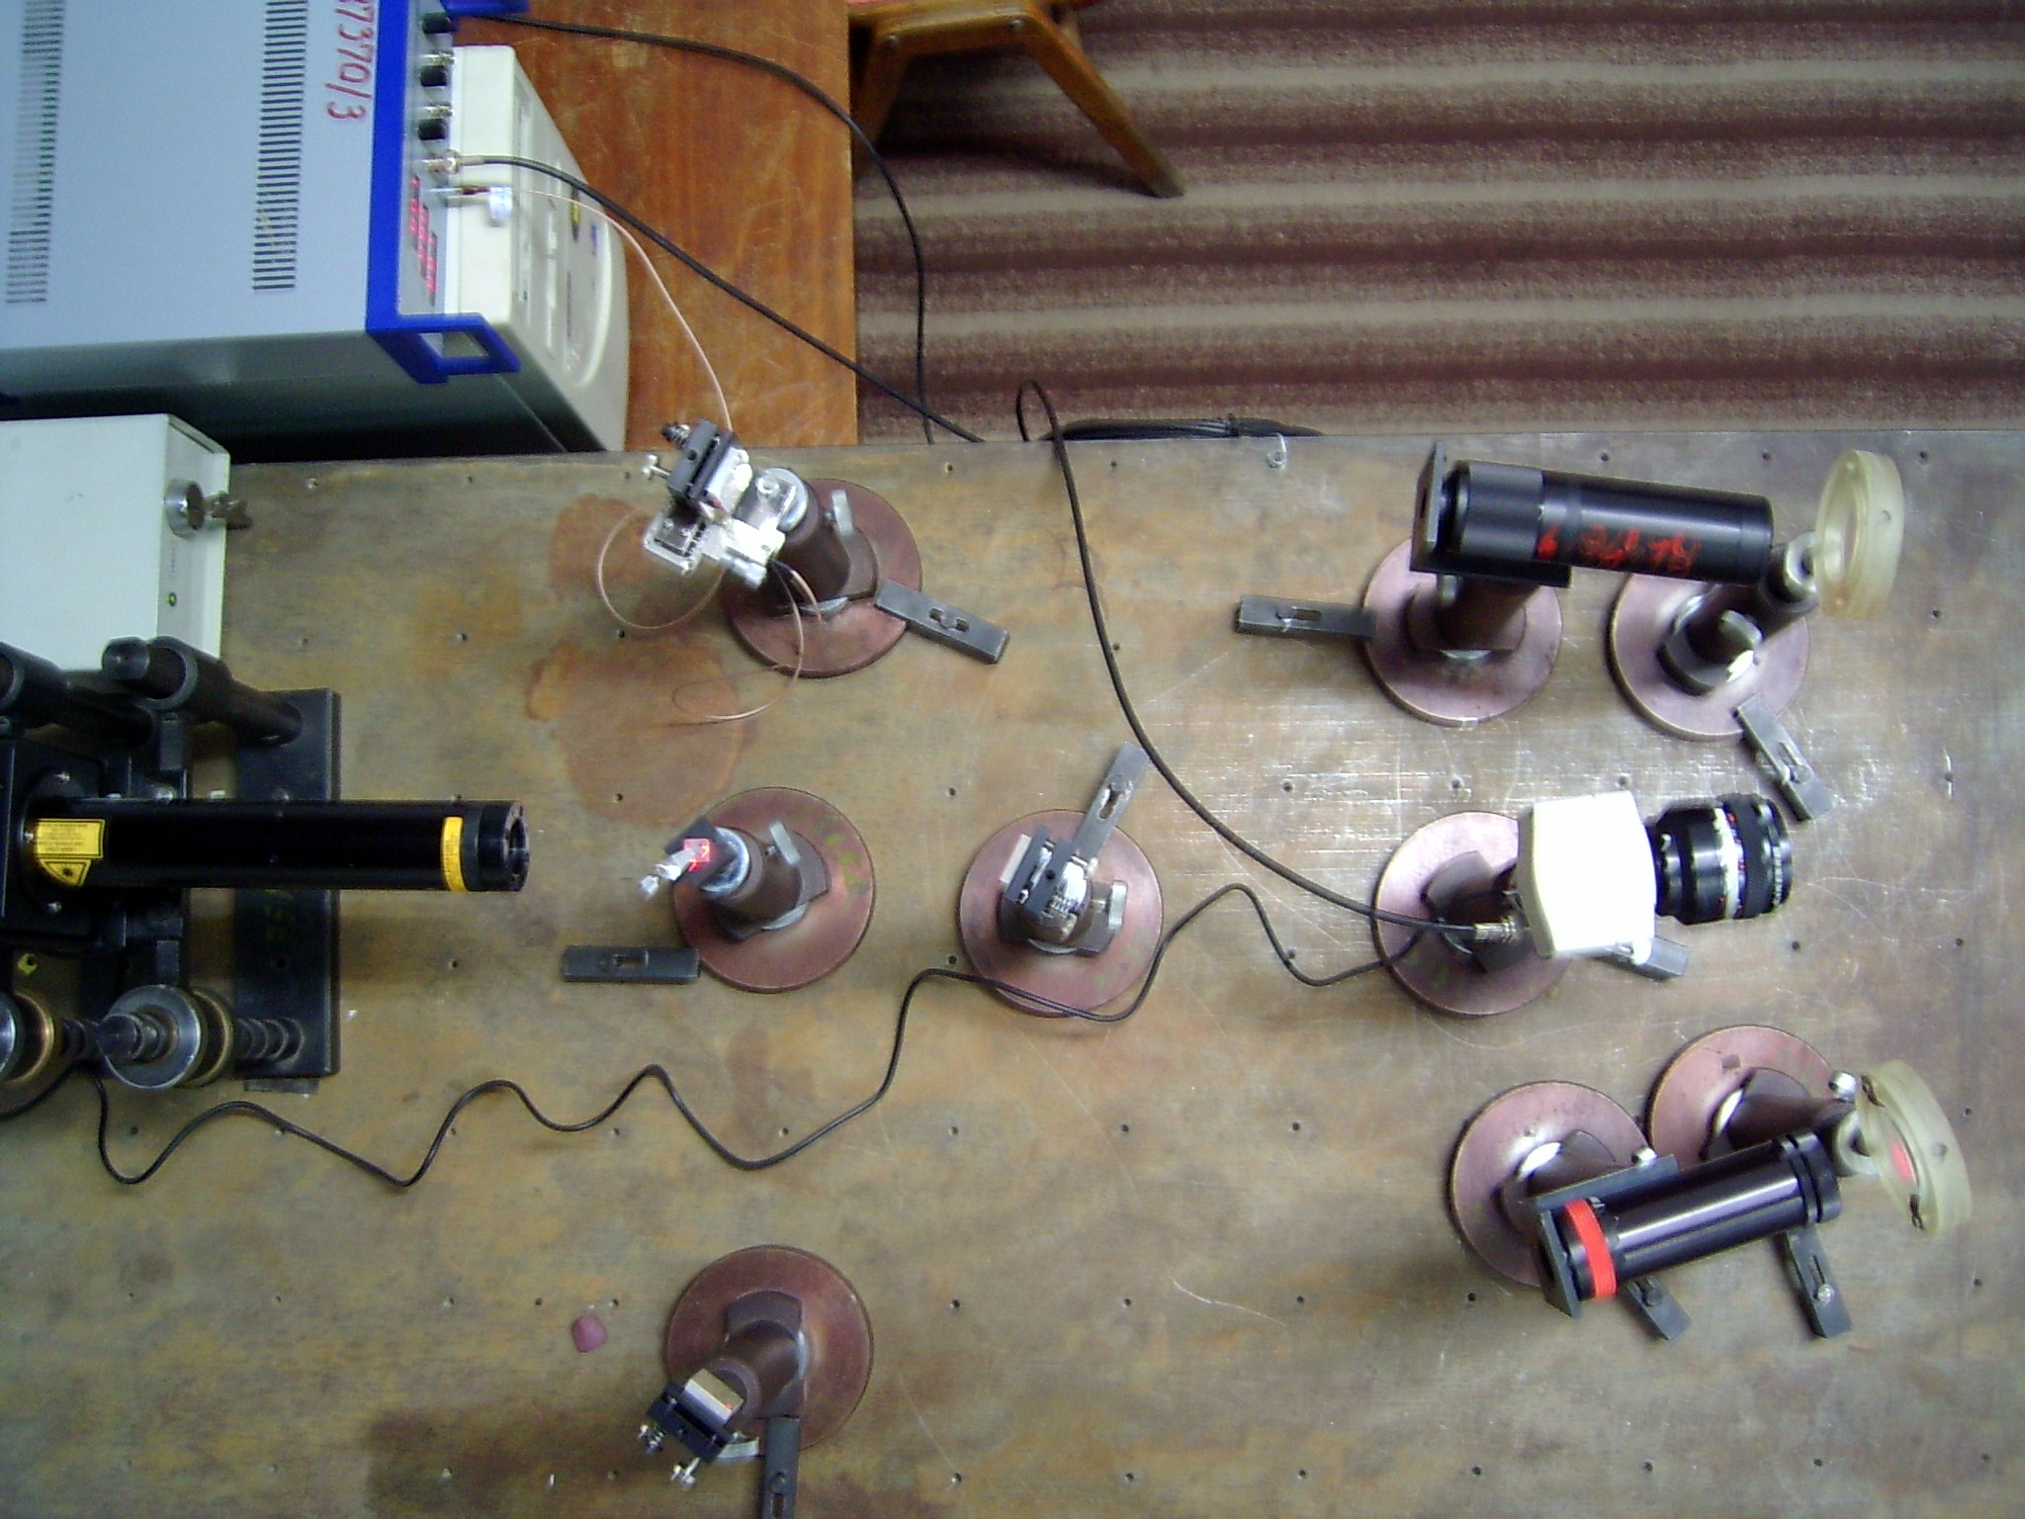
Figure 2: Principle of dual illumination method [2,10] and measuring set-up

For a disc diametric compressed, determination of in-plane displacements can be realized by ESPI using so called dual illumination method [3]. The principle is described in figure 2. Laser light passes a beam splitter and simultaneously illuminates the object with two laser waves directed symmetrically to the observation direction. Therefore, the resulting speckle pattern represents the difference Φ between the two light paths from the laser via object surface to the camera.

a) 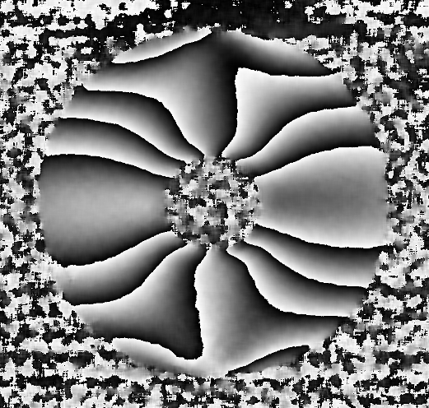 b) 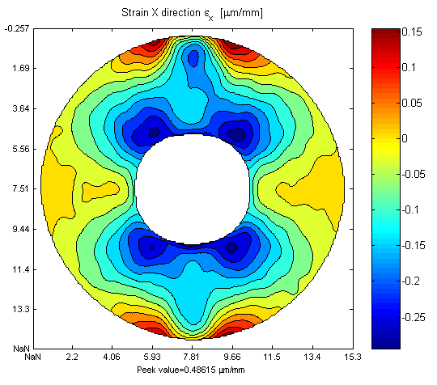

Figure. 3: (a) Phase map of the compressed disc and (b) strain distribution along horizontal axis
computed with the Scientific Toolbox

This speckle pattern is stored as a reference. A change of the two light paths relative to each other by movement of the object produces a new phase relation (Φ+ΔΦ). This creates a new speckle pattern. The difference (ΔΦ) between both patterns is represented by correlation fringes. By counting the number of fringes at every object point, the deformation of the object’s surface in fractions of the laser wavelength is obtained. The measuring direction is orthogonal to the viewing direction in the plane which is produced by the two illumination directions. Full field information can be obtained by phase shifting technique; the result is in a form of a phase map. Figure 3(a) depicted the phase map of the diametric compressed ring, full-field distribution of in-plane displacement ca be obtained by phase unwrapping procedure.
Using MATLAB Scientific Toolbox the value of normal strain along horizontal direction can be computed and display as isolines (Fig. 3(b)). It can be quickly noticed the strain concentration around the hole. In order to analyze simultaneously two orthogonal in-plane directions a complex set-up is needed. The results are in this case in terms of normal and shear strains and stresses and their principal directions.

3.2. Determination of shear stresses in bars subjected to torsion using membrane analogy

Experimental membrane’s deformed shape was reconstructed using shadow moiré by phase shifting method [4] and a complete computerized measurement system. The method has an accuracy of about 0.01 mm that is ten times better than classical shadow moiré method.

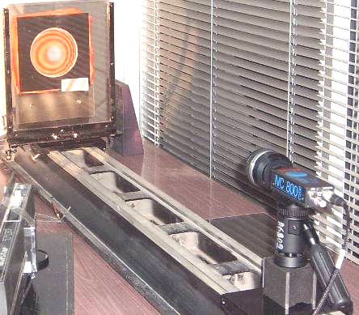

Figure 4: Principle of shadow Moiré by phase shifting method and experimental setup

The method’s principle is presented in figure 4. The dot white light source projects the shadow of a two lines per millimetre grating. This grating is fixed while the object (a thin stretched membrane on a hole having the contour identically with analyzed cross section and subjected to a constant internal pressure) is mounted on a translation moving stage.

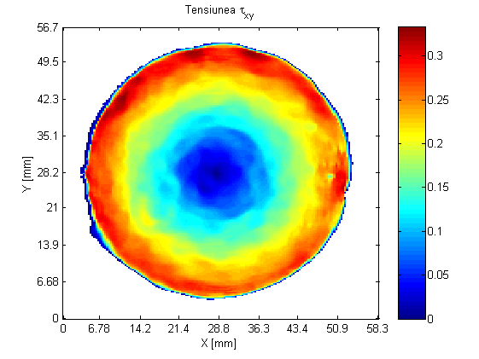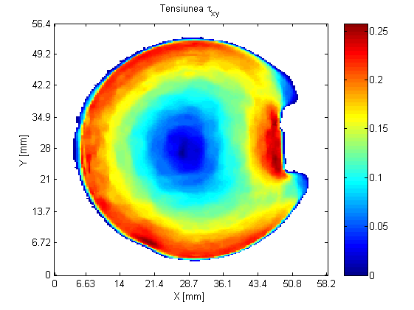

Figure 5: Full-field distribution of shear stress for a circular bar without an with a key slot

The observation of object through the master grating shows a fringe pattern representing the contour lines of the object with respect to the reference plan of the grating. The fringe patterns are recorded by a CCD camera and digitized by a frame grabber. Near the object a witness plate is placed which is needed for accurate phase shifts calculation. Using computer software Ombre v.2.1 [5], membrane surface can be automatically obtained. Based on shape information experimentally determined [7] and using developed MATLAB scientific toolbox, full-field shear stress distribution was computed for a bar subjected to torsion having circular cross-section without and with a key slot.
The results are presented in figure 5 as colour coded images accompanied by a colour bar graded in millimeters similar to a FEM presentation. A horizontal diametric profile (not at scale) obtained using “Profile” function belonging to the scientific toolbox shows the linear variation of the shear stresses, that is in agreement with the theory. The case of a bar having circular cross section and a key slot is very common in practice and a precise theoretical solution to describe the shear stress distribution doesn’t exist. Full-field stress computation using MATLAB Scientific Toolbox reveals the stress distribution in this case and gives the possibility to quickly identify the stress gradients.

4. CONCLUSIONS

Full-field post processing of the experimental data using MATLAB to calculate strain and stress distribution for design and research purposes is an original idea, with immediate practical application and a low cost solution with a high scientific value. Novelty of the concept consists of combination between MATLAB’s facilities to compute, visualize large quantity of data, powerful image processing and full-field displacements information obtained by optical methods of engineering analysis. Utilizing commercial software is also an important argument and a new idea about how to reach scientific excellence using knowledge and original solutions. The Scientific Toolbox results have been tested using simulated (synthetic) input data and have been compared with other theoretical or numerical methods, proven its reliability.
Although based on software development, the work done has a strong practical character realizing a complete computation of strains and stresses components based on experimental deformations measurement. Rapid design decision regarding the safety design and reliability of machine parts nowadays request full-field visualisation of the measurement results in experimental mechanics. Offering an easy identification of the hot spots, in terms of strains or stresses, the MATLAB Scientific Toolbox for Strain and Stress Analysis has an important contribution to state of the art of the processing of measuring results in mechanics of materials.

5. ACKNOWLEDGEMENTS

This research was supported by a Marie Curie European Reintegration Grant (MERG-CT-2004-510256) within the 6th European Community RTD Framework Programme.

6. REFERENCES

[1] Using MATLAB v.6, The MathWorks Inc, 2000.
[2] ISTRA MicroStar v.2.2, User Manual, Ettemeyer AG. Germany, 2000.
[3] Jones, R. and Wykes, C.: Holographic and Speckle Interferometry, Cambridge University Press, Cambridge, England, 1989.
[4] Mauvoisin, G., Brémand, F., Lagarde, A.: Quasi-heterodyne shadow Moiré. Recent advances in experimental mechanics pp. 245-250, 1994.
[5] Dupré, J.C, Valle, V., Brémand, F.: Logiciel Ombre v.2.1, Université de Poitiers, Laboratoire de Mecanique des Solides, France, 1997.
[6] Yang, L., Ettemeyer, A.,: Strain measurement by three-dimensional electronic speckle pattern interferometry: potentials, limitations, and applications, Optical Engineering, SPIE, Vol. 42, No. 5, 2003.
[7] Păstrav, I., Badea, C., Dudescu M.: Study by Shadow-Moiré of the Prismatic Bars Subjected to Torsion, 18th Danubia-Adria Symposium on Experimental Methods in Solid Mechanics, Steyr, Austria, 2001.
[8] Dudescu, M.: Improving of the strain-stress calculation tool for a 3D-ESPI measuring system, Marie-Curie Fellowships European Scientific Workshop, San Sebastian, Spain, 2002.
[9] Dudescu, M.: Processing of the experimental data using MATLAB, 2nd Youth Symposium on Experimental Solid Mechanics, Milano Maritima, Italy, 2003.
[10] Presentation booklets and products literature, Dantec-Ettemeyer GmbH., Germany, (www.dantec-ettemeyer.de) 1998-2004.

