CHARACTERISTICS OF THE SPECIAL BATTERY OF TWO PHASE EJECTORS AND THE POSSIBLE PRACTICAL APPLICATIONS
BULLETIN OF THE TRANSILVANIA UNIVERSITY OF BRAŞOV

O. M. CRACIUIN*

Abstract: In this article are presented four specific characteristics of the special two phase ejectors battery established through measurements on the experimental stand. Altogether, there are many practical applications of such installation present. The present stand realise a good purifying of the air with high dust particles continent. This installation can be used for many domains of applications.

Keywords: two phase ejector, air purifying.

1. Introduction

This work represents the specific characteristics of the special two phase ejectors battery established through measurements on the experimental stand. Altogether, there are many practical applications of such installation present. The present stand realise a good purifying of the air with high dust particles continent.

2. Stand presentation

Figure 1 presents the experimental stand components. The liquid is sucked by a pump 3 from a principal reservoir 1 through an aspiration pipe 2 with a special constructed flow-rate meter 18, connected at a gauge meter bridge 16. On all 8 parallel branches there are placed two-phase ejectors of special construction 7, which assure an intense mixture between the motor fluid (the water) and the atmospheric air, sucked through the pipe 9, producing a pressurized mixture. In the two reservoirs 1 and 10 it takes place the expansion mixture and also the separation between the under-pressure moist air and water.
On the piezometer 14 one can read permanently the existent overpressure in the moist air cushion formed in the main reservoir 1 and on the pressure gauge battery 5, the input water pressure. From the main reservoir 1, the under-pressure moist air is sent through the pipe 13 to diverse users. The sucked atmospheric air parameters entered in the test rig are established on the horizontal rectilinear pipe 9. Other components are: electrical motor 4, valves 6, 21, 24, connection pipe 11, pressure gauge with pipe 15, wattmeter 17, electrical start block 19, atmospheric pipe 20, flexible connection 22, water evacuation pipe 23, general pressure gauge 25.

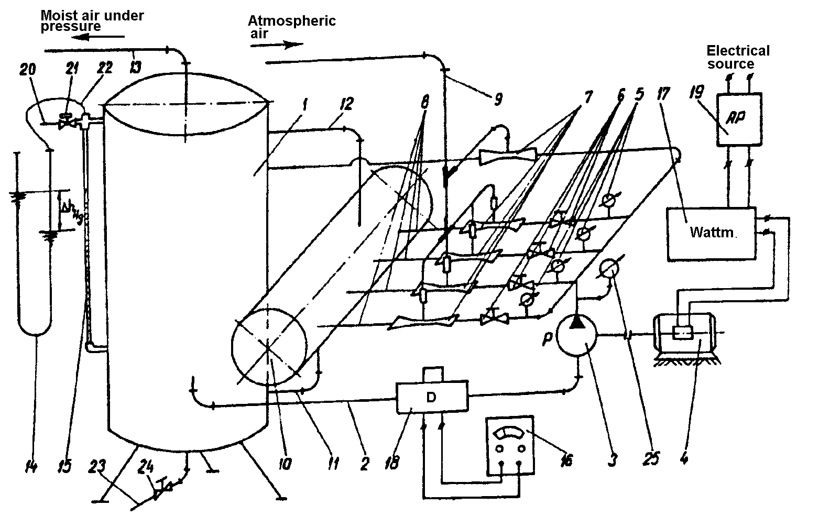

Fig. 1. Experimental set-up
Using the above multifunctional hydro-pneumatic stand, we realised the output pressure control between 1.2 and 8.2 kPa.
For the determination of the average velocity in the suction pipe 9, it was used the method of Reynolds criterion with maximum velocity measured in the pipe axis, using a Thermo-Anemometer, of TESTO 490/491 of velocity type of high precision. We looked for the ratio between the average and maximum velocity. The wet air state was determined using the ASSMAN psychrometer.

3. Experimental results

Based on experimental results, also, it can be plotted three different characteristics of the stand having two phase ejectors. The table 1 presents experimental results.
Table 1
Nr | p [kPa] | Q [m³/s×10⁻³] | N_{a} [W] | $\overset{˙}{m}$ [kg/s×10⁻³]
1 | 1,33416 | 9,62576 | 12,84230 | 10,89184
2 | 1,86782 | 9,39697 | 17,55184 | 1062929
3 | 2,40149 | 9,15182 | 21,97800 | 10,34843
4 | 3,06857 | 8,95571 | 27,48122 | 10,11969
5 | 4,00248 | 8,67789 | 34,73308 | 9,80238
6 | 4,66956 | 8,51447 | 39,75882 | 9,60790
7 | 5,60347 | 8,13858 | 45,60428 | 9,18057
8 | 6,27055 | 7,74705 | 48,57826 | 8,73512
9 | 6,6708 | 7,40317 | 49,38506 | 8,34523
10 | 8,13838 | 4,77202 | 38,83651 | 5,37373

The first characteristic illustrates the mass flow rate function of the air pressure and is presented in figure 2.
Fig. 2. Mass flow rate to the air pressure characteristic
The second characteristic represents the air flow power at the stand output function of the mass flow rate (fig. 3).

Fig. 3. Air flow power function of the mass flow rate
Another interesting characteristic is the air flow power function of the air flow pressure, presented in the figure 4.

Fig. 4. Air flow power function of the air pressure

A such two-phase ejector may exhibit values of the aspiration pipe depression up to 200 mmHg, fact demonstrated experimentally. So this two-phase ejector operates with under pressure in delivery section. Table 2 presents the experimental characteristic of a single two phase ejector.
Table 2.
No. | Volume flow rate  Q [m³/s] | Low pressure  $p_{d}$ [mmHg]
- 1 | 2.8.10⁻³ | 60
- 4 | 3.4.10⁻³ | 80
- 6 | 3.7.10⁻³ | 100
 | 3.9.10⁻³ | 120
 | 4.5.10⁻³ | 140
 | 4.75.10⁻³ | 160
 | 5.3.10⁻³ | 180
 | 8.35.10⁻³ | 200

In order to utilise the ejector to exhaust toxic gases that includes solid particles has plotted this characteristic: low pressure (vacuum) function of the volume flow rate (fig. 5).

Fig. 5. Volume flow rate function of the vacuum

A such installation can be used for many domains of applications:
- the possibility of using the stand for the overcharge engines with moisture air concerning the pollution decrease:
- using the stand in ventilation and in spaces with controlled climate conditions;
- in the chemical industry the high toxic gases can be aspirated in such a stand with immerse evacuation, into a pool for the neutralisation of toxic components;
- the possibility of air humidity control in engines testing spaces;
- in the sugar industry, the two phase ejectors can be successfully used as vacuum pumps;
- at the ventilation by air of the waste industrial waters in order to purifying;
- the air purifying with dust and other solid particles in the foundries.

4. The description of the possible installation for exhaust toxic gas cleaning

An adjustment valve is mounted in the smoke stack of the installation. This valve will direct the gases through a system of pipes to a two-phase ejectors battery, the ejectors being connected in parallel. A pump station furnishers the water utilised as working fluid; the pumps are connected in parallel. The ejectors realize the two-phase mixture (noxious gases and water). The mixture is conveyed to a disperser mounted below the free surface water level, in a separation-sedimentation reservoir (at the deep: 1.5…2 m).
The water, clean as a result of the impurities sedimentation will pass through a separating wall into another compartment of the reservoir. Here, the finer impurities will sediment. And finally, the water arrives, through another separating wall, in the reservoir compartment where there are mounted the aspirations pipes of the pumps.
The main components of the possible experimental installation (fig. 6) are:
  - Pump;
  - Two-phase ejectors mounted in parallel;
  - Scattering element;
  - Adjustment tape;
  - Manometer
  - Toxic gases source;
  - Connection pipes;
  - Impurities separation and sedimentation reservoir neutralization substance in the case of toxic gases;
  - Compartment of the reservoir, containing liquid with very small solid impurities;
  - Aspiration tank containing water without solid impurities;
  - Pipe for gases containing impurities or noxes;
  - Aspiration valve.
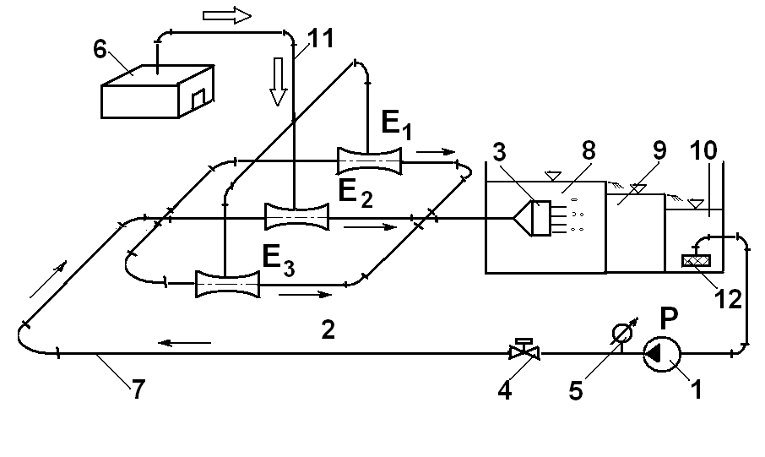
Fig. 6: Scheme of the proposed industrial installation
So, the working fluid travels a closed circuit (the sedimentation of the impurities is made in the compartments 8 and 9 of the reservoir).

5. The calculus procedure for an ejector

The system uses as main element a two-phase ejector (water-air) mounted in the working fluid circuit.
We assume the velocity and the pressure distributions in the measurement sections – for the working (water), mixed (water-air) and aspirated (air) fluids – are uniform.
We shall use the following parameters:
- ${\overset{˙}{m}}_{m}$ - the mass flow-rate of the working fluid;
- ${\overset{˙}{m}}_{\text{am}}$the mass flow-rate of the two-phase mixture (mixed fluid);
- ${\overset{˙}{m}}_{a}$the mass flow-rate of the aspirated fluid
and also, the mixture coefficient:
$u=\frac{{\overset{˙}{m}}_{a}}{{\overset{˙}{m}}_{m}}$. (1)
From the mass-conservation principle, we deduce:
${\overset{˙}{m}}_{\text{am}}={\overset{˙}{m}}_{m}+{\overset{˙}{m}}_{a}$. (2)
One can define the head of the working fluid, $H_{m}$ and that of the mixed fluid, $H_{\text{am}}$ in sections close upstream and downstream of the ejector, respectively:
$\begin{aligned}H_{m}=\frac{p_{m}}{ρ_{m}⋅g}+\frac{v_{m}^{2}}{2g}; \\ H_{\text{am}}=\frac{p_{\text{am}}}{ρ_{\text{am}}⋅g}+\frac{v_{\text{am}}^{2}}{2g},\end{aligned}$ (3)
where: $p_{m}$ is the working fluid static pressure, measured upstream of the ejector; $v_{m}$ - the working fluid velocity, in the measurement section of the mixed fluid static pressure, measured downstream of the ejector; $v_{\text{am}}$ - the mixed fluid velocity, in the measurement section of $p_{\text{am}}$.
But the density of the air is approximately less than that of the water, hence we can put for the correspondent fluid densities:
$ρ_{\text{am}}≃ρ_{m}=ρ$. (4)
In the stations where there are established the heads, one can write the powers:
$\begin{aligned}N_{m}=ρ_{m}{\text{gQ}}_{m}H_{m}=ρ{\text{gQ}}_{m}H_{m}; \\ N_{\text{am}}=ρ_{\text{am}}{\text{gQ}}_{\text{am}}H_{\text{am}}=ρ{\text{gQ}}_{\text{am}}H_{\text{am}}\end{aligned}$, (5)
or:
$\begin{aligned}N_{m}=g⋅{\overset{˙}{m}}_{m}⋅H_{m} \\ N_{\text{am}}=g⋅{\overset{˙}{m}}_{\text{am}}⋅H_{\text{am}}\end{aligned}$. (6)
The efficiency of the ejector is:
$η=\frac{N_{\text{am}}}{N_{m}}=\left(1+u\right)\frac{H_{\text{am}}}{H_{m}}$. (7)

6. Conclusion

We point out several advantages of the proposed system:
- a constant efficiency in service;
- the air exhausted in the atmosphere is not dangerous, for the pollution;
- longs periods in service, without the necessity of draining the sedimentation reservoir;
- a good reliability, because the two-phase ejectors have not moving machine parts;
- the main starting and the initial cost of the investment.

7. References

- Craciun O.M. Ungureanu V.B. The influence of the diesel engine overcharging with moist air delivered by a hidro-pneumatic stand over and other applications. HEFAT2005, 4th International Conference on Heat Transfer, Fluid Mechanics and Thermodynamics, Cairo, Egypt, Paper number: CO1.
- Crăciun O.M. Contribuţii la supraalimentarea motoarelor cu ardere interna. Teză de doctorat, Univ. Transilvania, Braşov, 1999.
- Crăciun O.M., Postelnicu A. Depolluant system with industrial applications. Bulletin of the Transilvania University of Brasov, series A, vol. XXXIV (1992).
- Medar S., Ionescu F. Filtre pentru acţionări hidraulice şi pneumatice. Editura Tehnică, (1986).

Caracteristicile unei baterii speciale de ejectoare bifazice şi posibilele aplicaţii practice

Rezumat: În acest articol sunt prezentate patru caracteristici specifice unei baterii speciale de ejectoare bifazice stabilite pe baza măsurătorilor experimentale pe stand. De asemenea, sunt prezentate mai multe aplicaţii practice ale acestui stand experimental. Standul prezentat realizează o bună purificare a aerului cu un conţinut ridicat de particule de praf. Această instalaţie poate fi utilizată în diverse domenii.

Cuvinte cheie: ejectoare bifazice, purificarea aerului .

* Transilvania University of Brasov, Faculty of Mechanics, Thermo technical Department

