The 40th International Conference on
Mechanics of Solids, Acoustics and Vibrations &
The 6th International Conference on
“Advanced Composite Materials Engineering”
COMAT2016 & ICMSAV2016
Brasov, ROMANIA, 24-25 November 2016

The 40th International Conference on
Mechanics of Solids, Acoustics and Vibrations &
The 6th International Conference on
“Advanced Composite Materials Engineering”
COMAT2016 & ICMSAV2016
Brasov, ROMANIA, 24-25 November 2016

The 40th International Conference on
Mechanics of Solids, Acoustics and Vibrations &
The 6th International Conference on
“Advanced Composite Materials Engineering”
COMAT2016 & ICMSAV2016
Brasov, ROMANIA, 24-25 November 2016

FLEXURAL PROPERTIES OF CELLITE COMPOSITE SANDWICH

Horatiu Teodorescu-Draghicescu¹, Ioan Szava², Maria Luminita Scutaru³, Florin Teodorescu-Draghicescu⁴
¹ Transilvania University of Brasov, Brasov, ROMANIA, e-mail: draghicescu.teodorescu@unitbv.ro
² Transilvania University of Brasov, Brasov, ROMANIA, e-mail: apukam27@gmail.com
³ Transilvania University of Brasov, Brasov, ROMANIA, e-mail: lscutaru@unitbv.ro
⁴ Politehnica University of Bucharest, Bucharest, ROMANIA, e-mail: florin.teodorescu@ltpc.pub.ro

Abstract: Within this paper the flexural properties of a CELLITE composite sandwich have been determined in three-point bend tests using a LR5KPlus Lloyd Instrument materials testing machine and NEXYGEN software. The sandwich consists of a 13.8 mm thick aluminum honeycomb core and two opposite plies of 0.1 mm thick glass fibers-reinforced polymer matrix laminate as skin. Various load-deflection distributions have been carried out until break and five specimens have been subjected to a 50 mm deflection. The most frequent value of deflection at which the sandwich structure exhibits irreversible failure is 10.5 mm. Due to its good flexural and damping properties this kind of structure is suitable for a wide range of applications in which the high ratio between strength and specific weight is an important demand.
Keywords: CELLITE panel, Aluminum honeycomb, Glass fibers-reinforced laminate, Core, Skin

1. INTRODUCTION

The CELLITE sandwich composite structures are lightweight structures having the core made from aluminum honeycomb and the skins manufactured from thermoset resins reinforced with glass fibers fabrics. These structures are used as constructive elements in various industries such as transport, defense, aerospace, shipbuilding, etc. The bond between skins and core is a particularly resistant one due to the use of a special adhesive. An important feature of fiber-reinforced composite structures is the anisotropy, these structures exhibiting different properties in different directions [1], [2]. These properties depend mainly on the fibers volume fraction, on their orientation in composite as well as the interaction between fibers and matrix [3], [4], [5]. Mechanical properties of some advanced polymer matrix composites are presented in papers [6-12]. New materials have been developed to achieve high strength to weight ratios [13-17]. Extended experiments have been carried out to determine the mechanical properties of various composite materials based on thermosetting resins reinforced with various types of fibers and loaded in different ways [18-23]. Some hybrid composite materials have been subjected to different ranges of irradiation to see the radiations influence on the mechanical properties of these kind of composite structures [24-27]. Finally, new experimental techniques using the Video Image Correlation (VIC) method have been carried out to determine bio-mechanical properties of various composite structures [28-29].

2. THE SANDWICH STRUCTURE

The CELLITE sandwich structure presents following disposals of plies:
- One layer of composite laminate based on glass fibers fabric reinforced polymer matrix with 0.1 mm thickness, as skin;
- One aluminum honeycomb core with 13.8 mm thickness;
- One layer of composite laminate based on glass fibers fabric reinforced polymer matrix with 0.1 mm thickness, as skin.
Usually, the CELLITE sandwich structure can be delivered as plates with initial dimensions 2500x1250x14 mm. To perform experimental tests, from a plate with dimensions 1250x380x14 mm specimens have been cut and subjected to three-point-bend tests until break and until a specific deflection.
3. RESULTS OF THREE-POINT BEND TESTS

From the sandwich plate with size 1250x380x14 mm, ten specimens have been cut with following dimensions:
- Specimens’ length: 280 mm;
- Specimens’ width: 30 mm;
- Specimens’ thickness: 14 mm.
The specimens have been subjected to three-point bend tests on an LR5KPlus materials testing machine produced by Lloyd’s Instruments, UK. The three-point bend test features are:
- Test direction: compression;
- Test speed: 10 mm/min;
- Test method: three-point bend;
- Span between supports: 240 mm.
Five of the specimens taken from the sandwich plate and numbered 1 to 5 have been tested until break. Using the Nexygen Plus software, following distributions have been determined: load-deflection, Young’s modulus of bending-stiffness, Young’s modulus of bending-work to maximum deflection, work to maximum load-work to maximum deflection. These distributions are presented in Figs. 1-4. Five of the specimens taken from the sandwich plate and numbered 6 to 10 have been tested to a 50 mm maximum deflection. Using the Nexygen Plus software, following distributions have been determined: load-deflection, Young’s modulus of bending-stiffness, Young’s modulus of bending-work to maximum deflection, work to maximum load-work to maximum deflection. These distributions are presented in Figs. 5-8.
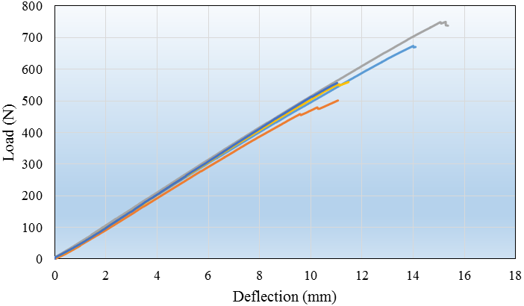
Figure 1: Load-deflection distribution of five Cellite composite sandwich specimens
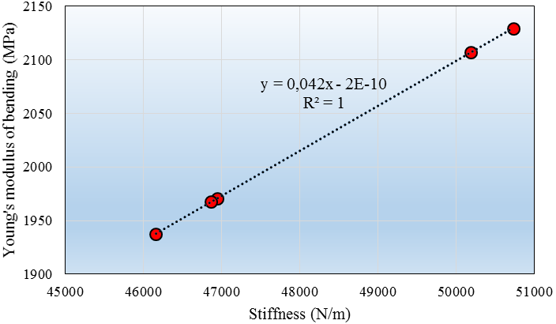
Figure 2: Young’s modulus of bending-stiffness distribution of five Cellite composite sandwich specimens
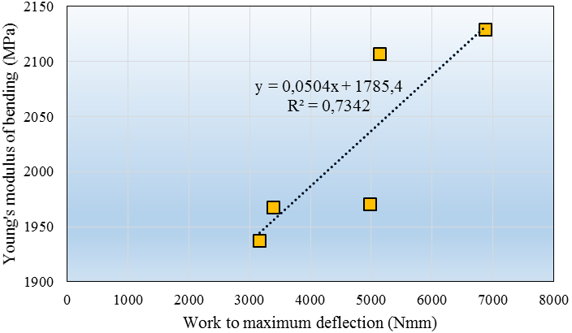
Figure 3: Young’s modulus of bending-work to maximum deflection distribution of five Cellite composite sandwich specimens
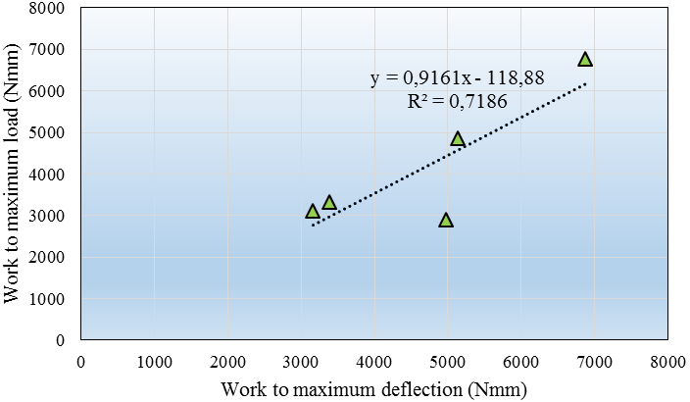
Figure 4: Work to maximum load-work to maximum deflection distribution of five Cellite composite sandwich specimens
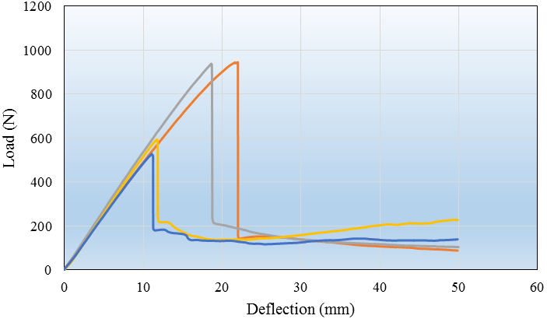
Figure 5: Load-deflection distributions of five Cellite specimens subjected until 50 mm deflection
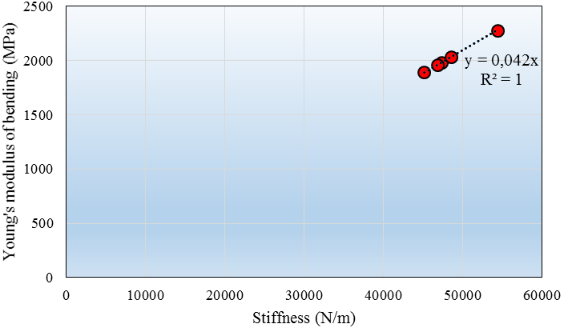
Figure 6: Young’s modulus of bending-stiffness distribution of five specimens subjected until 50 mm deflection
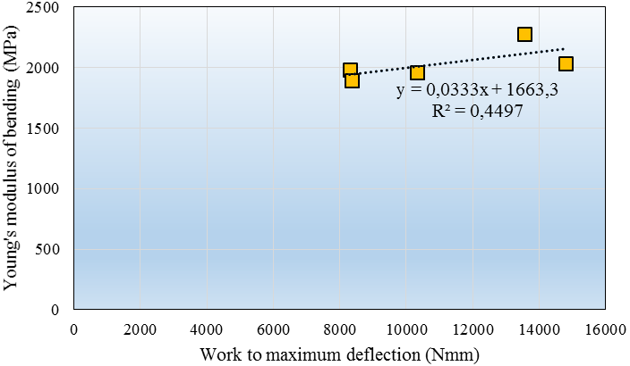
Figure 7: Young’s modulus of bending-work to maximum 50 mm deflection distribution of five specimens
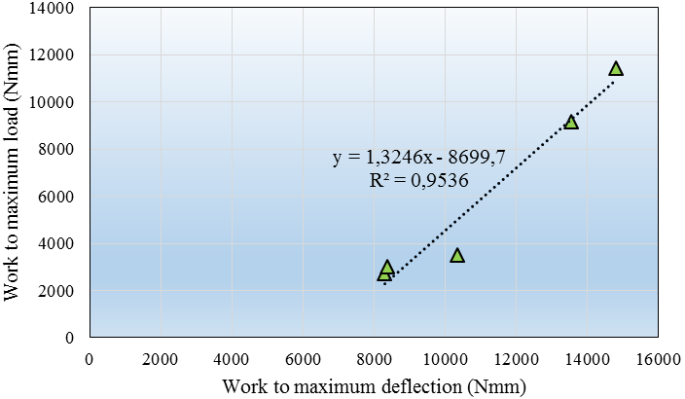
Figure 8: Work to maximum load-work to maximum 50 mm deflection distribution of five Cellite composite sandwich specimens
3. CONCLUSION

It can be seen that the load, until which permanent damage will occur in the sandwich composite structure has been ranged from 500 - 1000 N. Also, the deflection in which irreversible damage to the material structure of sandwich type Cellite occurred, varied from 10.5 to 22 mm. Frequent deformation value at which irreversible damage has occurred was 10.5 mm.

REFERENCES

- Cristescu ND, Craciun EM, Soos E., Mechanics of elastic composites, Chapman & Hall/CRC; 2003.
- Schürmann H., Konstruiren mit Faser-Kunststoff-Verbunden, Springer, 2005.
- Teodorescu-Draghicescu H, Vlase S., Homogenization and Averaging Methods to Predict Elastic Properties of Pre-Impregnated Composite Materials. Computational Materials Science, 50, 4, 2011, p. 1310–1314.
- Teodorescu-Draghicescu H, Vlase S, Scutaru ML, Serbina L, Calin MR., Hysteresis Effect in a Three-Phase Polymer Matrix Composite Subjected to Static Cyclic Loadings. Optoelectronics and Advanced Materials – Rapid Communications (OPTOELECTRON ADV MAT), Vol. 5, No. 3, 2011, p. 273-277.
- Teodorescu-Draghicescu H, Stanciu A, Vlase S, Scutaru ML, Calin MR, Serbina L., Finite Element Method Analysis Of Some Fibre-Reinforced Composite Laminates, Optoelectronics and Advanced Materials – Rapid Communications (OPTOELECTRON ADV MAT), Vol. 5, No. 7, 2011, p. 782-785.
- Stanciu A, Teodorescu-Draghicescu H, Vlase S, Scutaru ML, Calin MR., Mechanical Behavior of CSM450 and RT800 Laminates Subjected to Four-Point Bend Tests, Optoelectronics and Advanced Materials – Rapid Communications (OPTOELECTRON ADV MAT), Vol. 6, No. 3-4, 2012, p. 495-497.
- Modrea A, Vlase S, Teodorescu-Draghicescu H, Calin MR, Astalos C., Properties of advanced new materials used in automotive engineering. Optoelectronics and Advanced Materials – Rapid Communications (OAM-RC), Vol. 7, No. 5-6, 2013, p. 452–455.
- Heitz T, Teodorescu-Draghicescu H, Lache S, Chiru A, Calin MR., Advanced T700/XB3585 UD carbon fibers-reinforced composite, Journal of Optoelectronics and Advanced Materials (J OPTOELECTRON ADV M), Vol. 16, No. 5-6, 2014, p. 568-573.
- Teodorescu-Draghicescu H, Vlase S, Stanciu MD, Curtu I, Mihalcica M., Advanced Pultruded Glass Fibers-Reinforced Isophtalic Polyester Resin, Materiale Plastice (MATER PLAST), Vol. 52, No. 1, 2015, p. 62-64.
- Scutaru ML, Teodorescu-Draghicescu H, Vlase S, Marin M., Advanced HDPE with increased stiffness used for water supply networks, Journal of Optoelectronics and Advanced Materials (J OPTOELECTRON ADV M), Vol. 17, No. 3-4, 2015, p. 484-488.
- Niculita C, Vlase S, Bencze A, Mihalcica M, Calin MR, Serbina L., Optimum stacking in a multi-ply laminate used for the skin of adaptive wings. Optoelectronics and Advanced Materials – Rapid Communications (OAM-RC), 5, 11, 2011.
- Teodorescu-Draghicescu H, Scutaru ML, Rosu D, Calin MR, Grigore P., New Advanced Sandwich Composite with twill weave carbon and EPS. Journal of Optoelectronics and Advanced Materials (JOAM), Vol. 15, No.3-4, 2013, p.199–203.
- Teodorescu-Draghicescu H, Vlase S, Chiru A, Purcarea R, Munteanu V., Theoretical and Experimental Approaches Regarding the Stiffness Increase of Fibre-Reinforced Composite Structures. Proc. of the 1st Int. Conf. on Manufacturing Engineering, Quality and Production Systems (MEQAPS’09), Transilvania University of Brasov, Romania, WSEAS Press, 2009, p. 449–452.
- Vlase S, Teodorescu-Draghicescu H, Motoc DL, Scutaru ML, Serbina L, Calin MR., Behavior of Multiphase Fiber-Reinforced Polymers Under Short Time Cyclic Loading. Optoelectronics and Advanced Materials – Rapid Communications (OAM-RC), 5, 4, 2011.
- Vlase S, Purcarea R, Teodorescu-Draghicescu H, Calin MR, Szava I, Mihalcica M., Behavior of a new Heliopol/Stratimat300 composite laminate. Optoelectronics and Advanced Materials – Rapid Communications (OAM-RC), Vol.7, No.7-8, 2013, p. 569–572.
- Teodorescu-Draghicescu H, Vlase S, Goia I, Scutaru ML, Stanciu A, Vasii M., Tensile Behaviour of Composite Specimens Made From Chopped Strand Mat Reinforced Polyester Resin. 24th Danubia – Adria Symposium on Developments in Experimental Mechanics, 19-22 September, 2007, Sibiu, Editura Universităţii Lucian Blaga Sibiu, p. 255–256.
- Vlase S, Teodorescu-Draghicescu H, Calin MR, Serbina L., Simulation of the Elastic Properties of Some Fibre-Reinforced Composite Laminates Under Off-Axis Loading System. Optoelectronics and Advanced Materials – Rapid Communications, 5 (3–4), 2011, p. 424–429.
- Naughton BP, Panhuizen F, Vermeulen VC., The Elastic Properties of Chopped Strand Mat and Woven Roving in G.R. Laminae. Journal of Reinforced Plastics and Composites, 4 (2), 1985, p. 195–204.
- Teodorescu-Draghicescu H, Vlase S, Chiru A, Purcarea R, Munteanu V., Theoretical and Experimental Approaches Regarding the Stiffness Increase of Fibre-Reinforced Composite Structures. Proc. of the 1st Int. Conf. on Manufacturing Engineering, Quality and Production Systems (MEQAPS’09), Transilvania University of Brasov, Romania, WSEAS Press, 2009, p. 449–452.
- Purcarea R, Motoc DL, Scutaru ML., Mechanical behavior of a thin nonwoven polyester mat subjected to three-point bend tests, Optoelectronics and Advanced Materials – Rapid Communications, Vol. 6, No. 1-2, 2012, p. 214 – 217.
- Vlase S, Teodorescu-Draghicescu H, Calin MR, et al., Advanced Polylite composite laminate material behavior to tensile stress on weft direction. Journal of Optoelectronics and Advanced Materials (JOAM), Vol. 14, No. 7-8, 2012, p. 658–663.
- Modrea A, Vlase S, Calin MR, et al., The influence of dimensional and structural shifts of the elastic constant values in cylinder fiber composites. Journal of Optoelectronics and Advanced Materials (JOAM), Vol. 15, No. 3-4, 2013, p. 278–283.
- Niculita C, Gabor A, Gheorghe V, Calin MR, Scutaru ML., A new epoxy glass roving fabric material with a nonwoven PES fibers structure used in a composite laminates, Journal of Optoelectronics and Advanced Materials (JOAM), Vol. 15, No. 3-4, 2013, p. 176-181.
- Scutaru ML, Baritz M, Galfi BP., Radiation influence on micro-structural mechanics of an advanced hemp carbon hybrid composite, Optoelectronics and Advanced Materials – Rapid Communications (OAM-RC), Vol. 8, No. 11-12, 2014, p. 1145-1149.
- Scutaru ML., Toward the use of irradiation for the composite materials properties improvement, Journal of Optoelectronics and Advanced Materials (JOAM), Vol. 16, No. 9-10, 2014, p. 1165-1169.
- Scutaru ML, Baba M, Baritz MI., Irradiation influence on a new hybrid hemp bio-composite, Journal of Optoelectronics and Advanced Materials (JOAM), Vol. 16, No. 7-8, 2014, p. 887-891.
- Scutaru ML, Baba M., Investigation of the Mechanical Properties of Hybrid Carbon-Hemp Laminated Composites Used as Thermal Insulation for Different Industrial Applications, Advances in Mechanical Engineering, Article Number: 829426, 2014.
- Gálfi B, Száva I, Borbás L, Szalai J, Harangus K., Stand and preliminary testing results on disc-shape hardwood specimens obtained with video image correlation method, 9th YSESM, Trieste, Italy, 2010, p. 9-12.
- Szava I, Necula RD, Galfi B, Szava D, Samota I., New methods in bio-mechanical experimental investigations, Proceedings of the 50th Annual Conference on Experimental Stress Analysis, 2012, p. 449-456.

