The 40th International Conference on
Mechanics of Solids, Acoustics and Vibrations &
The 6th International Conference on
“Advanced Composite Materials Engineering”
COMAT2016 & ICMSAV2016
Brasov, ROMANIA, 24-25 November 2016

The 40th International Conference on
Mechanics of Solids, Acoustics and Vibrations &
The 6th International Conference on
“Advanced Composite Materials Engineering”
COMAT2016 & ICMSAV2016
Brasov, ROMANIA, 24-25 November 2016

The 40th International Conference on
Mechanics of Solids, Acoustics and Vibrations &
The 6th International Conference on
“Advanced Composite Materials Engineering”
COMAT2016 & ICMSAV2016
Brasov, ROMANIA, 24-25 November 2016

HYSTERESIS OF CSM600/Al₂O₃ COMPOSITE SUBJECTED TO STATIC TENSION-COMPRESSION LOADINGS

Horatiu Teodorescu-Draghicescu¹, Sorin Vlase², Florin Teodorescu-Draghicescu³
¹ Transilvania University of Brasov, Brasov, ROMANIA, e-mail: draghicescu.teodorescu@unitbv.ro
² Transilvania University of Brasov, Brasov, ROMANIA, e-mail: svlase@unitbv.ro
³ Politehnica University of Bucharest, Bucharest, ROMANIA, e-mail: florin.teodorescu@ltpc.pub.ro

Abstract: Experimental researches regarding hysteresis behaviors of three-phase polymer matrix composite material (Chopped Strand Mat 600-Al₂O₃ ceramic particles-reinforced polyester resin) subjected to static cyclic tension-compression loadings have been carried out on a Lloyd Instruments LS100Plus materials testing machine using a STGA/50/50 E85454 extensometer and NEXYGEN software. Various static cyclic tension-compression tests with different test speeds, load limits and number of cycles have been carried out. Maximum hysteresis values (computed as the difference between the first and the last cycle extension) as well as stiffness distributions of specimens that exhibit maximum hysteresis have been determined. Maximum hysteresis effect has been reported to be at 10 mm/min test speed with a decreasing tendency once the test speed is increased.
Keywords: Chopped Strand Mat 600, Al₂O₃ ceramic particles, Hysteresis effect, Static cyclic loadings, Polymer matrix

1. INTRODUCTION

Cyclically tension-compression tests performed both in static as well as in dynamic ways are for a great importance to put into evidence structural changes inside a material taking into consideration the influence of time. One of the most important problem in a static cyclic tension-compression test of any composite material and especially in thin composite structures and polymer matrix composite laminates is how to grip the specimen without introducing supplementary stress concentrations in its structure [1-10]. For example, the grips are clamped into the specimen ends, transferring the applied static cyclic tension-compression loads at the specimen’s surface into tensile-compression stresses within the specimen and therefore the clamping forces are significant [11-15]. To avoid high clamping forces it is necessary to manufacture specimens as thin as practically possible or to ensure longer grip lengths so that the clamping forces can be transferred over a larger area [16-29]. Setiadi et al., have been accomplished tensile and fatigue tests on both polyester and polyurethane-based fiber-reinforced polymer matrix composites as well as studies concerning the damage development in randomly disposed E-glass fiber-reinforced polymers under fatigue loadings up to 105 cycles [30]. To estimate the failure and cyclic life, Tan and Dharan have determined cyclic hysteresis experimental data, for instance, on notched [0/90] E-glass/epoxy laminates [31]. In general, a randomly disposed chopped strand mat presents 25.4 mm or 50 mm glass fibers lengths. This type of reinforcement is manufactured from E-glass continuous fibers, bound with powder binder, compatible with synthetic resins and used in a wide range of applications. It is usually used for the hand lay-up technique and for parts that do not require high strength.

2. MATERIALS AND EXPERIMENTAL PROCEDURE

The composite material used in static cyclic tension-compression loadings is a three-phase one based on following compounds:
- Chopped strand mat CSM 600 (up to 60% E-glass fibers volume fraction);
- Al2O3 ceramic particles (up to 10% volume fraction);
- Polyester resin.
A 5 mm thick composite plate has been manufactured from which specimens (dimensions: 5 x 15 x 150 mm) have been cut. The composite specimens have been subjected to different static tension-compression cyclic loadings at various test speeds and cycle limits on a Lloyd Instruments LS100Plus (up to 100 kN force range) materials testing machine with a STGA/50/50 E85454 extensometer (Epsilon Technology Corp.). All experimental data have been processed using the Nexygen Plus materials testing software. Specimens and tests features are presented in Table 1.

Table 1: Test speeds, cycle limits, number of cycles and specimens features used in cyclic tests
Gauge length [mm] | 50 | 50 | 50 | 50 | 50 | 50
Test speed [mm/min] | 1 | 10 | 20 | 40 | 60 | 60
Specimens’ width [mm] | 15 | 15 | 15 | 15 | 15 | 15
Specimens’ thickness [mm] | 4.86 | 4.86 | 4.86 | 4.86 | 4.86 | 4.86
Cycle limit 1 [kN] | 3 | 3 | 3 | 3 | 3.5 | 3.5
Cycle limit 2 [kN] | 0.3 | 0.3 | 0.3 | -2 | -3.5 | -3.5
Number of cycles | 10 | 10 | 10 | 10 | 10 | 100

3. EXPERIMENTAL RESULTS AND CONCLUSIONS

Following mechanical properties have been determined: stiffness, Young’s modulus, load at maximum load, stress at maximum load, machine extension at maximum load, extension at maximum load, strain at maximum load, percentage strain at maximum load, work to maximum load, load at maximum extension, stress at maximum extension, machine extension at maximum extension, extension at maximum extension, strain at maximum extension, percentage strain at maximum extension, work to maximum extension, load at minimum load, stress at minimum load, machine extension at minimum load, extension at minimum load, strain at minimum load, percentage strain at minimum load, work to minimum load, load at minimum extension, stress at minimum extension, machine extension at minimum extension, extension at minimum extension, strain at minimum extension, percentage strain at minimum extension, work to minimum extension, load at first cycle, stress at first cycle, machine extension at first cycle, extension at first cycle, strain at first cycle, percentage strain at first cycle, first cycle work, load at last cycle, stress at last cycle, machine extension at last cycle, extension at last cycle, strain at last cycle, percentage strain at last cycle, last cycle work, load at break, stress at break, machine extension at break, extension at break, strain at break, percentage strain at break and work to break. Distributions of tension-compression cycles determined on specimens that exhibit maximum hysteresis, at various test speeds and cycle limits are presented in Figs. 1–5. Maximum hysteresis at different test speeds and cycle limits are presented in Fig. 6. The maximum hysteresis values have been determined as a difference between maximum extension at first cycle and maximum extension at last cycle.

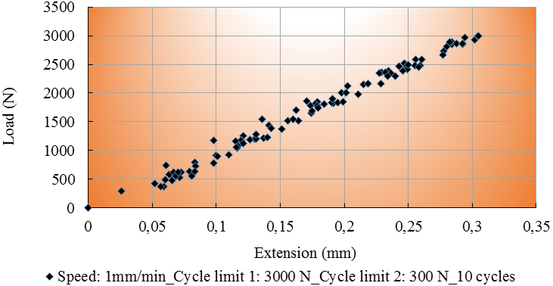
Figure 1: Static tension-compression loadings. Maximum hysteresis specimen of CSM600/AL₂O₃ composite
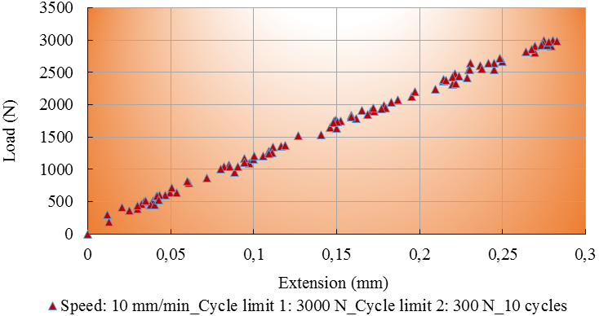
Figure 2: Tension-compression loadings (10 mm/min test speed, 10 cycles). Maximum hysteresis specimen

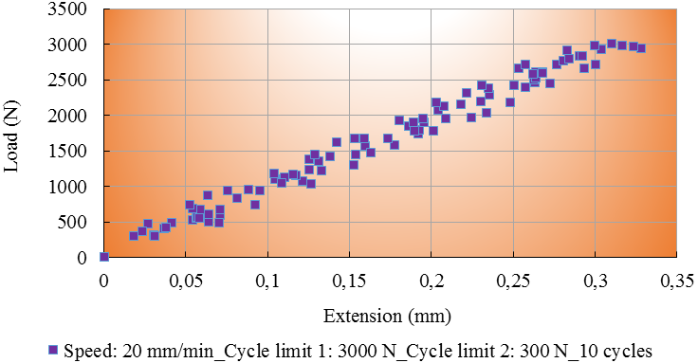
Figure 3: Tension-compression loadings (20 mm/min test speed, 10 cycles). Maximum hysteresis specimen

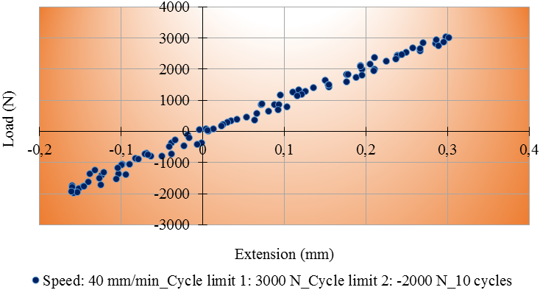
Figure 4: Tension-compression loadings (40 mm/min test speed, 10 cycles). Maximum hysteresis specimen
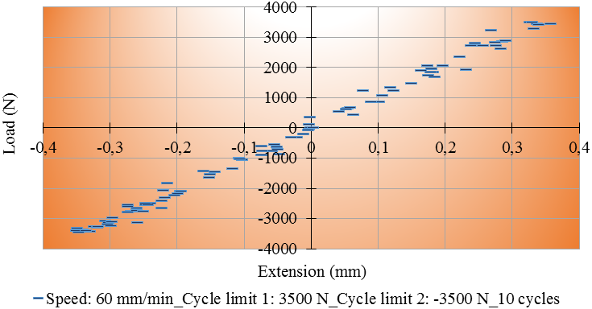
Figure 5: Tension-compression loadings (60 mm/min test speed, 10 cycles). Maximum hysteresis specimen

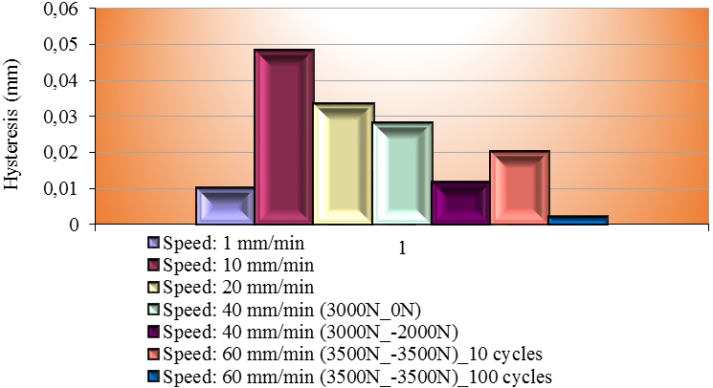
Figure 6: Maximum hysteresis at different test speeds and cycle limits

At 1 mm/min test speed the composite material presents a 0.29 mm extension at maximum load while at 10 mm/min test speed, the extension at maximum load exhibits 0.28 mm. The decreasing tendency maintains until 40 mm/min test speed when the extension at maximum load presents the median value of 0.26 mm. With the test speed of 60 mm/min, this extension at maximum load increases quickly at a median value of 0.31 mm. Unlike the decreasing tendency of this extension, the load at maximum load presents an increasing tendency once the test speed is increased (from 3.005 kN median value at 1 mm/min test speed to 3.542 kN median value at 60 mm/min test speed). The stiffness of the composite material presents an increased tendency with the increase of test speed. This increase is up to 10 times at 60 mm/min test speed. Between 300 N and 3000 N cycle limits, the load at first cycle presents an increased distribution from a median value of 0.308 kN at 1 mm/min test speed to 0.33 kN at 20 mm/min test speed. The extension at last cycle distribution presents a decreased tendency while the load at last cycle presents an increasing tendency.
It can be noticed that with the test speed increase, non-linear behavior at unloading phase is more significant. Maximum hysteresis value has been determined at 10 mm/min test speed with a decreasing tendency once the test speed increases. Maximum stiffness has been determined at 60 mm/min tests speed, the general tendency is the increase of this stiffness. With the increase of cycle limits, the maximum hysteresis presents a decreasing tendency while the stiffness distribution increases. The same specimens have been subjected to increased loading conditions; this means increased cycle limits, test speeds and number of cycles. The break detector reported breaking of the composite material after 115 static cyclic tension-compression loadings. All the experimental data have been processed statistically. For instance, some statistics for maximum hysteresis results are presented below:
- Stiffness coefficient of variance: 74.19%;
- Young’s modulus coefficient of variance: 72.14%;
- Load at maximum load coefficient of variance: 0.06%;
- Extension at maximum load coefficient of variance: 15.09%;
- Work to maximum load coefficient of variance: 18.61%;
- Load at maximum extension coefficient of variance: 0.29%;
- Extension at maximum extension coefficient of variance: 7.87%;
- Work to maximum extension coefficient of variance: 16.16%;
- Load at first cycle coefficient of variance: 2.47%;
- Extension at first cycle coefficient of variance: 36.72%;
- Load at last cycle coefficient of variance: 2.37%;
- Extension at last cycle coefficient of variance: 126.82%.

REFERENCES

- Cristescu ND, Craciun EM, Soos E., Mechanics of elastic composites, Chapman & Hall/CRC; 2003.
- Schürmann H., Konstruiren mit Faser-Kunststoff-Verbunden, Springer, 2005.
- Teodorescu-Draghicescu H, Vlase S., Homogenization and Averaging Methods to Predict Elastic Properties of Pre-Impregnated Composite Materials. Computational Materials Science, 50, 4, 2011, p. 1310–1314.
- Teodorescu-Draghicescu H, Vlase S, Scutaru ML, Serbina L, Calin MR., Hysteresis Effect in a Three-Phase Polymer Matrix Composite Subjected to Static Cyclic Loadings. Optoelectronics and Advanced Materials – Rapid Communications (OPTOELECTRON ADV MAT), Vol. 5, No. 3, 2011, p. 273-277.
- Teodorescu-Draghicescu H, Stanciu A, Vlase S, Scutaru ML, Calin MR, Serbina L., Finite Element Method Analysis Of Some Fibre-Reinforced Composite Laminates, Optoelectronics and Advanced Materials – Rapid Communications (OPTOELECTRON ADV MAT), Vol. 5, No. 7, 2011, p. 782-785.
- Stanciu A, Teodorescu-Draghicescu H, Vlase S, Scutaru ML, Calin MR., Mechanical Behavior of CSM450 and RT800 Laminates Subjected to Four-Point Bend Tests, Optoelectronics and Advanced Materials – Rapid Communications (OPTOELECTRON ADV MAT), Vol. 6, No. 3-4, 2012, p. 495-497.
- Modrea A, Vlase S, Teodorescu-Draghicescu H, Calin MR, Astalos C., Properties of advanced new materials used in automotive engineering. Optoelectronics and Advanced Materials – Rapid Communications (OAM-RC), Vol. 7, No. 5-6, 2013, p. 452–455.
- Heitz T, Teodorescu-Draghicescu H, Lache S, Chiru A, Calin MR., Advanced T700/XB3585 UD carbon fibers-reinforced composite, Journal of Optoelectronics and Advanced Materials (J OPTOELECTRON ADV M), Vol. 16, No. 5-6, 2014, p. 568-573.
- Teodorescu-Draghicescu H, Vlase S, Stanciu MD, Curtu I, Mihalcica M., Advanced Pultruded Glass Fibers-Reinforced Isophtalic Polyester Resin, Materiale Plastice (MATER PLAST), Vol. 52, No. 1, 2015, p. 62-64.
- Scutaru ML, Teodorescu-Draghicescu H, Vlase S, Marin M., Advanced HDPE with increased stiffness used for water supply networks, Journal of Optoelectronics and Advanced Materials (J OPTOELECTRON ADV M), Vol. 17, No. 3-4, 2015, p. 484-488.
- Niculita C, Vlase S, Bencze A, Mihalcica M, Calin MR, Serbina L., Optimum stacking in a multi-ply laminate used for the skin of adaptive wings. Optoelectronics and Advanced Materials – Rapid Communications (OAM-RC), 5, 11, 2011.
- Teodorescu-Draghicescu H, Scutaru ML, Rosu D, Calin MR, Grigore P., New Advanced Sandwich Composite with twill weave carbon and EPS. Journal of Optoelectronics and Advanced Materials (JOAM), Vol. 15, No.3-4, 2013, p.199–203.
- Teodorescu-Draghicescu H, Vlase S, Chiru A, Purcarea R, Munteanu V., Theoretical and Experimental Approaches Regarding the Stiffness Increase of Fibre-Reinforced Composite Structures. Proc. of the 1st Int. Conf. on Manufacturing Engineering, Quality and Production Systems (MEQAPS’09), Transilvania University of Brasov, Romania, WSEAS Press, 2009, p. 449–452.
- Vlase S, Teodorescu-Draghicescu H, Motoc DL, Scutaru ML, Serbina L, Calin MR., Behavior of Multiphase Fiber-Reinforced Polymers Under Short Time Cyclic Loading. Optoelectronics and Advanced Materials – Rapid Communications (OAM-RC), 5, 4, 2011.
- Vlase S, Purcarea R, Teodorescu-Draghicescu H, Calin MR, Szava I, Mihalcica M., Behavior of a new Heliopol/Stratimat300 composite laminate. Optoelectronics and Advanced Materials – Rapid Communications (OAM-RC), Vol.7, No.7-8, 2013, p. 569–572.
- Teodorescu-Draghicescu H, Vlase S, Goia I, Scutaru ML, Stanciu A, Vasii M., Tensile Behaviour of Composite Specimens Made From Chopped Strand Mat Reinforced Polyester Resin. 24th Danubia – Adria Symposium on Developments in Experimental Mechanics, 19-22 September, 2007, Sibiu, Editura Universităţii Lucian Blaga Sibiu, p. 255–256.
- Vlase S, Teodorescu-Draghicescu H, Calin MR, Serbina L., Simulation of the Elastic Properties of Some Fibre-Reinforced Composite Laminates Under Off-Axis Loading System. Optoelectronics and Advanced Materials – Rapid Communications, 5 (3–4), 2011, p. 424–429.
- Naughton BP, Panhuizen F, Vermeulen VC., The Elastic Properties of Chopped Strand Mat and Woven Roving in G.R. Laminae. Journal of Reinforced Plastics and Composites, 4 (2), 1985, p. 195–204.
- Teodorescu-Draghicescu H, Vlase S, Chiru A, Purcarea R, Munteanu V., Theoretical and Experimental Approaches Regarding the Stiffness Increase of Fibre-Reinforced Composite Structures. Proc. of the 1st Int. Conf. on Manufacturing Engineering, Quality and Production Systems (MEQAPS’09), Transilvania University of Brasov, Romania, WSEAS Press, 2009, p. 449–452.
- Purcarea R, Motoc DL, Scutaru ML., Mechanical behavior of a thin nonwoven polyester mat subjected to three-point bend tests, Optoelectronics and Advanced Materials – Rapid Communications, Vol. 6, No. 1-2, 2012, p. 214 – 217.
- Vlase S, Teodorescu-Draghicescu H, Calin MR, et al., Advanced Polylite composite laminate material behavior to tensile stress on weft direction. Journal of Optoelectronics and Advanced Materials (JOAM), Vol. 14, No. 7-8, 2012, p. 658–663.
- Modrea A, Vlase S, Calin MR, et al., The influence of dimensional and structural shifts of the elastic constant values in cylinder fiber composites. Journal of Optoelectronics and Advanced Materials (JOAM), Vol. 15, No. 3-4, 2013, p. 278–283.
- Niculita C, Gabor A, Gheorghe V, Calin MR, Scutaru ML., A new epoxy glass roving fabric material with a nonwoven PES fibers structure used in a composite laminates, Journal of Optoelectronics and Advanced Materials (JOAM), Vol. 15, No. 3-4, 2013, p. 176-181.
- Scutaru ML, Baritz M, Galfi BP., Radiation influence on micro-structural mechanics of an advanced hemp carbon hybrid composite, Optoelectronics and Advanced Materials – Rapid Communications (OAM-RC), Vol. 8, No. 11-12, 2014, p. 1145-1149.
- Scutaru ML., Toward the use of irradiation for the composite materials properties improvement, Journal of Optoelectronics and Advanced Materials (JOAM), Vol. 16, No. 9-10, 2014, p. 1165-1169.
- Scutaru ML, Baba M, Baritz MI., Irradiation influence on a new hybrid hemp bio-composite, Journal of Optoelectronics and Advanced Materials (JOAM), Vol. 16, No. 7-8, 2014, p. 887-891.
- Scutaru ML, Baba M., Investigation of the Mechanical Properties of Hybrid Carbon-Hemp Laminated Composites Used as Thermal Insulation for Different Industrial Applications, Advances in Mechanical Engineering, Article Number: 829426, 2014.
- Gálfi B, Száva I, Borbás L, Szalai J, Harangus K., Stand and preliminary testing results on disc-shape hardwood specimens obtained with video image correlation method, 9th YSESM, Trieste, Italy, 2010, p. 9-12.
- Szava I, Necula RD, Galfi B, Szava D, Samota I., New methods in bio-mechanical experimental investigations, Proceedings of the 50th Annual Conference on Experimental Stress Analysis, 2012, p. 449-456.
- Setiadi Y, Jar P-YB, Kuboki T, Cheng J-JR., Comparison of Damage Development in Random Fiber-Reinforced Polymers (FRPs) under Cyclic Loading, J. of Comp. Mat., Vol. 40, No. 1, 2006.
- Tan TF, Dharan CKH., Cyclic Hysteresis Evolution as a Damage Parameter for Notched Composite Laminates, J. of Comp. Mat., Vol. 44, No. 16, 2010.

