The 2nd International Conference
″Computational Mechanics
and
Virtual Engineering″
COMEC 2007
11 – 13 OCTOBER 2007, Brasov, Romania

STUDIES CONCERNING A NEW MOUNTING SYSTEM OF THE ARBOR-TYPE MILLING CUTTER ON THE WORKING SHAFT OF A SPINDLE MOULDER

Prof.Dr. Mihai iSPAS¹
¹ “Transilvania” University, Faculty of Wood Industry, Braşov, ROMANIA, ispas.m@unitbv.ro

Abstract: The paper presents the theoretical justification for a new mounting system of the tool on a vertical moulding machine (spindle moulder), by using conical-shaped mandrel. The new assembling mode is presented, as well as the advantages of this system. The recommended solution can be used in the present conditions, without modifying the tool.
Key words: spindle moulder,working shaft, milling cutter, mounting system, finite element method.

1. GENERAL ASPECTS

The utilisation of wood with maximum efficiency imposes – among others – a high working accuracy for every operation of the technological process through that the raw material is transformed into finished products.
For the milling operation on vertical moulding machines (spindle moulders), the obtaining of a high working accuracy is influenced in a decisive way by the radial beat of the tool. This is determined by the sharpening accuracy, by the difference between the bore diameter of the milling cutter and the mandrel diameter (the fit clearance) and also by the mandrel rigidity, of course in the conditions of applying an optimum working regime.
This shows that a very important element which determines the working accuracy on spindle moulders is the assembling way of the tool with the working shaft. The “classical” system used in present (fig. 1) is the milling cutter with cylindrical bore mounted on a cylindrical mandrel (clearance fit H7/h6). This isn’t the optimum solution with a view to tool centering and rigidity of the mandrel-cutter assembly.
Therefore, the author recommends an other solution for the assembling of the milling cutter on the working shaft, namely by tightening on cone.

2. THE CUTTER ASSEMBLING BY TIGHTENING ON CONE

The assembling by tightening on cone is generally used for putting together certain machine parts (gear wheels, belt pulleys, flywheels etc.) on shafts with rotating motion, there where it is necessary to eliminate the fit play and to obtain a high accuracy of centering and/or an easy mounting/dismounting.
A possible solution for mounting the milling cutter on the working shaft is presented in fig. 2. The milling cutter 1 is fixed on the conical mandrel 2 by the chuck collet 3. The assembly rigidisation is achieved by tightening on cone the chuck collet 3 by means of nut 4. This way, the fit play is eliminated and it isn’t necessary to modify the present shape of the milling cutter, so neither that of the present manufacturing technology. Thus, the milling cutters used in present are entirely compatible with the presented fixing system.
The mandrel 2 (fig. 2) is also fixed on the working shaft 5 by tightening on cone with the nut 6, in the same way with that used in present.
The theoretical justification of the recommended solution imposes a dynamic analysis of the cutter-mandrel assembly.
If the mandrel is considered as a cantilevered beam, loaded with a horizontal force at the upper end (fig. 3), we can demonstrate that the cylindrical shape of this isn’t optimum from the point of view of the strength and not even that of rigidity.
Thus, the mandrel is behaving like a beam loaded to bending by a force F. The diagram of the bending moments is presented in fig. 3, b. In a current section “x” the bending moment is:
$\left|M_{i}(x)\right|=F⋅x$ (1)
The mandrel diameter results from Navier’s formula:
$W_{z}(x)=\frac{M_{i}(x)}{σ_{a}}$ (2)
or
$\frac{{πd}^{3}(x)}{\text{32}}=\frac{F⋅x}{σ_{a}}$, (3)
where: W_{z} is the strength modulus;
σ_{a} – the admissible stress.

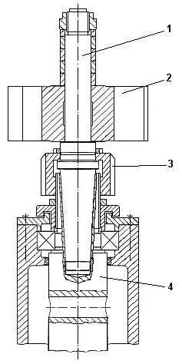 | 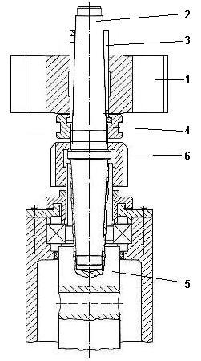
Figure 1: Assembling modality of the tool on the working shaft of a vertical moulding machine  (spindle moulder):  1 – mandrel; 2 – milling cutter; 3 – nut; 4 – main shaft. | Figure 2: The assembling by tightening on cone of the tool on the working shaft of a vertical moulding machine (spindle moulder).

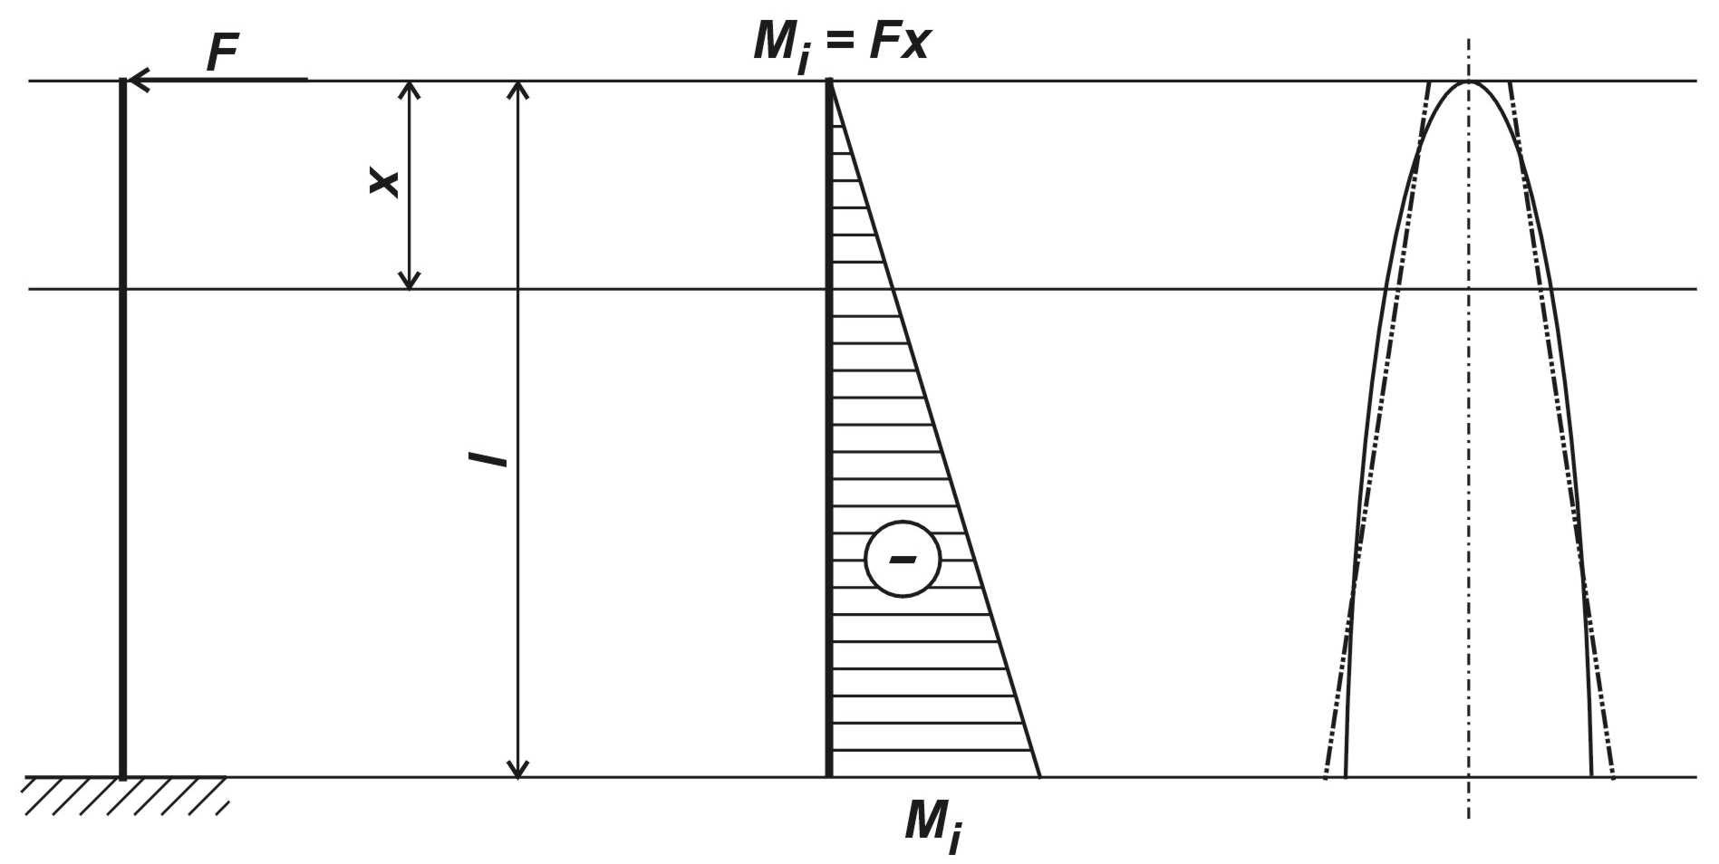
a. | b. | c.
Figure 3: Bending strain for the mandrel:
a. loading scheme; b. bending moments diagram; c. optimum shape of the mandrel: theoretical (parabolic) and practical (conical).

Thus:
$d(x)=\sqrt[3]{\frac{\text{32}F⋅x}{π⋅σ_{a}}}=C⋅\sqrt[3]{x}=C⋅x^{\frac{1}{3}}$. (4)
This expression shows that, in order to be an equal resistance bar to bending, the mandrel must have a parabolic shape in longitudinal section (fig. 5). But this shape has a big disadvantage: it isn’t useful for the milling cutter assembling. Therefore, because the conical shape is near to the parabolic one, we can say that a conical shape of the mandrel is to be preferred with regard to resistance.
It is also obvious that the rigidity of the mandrel is increasing with the diameter enlargement from the top to the base, the bending strain being in inverse proportionality with the rigidity modulus EI_{z} , where E is the longitudinal elasticity modulus and I_{z} the main central inertia moment of the cross section.
In the same time the inertial moment I_{z} for a circular section is:
$I_{z}=\frac{{πd}^{4}}{\text{64}}$. (5)
Thus, the mandrel strain caused by bending decreases with the increasing diameter.
In order to evaluate better the two fixing systems for both kinds of mandrels (cylindrical and conical) a FEM-analysis was performed.

3. FEM ANALYSIS

The studies have been performed by using the FEM (finite element method) with SolidWorks and Cosmos/Works programmes.
A first study was carried out in order to establish the level of stress and deformation of the two mandrel types. The second study was carried out in order to determine the first 5 vibration modes (frequencies and deformations) for the two kinds of mandrels. The studies were performed by taking into consideration the following hypotheses:
- the loading force: 1500N in perpendicular direction to the mandrel axis, at its upper end;
- the load is considered static;
- the considered material properties, in accordance with the real situation, are presented in figure 4;
- the meshing of the model has been performed with of “solid” type elements, size 7mm.

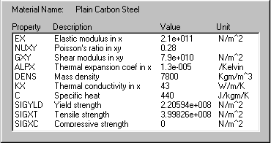
Figure 4: Material properties of the mandrels

4. RESULTS AND CONCLUSION

Some of the obtained results are presented in fig. 5 and 6. By analysing them, several important conclusions can be drawn with a view to the constructive optimisation of the studied main shaft sub-assembly. Thus:
- although stresses do not display dangerously high values, the deformations are too high (displacements reach 0,1895mm for the cylindrical mandrel and 0,1205mm for the conical one), considering that the behaviour of this working shaft is decisive for the processing accuracy;
- the first five natural frequencies for the cylindrical mandrel are: 869,72Hz, 873,99Hz, 4613,9Hz, 4637,7Hz and 5100,4Hz; among these, the two first are dangerously close to the excitation frequency during functioning under certain working conditions; thus, at a rotation speed of 9000rpm, a milling cutter with 6 teeth charges the mandrel with a frequency equal to: (9000rpm x 6 teeth) / 60 = 900Hz !!; a better situation is met with the conical mandrel, where the first five natural frequencies are: 1179,8Hz, 1183,3Hz, 5315,4Hz, 5321,5Hz and 6146,8Hz;
- thus, according to the above-mentioned, the fixing system for milling cutters with conical mandrel and chuck collet is better than the classical one (with cylindrical mandrel), offering also the advantage to use the existant tools without any modification.

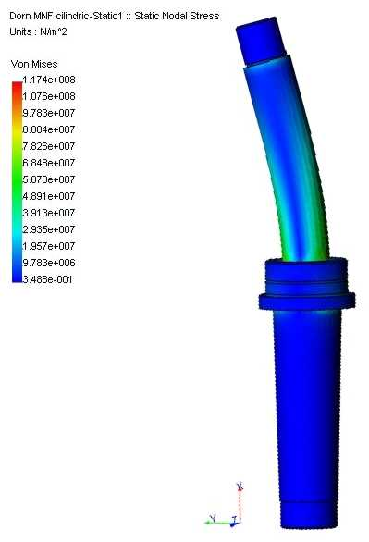 | 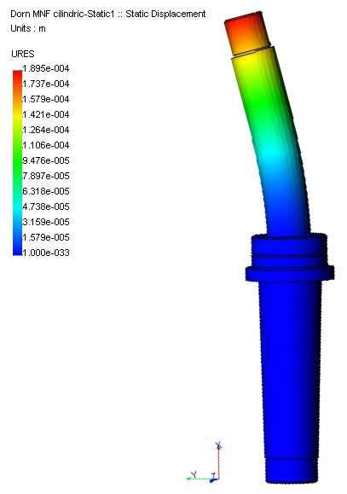
a. | b.
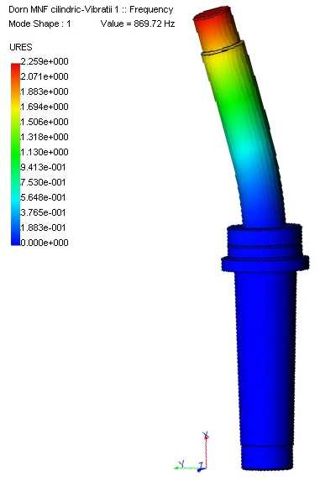 | 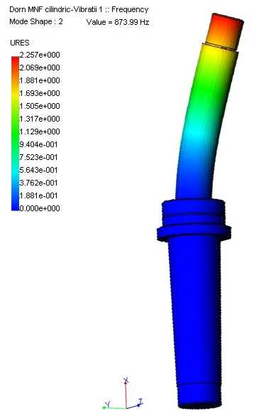
c. | d.
Figure 5: Results of FEM-analysis for the cylindrical mandrel:
a. stresses; b. displacements; c, d. the first two vibration modes.

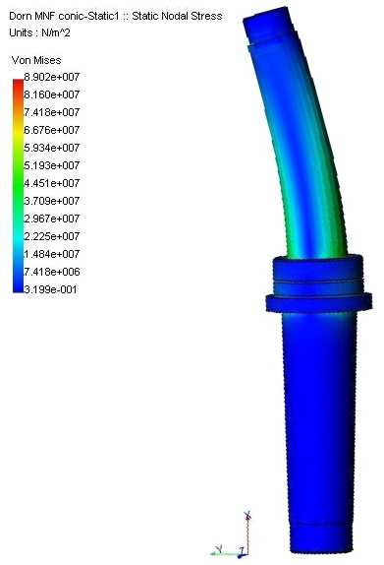 | 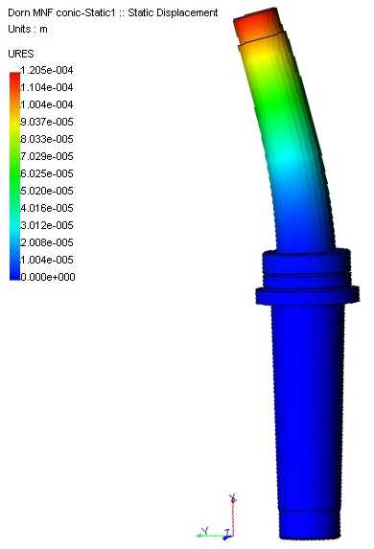
a. | b.
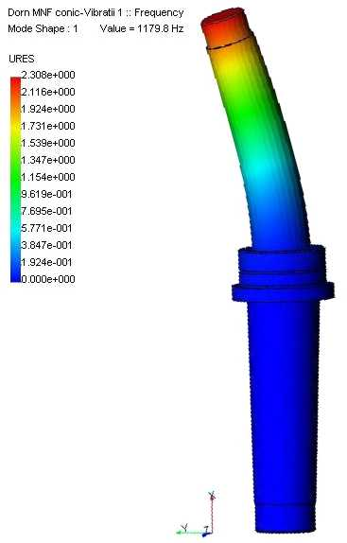 | 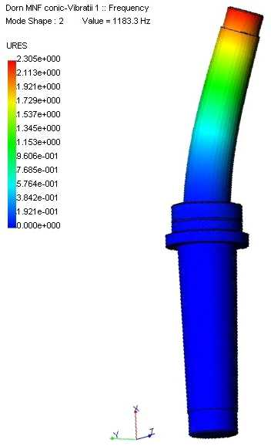
c. | d.
Figure 6: Results of FEM-analysis for the conical mandrel:
a. stresses; b. displacements; c, d. the first two vibration modes.

REFERENCES

[1] Ispas, M. 2000. Contribuţii la studiul prelucrării lemnului pe maşinile de frezat cu ax vertical în vederea optimizării constructive şi funcţionale (Contributions to the study of wood processing on vertical moulders with a view to constructive and functional optimisation). Ph.D. Thesis, “Transilvania” University of Braşov, Romania.

