1st International Conference
″Computational Mechanics and Virtual Engineering ″
COMEC 2005
20 – 22 October 2005, Brasov, Romania

ASPECTS CONCERNING THE OPTIMIZATION OF AN AUTOMOTIVE REAR AXLE

A. Camciuc¹, H. Gheorghiu¹, N. Constantin¹
¹Politechnical University of Bucharest, Romania, arthur_camciuc@yahoo.com

Abstract : Finding a reliable and efficient solution for automotive suspension is a permanent concern for designers in the field. A widely used solution is the compound rear axle beam. For the first time this solution was used at Volkswagen Golf and became almost a standard in designing the rear axle. In this paper a new solution for the construction of rear axle for automotives is presented. New elements were added in order to improve reliability. An analytical method is proposed, so the designer can optimise the design of the axle quite easy.
Keywords: handling, sensibility test.

1. INTRODUCTION

The torsion beam is a widely used solution for the rear suspension of the front-wheel drive cars. Torsion beam suspension is half-independent - there is a torsion beam connecting both wheels together, which allows limited degree of freedom in service conditions. For some less demanding compact cars, this solution saves the anti-roll bars. On the reverse, it doesn't provide the same level of ride and handling as double wishbones or multi-link suspensions, but in fact it is better than its only direct competitor, the McPherson strut. In figure 1. the rear axle of Volkswagen Golf is presented.

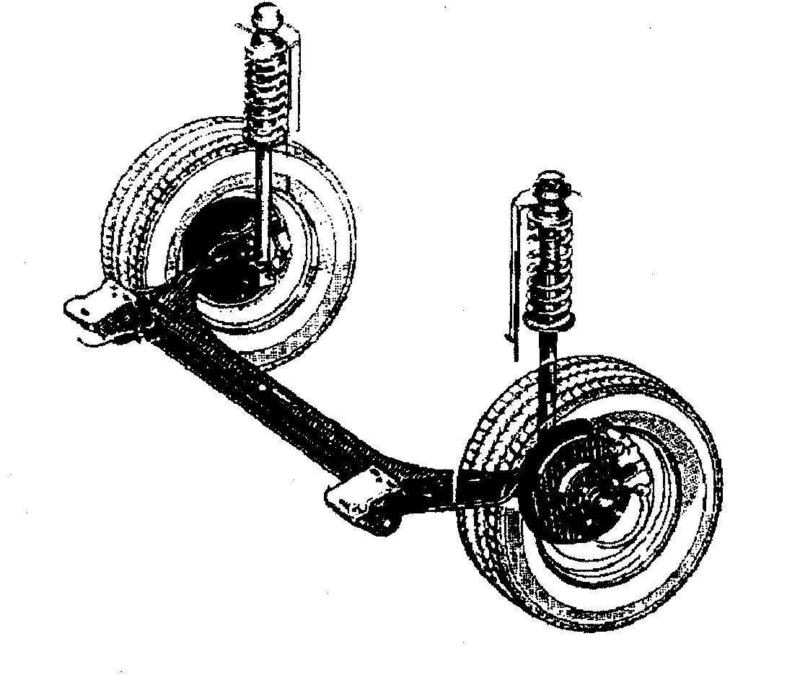

Fig. 1. The rear axle of Volkswagen Golf.
We propose to add a supplementary bar between the centers of the laterally arms, which is subjected only to torsion. The original connecting bar is moved closer to the wheels, so the bending loading influence becomes greater. The purpose is to improve handling and to make the structure redundant. The diameter of the torsion bar is obtained by imposing it to provide half of the anti-roll effect. So in case of failure of the connecting bar, the car can continue running with a reduced speed to the nearest service. In figure 2. the proposed solution is presented.
In figure2,$F_{1}$ and $F_{2}$ are the vertical loads of the wheels. ${ϕF}_{1}$ and ${ϕF}_{2}$ are the lateral forces which act on the contact patch, reduced to wheel spindle, and ${ϕF}_{1}r_{d}$ and ${ϕF}_{2}r_{d}$ are the moments created by lateral forces, $r_{d}$ is the dynamic radius of the wheel. It must be mentioned that only the anti-roll rate of the axle is studied. The anti-roll rate given by the springs is not considered. If a designer wants to take into account of the anti-roll rate given by the springs, he can modify the values of input data to such values in order to make a mechanically equivalent system, even the values for the dynamic radius and coefficient of adhesion do not have the original values.

Fig. 2. The proposed solution and the acting loads reduced to the center of the wheel during hard cornering.

2. ANALYTICAL APPROACH

The axle is a six time redundant system. In figure 3 the fundamental system is presented.

Fig. 3. Fundamental system.

The values for loads, element lengths and geometric characteristics of the sections were considered as input data. According to the usual methodology [2], the system was solved using the MathCad 7.0. code. The values of wheel center displacements and rotations were obtained and the maximum stresses in the two connection bars.

3. NUMERICAL APPROACH

For numerical approach the Ansys 5.6. code was used. Beam element 189 was used. Input data were: lateral arms have annular section 50x60 mm; the torsion bar has 25 mm in diameter; the connecting bar has an “I” section, with 20x5 mm equal web and flanges; the values of vertical loadings of the wheels are $F_{1}=\text{2000}N$ and $F_{2}=\text{4000}N$; the value of adherence coefficient is $φ=0,8$, which corresponds to dry asphalt ; the dynamic radius of the wheel is $r_{d}=\text{290}\text{mm}$; the values of different lengths presented in figure 3 are: $l_{1}=\text{400}\text{mm}$, $l_{2}=\text{50}\text{mm}$, $l_{3}=\text{550}\text{mm}$ and $e=\text{40}\text{mm}$. The chosen values correspond to a middle class car. In figure 4 the finite elements analyses results are presented in terms of the von Misses stresses.

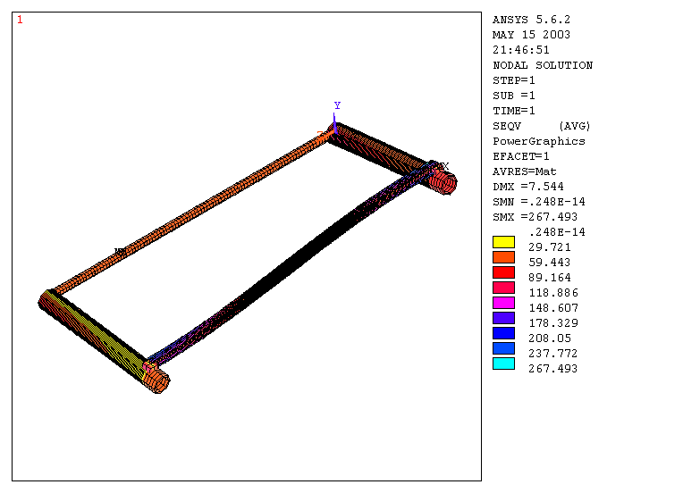

Fig. 4. Von Misses stresses .

4. Results

In table 1 are presented the values for the relative displacements of the wheel centers, which gives the body roll angle, the rotations of the arms, which modifies the camber angle of the wheel, and the stresses in connecting bars. The calculus corresponds to left cornering.

Table 1. The comparison of the values obtained from the two approaches

Obtained value
Obtained value | analytic | numeric | error [%]
$σ$[MPa] connecting bar | 250 | 267 | 6,3
$σ$[MPa] torsion bar | 29 | 34 | 14,7
$δ$[mm] | 16,3 | 14,8 | 10
$ϕ_{s}$[rad] | $$−0,\text{35}⋅{\text{10}}^{−2}$$ | $$−0,\text{42}⋅{\text{10}}^{−2}$$ | 16,6
$ϕ_{d}$[rad] | $$−0,\text{24}⋅{\text{10}}^{−3}$$ | $$−0,\text{26}⋅{\text{10}}^{−3}$$ | 7

Due to the close results obtained in the two approaches, the analytical approach can be used to emphasize the influence of the input parameters to the response of the structure (stresses, displacements, rotations). In figure 8 is presented the influence of the position of the connection bar (the value of l₁) on the output parameters. The influence of the e value, the torsional stiffness of the arms, the height of the „I“ profile of the connection bar, the width of the same profile and influence of the diameter of the torsion bar are presented in figures 5, 6, 7, 8, 9 and 10. The variation of the output parameters is presented in relative figures.

Fig. 5. The influence of the position of the connection bar on the output parameters.

Fig. 6. The influence of the e value on the output parameters.

Fig. 7. The influence of the torsional stiffness of the arms on the output parameters.

Fig. 8. The influence of the height of „I“ profile on the output parameters.

Fig. 9. The influence of the width of „I“ profile on the output parameters.

Fig. 10. The influence of the diameter of the torsion bar on the output parameters.

5. CONCLUSIONS

The results obtained following the two methods are in good agreement. In [1] it is specified that the complete optimization of a rear torsion beam axle is very difficult to achieve by analytical methods consequently the final design deeply depends on the finite element method. For the modified version presented in the paper, the designer can use the analytical method in order to get as close as possible to the optimum solution with full use of the sensitivity diagrams presented in figures 5, 6, 7, 8, 9 and 10. The use of a finite element code can establish the final parameters of the prototype design.

REFERENCES

[1] Bastow, D. Car Suspension and Handling , SAE , 1993.
[2] Buzdugan, Gh. Rezistenţa Materialelor, Editura Academiei Române, Bucureşti, 1986.

