1st International Conference
″Computational Mechanics and Virtual Engineering ″
COMEC 2005
20 – 22 October 2005, Brasov, Romania

Aspects of metal-rubber disk variational mathematical behavior
Vasile Ciofoaia
Transilvania University of Brasov, Romania, ciofoaiav@unitbv.ro

Abstract: This paper presents and develops a variational method based on Lagrange’s principle to determine a relation between displacement and compression tension of the metal – rubber disk.
Keywords: rubber, disk, elasticity.

1. Introduction

Components based on rubber materials have a very important part in the engineering processes and products. Rubber has various uses in a wide range of applications including hoses, tires, gaskets, seals, vibration isolators, bearing and dock fenders. In most applications, the performance of the product is determined by the rubber proprieties and by details of the product’s geometry. Rubber, which belongs to the group of materials called polymers, is included in a unique group of materials which may be identified by their ability, under certain conditions to undergo large deformations and recover almost completely and instantaneously after release of the deforming forces [Freakley, Gent, Treloar]. In practice many rubber springs are subjected only to relatively small strains, rarely exceeding 25% in extension or compression or 75% in simple shear [8]. A good approximation for the corresponding stresses is then given by conventional elastic analysis, assuming simple linear stress – strain relationship. Thus, it is possible to treat many common rubber design problems knowing only appropriate values for the modulus of elasticity [1,2, 6, 8, 10]. The property of rubber elasticity may be explained quantitatively based on its molecular structure and by reference to the first law of thermodynamics. A piece of unstretched rubber is a tangled mass of long irregular molecules. When rubber is stretched the molecules become aligned more or less in the direction of stretching. The laws of thermodynamics state that this more orderly arrangement is less probable than the original random arrangement and that work is required to be performed in order to generate the alignment, hence the rubber resists being stretched and if released will retract.
In this paper, we treat the sample calculation for products in which the rubber are bonded to rigid components and that are used for motion accommodation. For most designs the stiffness (spring rate [7]) is a design parameter. The stiffness K of a part is defined as the amount of force required to cause a unit deflection (K = F/d where F is the applied force and d is the deflection). Papers [1.2.6] presents experimental methods for determination of the mechanical static and dynamic features, by determining constitutive models for the rubber materials. The behavior at compression of the metal-rubber disk was presented in papers [2,6,9]. Determination of metal rubber jack in radial displacement with the analytic method have been presented in [9] and in paper [6] their resistance was estimated. In this paper presents and develops a variational method based on Lagrange’s principle to determine a relation between displacement and compression tension of the metal – rubber disk

2. Langrange equation for incompressible materials
Various computational methods based on the elasticity theory can be applied in order to determine the elements from rubber materials ( metal-rubber disks, rubber covered shafts etc) on small displacements (10-20%), as they follow the Hooke's law. The variational principle of Lagrange for a conservative system is formulated as follows: the total energy of system Π has stationary value, that is
. (1) For an elastic body where U is the potential deformation energy and V is the potential of the external forces. Tension forces σ_{ij} in compressed materials can be determined by Hooke's law
(i,j = 1, 2, 3) (2) where ε_{ij} are the small components of the deformation, linked to the u_{i} displacements through geometric relations
; (3) ε_{V} = ε_{ij} is the specific volume for small deformations; δ_{ij} – Kronecker symbol: λ = 2νG/(1- 2ν) – the Lamé constant; G – the transversal elastic module. The deformation specific energy U_{s} is expressed by the following formula
(4)
And the average tension value
. (5) For rubber it is generally accepted the the specific volume deformation is null, where J₁ is the first invariant of the deformation and Poisson coefficient υ = 0,5. Since si and the product λε_{V} in accordance to the relation (5) presents hydrostatic tension p = λε_{V}, (not directly dependant on deformation) [4]. According to this data, the second factor (4) is null, and Hooke's law (2) is expressed by the formula
. (6)
By integration in the incompressible material, U_{s} = U₁ + U₂, where U₁ = Gε_{ij}ε_{ij}, and the product λε_{V} becomes equal to the hydrostatic tension U₂ = /2 from the Lagrange principle (1) obtaining
. (7) Thus, generally it can be inferred
, where . (8) Equation (8) represent the Lagrange equation for incompressible materials. With the Ritz method for incompressible materials one can apply the equation (8) to solve elasticity theory problems.

3. Determination the behavior of the metal rubber disk at compression
Let's consider a rubber disk (fig.1) placed in a cylindrical coordinate system, subjected to compression by an F force. The load in symmetric relative to z axis. An approximate method of the problem can be obtained with the help of the Ritz method by considering the transversal sections of the rubber disk as remaining place after deformation (plane section hypothesis).
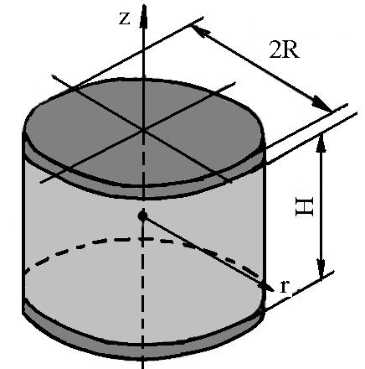  Figure 1 Rubber disk geometry | As a consequence, let us note u and w the displacement components in r and z directions. By noting  ; ; . (9) The components of displacement and hydrostatic tension can be expressed as  ;  ; . (10) Thus it can be observed that the contour conditions can be verified: at z = displacement is null u = 0 and it has maximal value at z=0; w(r,0) = 0 and w(r,h/2) = 0. The functions from the first relations (10) lead to and further to .
The potential deformation energy in the rubber disk [9] is determined with the formula (11)
After replacing the deformation components
; ; ; (12)
in relation (11) and after applying the integration - the following results are obtained
. (13) The integral U₂ for the volume of the rubber disk can be determined with the product pε_{V} where
. (14) The potential of the exterior forces is
. (15) The stationary condition (8) of the functional F = U₁ + U₂ + V is and . Thus two linear algebraic equations are obtained in rapport to the parameters a₁, b₁, c₁
; . (16) Adding to this system the equation 2a₁ + b₁ = 0 it follows that
; ; , (17)
where The normal tension σ_{z} and the deformation ε_{z} in transversal section z are determined with the help of the relation
; . (18)
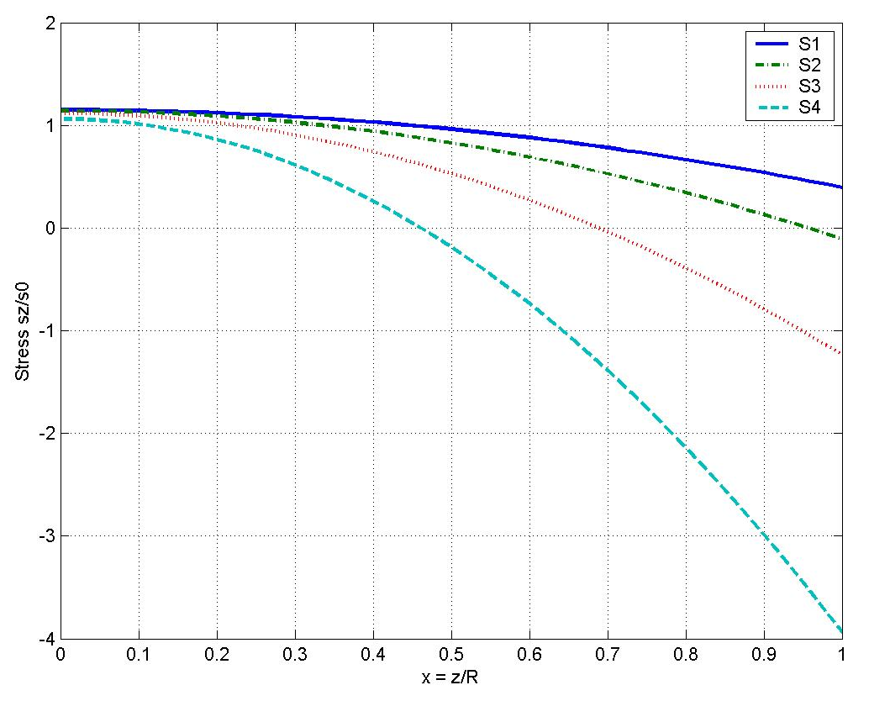
Figure 2 Tension distribution according to the rubber disk height
Four cases have been considered with the following parameters m = 1, m = 0,75, m = 0,50, m = 0,25 , G = 6 MPa. Figure 2 presents the distribution of the tension σ_{z,} and figure 3 presents the distribution of the deformation ε_{z} in relation tot he rubber disk height.
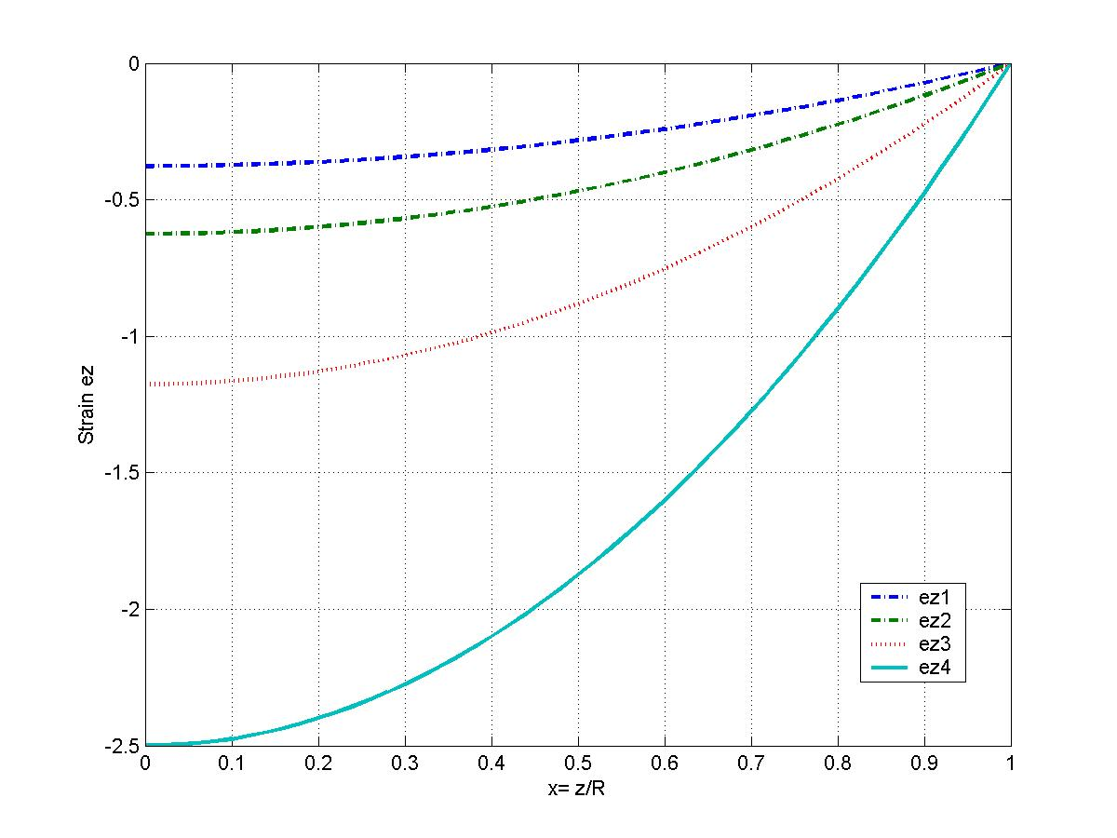
Figure 3 Deformation distribution according to the rubber disk height
4. Conclusions
This paper presents an approximate method of determination of the rubber disk behavior subjected to static loads. The results presented lead to the conclusion that the normal tension σ_{z} is not influenced by the radius, while the ε_{z} deformation depends on the rubber disk radius.

References

[1] | Alexandrescu L., Ciofoaia V. Experimental checking for the mechanical characteristics of the metal – rubber jack. A XXIX-a Sesiune de Comunicări Ştiinţifice cu Participare Internaţională „tehnologii Moderne în secolul XXI” 15 -16 Noiembrie , Academia Militară, Bucureşti, 2001, pp.231 -234.
[2] | Alexandrescu, L., Cercetări privind caracteristicile elastice şi de rezistenţă ale pieselor realizate din cauciuc. Teza de doctorat, Brasov, 2003.
[3] | Bratu P. Sisteme elastice de rezemare pentru maşini şi utilaje. Editura Tehnică, Bucureşti, 1990.
[4] | Бидерма, В.Л., Мартьянов, Г. В., Вариационный метод расчета деталей из несжимаемого материала. Расчеты на прочность. Машиностроение, Москва, 1977. pp.3 - 27.
[5] | Ciofoaia, V., Asupra estimării rezistenţei bucşelor elastice. A 8ª Conferinţă cu participare internaţională, Vehiculul şi Mediul.13 – 15 Noiembrie, Braşov1996, pp.25 – 30.
[6] | Ciofoaia, V., Cercetări teoretice şi experimentale privind optimizarea formei şi structurii pieselor din cauciuc şi alte materiale utilizate în covntrucţia de maşini. CNCSIS 537, Contract 33459/2002.
[7] | Freakley, P.K., Payne, A.R., Theory and practice of engineering with rubber. Applied Science Publishers LTD London, 1978.
[8] | Gent, A.N., Engineering with rubber, Hanser Publishers, Munich, Vienna New York Barcelona, Oxford University Press, 1992.
[9] | Ponomariov, S.D., Biderman, V.L., Liharev, K.K., Makusin, V.M., Malinin, N.N., Feodosiev, V.I.,Calculul de rezistenta in constructia de masini. Editura Tehnica, Bucuresti, 1963.
[10] | Treloar, L.R.G., The physics of rubber elasticity. Clarendons Press Oxford 1975.

