1st International Conference
″Computational Mechanics and Virtual Engineering ″
COMEC 2005
20 – 22 October 2005, Brasov, Romania

THE INFLUENCE OF ERRORS ON THE JOINT MOTIONS
FROM AN ISOSTATICAL MECHANISM (7R).
PART I: KINEMATICAL MODELING

Mircea Neagoe¹, Codruta Jaliu², Radu Saulescu³
¹Transilvania University, Brasov, ROMANIA, e-mail: mneagoe@unitbv.ro
²Transilvania University, Brasov, ROMANIA, e-mail: cjaliu@hotmail.com
³Transilvania University, Brasov, ROMANIA, e-mail: rsaulescu@unitbv.ro

Abstract: A new method for the identification of mechanisms’ redundant constraints is presented in this paper and it is proposed a program for modeling their effects in different technological, functional and constructive conditions.
Keywords: redundant constraint, hyperstatical mechanism, Isostatical mechanism.

- INTRODUCTION

In real conditions of functioning, due to the mechanical transmission’s manufacturing and assembling, its errors are unavoidable; there are also possible elastic and thermal deformations of its elements. The hyperstatical constraints that, in real conditions, have a negative influence on the mechanism manufacturing, functioning and/or durability are called structural defects.
Two methods can be used to increase the mechanical transmissions’ reliability:
- elimination of structural defects that are due to the statically undetermined constraints, which, in the presence of manufacturing and assembling inaccuracies tend to block up the transmission and introduce supplementary stresses, hardly reducing their life-cycle;
- reduction of these constraints’ negative effects, by making a compromise between the optimization costs and their effects on the transmission reliability.

An intuitive method for the structural modeling and testing of errors effects on the transmission functions and mechanisms behavior is proposed in this paper; the proposed method uses the rank of a system of equations that is described by constraints, simplifying, thus, the mathematical apparatus used in results interpretation. The modeling is presented on the base of a representative example [6]:
- a four-bar mechanism from an extractor mechanism used in grained materials extraction from silages – Fig. 1 (formed by aggregating four one-loop mechanisms);
in real assembling conditions, the mechanism is characterized by relatively high errors that can lead to the breakage of worm 11 and, therefore, to a relatively reduced life-cycle.

- STRUCTURAL MODELING OF THE 4-BAR MECHANISM

In theoretical conditions, the axes of joints A, B, C and D are parallel (Fig. 1), the clearances and frictions inside the joints are null, the mechanism elements are considered non-deformable and with a perfect technological processing etc. In this case, for establishing the considered mechanism structural defects, the passive kinematical constraints must be identified and, afterwards, a rational way to eliminate them from the structural model must be selected.
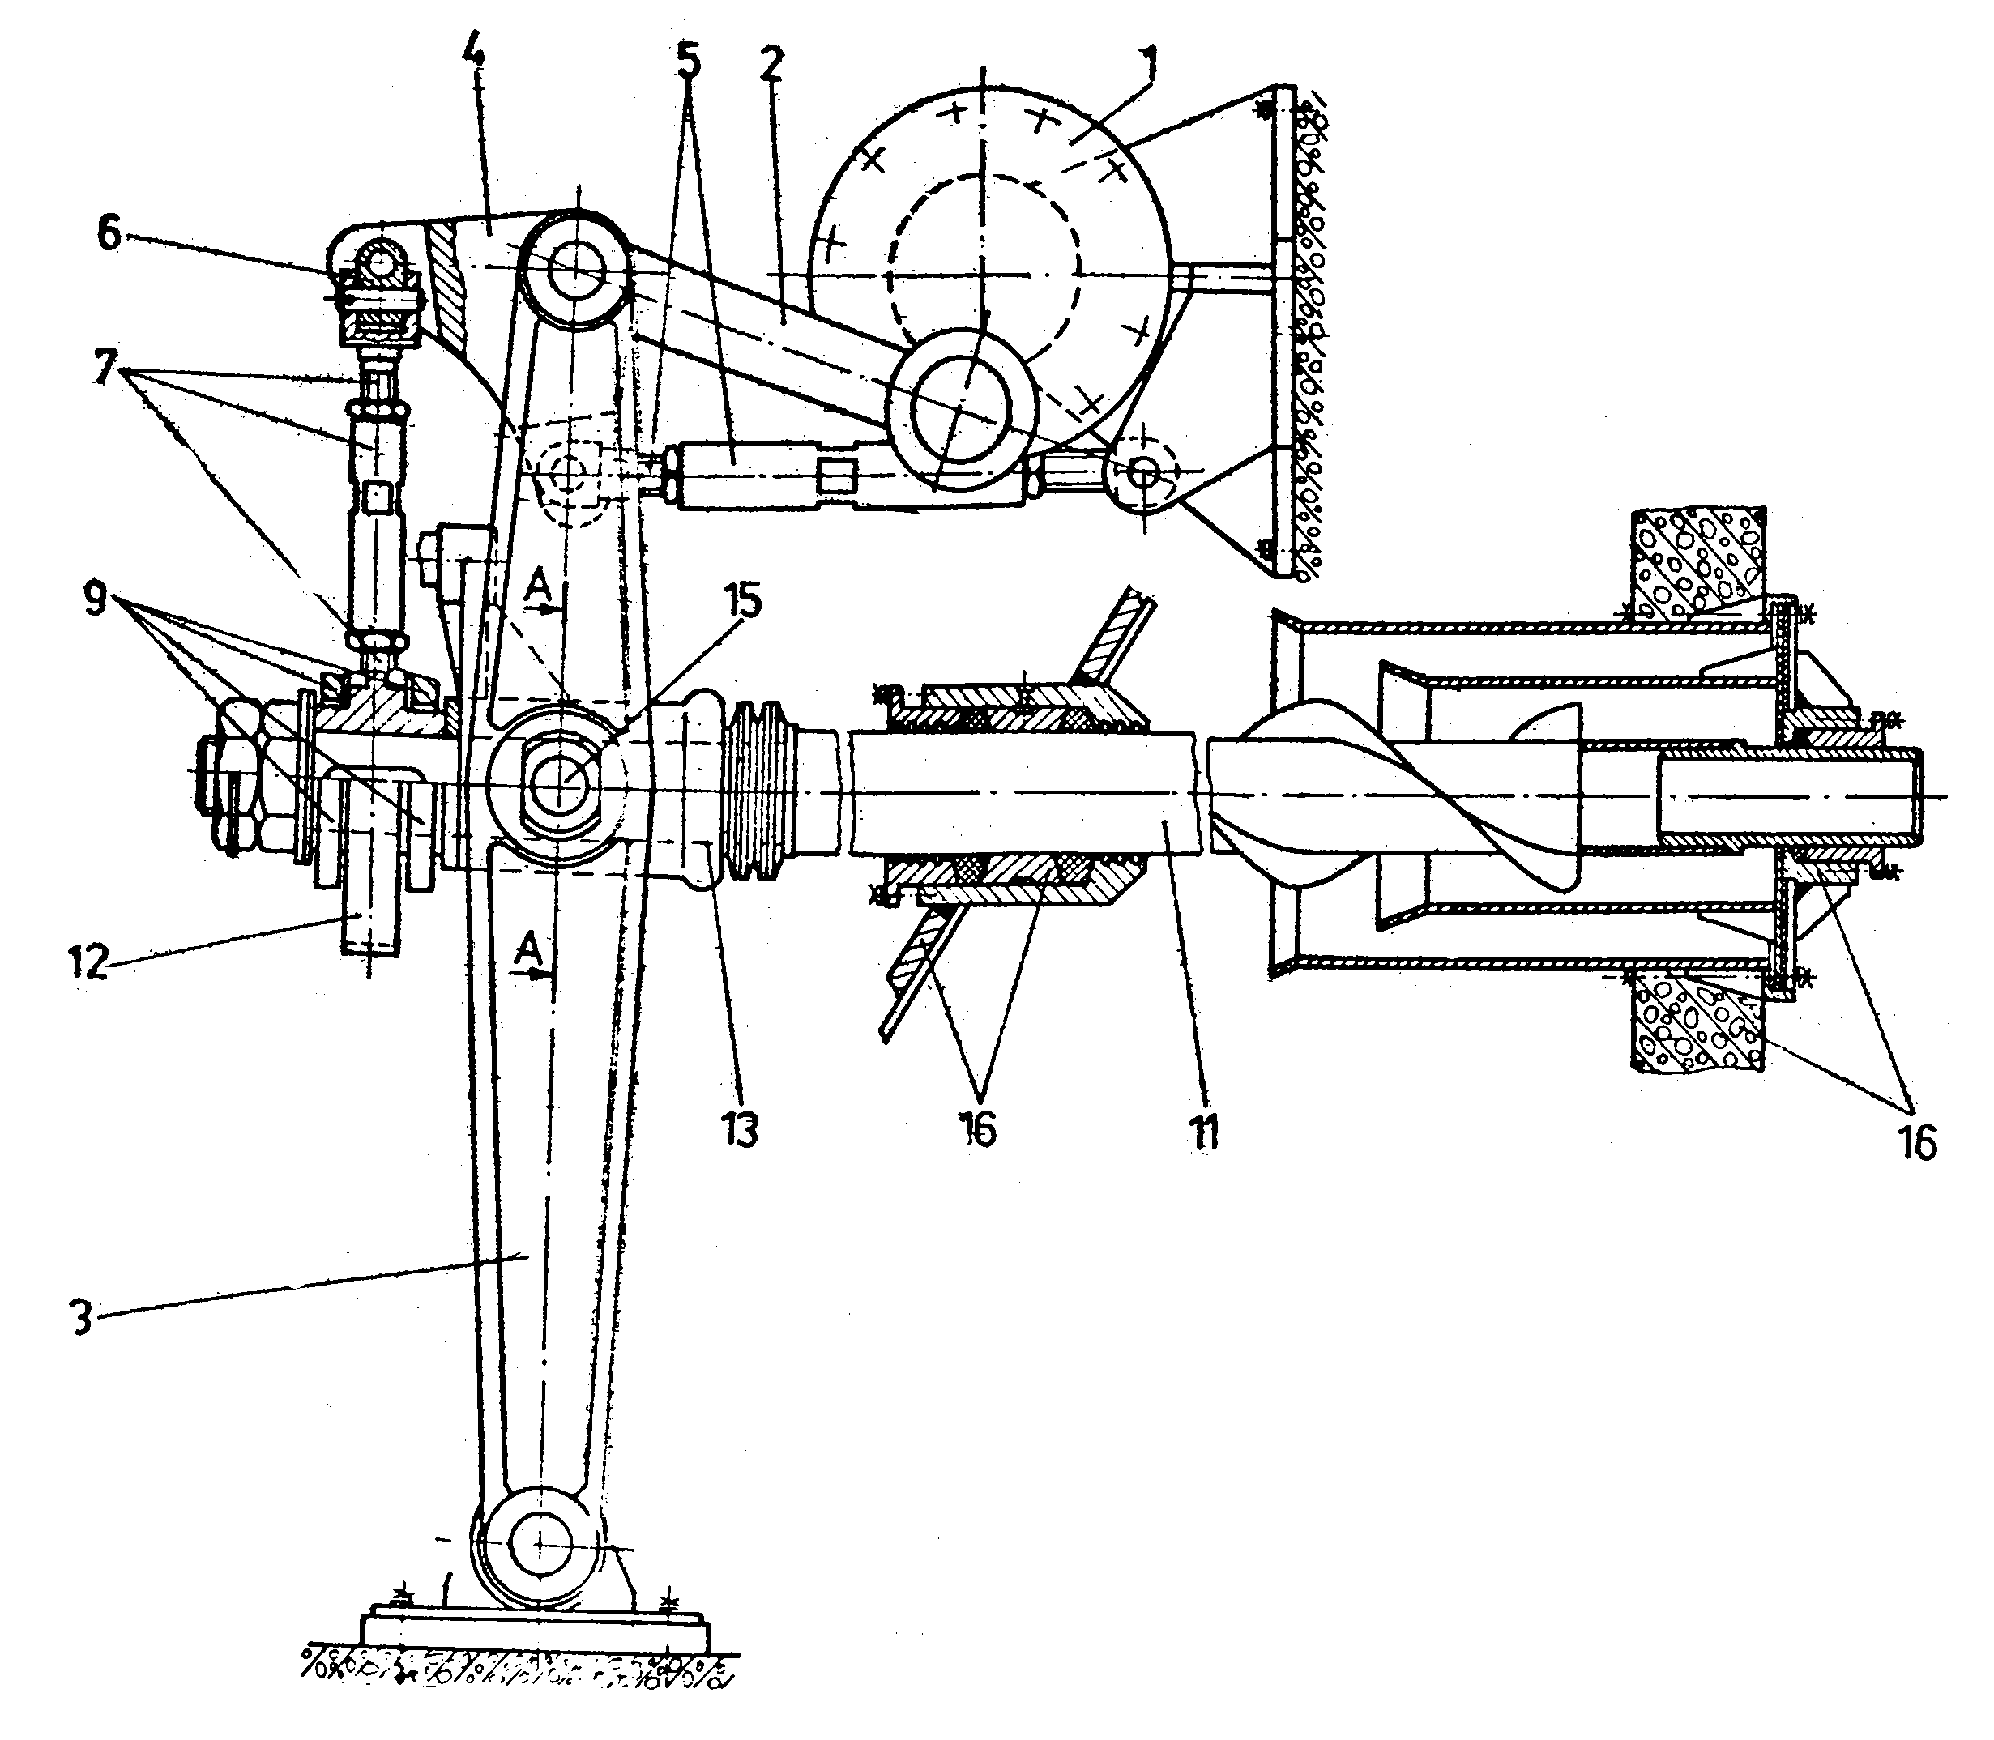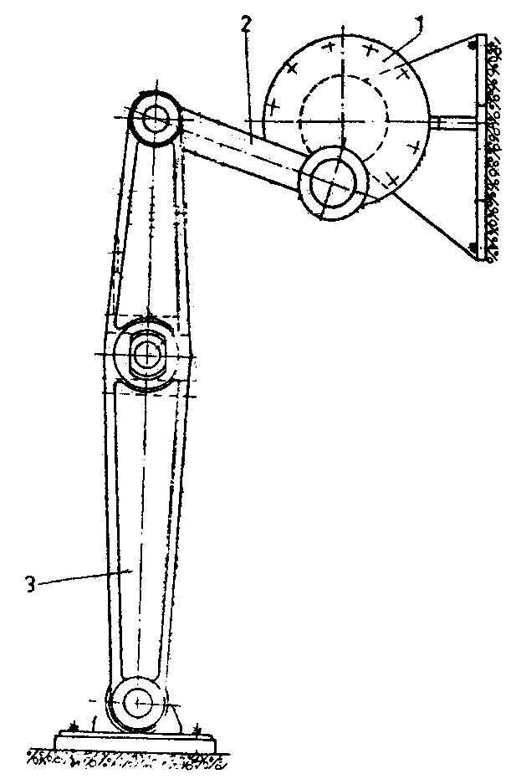

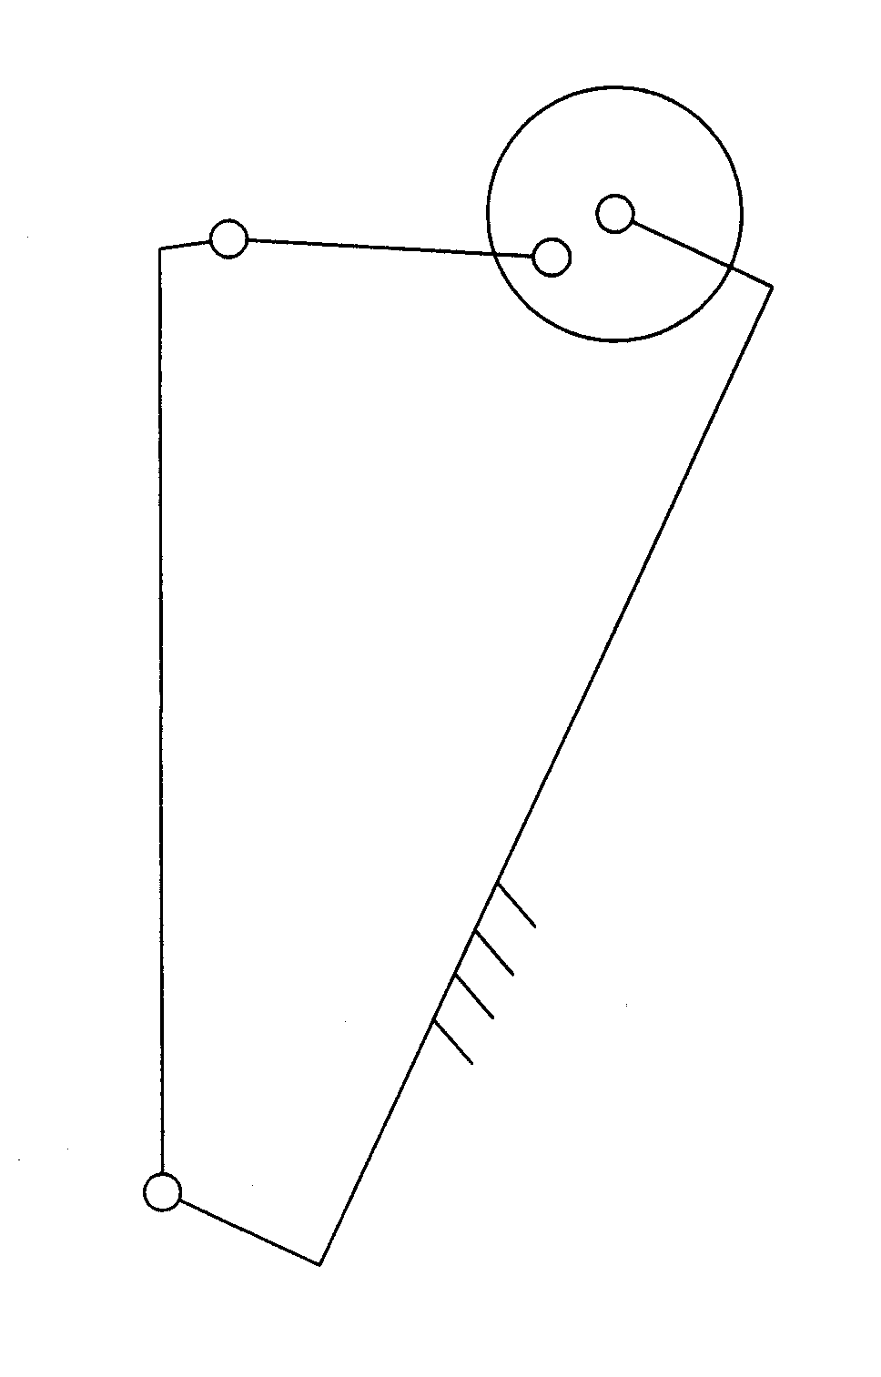
a. b.
B
A
C
D
x
z
1
3
2

c.

Figure 1: The extractor mechanism used in grained materials extraction from silages
(a – the constructive scheme; b, c – the four-bar mechanism)

Generally, these hyperstatical constraints don’t affect negatively the mechanism good functioning and its life cycle, if the errors from its theoretical configuration are small enough. But if these errors exceed certain limits, the hyperstatical constraints become structural defects, as they tend to overstress the kinematical chain, to block up the mechanism or, at limit, to make assembling impossible. The mechanism (Fig. 1, c) is characterized by three statically undetermined constraints (hyperstatical), of equations:

ω_{x} = 0, ω_{z} = 0, v_{y} = 0.
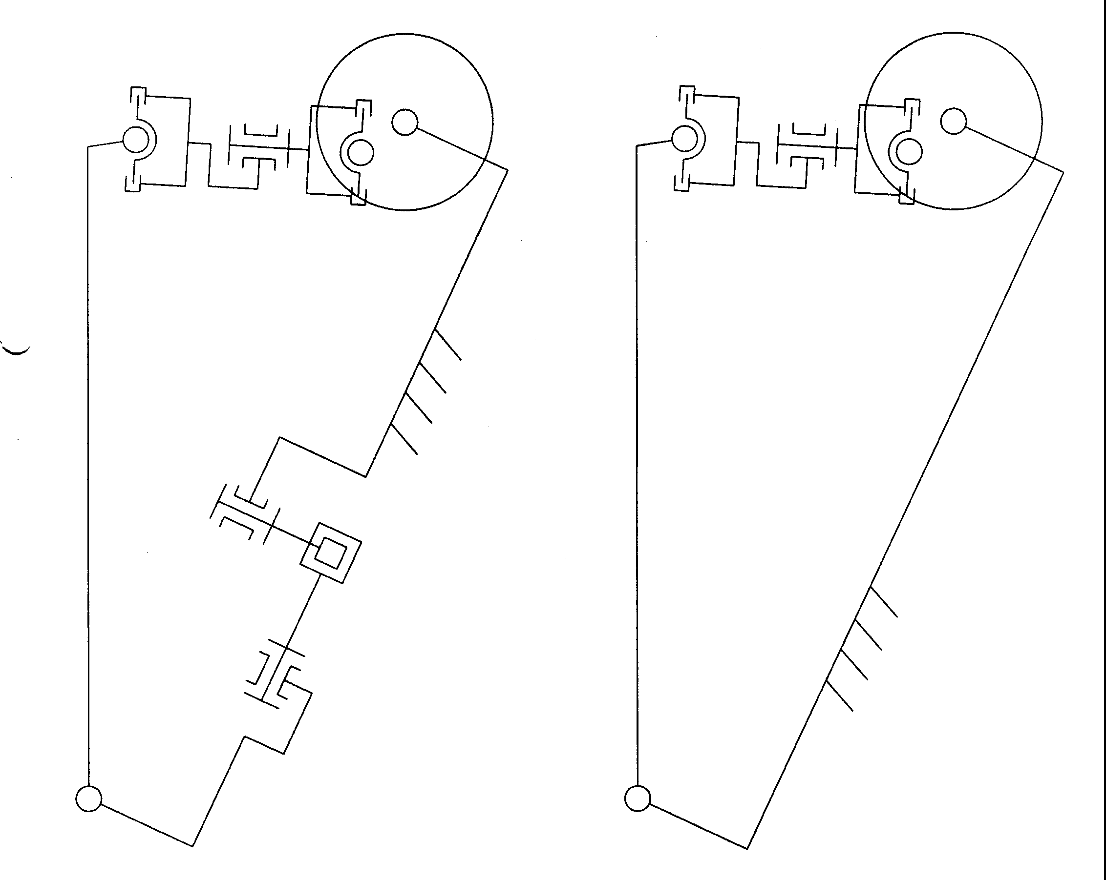

B
A
C
D
E
F
G
β
α
Δy
x
z
ϕ₁
ϕ₂
B
A
C
D
E
F
G
- b.

Figure 2: The 7R mechanism
(a – the structural diagram; b – the mechanism with the adjustment joints)

The elimination of these constraints can be done by introducing in the mechanism the following mobilities [3,4]:
ω_{x} , ω_{z} , v_{y};
the proposed isostatical mechanism (Fig. 2, a) is obtained by introducing three revolute joints in the mechanism from Fig. 1, c: joint F introduces a passive mobility among x* axis, while joints E and G, with the axes parallel to z*, insert the passive motions ω_{z} and v_{y} (the reference frame x*y*z* is attached to the connecting rod, in which x* axis is along BC).

- KINEMATICAL MODELING

In order to identify the effects of the errors on the transmission functions and on the closed kinematical chain behavior, a program for testing the influence of the errors from the mechanism planar configuration is presented in this paper.

The program [5] is built using Maple software, and is intended to establish:
- the influence of errors from the planar configuration, on the angular displacements from joints B, C and D;
- the influence of the errors from the planar configuration, on the angular displacements from joints E, F and G; when structural errors appear, the passive motions from joints E, F and G become active and the 4R mechanism becomes a spatial mechanism of 7R type;
- the errors’ influence on the pre-tensioning of the hyperstatical mechanism (S=3), through the angular displacements from joints E, F and G, which are considered as replaced by twistable elastic elements; therefore, the pre-tensioning moments can be modeled as products between a modulus of elasticity and the angular displacements of joints E, F, G, which were previously established.

In order to control the errors, three distinct joints (α, β and Δy - Fig. 2, b) are inserted in the considered mechanism (α allows a rotation around x, β - around z and Δy – a translation along y); the joints allow the introduction of angular / linear displacements that model the errors from the planar configuration (after moving with one angular / linear step in each of the joints used for adjustment, the respective joint is considered frozen).

The program encloses a method for the establishment of the output motion ϕ₂ as a function of the input motion ϕ₁ and of the displacements from the adjustment joints, α, β and Δy, by using the homogenous operators; firstly, there were written the matrixes of geometrical transformation from the initial reference frame Ax₀y₀z₀ to the reference frames from B (matrix AOB) and C (matrix AOC), respectively:

$\begin{aligned}\text{AOB}=\text{Ry}(ϕ_{1})⋅T(0,0,L1)=\left[\begin{matrix}1 & 0 & 0 & 0 \\ L_{1}\text{sin}ϕ_{1} & \text{cos}ϕ_{1} & 0 & \text{sin}ϕ_{1} \\ 0 & 0 & 1 & 0 \\ L_{1}\text{cps}ϕ_{1} & −\text{sin}ϕ_{1} & 0 & \text{cos}ϕ_{1}\end{matrix}\right]; \\ \\ \text{AOC}=T(L0,0,0)⋅T(0,Δy,0)⋅\text{Rz}(β)⋅\text{Ry}(ϕ_{2})⋅T(0,0,L3)= \\ \left[\begin{matrix}1 & 0 & 0 & 0 \\ L_{0}+(\text{cos}β\text{sin}ϕ_{2}+\text{sin}β\text{sin}α\text{cos}ϕ_{2})L_{3} & \text{cos}β\text{cos}ϕ_{2}\text{-sin}β\text{sin}α\text{sin}ϕ_{2} & \text{-sin}β\text{cos}α & \text{cos}β\text{sin}ϕ_{2}\text{+sin}β\text{sin}α\text{cos}ϕ_{2} \\ Δ\text{y+}(\text{sin}β\text{sin}ϕ_{2}\text{-cos}β\text{sin}α\text{cos}ϕ_{2})L_{3} & \text{sin}β\text{cos}ϕ_{2}\text{+cos}β\text{sin}α\text{sin}ϕ_{2} & \text{cos}β\text{cos}α & \text{sin}β\text{sin}ϕ_{2}\text{-cos}β\text{sin}α\text{cos}ϕ_{2} \\ \text{cos}α\text{cos}ϕ_{2}L_{3} & \text{-cos}α\text{sin}ϕ_{2} & \text{sin}α & \text{cos}α\text{cos}ϕ_{2}\end{matrix}\right]\end{aligned}$

afterwards, there were established the position vectors of points B and C, expressed in the initial reference frame:

$r_{B}=\left[\begin{matrix}L_{1}\text{sin}ϕ_{1} \\ 0 \\ L_{1}\text{cos}ϕ_{1}\end{matrix}\right]$;

$r_{C}=\left[\begin{matrix}L_{0}+(\text{cos}β⋅\text{sin}ϕ_{2}\text{+sin}β⋅\text{sin}α⋅\text{cos}ϕ_{2})⋅L_{3} \\ Δ\text{y+}(\text{sin}β⋅\text{sin}ϕ_{2}\text{-cos}β⋅\text{sin}α⋅\text{cos}ϕ_{2})⋅L_{3} \\ L_{3}\text{cos}α⋅\text{cos}ϕ_{2}\end{matrix}\right]$;

thus, the distance between joints B and C could be expressed as function of the angle ϕ₁ and the displacements α, β and Δy:

$r_{\text{BC}}=\left[\begin{matrix}L_{0}+(\text{cos}β⋅\text{sin}ϕ_{2}\text{+sin}β⋅\text{sin}α⋅\text{cos}ϕ_{2})L_{3}\text{-sin}ϕ_{1}⋅L_{1} \\ Δ\text{y+}(\text{sin}β⋅\text{sin}ϕ_{2}\text{-cos}β⋅\text{sin}α⋅\text{cos}ϕ_{2})⋅L_{3} \\ \text{cos}α⋅\text{cos}ϕ_{2}L_{3}\text{-cos}ϕ_{1}L_{1}\end{matrix}\right]=\text{const}\text{.}$;

the output angle ϕ₂ can be obtained from the previous relation.

Considering the angles ϕ₂, α, β and the displacement Δy as known quantities, it can be established the position of the reference frame from joint C relative to the reference frame from joint B; by modeling with the homogenous operators the transformation of the two reference frames from points B and C, there can be obtained the displacements from joints B, E, F, G and C:

$$\begin{aligned}ϕ_{E}=\text{arcsin}\frac{h_{1}}{L_{2}}; \\ \\ ϕ_{B}=−2\text{arctan}\frac{h_{2}}{L_{2}⋅\text{cos}ϕ_{E}(1+\frac{h_{3}}{L_{2}⋅\text{cos}ϕ_{E}})};\end{aligned}$$

$ϕ_{F}=−\text{arctan}\frac{\text{sin}ϕ_{B}⋅h_{4}\text{+cos}ϕ_{B}⋅h_{5}}{\text{sin}ϕ_{E}⋅\text{cos}ϕ_{B}⋅h_{4}\text{-sin}ϕ_{E}⋅\text{sin}ϕ_{B}⋅h_{5}\text{-cos}ϕ_{E}⋅h_{6}};$ (1)

$$ϕ_{G}=2\text{arctan}\frac{\text{-cos}ϕ_{E}\text{cos}ϕ_{B}⋅h_{4}\text{+cos}ϕ_{E}\text{sin}ϕ_{B}⋅h_{5}\text{-sin}ϕ_{E}⋅h_{6}}{\text{1-cos}ϕ_{F}\text{sin}ϕ_{E}\text{cos}ϕ_{B}⋅h_{4}\text{+cos}ϕ_{F}\text{sin}ϕ_{E}\text{sin}ϕ_{B}⋅h_{5}\text{+cos}ϕ_{F}\text{cos}ϕ_{E}⋅h_{6}\text{+sin}ϕ_{F}\text{sin}ϕ_{B}h_{4}\text{+sin}ϕ_{F}\text{cos}ϕ_{B}h_{5}};$$

$$ϕ_{C}=2\text{arctan}\frac{\text{-sin}ϕ_{F}\text{sin}ϕ_{E}\text{cos}ϕ_{B}h_{7}\text{+sin}ϕ_{F}\text{sin}ϕ_{E}\text{sin}ϕ_{B}h_{8}\text{+sin}ϕ_{F}\text{cos}ϕ_{E}h_{9}\text{-cos}ϕ_{F}\text{sin}ϕ_{B}h_{7}\text{-cos}ϕ_{F}\text{cos}ϕ_{B}h_{8}}{\text{1+sin}ϕ_{F}\text{sin}ϕ_{E}\text{cos}ϕ_{B}h_{\text{10}}\text{-sin}ϕ_{F}\text{sin}ϕ_{E}\text{sin}ϕ_{B}h_{\text{11}}\text{-sin}ϕ_{F}\text{cos}ϕ_{E}h_{\text{12}}\text{+cos}ϕ_{F}\text{sin}ϕ_{B}h_{\text{10}}\text{+cos}ϕ_{F}\text{cos}ϕ_{B}h_{\text{11}}}$$
in which

$\begin{aligned}h_{1}=Δy{\text{+L}}_{3}\text{sin}β\text{sin}ϕ_{2}{\text{-L}}_{3}\text{cos}β\text{sin}α\text{cos}ϕ_{2}; \\ h_{2}={\text{-L}}_{1}\text{+sin}ϕ_{1}L_{0}\text{+sin}ϕ_{1}L_{3}\text{cos}β\text{sin}ϕ_{2}\text{+sin}ϕ_{1}L_{3}\text{sin}β\text{*sin}α\text{cos}ϕ_{2}\text{+cos}ϕ_{1}\text{cos}α\text{cos}ϕ_{2}L_{3};\end{aligned}$
$\begin{aligned}h_{3}=\text{cos}ϕ_{1}L_{0}\text{+cos}ϕ_{1}L_{3}\text{cos}β\text{sin}ϕ_{2}\text{+cos}ϕ_{1}L_{3}\text{sin}β\text{sin}α\text{cos}ϕ_{2}\text{-sin}ϕ_{1}\text{cos}α\text{cos}ϕ_{2}L_{3}; \\ h_{4}=\text{-cos}ϕ_{1}\text{sin}β\text{cos}α\text{-sin}ϕ_{1}\text{sin}α; \\ h_{5}=\text{-sin}ϕ_{1}\text{sin}β\text{cos}α\text{+cos}ϕ_{1}\text{sin}α);\end{aligned}$
$\begin{aligned}h_{6}=\text{cos}β\text{cos}α; \\ h_{7}=\text{cos}ϕ_{1}\text{cos}β\text{cos}ϕ_{2}\text{-cos}ϕ_{1}\text{sin}β\text{sin}α\text{sin}ϕ_{2}\text{+sin}ϕ_{1}\text{cos}α\text{sin}ϕ_{2};\end{aligned}$
$\begin{aligned}h_{8}=\text{sin}ϕ_{1}\text{cos}β\text{cos}ϕ_{2}\text{-sin}ϕ_{1}\text{sin}β\text{sin}α\text{sin}ϕ_{2}\text{-cos}ϕ_{1}\text{cos}α\text{sin}ϕ_{2}; \\ h_{9}=\text{sin}β\text{cos}ϕ_{2}\text{+cos}β\text{sin}α\text{sin}ϕ_{2}; \\ h_{\text{10}}=\text{cos}ϕ_{1}\text{cos}β\text{sin}ϕ_{2}\text{+cos}ϕ_{1}\text{sin}β\text{sin}α\text{cos}ϕ_{2}\text{-sin}ϕ_{1}\text{cos}α\text{cos}ϕ_{2};\end{aligned}$
$h_{\text{11}}=\text{sin}ϕ_{1}\text{cos}β\text{sin}ϕ_{2}\text{+sin}ϕ_{1}\text{sin}β\text{sin}α\text{cos}ϕ_{2}\text{+cos}ϕ_{1}\text{cos}α\text{cos}ϕ_{2};$
$h_{\text{12}}=\text{sin}β\text{sin}ϕ_{2}\text{-cos}β\text{sin}α\text{cos}ϕ_{2}\text{.}$

- CONCLUSIONS

Thus, using relations (1) there can be established the influences of the three errors (α, β and Δy) directly on the mechanism transmission functions. The proposed program allows the calculus of the six functions (the angles from rel. 1and the angle ϕ₂) on the entire range of variation [0..360⁰] of the input angle ϕ₁; different values, separately and combined, are given to the displacements from the adjustment joints and their effects on the parameters previously established are numerically analyzed.
The numerical simulations, their representation and interpretation form the subject of the second part of this paper “The effects analysis by numerical simulation”. Afterwards, by processing the results which are obtained by simulation, there are formulated conclusions regarding the structural optimization under known constructive, technological and functioning conditions.

The angular displacements from the theoretically passive joints E, F and G grow together with the increase of the errors from the planar configuration: α, β and Δy. Under the premise that these joints are inexistent, pre-tensioning moments appear, moments that are equal to the product between the angular displacements and the elements modulus of elasticity. Obviously, due to the reduced elements elasticity, pre-tensioning moments of big values can appear in the closed chain; in these conditions, the mechanism durability is compromised, being necessary to insert supplementary adequate mobilities.

The modeling and numerical simulation highlight the necessity of an attentive numerical study about the influence of structural defects (α, β and Δy) in the design stage and, based on the obtained results, to identify the theoretically passive mobilities that are absolutely necessary and the optimal dimensioning of tolerances and adjustments.

REFERENCES

- BORZEC, R., LOTTERIE, J. Principes de la theorie de mecanismes. Dunod, 1975.
- DUDIŢĂ,F., DIACONESCU,D. Structurelle Optimierung der einfachen Mechanismen. Maschinenbautechnik, Berlin 35, 1986 11.
- DUDIŢĂ, FL., DIACONESCU, D.V. Structural Optimization of Mechanisms. (in Romanian). Editura Tehnică, Bucureşti, 1987.
- NEAGOE, M., DIACONESCU, D. Mecanisme. Bazele structurii mecanismelor. Mecanisme cu roţi dinţate. Ed. Universităţii Transilvania din Braşov, 2004
- JALIU, C., NEAGOE, M., CIOBANU, D. The influence of structural defects on the mechanisms transmission functions and on its durability. In Procc. IFTOMM Symp., 2005, pp. 239-244.
- DIACONESCU, D., JALIU, C., SAULESCU, R. On the structural effects of the mechanisms redundant constraints. In Procc. IFTOMM Symp., 2005, pp. 233-238.

