1st International Conference
″Computational Mechanics and Virtual Engineering ″
COMEC 2005
20 – 22 October 2005, Brasov, Romania

THE INFLUENCE OF ERRORS ON THE JOINT MOTIONS
FROM AN ISOSTATICAL MECHANISM (7R).
PART II: EFFECTS ANALYSIS
THROUGH NUMERICAL SIMULATION

Codruta Jaliu¹, Dorin Diaconescu², Mircea Neagoe³
¹Transilvania University, Brasov, ROMANIA, e-mail: cjaliu@hotmail.com
²Transilvania University, Brasov, ROMANIA, e-mail: dvdiaconescu@unitbv.ro
³Transilvania University, Brasov, ROMANIA, e-mail: mneagoe@unitbv.ro

Abstract: Using a representative mechanism, in the paper there are modeled and numerically simulated its motions and forces for different errors from the fundamental model of the mechanism, errors which were generated by the real constructive, technological and functioning conditions.
Keywords: structural defect, numerical simulation, structural optimization.

- INTRODUCTION

B
A
C
E
F
G
β
α
Δy
Figure 1: The 7R mechanism, including the adjustment joints
Figure 1: The 7R mechanism, including the adjustment joints

B
A
C
D
E
F
G
β
α
Δy
x
z
ϕ₁
ϕ₂
The structural and kinematical modeling of a four-bar mechanism (4R) used in an extractor was presented in the first part of the paper “The influence of errors on the joint motions from an isostatical mechanism”; the structural modeling, based on an intuitive method [1, 2], had established the qualitative transmission functions and had identified the redundant constraints. It was also proposed a statically determined variant of mechanism (by introducing in the mechanism three revolute joints E, F and G – Fig. 1, a); in order to simulate the errors influence, the adjustment joints α, β and Δy (Fig. 1) were inserted into the isostatical variant of mechanism.
The kinematical modeling had established the transmission functions and the displacements from the joints of the 7R mechanism as functions of the input motion ϕ₁ and of the errors from the adjustment joints α, β and Δy. With this aim, it was proposed a program for the kinematical modeling and for the analysis of the influence of the errors from the mechanism’s planar configuration, on the following entities:
  - the dependent angular displacements (from joints B, C, D);
  - the angular displacements from joints E, F and G; the mechanism pre-tensioning moments can be modeled as products between a modulus of elasticity and the angular displacements from joints E, F, G, which were previously established.

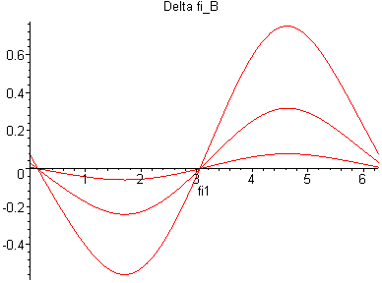
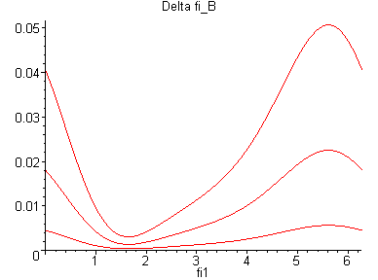
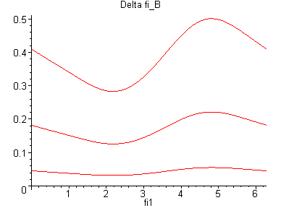
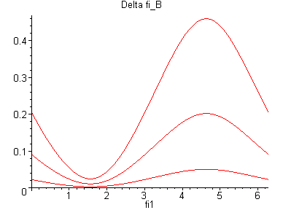
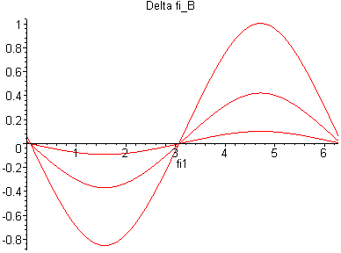
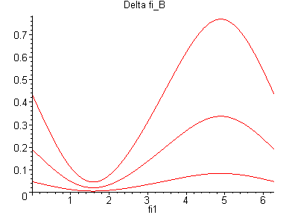
α=±3⁰; β =0
Δy=± 0.12 m
α=± 3⁰ ; ^{β}= 0
Δy= 0
α=β= ± 3⁰
Δy= ± 0.12 m
β =± 3⁰ ; ^{α}=0
Δy= 0
α=β =0
Δy=± 0.12 m
α=β =±3⁰
Δy=0

Figure 2: The variation of ϕ_{B}

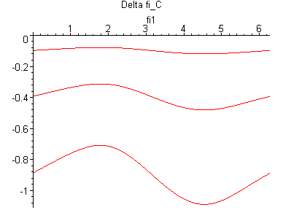
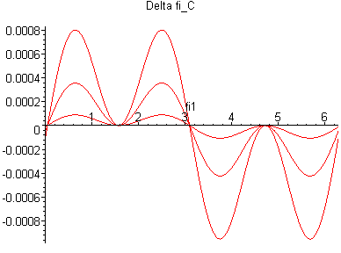
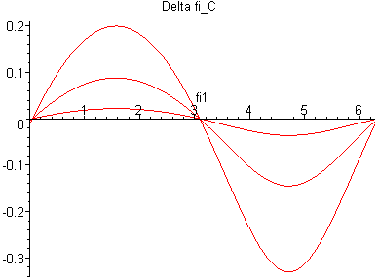
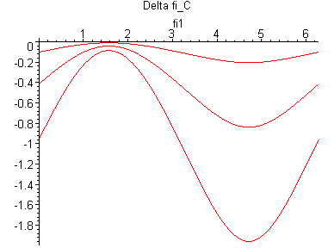
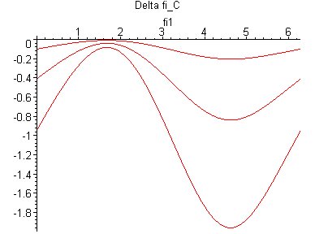
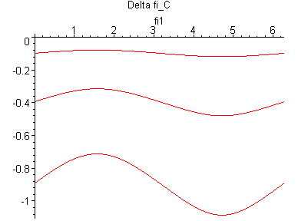
α=β= ± 3⁰
Δy= ± 0.12 m
α=± 3⁰ ; ^{β}= 0
Δy= 0
β =± 3⁰ ; ^{α}=0
Δy= 0
α=β =0
Δy=± 0.12 m
α=±3⁰; β =0
Δy=± 0.12 m
β =±3⁰ ; α=0,
Δy= ±0.12

Figure 3: The variation of ϕ_{C}

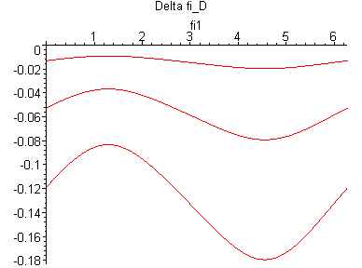
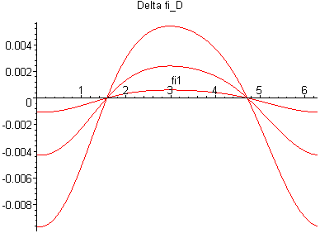
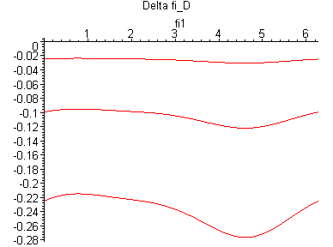
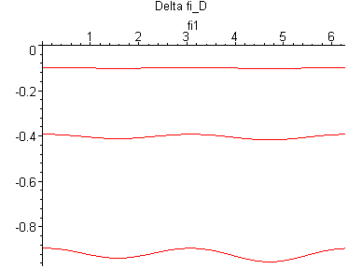
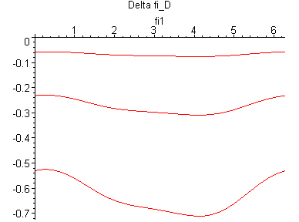
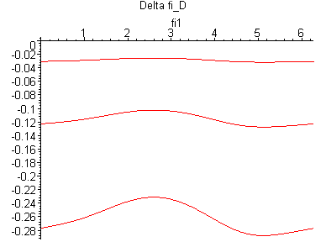
α=β= ± 3⁰
Δy= ± 0.12 m
α=± 3⁰ ; ^{β}= 0
Δy= 0
β =± 3⁰ ; ^{α}=0
Δy= 0
α=β =0
Δy=± 0.12 m
α=±3⁰; β =0
Δy=± 0.12 m
β =±3⁰ ; α=0,
Δy= ±0.12

Figure 4: The variation of ϕ_{D}

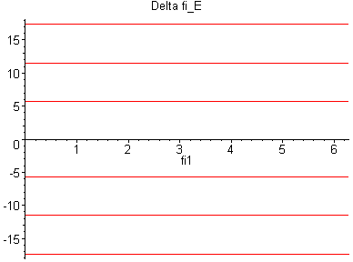
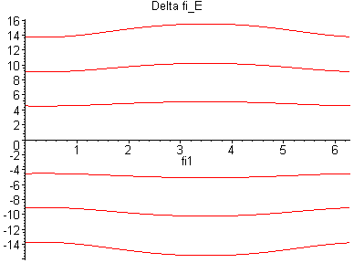
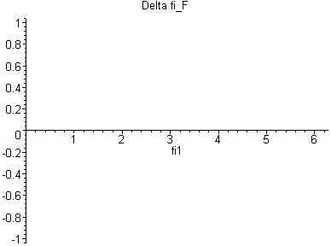
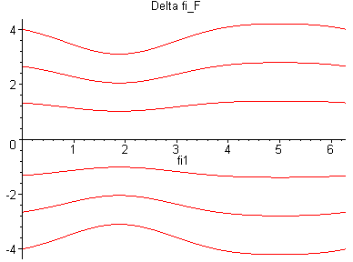
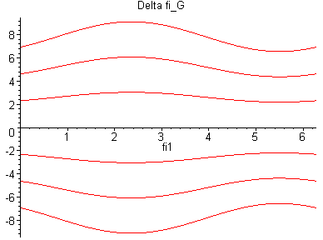
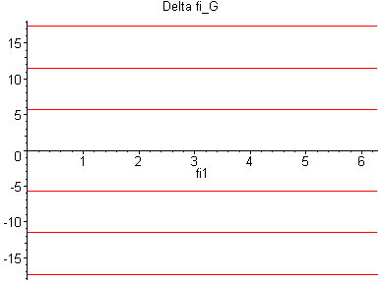
α=β =0
Δy=+ 0.12 m
α=+3⁰; β =0
Δy=+ 0.12 m
α=β =0
Δy=+ 0.12 m

α=β= + 3⁰
Δy= + 0.12 m
α=β= + 3⁰
Δy= + 0.12 m
α=β =0
Δy=+ 0.12 m

Figure 5: The variation of ϕ_{E}, ϕ_{F}, ϕ_{G}

- NUMERICAL SIMULATION

In the present paper, the simulation program is run with the following numerical values for the dimensions of the mechanism elements:
L₀=1.246 m, AB=L₁=0.12 m, CD=L₂=1.18 m, BC=L₃=0.4 m and ϕ₁ = [0, 2π] rad.
The errors are introduced in the mechanism, through the adjustment joints α, β and Δy, with the following range of variation:
$α, β ∈[−3^{0}, +3^{0}] , Δy ∈ [−0\text{.}\text{12} m, +0\text{.}\text{12} m]\text{.}$
Based on these numerical data, a program for the kinematical modeling of the mechanism in the spatial state (with non-zero values for α, β and Δy errors) was then elaborated. Firstly, the influence of each error on the angular displacements was numerically analyzed; the diagrams show the changes in the displacements values due to the errors from the adjustment joints; afterwards, the influence of the combinations of different errors on the same entities was numerically analyzed. In Fig. 2, 3, 4 and 5 there are represented the variations Δϕ_{i}=ϕ_{i}(α,β,Δy) - ϕ_{i}(0,0,0).
According to Fig. 2, it can be observed that the influence of α, β and Δy errors (considered with the extreme values) on the displacement from joints B can be characterized as follows: the error α don’t practically influence the relative motions from joint B; the influence of error Δy is the biggest. The pair of values α,β=±3⁰, ±2⁰, ±1⁰ and Δy=±0.12, ±0.08, ±0.04 have the same influence on the function Δϕ_{B} (in Fig. 2, each curve corresponds to two pairs of values for the same error).
According to Fig. 3, it can be observed that the influence of Δy error on the displacements from joint C is the biggest; the influences of α and β errors on the displacements from joint C are small, even if the errors are relatively big.
The influence of Δy on the output motion Δϕ_{D} is the biggest (Fig. 4); the influences of α and β errors on the displacements from joint D are small, even if the errors are relatively big.
The representations of the functions ΔE, ΔF, ΔG (Fig. 5) coincide to the diagrams of the functions ϕ_{E}(α,β,Δy), ϕ_{F}(α,β,Δy), ϕ_{G}(α,β,Δy), because the angles are null when the errors are zero (in the mechanism theoretical functioning conditions, the motions from joints E, F and G are passive). The error Δy doesn’t influence the displacements from joint F, but has a big influence on the other two joints.
In the case of combined errors (Fig. 2, 3, 4, 5) it can be observed that the influence of deviation Δy is irrelevant for joint F and much accentuated for joints E and G, in which the angular displacements are equal and of opposite direction; deviation β has comparable influences on the displacements from joints E and G, but are backwards.

- CONCLUSIONS

The errors have an irrelevant influence on the displacements from joints B, C and D. The angular displacements from the theoretically passive joints E, F and G grow together with the increase of the errors from the planar configuration: α, β and Δy. Under the premise that these joints are inexistent, pre-tensioning moments appear, moments that are equal to the product between the angular displacements and the elements modulus of elasticity. Obviously, due to the reduced elements elasticity, pre-tensioning moments of big values can appear in the closed chain; in these conditions, the mechanism durability is compromised, being necessary to insert supplementary adequate mobilities.

REFERENCES

- DUDIŢĂ, FL., DIACONESCU, D.V. Structural Optimization of Mechanisms. (in Romanian). Editura Tehnică, Bucureşti, 1987.
- DUDIŢĂ,F., DIACONESCU,D. Structurelle Optimierung der einfachen Mechanismen. Maschinenbautechnik, Berlin 35, 1986 11.

