1st International Conference
″Computational Mechanics and Virtual Engineering ″
COMEC 2005
20 – 22 October 2005, Brasov, Romania

ASPECTS REGARDING THE CALCULUS OF ELASTIC STRUCTURES WITH STATIC UNDETERMINED RODS FOR FORCE/TORQUE SENSORS

A. Dumitriu¹
¹ “Transilvania” University of Braşov, Romania, e-mail: adrdum@unitbv.ro

Abstract: The paper presents the theoretic calculus, using the displacements’ method of the coupling matrices for force/torque sensors, composed of static undetermined rods, which support strain gauges mounted in eight Wheatstone bridges. The configuration with four horizontal and four vertical rods is considered. Theoretical results are compared with the experimental data, measured on a sensor, developed and manufactured in the laboratory.
Keywords: Force sensor, Elastic structure, Coupling matrix

1. INTRODUCTION

A great number of force/torque sensors in robotic applications use strain gauges, mounted on their elastic structure (composed of rods fixed at both ends) and connected in 8 Wheatstone bridges, in such a manner, that only the bending stresses of the rods become relevant. This category of sensors include the Maltese cross ones [1, 2] and those with four horizontal and four vertical rods [1, 3, 4]. The study of the main features, which allow the theoretic calculus of coupling and decoupling matrices, is necessary for two reasons:
- The computer aided design of the elastic structures;
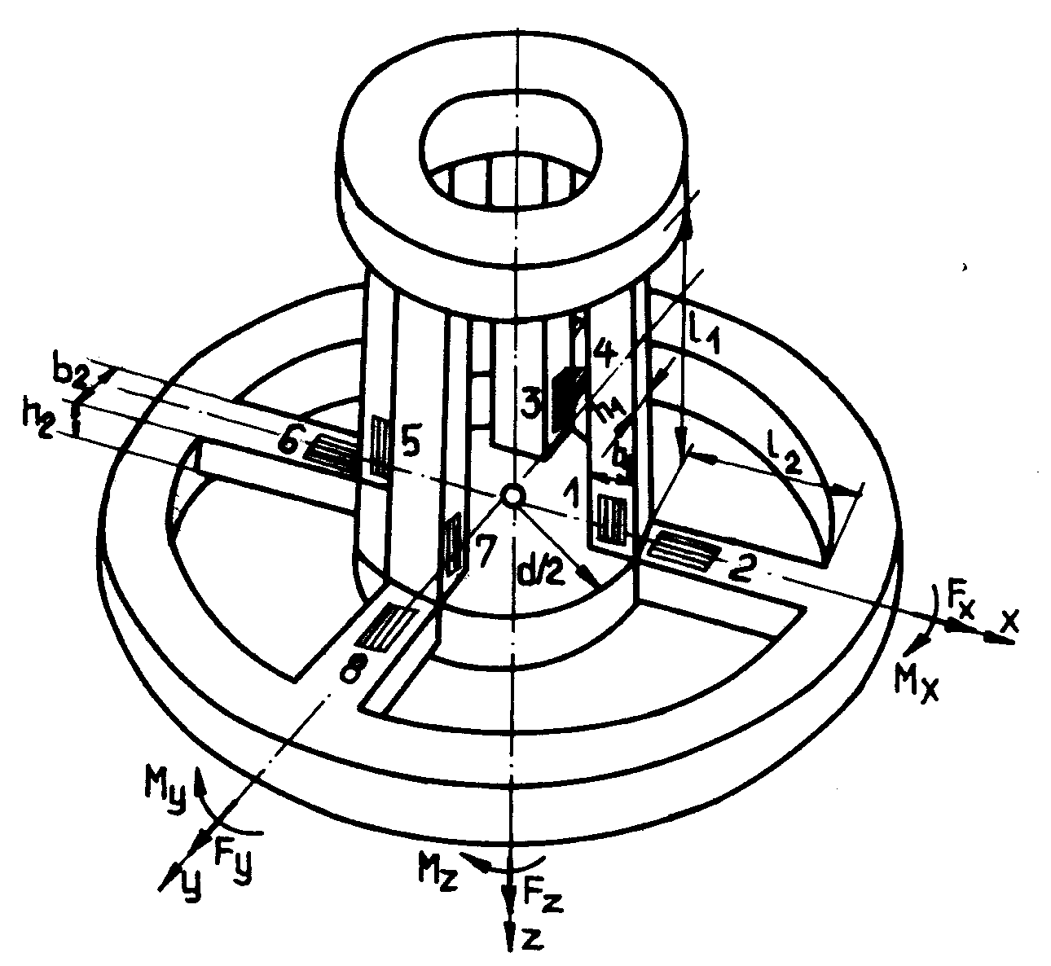
- In order to identify for these types of sensors some deficiencies which limit their sensitivity and to propose new solutions, with superior performances.

Figure 1: Configuration and notations for the sensor with 4 vertical and 4 horizontal rods
A sensor with four horizontal and four vertical rods is presented in figure 1. It can measure all six components of force and torque interaction with the environment.

The four vertical rods are fixed at one end with an upper ring and at the other end with a central ring, which also supports the horizontal elements at one end. It will be also considered that the upper ring is fixed at the robot’s arm and at the lower ring, which supports the horizontal rods at the other end and has the possibility of small displacements and rotations, the end-effector of the robot is fixed.

On each rod of the elastic structure, near the central ring, two strain gauges are disposed, connected in adjacent arms of a Wheatstone bridge and reacting to the bending stresses of the elastic elements as follows:
- Gauges 1 and 5 - to F_{y}, M_{z};
- Gauges 2 and 6 - to F_{z}, M_{y}
- Gauges 3 and 7 - to F_{x}, M_{z};
- Gauges 4 and 8 - to F_{z}, M_{x}.

All rods are considered rigid fixed at both ends, and, hence, static undetermined. In order to solve the indetermination, the displacements’ method has been used [1].

2. CALCULUS OF THE COUPLING MATRIX
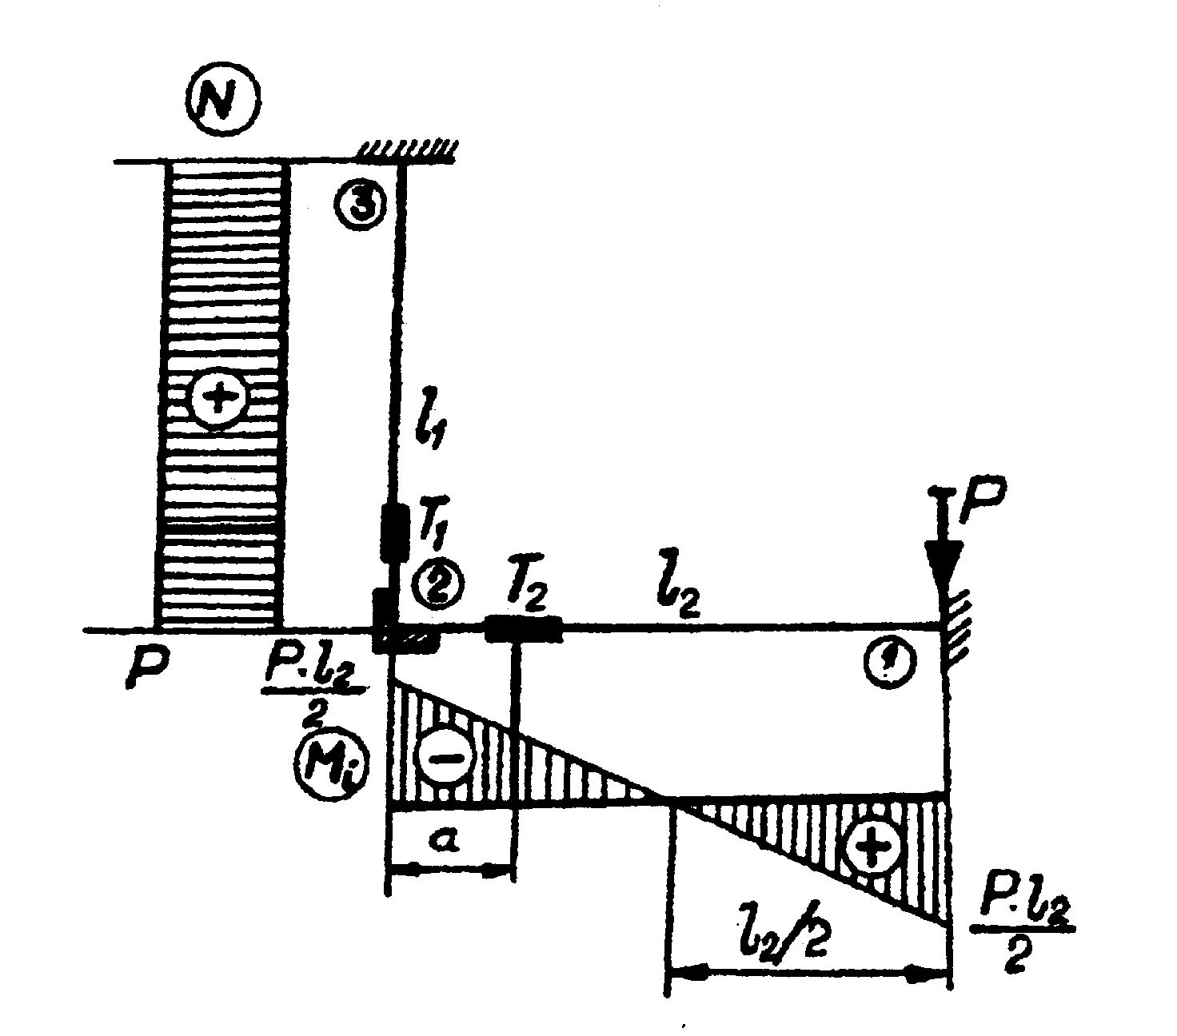
2.1 Calculus of displacements determined by force components
Figure2: Stress diagram for rods subject to forces F_{Z}

To determine the sensor’s response to F_{z} forces, the stress diagram in figure 2 is used. The F_{z} component produces bending of all horizontal rods, while the vertical rods are subject to traction. Considering, a, the distance between the centre of a gauge and the point of fixing the rods, the output signals of the gauges are proportional with:
$\begin{aligned}σ_{\text{gauge}2}=\frac{M_{\text{gauge}2}}{W_{\text{z2}}}=\frac{3⋅F_{z}}{4⋅b_{2}⋅h_{2}^{2}}⋅(l_{2}⋅a) \\ σ_{\text{gauge}1}\text{ = }\frac{F_{z}}{4⋅b_{1}⋅h_{1}}\text{.}\end{aligned}$ (1)
The displacement of point 1 of the rod structure is:
$\text{w=}\frac{F_{z}}{4}⋅(\frac{l_{1}}{E⋅A_{2}}+\frac{l_{2}^{3}}{\text{12}⋅E⋅I_{\text{z2}}})$ (2)
When the sensor is subject to forces along the x or y axes, we consider that the upper ring and the lower ensemble, build up by the inner ring, the four horizontal rods and the outer ring, have a great stiffness, with respect to the vertical rods 1, 3, 5 şi 7, which are all subject to bending efforts. The maximum strain will be at the lower end of the rods, caused by the displacement of the whole ensemble with the deflection induced by the applied force. In case of F_{x} forces, gauges 3 and 7 are sensitive, while for F_{y} forces useful signals are picked up from gauges 1 and 5. The two rods along the axis of maxim sensitivity will take over a fraction α of the applied force, while the other two rods, along a perpendicular axis, a fraction β.
To determine the coefficients α and β, two bundle conditions have to be imposed:

$α\text{ + }β\text{ = }\frac{1}{2}\text{; }\frac{β\text{.}F_{x}\text{.}l_{1}^{3}}{\text{12}\text{.}E\text{.}\frac{b_{1}\text{.}h_{1}^{3}}{\text{12}}}\text{ = }\frac{α\text{.}F_{x}\text{.}l_{1}^{3}}{\text{12}\text{.}E\text{.}\frac{b_{1}^{3}\text{.}h_{1}}{\text{12}}},$ (3)
resulting:
$α = \frac{b_{1^{2}}}{2⋅(b_{1^{2}}+h_{1^{2}})}; β = \frac{h_{1^{2}}}{2⋅(b_{1^{2}}+h_{1^{2}})}\text{.}$ (4)

Thus, a force F_{x} , along the x-axis, will determine following effects upon the gauges:

$\begin{aligned}ε_{\text{gauge}3}=ε_{\text{gauge7}}=\frac{3⋅F_{x}}{2}⋅\frac{l_{1}\text{-2}⋅a}{b_{1}⋅(b_{1}^{2}+h_{1}^{2})}; \\ ε_{\text{gauge1,2,4,5,6,8}}\text{ = 0}\end{aligned}$ (5)
and a deflection of the lower ring, expressed by:
$\text{v=}\frac{F_{x}}{2⋅E}⋅\frac{h_{1}^{2}}{b_{1}^{2}+h_{1}^{2}}⋅\frac{l_{1}^{3}}{b_{1}⋅h_{1}^{3}}\text{.}$ (6)

A torque along the z-axis of the sensor determines bending stresses, but, due to the manner the strain gauges are mounted on the rods, only the gauges on the vertical rods will seize the effects. The global action of a torque M_{z} is equivalent to that of applying a perpendicular force, F=M_{z}/4.(d/2+l₂), upon the frame build up by a horizontal and a vertical rod. The problem of determining the stresses is more complicated, as the lower inner and outer rings rotate, due to the strains of the horizontal and vertical rods. Things have been simplified by considering that force F determines bending stresses on the vertical rods, and the following effects upon the strain gauges mounted on the rods:
$σ_{\text{gauge2}}=σ_{\text{gauge4}}= −σ_{\text{gauge6}}= −σ_{\text{gauge8}}=3⋅\frac{(\frac{l_{1}}{2}\text{-a})}{2⋅b_{1}⋅h_{1}^{2}⋅(\frac{d}{2}+ l_{2})}M_{z}σ_{\text{gauge1,3,5,7}}$ (7)
To establish the relation between the deformation of the elastic elements and the M_{x} torque applied, the calculus model is modified: a fraction of M_{x} is used to bend the rods 4 and 8, while another important fraction is consumed to torsion the elastic elements 2 and 6, considerably reducing the sensor’s sensitivity with respect to this component. The lower outside ring will rotate with an angle φ and a radius of d/2+l₂=D/2 (figure 3).
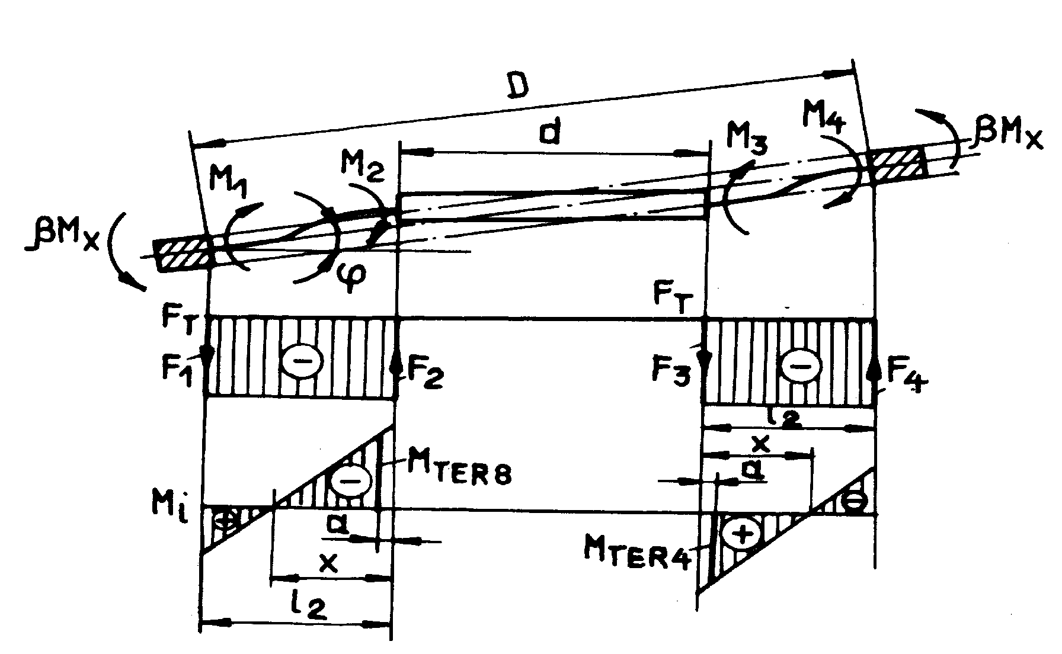
Figure 3: Stress diagram for rods subject to torques M_{x} or M_{y}

The displacement matrix has the following configuration:
$δ \text{ = } [\text{0, } ϕ\text{.}\frac{D}{2}\text{, } −ϕ\text{, } \text{0, } \text{0, } 0]\text{.}$ (8)
Introducing the displacements (8) in the matrix relation which relates them to the forces, via the stiffness matrix [1], the values for shearing forces and bending torques can be determined (9), which enable the draw up of the stress diagram presented in figure 3.
$\begin{aligned}F_{1}\text{ = -}F_{2}\text{ = }\frac{\text{12}\text{.}E\text{.}I_{i}}{l_{2}^{3}}\text{.}ϕ\text{.}\frac{D}{2}−\frac{6\text{.}E\text{.}I_{i}}{l_{2}^{2}}\text{.}ϕ\text{ = }\frac{6\text{.}E\text{.}I_{i}}{l_{2}^{2}}\text{.}ϕ\text{.}(\frac{D}{l_{2}}\text{-1}); \\ M_{1}\text{ = }\frac{6\text{.}E\text{.}I_{i}}{l_{2}^{2}}\text{.}ϕ\text{.}\frac{D}{2}−\frac{4\text{.}E\text{.}I_{i}}{l_{2}}\text{.}ϕ\text{; }M_{2}\text{ = }\frac{6\text{.}E\text{.}I_{i}}{l_{2}^{2}}\text{.}ϕ\text{.}\frac{D}{2}−\frac{2\text{.}E\text{.}I_{i}}{l_{2}}\text{.}ϕ\text{.}\end{aligned}$ (9)
The bundle condition in this case can be expressed by equalling the rotation angles of the horizontal rod pairs: rods 4 and 8, subject to bending stresses and rods 2 and 6, subject to torsion:
$ϕ\text{ = }\frac{M_{1}⋅l_{2}^{2}}{E\text{.}I_{i}\text{.}(3\text{.}\text{D-4}\text{.}l_{2})}\text{ = }\frac{M_{t}\text{.}l_{2}}{G\text{.}I_{t}} → \frac{M_{1}}{M_{t}}\text{ = }\frac{E\text{.}I_{i}\text{.}(3\text{.}\text{D-4}\text{.}l_{2})}{G\text{.}I_{t}\text{.}l_{2}} = c_{\text{31}},$ (10)
Adding the condition:
$2\text{.}(M_{1}{\text{ + M}}_{t}){\text{ = M}}_{x}{\text{ - F}}_{1}\text{.}D_{1}\text{.}$ (11)
following equations can be determined:
$\begin{aligned}M_{1} \text{ = } c_{\text{31}}\text{.}\frac{G\text{.}I_{t}\text{.}l_{2}\text{+E}\text{.}I_{i}\text{.}(3\text{.}\text{D-4}\text{.}l_{2})}{G\text{.}I_{t}\text{.}l_{2}\text{+E}\text{.}I_{i}\text{.}(2\text{.}{\text{D+D}}^{2}{\text{/l}}_{2}\text{-4}\text{.}l_{2})}\text{.}\frac{M_{x}}{2}{\text{ = c}}_{\text{31}}\text{.}c_{\text{32}}\text{.}\frac{M_{x}}{2} \\ \frac{M_{2}}{M_{1}}\text{ = }\frac{3\text{.}\text{D-2}\text{.}l_{2}}{3\text{.}\text{D-4}\text{.}l_{2}}{\text{; M}}_{2}\text{ = }\frac{3\text{.}\text{D-2}\text{.}l_{2}}{3\text{.}\text{D-4}\text{.}l_{2}}\text{.}M_{1}{\text{; x = l}}_{2}\text{.}\frac{3\text{.}\text{D-2}\text{.}l_{2}}{6\text{.}({\text{D-l}}_{2})}; \\ σ_{\text{gauge4,8}}\text{ = }\frac{6}{b_{2}\text{.}h_{2^{2}}}\text{.}\frac{\text{x-a}}{x}\text{.}\frac{3\text{.}\text{D-2}\text{.}l_{2}}{3\text{.}\text{D-4}\text{.}l_{2}}\text{.}c_{\text{31}}\text{.}c_{\text{32}}\text{.}\frac{M_{x}}{2}\text{.}\end{aligned}$ (12)

2.2 Configuration of coupling and decoupling matrices

The configuration of the sensor’s coupling matrix can be expressed using equation (1), (5), (7) and (12). Extension/compression effects are ignored, as long as, they are eliminated by a proper mounting of gauges in the measuring bridges. The coupling matrix (13) links the relative strains of gauges and, hence, the electric signals acquired from Wheatstone bridges, to the interaction forces between the sensor and his environment:
$\left[\begin{matrix}ε_{1} \\ ε_{2} \\ ε_{3} \\ ε_{4} \\ ε_{5} \\ ε_{6} \\ ε_{7} \\ ε_{8}\end{matrix}\right]=\frac{1}{E}⋅\left[\begin{matrix}0 & {\text{-c}}_{1} & 0 & 0 & 0 & c_{4} \\ 0 & 0 & c_{2} & 0 & −c_{3} & 0 \\ −c_{1} & 0 & 0 & 0 & 0 & c_{4} \\ 0 & 0 & c_{2} & −c_{3} & 0 & 0 \\ 0 & −c_{1} & 0 & 0 & 0 & c_{4} \\ 0 & 0 & c_{2} & 0 & c_{3} & 0 \\ −c_{1} & 0 & 0 & 0 & 0 & c_{4} \\ 0 & 0 & c_{2} & c_{3} & 0 & 0\end{matrix}\right]⋅\left[\begin{matrix}F_{x} \\ F_{y} \\ F_{z} \\ M_{x} \\ M_{y} \\ M_{z}\end{matrix}\right]$ (13)
where:
$\begin{aligned}c_{1}\text{ =}\frac{3}{2}\text{.}\frac{l_{1}\text{-2}\text{.}a}{b_{1}\text{.}(b_{1^{2}}{\text{+h}}_{1^{2}})}{\text{; c}}_{2}\text{ = }\frac{3\text{.}(\frac{l_{2}}{2}\text{-a})}{2\text{.}b_{2}\text{.}h_{2^{2}}}; c_{3}\text{ = }\frac{3}{b_{2}\text{.}h_{2^{2}}}\text{.}\frac{\text{x-a}}{x}\text{.}\frac{3\text{.}\text{D-2}\text{.}l_{2}}{3\text{.}\text{D-4}\text{.}l_{2}}\text{.}c_{\text{31}}\text{.}c_{\text{32}}; \\ c_{4}\text{ = }\frac{3\text{.}(\frac{l_{1}}{2}\text{-a})}{2\text{.}b_{1}\text{.}h_{1^{2}}\text{.}(\frac{d}{2}{\text{+l}}_{2})}{\text{; I}}_{i}\text{ = }\frac{b_{2}\text{.}h_{2^{3}}}{\text{12}}{\text{; I}}^{t}\text{ = k}\text{.}b_{2}\text{.}h_{2^{3}}\text{.}\end{aligned}$ (14)
The decoupling matrix is calculated as a pseudo-inverse matrix of the coupling matrix [1] and relates the force/torque vector to the signals from strain gauges. This matrix actually serves for calculating the interaction forces and is provided by the sensor producer based on an experimental calibration procedure.

3. EXPERIMENTAL RESULTS

In the robotics laboratory of the Precision-Mechanics and Mechatronics Department a force/torque sensor with four horizontal and four vertical rods has been developed, manufactured and tested. Taking into account the notations in figure 1, the dimensions of the sensor used for experiments are:
l₁ = 40 mm; b₁ = 8mm; h₁ = 2,8 mm;
l₂ = 40 mm; b₂ = 8 mm; h₂ = 2,8 mm;
a = 8 mm; d = 28 mm.
Using equations (14) and (13) the theoretical coupling matrix has been calculated, with E = 2.10¹¹ N/m² for steel (elastic structure manufactured of 50 VC 11 steel):
$\left[\begin{matrix}ε_{1} \\ ε_{2} \\ ε_{3} \\ ε_{4} \\ ε_{5} \\ ε_{6} \\ ε_{7} \\ ε_{8}\end{matrix}\right] = \left[\begin{matrix}0 & −0,\text{31} & 0 & 0 & 0 & 0,\text{0256} \\ 0 & 0 & 1,\text{435} & 0 & −0,\text{09} & 0 \\ −0,\text{31} & 0 & 0 & 0 & 0 & 0,\text{0256} \\ 0 & 0 & 1,\text{435} & −0,\text{09} & 0 & 0 \\ 0 & −0,\text{31} & 0 & 0 & 0 & 0,\text{0256} \\ 0 & 0 & 1,\text{435} & 0 & 0,\text{09} & 0 \\ −0,\text{31} & 0 & 0 & 0 & 0 & 0,\text{0256} \\ 0 & 0 & 1,\text{435} & 0,\text{09} & 0 & 0\end{matrix}\right]⋅\left[\begin{matrix}F_{x} \\ F_{y} \\ F_{z} \\ M_{x} \\ M_{y} \\ M_{z}\end{matrix}\right]$ (15)
The experimental matrix has been determined using:
- A calibration device, which allows to load the sensor with certain forces and torque along the three axes;
- A signal processing chain, including a very sensitive signal-conditioning unit for 8 channels, a analog/digital conversion board and a PC, with the adequate software.

The decoupling matrix determined experimentally:

$\left[\begin{matrix}ε_{1} \\ ε_{2} \\ ε_{3} \\ ε_{4} \\ ε_{5} \\ ε_{6} \\ ε_{7} \\ ε_{8}\end{matrix}\right] = \left[\begin{matrix}0 & −0,\text{38} & 0 & 0 & 0 & 0,\text{0251} \\ 0 & 0 & 1,\text{79} & 0 & −0,\text{109} & 0 \\ −0,\text{38} & 0 & 0 & 0 & 0 & 0,\text{0251} \\ 0 & 0 & 1,\text{79} & −0,\text{109} & 0 & 0 \\ 0 & −0,\text{38} & 0 & 0 & 0 & 0,\text{0251} \\ 0 & 0 & 1,\text{79} & 0 & 0,\text{109} & 0 \\ −0,\text{38} & 0 & 0 & 0 & 0 & 0,\text{0251} \\ 0 & 0 & 1,\text{79} & 0,\text{109} & 0 & 0\end{matrix}\right]⋅\left[\begin{matrix}F_{x} \\ F_{y} \\ F_{z} \\ M_{x} \\ M_{y} \\ M_{z}\end{matrix}\right]$ (16)

matches very satisfactory with the theoretic one (15).

Both prove a very good sensitivity for F_{z} , M_{x} and M_{y} components, but a considerable less sensitivity for F_{x}, F_{y} and M_{z} components. In case of Fx and Fy, the lower sensitivity is caused by the fact that only a small fraction of the measured force influences the active gauges, while the other part serves for bending the perpendicular rod pair. Thus the active fraction is:
$c_{{F_{x}}/{F_{y}}} = \frac{b_{1}\text{.}h_{1^{2}}}{b_{1^{2}}\text{.}h_{1} + b_{1}h_{1^{2}}} = 0,\text{27}\text{.}$ (17)

The sensitivity for M_{x} and M_{y} is remarcable, due to the fact that a part of this components serves to torsion the rods and is not seized by the active gauges.

REFERENCES

[1] Dumitriu, A.; Bucşan, C.; Demian, T.: Sisteme senzoriale pentru roboţi, Editura Medro, Bucureşti,1996.
[2] Dumitriu, A., The Calculus of Elastic Structures with Static Undetermined Rods for Force/Torque Sensors, Bulletin of the Transilvania University of Braşov, Vol.1 (36) – New series, Series A, 1994, pp.21-28.
[3] Hirzinger, G. et all: The New Generation of DFVLR Robot Sensors, International Advanced Robotics Programme, Karlsruhe, 1987.
[4] Kasai, M. et all: Trainable Assembly Systems with an Active Sensory Table Possessing 6 Axes, Robot Sensors, vol.2, Springer Verlag,1985.

