1st International Conference
″Computational Mechanics and Virtual Engineering ″
COMEC 2005
20 – 22 October 2005, Brasov, Romania

SOME ASPECTS OF THE DYNAMIC STABILITY OF AN INDUSTRIAL MACHINE

Cristian DRAGOMIRESCU¹, Victor ILIESCU²
¹ Polytechnic University of Bucharest, Bucharest, romania, dragom@cat.mec.pub.ro
² Civil Engineering Technical University of Bucharest, Bucharest, ROMNAIA, victori@mec.edu.ro

Abstract: The paper is using the stroboscopic application to study different aspects of the stability of the motion for the adopted model, in certain conditions, in order to highlight out the corresponding Poincaré sections.
The obtained results, together with the phase space representations, are pointing out, from a qualitative point of view, the possibility of apparition of deterministic chaotically motions.
Keywords: deterministic chaos, Poincaré application, phase space, dynamical system

1. The presentation of the studied model and the calculation of the differential equation of the system motion

The studied model [3] was adopted as shown in figure 1 and is showing a situation that is frequently met in engineering, when an inertial vibrations generator is present.

Figure 1: The studied model
c₁
c₁
c₂
c₂
k₂
k₂
k₁
k₁
M+m
e
C₀
x
The position of static equilibrium
e
The model is pointing out the existence of a forced vibratory system with F_{p}(t) as the force inducing the vibrations. The elastic connections of the vibrating element (masses m+M) with the foundation are done with the springs having the stiffness k₁. If the displacement is greater than “e”, then an elastic limiting device of the motion is activated. The stiffness of this element is k₂. The system is also having viscous dampers both on the vibrating system (damping coefficient c₁) and on the limiting device (damping coefficient c₂).
The excitation force F_{p}(t) is oriented along the motion direction of the vibrating element and it is produced by two elements having opposite motions (eccentric elements).
In order to determine the differential equation of the motion, the d’Alembert principle is used, based on the equivalences shown in figure 2.
According to the figures 2a and 2b, the equation (1) and respectively (2) are deduced.
$\left(M+m\right)\overset{¨}{x}+2c_{1}\overset{˙}{x}+2k_{1}x=\text{mr}Ω^{2}\text{cos}\left(Ωt\right)$, (1)
$\left(M+m\right)\overset{¨}{x}+2c_{1}\overset{˙}{x}+c_{2}\overset{˙}{x}+2k_{1}x+k_{2}\left(x−e\right)=\text{mr}Ω^{2}\text{cos}\left(Ωt\right)$. (2)
where: M is the mass of the oscillator; m – the total mass of the eccentrics elements; k₁ – the stiffness of the springs connecting the vibrating element to the foundation; k₂ – the stiffness of the springs of the limiting device of the motion; c₁ – the damper coefficient of the connection of the vibrating element to the foundation; c₂ – the damper coefficient of the limiting device of the motion; e – the free movement of the oscillator to limiting device of the motion; r – the distance from the mass centre of the oscillator to the eccentric; Ω – angular speed of the inertial generator.

C
(a)
x ≤ e (– e ≤ x)
C₀
x

Figure 2: The equivalence pattern
C
(b)
x > e (x < - e)
C₀
x

Using the following values and notation:
$\begin{aligned}\left.k_{1}=0,5k\text{ ; }k_{2}=k ; c_{1}=0,5c\text{ ; }c_{2}=c\text{ ; }γ=\frac{\text{mr}}{M+m}Ω^{2} | \right\}\left.ω_{1}^{2}=\frac{k_{2}}{M+m}=\frac{k}{M+m} ; ω_{2}^{2}=\frac{2k_{1}+k_{2}}{M+m}=\frac{2k}{M+m} | \right\}\end{aligned}$, (3)
we may write the general form for (1) and (2) equations:
$\overset{¨}{x}+2δ_{2}\overset{˙}{x}+ω_{2}^{2}x−γ\text{cos}\left(Ωt\right)=\begin{aligned}\left\{ω_{1}^{2}e\text{ , }x<e | \right.\left\{2δ_{1}\overset{˙}{x}+ω_{1}^{2}x\text{ , -e}≤x≤e | \right.\end{aligned}$, (4)
that is equivalent with the following form:
$\overset{¨}{q}+2α\overset{˙}{q}+β^{2}q=γ\text{cos}\left(Ωt\right)$, (5)
where
$\begin{aligned}\left.2α=2δ_{2}=\frac{2c}{M+m} ; β^{2}=ω_{2}^{2}=\frac{2k}{M+m} ; q=x∓\frac{e}{2}\text{ for }x>e\text{ or }\text{ x}<−e | \right\}\end{aligned}$ (6)
If the spring stiffness is nonlinear (which may be true due to the constructive reasons or by accident due to the spring material, spring to large elongation etc.), suing a similar approach as before, we may obtain the following equivalence for the equation (5):
$\overset{¨}{q}+2α\overset{˙}{q}+β^{2}q+{δq}^{3}=γ\text{cos}\left(Ωt\right)$. (7)

2. Theoretical considerations on the stability of the periodically solutions, using the Poincaré application

In the specialised literature [4] we note with “p” the single point where the periodical orbit γ is intersecting the transversal hyper-surface Σ, with U ≤ Σ, a certain neighbourhood of “p” and is defined as the first “return” or the Poincaré application P : U → Σ, having the following form:
$P\left(q\right)=Φ_{τ}\left(q\right)$, (8)
where q ∈ U; τ = τ(q) is the time necessary to cover the trajectory that starts in “q” and ends, after the first return, in Σ (it is not necessary equal with the T period of the γ orbit); Φ_{τ} –a current of the differential equation system $\overset{˙}{x}=f\left(x\right), x∈R^{n}$.
If q → p, then τ → T and results that p is a fix point of the Poincaré application, that means that P(p) = p.

The equation (5) is equivalent with the differential equation system:
$\begin{aligned}\left\{{\overset{˙}{q}}_{1}=q_{2} | \right.\left\{{\overset{˙}{q}}_{2}=−2{αq}_{2}−β^{2}q_{1}+γ\text{cos}q_{3} | \right.\end{aligned}$, (9)
having the general solution:
$\begin{aligned}\left\{q_{1}=e^{−αt}\left[C_{1}\text{cos}\left(\sqrt{β^{2}−α^{2}}t\right)+C_{2}\text{sin}\left(\sqrt{β^{2}−α^{2}}t\right)\right]+ | \right.\left\{ +\frac{\left(β^{2}−Ω^{2}\right)γ}{\sqrt{{\left(β^{2}−Ω^{2}\right)}^{2}+4α^{2}Ω^{2}}}\text{cos}\left(Ωt\right)+\frac{2αΩγ}{\sqrt{{\left(β^{2}−Ω^{2}\right)}^{2}+4α^{2}Ω^{2}}}\text{sin}\left(Ωt\right) | \right.\left\{q_{1}=e^{−αt}\left[\left(C_{2}\sqrt{β^{2}−α^{2}}−{αC}_{1}\right)\text{cos}\left(\sqrt{β^{2}−α^{2}}t\right)+\left(C_{1}\sqrt{β^{2}−α^{2}}+{αC}_{2}\right)\text{sin}\left(\sqrt{β^{2}−α^{2}}t\right)\right]− | \right.\left\{ −\frac{\left(β^{2}−Ω^{2}\right)γΩ}{\sqrt{{\left(β^{2}−Ω^{2}\right)}^{2}+4α^{2}Ω^{2}}}\text{sin}\left(Ωt\right)+\frac{2αΩ^{2}γ}{\sqrt{{\left(β^{2}−Ω^{2}\right)}^{2}+4α^{2}Ω^{2}}}\text{cos}\left(Ωt\right) | \right.\end{aligned}$. (10)
C₁ and C₂ constants are determined considering the initial conditions $\left(t=0⇒\left\{\begin{matrix}q_{1}=q_{\text{10}} \\ q_{2}=q_{\text{20}}\end{matrix}\right.\right)$. Applying the classical procedure [4] we obtain the following values:
$\begin{aligned}\left\{C_{1}=q_{\text{10}}−\frac{γ\left(β^{2}−Ω^{2}\right)}{\sqrt{{\left(β^{2}−Ω^{2}\right)}^{2}+4α^{2}Ω^{2}}} | \right.\end{aligned}$. (11)
Because the variable q₃ is circular, the trajectory is crossing the hyper-surface Σ (considered in this case the Oq₁q₂ plane) at time intervals equals with $\frac{2π}{Ω}$, corresponding with the following values of the q₃ variable [4]: 2π, 4π, …
Considering $t=\frac{2π}{Ω}$ in the equation (10) and also considering the values for C₁ and C₂ obtained above, (11), the Poincaré application becomes:
$\begin{aligned}P\left(q_{\text{10}},q_{\text{20}}\right)=\left\{e^{−α\frac{2π}{Ω}}[\left(q_{\text{10}}−\frac{γ\left(β^{2}−Ω^{2}\right)}{\sqrt{{\left(β^{2}−Ω^{2}\right)}^{2}+4α^{2}Ω^{2}}}\right)\text{cos}\left(\frac{2π}{Ω}\sqrt{\left(β^{2}−Ω^{2}\right)}\right)+\right. \\ +\left(\frac{\left(q_{\text{20}}+{αq}_{\text{10}}\right)\sqrt{{\left(β^{2}−Ω^{2}\right)}^{2}+4α^{2}Ω^{2}}−\text{αγ}\left(β^{2}+Ω^{2}\right)}{\sqrt{\left(β^{2}−α^{2}\right)\left[{\left(β^{2}−Ω^{2}\right)}^{2}+4α^{2}Ω^{2}\right]}}\right)\text{sin}\left(\frac{2π}{Ω}\sqrt{\left(β^{2}−Ω^{2}\right)}\right)]+ \\ +\frac{γ\left(β^{2}−Ω^{2}\right)}{\sqrt{{\left(β^{2}−Ω^{2}\right)}^{2}+4α^{2}Ω^{2}}} ; e^{−α\frac{2π}{Ω}}[\left(q_{\text{20}}−\frac{2\text{αγ}Ω^{2}}{\sqrt{{\left(β^{2}−Ω^{2}\right)}^{2}+4α^{2}Ω^{2}}}\right)\text{cos}\left(\frac{2π}{Ω}\sqrt{\left(β^{2}−Ω^{2}\right)}\right)− \\ −\frac{β^{2}\left[q_{\text{10}}\sqrt{{\left(β^{2}−Ω^{2}\right)}^{2}+4α^{2}Ω^{2}}−γ\left(β^{2}−Ω^{2}\right)\right]+α\left(q_{\text{20}}−2\text{αγ}Ω^{2}\right)}{\sqrt{\left(β^{2}−α^{2}\right)\left[{\left(β^{2}−Ω^{2}\right)}^{2}+4α^{2}Ω^{2}\right]}}\text{sin}\left(\frac{2π}{Ω}\sqrt{\left(β^{2}−Ω^{2}\right)}\right)]+ \\ \left.+\frac{2\text{αγ}Ω^{2}}{\sqrt{{\left(β^{2}−Ω^{2}\right)}^{2}+4α^{2}Ω^{2}}}\right\}\end{aligned}$. (12)
Application shown in expression (12) is linear and the matrix
$\begin{aligned}\left[\begin{matrix}\frac{∂P_{1}}{∂q_{\text{10}}} & \frac{∂P_{1}}{∂q_{\text{20}}} \\ \frac{∂P_{2}}{∂q_{\text{10}}} & \frac{∂P_{2}}{∂q_{\text{20}}}\end{matrix}\right]=[\begin{matrix}e^{−α\frac{2π}{Ω}}\left[\text{cos}\left(\frac{2π}{Ω}\sqrt{β^{2}−α^{2}}\right)+\frac{α}{\sqrt{β^{2}−α^{2}}}\text{sin}\left(\frac{2π}{Ω}\sqrt{β^{2}−α^{2}}\right)\right] \\ e^{−α\frac{2π}{Ω}}\frac{β}{\sqrt{β^{2}−α^{2}}}\text{sin}\left(\frac{2π}{Ω}\sqrt{β^{2}−α^{2}}\right)\end{matrix} \\ \\ \begin{matrix}e^{−α\frac{2π}{Ω}}\frac{1}{\sqrt{β^{2}−α^{2}}}\text{sin}\left(\frac{2π}{Ω}\sqrt{β^{2}−α^{2}}\right) \\ e^{−α\frac{2π}{Ω}}\left[\text{cos}\left(\frac{2π}{Ω}\sqrt{β^{2}−α^{2}}\right)−\frac{α}{\sqrt{β^{2}−α^{2}}}\text{sin}\left(\frac{2π}{Ω}\sqrt{β^{2}−α^{2}}\right)\right]\end{matrix}]\end{aligned}$ (13)
is leading to the characteristic equation
$λ^{2}+{λe}^{−α\frac{2π}{Ω}}\text{cos}\left(\frac{2π}{Ω}\sqrt{β^{2}−α^{2}}\right)+e^{−α\frac{4π}{Ω}}=0$. (14)
The solutions of the complex equation (13)
$λ_{1,2}=\frac{1}{2}e^{−α\frac{2π}{Ω}}\left[−\text{cos}\left(\frac{2π}{Ω}\sqrt{β^{2}−α^{2}}\right)±i\sqrt{4−{\text{cos}}^{2}\left(\frac{2π}{Ω}\sqrt{β^{2}−α^{2}}\right)}\right]$, (15)
are having the following modules
$\left|λ_{1}\right|=\left|λ_{2}\right|=e^{−α\frac{2π}{Ω}}<1$. (16)
It results that the orbits of the point P are getting closer to a point having the following coordinates $\left(q_{1}=\frac{γ\left(β^{2}−α^{2}\right)}{\sqrt{{\left(β^{2}−α^{2}\right)}^{2}+4α^{2}Ω^{2}}};q_{2}=\frac{2\text{αγ}Ω^{2}}{\sqrt{{\left(β^{2}−α^{2}\right)}^{2}+4α^{2}Ω^{2}}}\right)$. This point is fix point of the Poincaré application (12). This point corresponds to the periodical solution of the system, towards which any of its random solution is asymptotically tending.
One can observe that the time intervals after which the trajectory, from the space defined by q₁, q₂, q₃, is crossing the plane q₁q₂ are equals. That leads to the conclusion that the studied Poincaré application is a stroboscopic one [4].
Because ${\overset{˙}{q}}_{3}=Ω=$constant, we may observe that the system formed with the first two equation from the differential equation system (9) is having the following particular periodical solution:
$\begin{aligned}\left\{q_{1}=\frac{γ}{\sqrt{{\left(β^{2}−α^{2}\right)}^{2}+4α^{2}Ω^{2}}}\text{cos}\left(Ωt−Φ\right) | \right.\end{aligned}$, (17)
which corresponds in the phase plane to a closed trajectory, like an ellipse, of equation
$\frac{q_{1}^{2}}{\frac{γ^{2}}{{\left(β^{2}−α^{2}\right)}^{2}+4α^{2}Ω^{2}}}+\frac{q_{1}^{2}}{\frac{γ^{2}Ω^{2}}{{\left(β^{2}−α^{2}\right)}^{2}+4α^{2}Ω^{2}}}=1$. (18)
Plotting different possible trajectories in the phase plane, we may observe that the trajectories are spiral shaped. These spirals may start either from a point inside the ellipse or from a point exterior to the above mentioned ellipse. All the trajectories are asymptotically driving towards the ellipse described by the equation (18).
We may conclude several things, as follows:
- For periodical motion, the Poincaré section is reduced either to a single point or to a finite number of points (periodically sub harmonic motions).
- In the case of a motion either tending towards a periodically motion or towards an equilibrium point, the Poincaré section is represented by an infinity of points, all having as limit the stroboscopic image of the critical point.
- The Poincaré section of a chaotically motion is formed by a great and dense number of points having a complex structure [4].

3. Numeric simulation and conclusions

The theoretical analysis done on the mechanical model shown in figure 1, allows the determination of the differential equation of the motion and, as well the study of the motion using the stroboscopic Poincaré application.
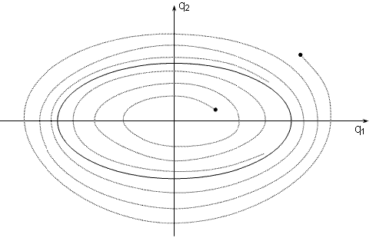
Based on the hypotheses that the elastic element is linear (having the generic form “aq”), we may highlight a fixed point of the Poincaré application, towards which any solution of the differential equation system (9) is asymptotically driving. For this situation, the spiral shaped trajectories are shown in figure 3.
Figure 3: The spiral shaped trajectories in the case of an elastic linear element

The spirals, as mentioned above, may start either from a point inside the ellipse or from a point exterior to the above mentioned ellipse and are all asymptotically driving towards the ellipse given by the equation (18). This ellipse is corresponding to the periodical solution (17) of the differential equation system (9) and represents a “limit cycle” type of attractor, characteristic for the elastic systems excited by periodically forces.
If the study hypotheses is considering a non linear elastic element (having the generic form “aq + bq³”), the trajectories in the phase plane are becoming more complex and relatively twisted, as shown in figure 4.
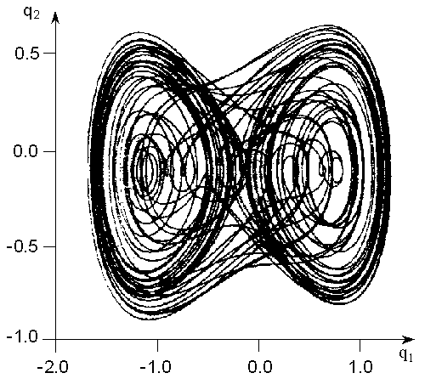
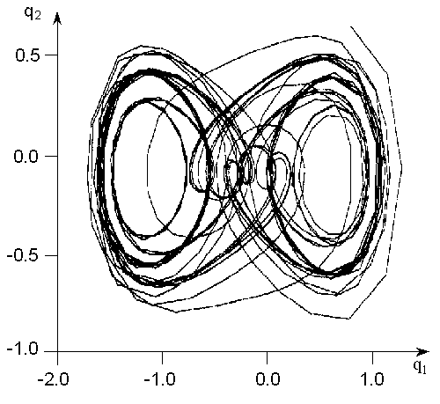
(a)
(b)
Figure 4: The twisted trajectories in the case of a non linear elastic element

In this situation, the Poincaré section is formed by a great and dense number of points having a complex structure, as shown in figure 5.
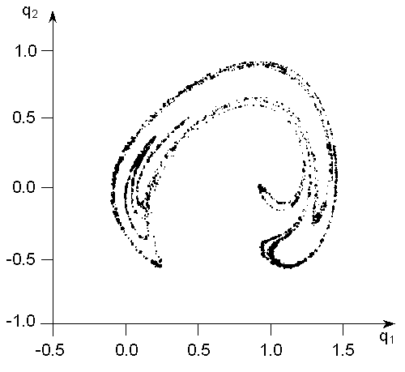
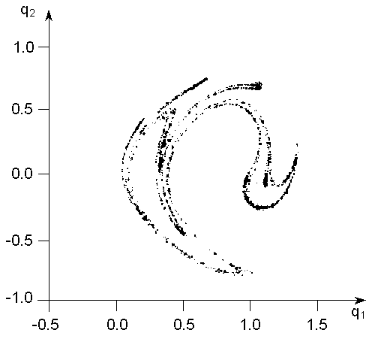
(b)
(a)

The numeric simulation have been done considering certain initial values for the coefficients of the differential non linear equation (6): 2α = 0,04, β² = 0,53, δ = 0,2, γ = 0,4 and Ω = 0,16 – figure 4 (a) and figure 5 (a) or Ω = 0,19 – figure 4 (b) and figure 5 (b). The simulations used MATLAB software.
The values for the coefficients of the differential non linear equation (6) were chosen from the specialised literature [1], [5], in order to enable a certain comparison of the results determined in the present paper with the already existing ones.
The paper is thus pointing out the possibility of apparition of the deterministic chaotically motions in the case of an industrial unit, modelled as shown in figure 1, for certain initial conditions and certain values for the non linear differential equation coefficients. The scope is to identify and avoid the “domains” where the running of the industrial unit might become undesired. These results offer the possibility, starting with the moment when the considered industrial unit is only designed, to choose certain values for different constructive parameters in order to either “shrink” the dangerous domain or “displace” it, so that, considering the normal working conditions, the dangerous domain to be out of reach.

References

- Argyris,J., Faust,G., Haase,M.: Die Erforschung des Chaos, Vieweg, Wiesbaden, 1994.
- Dragomirescu,C., Iliescu,V.: Some Aspects About the Evolution Towards Deterministic Chaos of a Dynamical Model, Simpozionul Internaţional Universitaria ROPET 2001, Petroşani, 2001.
- Holzweißig,D.., Fischer,S.: Machinendynamik Schwingungslehre, VEB-Fachbuchverlag, Leipzig, 1987.
- Voinea,R., Stroe,I.: Introducere în teoria sistemelor dinamice, Editura Academiei Române, Bucureşti, 2000.

