1st International Conference
″Computational Mechanics and Virtual Engineering ″
COMEC 2005
20 – 22 October 2005, Brasov, Romania

STRESS STUDY OF THE VARIABLE STEP SPRING USED WITHIN THE REAR SUSPENSION

IONEL VIERU¹, Nicolae–Doru stĂnescu², DĂNuŢ MARINESCU³
¹ University of Piteşti, Piteşti, ROMANIA, e-mail: ionel_v@yahoo.com
² University of Piteşti, Piteşti, ROMANIA, e-mail: s_doru@yahoo.com
University of Piteşti, Piteşti, ROMANIA, e-mail: dan.marinescu@upit.ro

Abstract: This study focuses on a spring used within the rear suspension, which progressive characteristic is obtained by varying the rolling slope of the helix. The calculation was done using Finite Element Method (FEM), using MSC/Nastran software. The authors determined the main strains, and the calculated values were compared with the experimental ones.
Keywords: variable step spring, strain, FEM, MSC/Nastran

1. INTRODUCTION

It is well known that, nowadays, the rate between the automotive total admissible weight and its own weight is even bigger. In the same time, the demands for comfort and safety during transport increase; it is a desire for obtaining the same qualities during transport in all load conditions. Considering the suspension, there are two antagonist demands: on one side, there is a demand for a less amount of characteristic oscillations, which impose a soft suspension, and on the other side the maximum stroke of the wheels considered for the exterior aspect of the automotive impose a rigid suspension.
By using springs with progressive characteristics permit us to realize a variation of rigidity depending on the load. This study describe a spring with constant wire diameter and medium diameter, the progressive characteristic resulting by varying the rolling slope of the helix, so the whirls “get out of work” gradually, as the number of active whirls decrease and the spring rigidity increases.
The advantage of this spring is represented by its simple manufacturing technology, and the disadvantage is that it requires a larger consumption of material and the space for montage could be relatively big.
The calculation was done using FEM, and the calculated values were compared with the values determined on the test bench.

2. GENERATE THE MODEL FOR SPRING CALCULATION

The authors establish the model for stress calculation of the structure, by passing from the real structure to the ideal one. This process has an arbitrary level, because there aren’t algorithms or general procedures for it.
It is a paradox that, in order to make a correct model for a structure it is necessary to know it very comprehensive, which is in opposition with the need to research it.
Also, the model must be adequate to the scope: a very complicate model (considering all the aspects and the details of the structure) could be expensive, difficult or impossible to use, as a result of neglecting some important aspects of the structure.
In order to emphasize the strain distribution, the spring was generated using solid elements. The model contains 2754 HEXA elements, corresponding to 9776 nodes (GRID). The contact between whirls was simulated using 90 GAP elements. The load force of the spring was distributed on 37 nodes.

3. RESULTS OBTAINED BY CALCULATION

Figure 1 presents the maximum strains obtained for the whole model during maximum load; it could be observed that they are at the level of 807 [MPa].
Figures 2 and 3 offer a comparative presentation of the maximum unity efforts in the middle whirl and the whirl placed at the bottom of the spring, for the normal load during running plus three passengers.

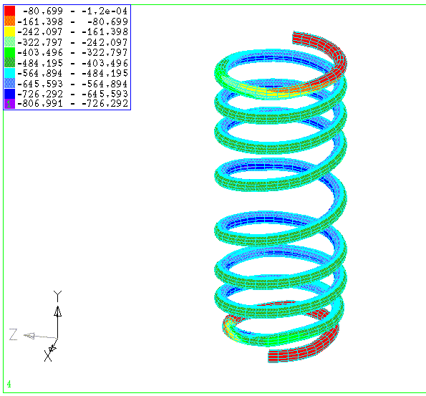
Figure1. The calculated strains for the whole model.

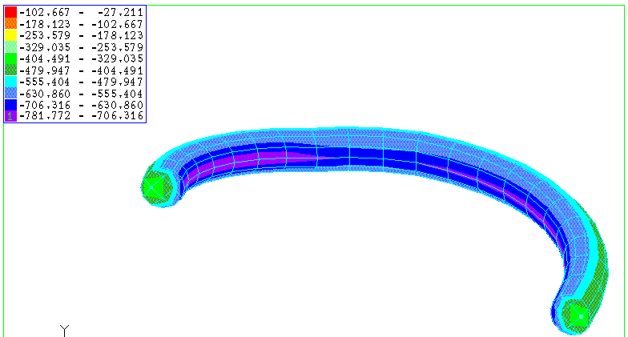
Figure 2. The calculated strains for the whirl placed in the middle of the spring.

It could be observed that in the whirl section the efforts have an asymmetrical distribution, so on the interior side of the whirls the efforts are greater than on the exterior side. The bend efforts caused this asymmetry. For the classic calculation, this increase is taken into consideration using a correction coefficient k. This coefficient depends on the rate D/d, with D – medium diameter of the spring, d – whirl diameter. For the spring with constant step, the values for the k coefficient are presented in Table 1.
For the present situation, the recomended coefficient could be k = 1.14 (for D/d = 10). Making calculations using FEM, the value for k coefficient in this case is bigger, around k = 1.5.

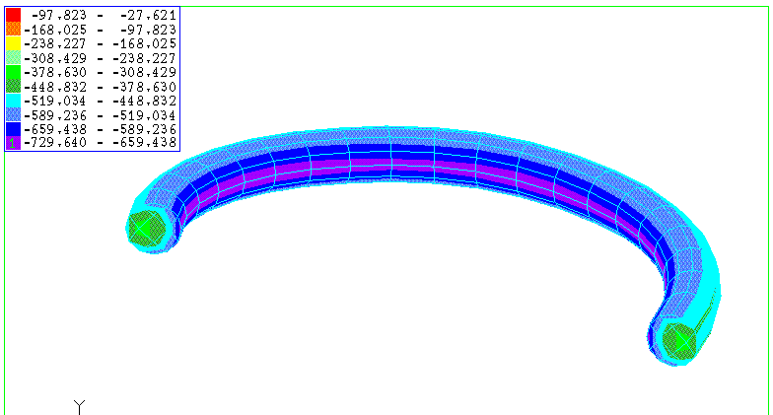
Figure 3. The calculated strains for the third whirl from the bottom of the spring.

Table 1. The indicated values for the correction coefficient k.
D/d | 2,5 | 3 | 4 | 5 | 6 | 7 | 8 | 9 | 10
k | 1,70 | 1,55 | 1,39 | 1,29 | 1,24 | 1,20 | 1,18 | 1,16 | 1,14

4. EXPERIMENTS MADE ON THE TEST BENCH

In order to measure the specific deformations — ε_{a} (translator at - 45°), ε_{b} (translator placed in the center) and ε_{c} (translator placed at + 45°) — the authors used strain rosette translators (made by three translators placed at 45°); the angles were measured in trigonometric direction.
For the general case, using the specific deformations, there could be calculated the main normal strains using the following relations:
$$σ_{1,2}=\frac{E}{2}\frac{ε_{a}+ε_{c}}{1−ν}±\frac{E}{2}\frac{{\left\{{\left(ε_{1}+ε_{c}\right)}^{2}+{\left[2ε_{b}−\left(ε_{1}+ε_{c}\right)\right]}^{2}\right\}}^{\frac{1}{2}}}{1−ν}$$ | (1)
with:
$ε_{a}=ε_{−\text{45}}$; $ε_{a}=ε_{0}$; $ε_{a}=ε_{+\text{45}}$; $E=\text{210}\left[\text{GPa}\right]$; $ν=0\text{.}3$. | (2)
The orientation of the main direction 1 was calculated with the relation
$ϕ_{1}=\frac{1}{2}{\text{tan}}^{−1}\left[\frac{2ε_{b}−\left(ε_{a}+ε_{c}\right)}{ε_{a}−ε_{c}}\right]$, | (3)
where the angle ϕ ₁ is measured from direction 1 to translator - 45° in trigonometric direction.
Considering the theory of specific energy for shape variation, the normal equivalent stress will be
$$σ_{\text{ech}}=\sqrt{σ_{1}^{2}+σ_{2}^{2}−σ_{1}σ_{2}}$$ | (4)
Tangential efforts were calculated with relation
$τ_{\text{max}}=±\frac{σ_{1}−σ_{2}}{2}$. | (5)
The resistive translators were mounted as follows:
- position 1 – on the whirl placed at the top of the spring (the third whirl);
- position 2 – on the whirl placed at the middle of the spring.
We used during experiments type SR-4 resistive translators manufactured by BLH Electronics (USA); they have a resistance of 120 [Ω].
The spring was mounted on the test bench presented in Figure 4. It was realised also the signal/force diagram.
The value of maximum unitary effort for the central whirl is 540 [MPa], for the exterior side of the central whirl.
Considering that the correction coefficient is k = 1.5, it result an effort of 810 [MPa] on the interior side of the whirl.
For the third whirl we obtained an effort of 510 [MPa].
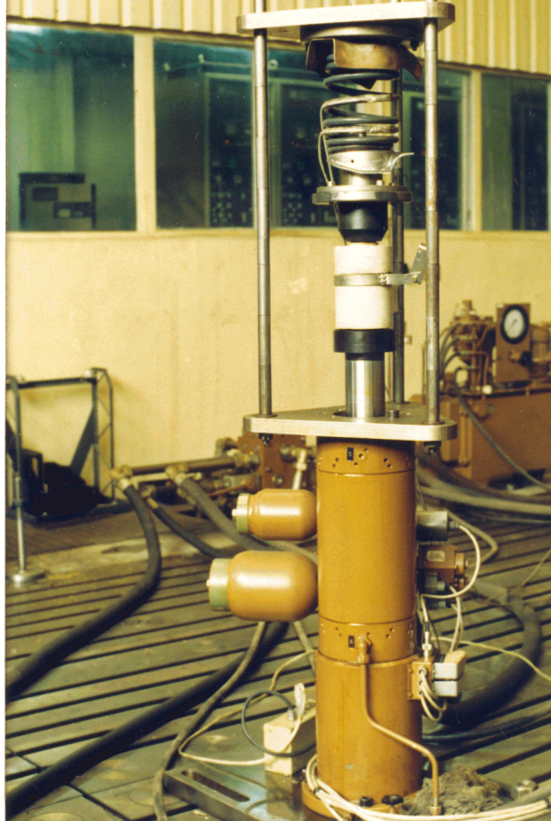
Figure 4. The spring tested on the test bench.

4. CONCLUSIONS

It could be notice a good concordance between the values of measured unitary efforts and the ones calculated by FEM, so this calculation method could be used for the study of any spring of this type.
As a result of the calculation we obtain an important asymmetry of the efforts at the level of the transversal section of whirl, this indicating the existence of bend efforts.
Also, we noticed that the values of the stresses at the level of the third whirl of the spring are closed with those in the central whirl, end this is the explanation for the spring breakings in this area.
We mention that in order to do such a calculation, you need the complete spring geometric definition, so for realizing a spring with an imposed characteristic there are necessary successive tests, by proper modification of the geometry after each result obtained.
As a conclusion, the variable step spring provides an increased comfort compared with the constant step spring, but it is more stressed than it (the strains have bigger values for the same load); this impose a material with superior mechanical properties for the same reliability.

references

[1] Drăghici I. ş. a.: Îndrumar de proiectare în construcţia de maşini, Vol 1, Editura Tehnică, Bucureşti, 1981.
[2] * * *: Handling coil spring problems, Auto & Truck International, Vol. 70, nr. 3, 1993.
[3] Perachino L.: Analisi teorica e numerica sulla formulazione degli elementi finiti gerarchici, ATA ,1990, vol. 43, nr. 8-9.
[4] * * *: MSC/Nastran Documentation.

