1st International Conference
″Computational Mechanics and Virtual Engineering ″
COMEC 2005
20 – 22 October 2005, Brasov, Romania

SOME MATHEMATICAL ASPECTS AND THE CAD OF THE CONICAL HELIX

Nicolae Ursu-Fischer¹, Nicolae Haiduc², Radu Morariu-Gligor³, Mihai Ursu⁴
¹ Technical University, Cluj-Napoca, ROMANIA, nic_ursu@yahoo.ro
² Technical University, Cluj-Napoca, ROMANIA, nhaiduc@clujnapoca.ro
³ Technical University, Cluj-Napoca, ROMANIA, rmogli@clujnapoca.ro
⁴ Technical University, Cluj-Napoca, ROMANIA, mihai_ursu_1492@yahoo.com

Abstract: The CAD programs allow the representation of cones and of the wrapped conical helix in 3D view. The programmers do not foresight the necessity to represent the planar shape of the conical helix, required to manufacture this part.
In this paper the authors have solved the problem of the computing coordinates of the conical helix planar shape made by an iron plate.
Such a problem appeared as a demand on behalf of some mechanical factory representatives.
Keywords: conical helix, spatial representation, planar shape

1. Introduction

Several technical problems assume the design and manufacturing of straight or conical propellers. Their achievement includes the determination of the propeller’s plane profile, the material molding after it and the wrapping of the material strip on a cylinder or a cone. Such devices are used as parts of the food and mining industries equipment, such as transporters, elevators, ground-drilling machines and many others.
A 3D model of a conical propeller made with SolidEdge computer program is presented in figure 1. The modeling is possible with the use of the “Helical Protrusion” command. It assumes the following steps: i) the propeller profile definition (the profile can be parallel or perpendicular to the propeller’s axis), ii) the setting of the beginning point for the wrapping, iii) the setting of the propeller’s parameters, and iv) the setting of the propeller’s direction.
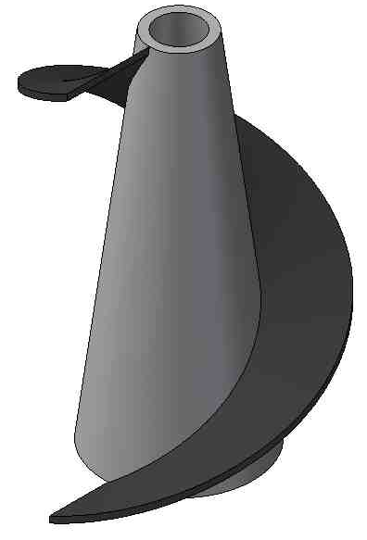

Figure 1
Step iii) is visualized in figure 2, where four parameter categories can be settled in a dialog box. The first one is the propeller generation method (helix method). The user may choose one of the following: the axis length and pitch value definition (Axis length & Pitch), the axis length and turns number (Axis length & Turns), or the pitch value and turns number (Pitch & Turns). The second one is the wrapping sense which can be Right- or Left-handed. The third one is the (Taper) which can be settled either by entering the apex angle (By Angle), either by giving the radius for both circles that define the propeller cone (By Radius). For straight propellers the option that should be checked is (None). The fourth one is the wrapping pitch (Pitch). It can be (Constant) or (Variable), case where the step modification rule and its last value must be specified.
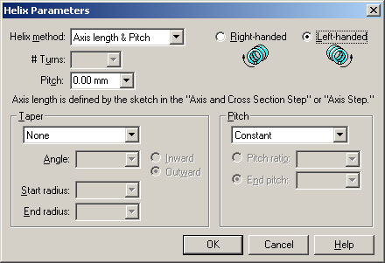

Figure 2

The above presented parameters were considered for solving the problem, being input data for the program.

2. Mathematical background

A cone and a conical helix are represented in figure 3. They have as parameters the following: the cone’s height h, the basis radius R, the helix pitch h and the width of the helix a. The conical helix is generated by a straight horizontal line MN (with length a) that intersects the vertical axis O₁z in point O. The point M generates the helix AMB wrapped up on the cone and the point N generates the external helix CND.

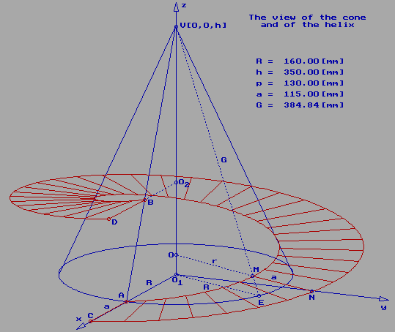
Figure 3
If the numerical values of these four parameters (h, R, p and a) are known we have the possibility to establish the coordinates of all points that belong to the helicoidal surface, especially the spatial coordinates of the two boundary curves.
The cone generatrix G is $G = \sqrt{ R^{2} + h^{2}}$ and the Cartesian coordinates of the point M are as follows
$x_{M} = r \text{cos} ϕ , y_{M} = r \text{sin} ϕ , z_{M} = \frac{ p ϕ}{2 π}$ (1)
denoting with φ the angle between O₁x and O₁E and r=OM .

Noticing that Δ VOM ~ Δ VO₁E, results
$$r = \frac{R \left( h − z_{M} \right)}{h} = R − \frac{R p}{2 π h} ϕ$$
and substituting in (1) one obtains the coordinates of the point M:
$\begin{aligned}x_{M} = R \text{cos} ϕ − \frac{R p}{2 π h} ϕ \text{cos} ϕ , \\ y_{M} = R \text{sin} ϕ − \frac{R p}{2 π h} ϕ \text{sin} ϕ , \\ z_{M} = \frac{p ϕ}{2 π} \end{aligned}$ (2)
The point E belongs to the circle with radius R and has the coordinates:
$x_{E} = R \text{cos} ϕ , y_{E} = R \text{sin} ϕ , z_{E} = 0 \text{.}$ (3)
The length of the segment ME results
$d = \text{ME} = \sqrt{ {\left( x_{M} − x_{E} \right)}^{2} + {\left( y_{M} − y_{E} \right)}^{2} + {\left( z_{M} − z_{E} \right)}^{2}} = \frac{p ϕ}{2 π h} \sqrt{ R^{2} + h^{2}}$
The cone lateral surface is represented in figure 4. The relation between angle φ and angle ψ (between VA and VE on the unfold lateral cone surface) is
$$R ϕ = G ψ , ψ = \frac{R}{G} ϕ$$
thus we may write the coordinates of point M with respect to the cartesian frame from the 4rd figure:
$x_{M} = ( G − d ) \text{cos} ψ , y_{M} = ( G − d ) \text{sin} ψ$ (4)
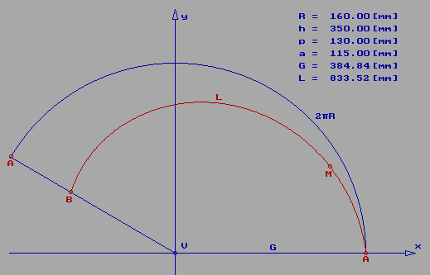
Figure 4

In a similar way, as we have written the coordinates of point M of the conical helix, we may proceed to obtain the point N coordinates. In this case the new cone has a as base radius R+a and as height O₁V₁ (see figure 5).

The triangles VO₁A and V₁O₁C are congruent (Δ VO₁A ~ Δ V₁O₁C) and one may write
$${\text{VV}}_{1} = Δh , \frac{h}{h + Δh} = \frac{R}{R + a} , Δh = \frac{a h}{R}$$
resulting the length of ON segment (in figure 2),
$r_{1} = \text{ON} = R + a − \frac{( R + a ) p}{2 π ( h + Δh )} ϕ$ (5)
and as a consequence the coordinates of point N, that generates the other boundary curve of the conical helix
$\begin{aligned}x_{N} = ( R + a ) \text{cos} ϕ − \frac{( R + a ) p}{2 π ( h + Δh )} ϕ \text{cos} ϕ , \\ y_{N} = ( R + a ) \text{sin} ϕ − \frac{( R + a ) p}{2 π ( h + Δh ) } ϕ \text{sin} ϕ , \\ z_{N} = \frac{p ϕ}{2 π} \end{aligned}$ (6)
According to figure 3, the conical helix has a shape with well known coordinates in space and we must know the coordinates of the part made from iron plate having not one spatial shape but a planar form.

There are two procedures to obtain the coordinates of this initial planar conical helix.

The first procedure is time expensive but accurate. It is based on the differential geometry of curves and surfaces. A plane that rolls on the conical helix at each position has to be considered, having as common tangent one segment like MN. The plane will belong to the osculating plane of the Frenet frame. The relations between the tangent plane infinitesimal rotation and angle φ variation may be established and one may obtain the coordinates of projections on the rolling plane of the current points of the two conical helices. We must also notice that for industrial purposes such a high accuracy is not necessary.

The second procedure is simpler and its accuracy may be improved if the number of points that define the two curves is increased.

Let us now consider figures 3 and 6. We have to notice that the conical helix may be seen as it has been built from a big number of pieces of quadrilateral form, two sides having the lengths $I_{i} E_{i} = I_{i + 1} E_{i + 1} = a$ and the lengths of the others two
$$d_{1} = I_{i + 1} E_{i} , d_{2} = I_{i} E_{i + 1}$$
are known because the coordinates of all points I_{i} , I_{i+1} , E_{i} , E_{i+i} have been previously calculated.

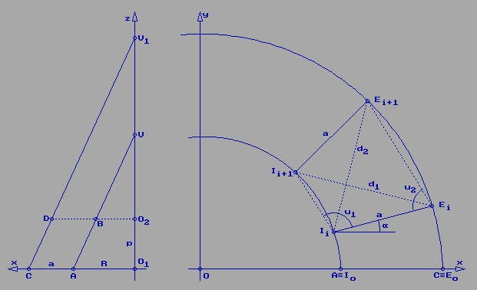

Figure 5 Figure 6
Firstly, the quadrilateral surface I₀ E₀E₁I₁ is considered to be in plane and the lengths of curves I₀I₁ and E₀E₁ are replaced by the lengths of the chords that link these pair of points. After one obtains the positions in the Oxy plane of the points I₁ and E₁, one may consider the second quadrilateral surface I₁E₁E₂I₂ and make the same operations further on.

At each step, when the quadrilateral surface I_{i} E_{i}E_{i+1}I_{i+1} is considered, dealing with the triangles Δ I_{i+1} I_{i} E_{i} and Δ E_{i+1} E_{i} I_{i} one may obtain the angles u₁ and u₂ :
$u_{1} = \text{ac}\text{os} \frac{{\overline{I I_{i + 1}}}^{2} + a^{2} − d_{1}^{2}}{2 a \overline{I_{i} I_{i + 1}}}$ $u_{2} = \text{ac}\text{os} \frac{{\overline{E E_{i + 1}}}^{2} + a^{2} − d_{2}^{2}}{2 a \overline{E_{i} E_{i + 1}}}$
and compute the coordinates of the following point in plane (I_{i+1} and E_{i+1}):
$x_{I ( i + 1 )} = x_{I ( i )} + \overline{I_{i} I_{i + 1}} \text{cos} ( u_{1} + α ) ,$$y_{I ( i + 1 )} = y_{I ( i )} + \overline{I_{i} I_{i + 1}} \text{sin} ( u_{1} + α ) ,$
(7)
$x_{E ( i + 1 )} = x_{E ( i )} + \overline{E_{i} E_{i + 1}} \text{cos} ( u_{2} − α_{i} ) ,$$y_{E ( i + 1 )} = y_{E ( i )} + \overline{E_{i} E_{i + 1}} \text{sin} ( u_{2} − α_{i} )$
the angle  having the expression
$α_{ i + 1} = \text{at}\text{an} \frac{y_{E ( i + 1 )} − y_{I ( i + 1 )}}{x_{E ( i + 1 ) } − x_{I ( i + 1 ) }}$ (8)

With this approximate procedure it is possible to compute the coordinates of the boundary points of the iron plate that will be used to make the conical helix with a desired shape.

For the considered numerical values the iron plate shape is presented in figure 7. For a higher accuracy, the number of points that define the two conical helices has to be increased.

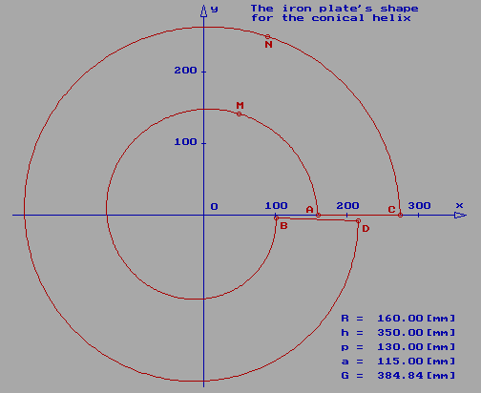
Figure 7

3. Conclusions

In the available CAD software the facility of representing the cone and also the conical helix exists, but the practical and also very important problem of planar representation of the helix is not solved. With our work we consider that that omission has been removed.

Solving such problems is not always at hand for CAD users, the practical achievement of the tridimensional model being impossible without determining the plane profile of the propeller.

References

[1] Gheorghiu, Gh. Th., Linear Algebra, Analytical and Differential Geometry (in Romanian), Bucureşti, Editura Didactică şi Pedagogică, 1977, 469 pp.
[2] Murgulescu, Elena et al., Analytical and Differential Geometry (in Romanian), Bucureşti, Editura didactică şi pedagogică, 1965, 772 pp.
[3] Pansu, P., Topologie et géométrie différentielle, Université de Paris-Sud, 2003, 129 pp., http://www.math.u-psud.fr/~pansu/cours.pdf
[4] Popescu, Diana Ioana, Some Practical Problems with SolidWorks. CAD in Mechanical Engineering (in Romanian), Cluj-Napoca, Editura Dacia, 2003, 190 pp.
[5] Pozrikidis, C., Numerical Computation in Science and Engineering, Oxford, University Press, 1998, 640 pp.
[6] Ursu-Fischer, N., Ursu, M., Programming with C in Engineering (in Romanian), Cluj-Napoca, Casa Cărţii de Ştiinţă, 2001, 405 pp.
[7] http://www.solidworks.com

