1st International Conference
″Computational Mechanics and Virtual Engineering ″
COMEC 2005
20 – 22 October 2005, Brasov, Romania

CAE METHODOLOGY USED TO DESIGN AND SIMULATE THE BEHAVIOUR OF A MILLING MACHINE USED IN MINING INDUSTRY
PART I – the FINITE ELEMENT MODEL

Ioan Călin ROŞCA, Ph.D.
Transilvania University of Braşov, Romania, icrosca@unitbv.ro

Abstract: In this paper it is presented a methodology based on CAE concept used to design and simulate the behaviour of an equipment used in mining industry, a milling machine. The 3D model was made using technical possibilities of I-DEAS. In the same time there were made volume and surface meshes for each part. The assembly was realised, as position and connections, using ALGOR soft and the analysing was done with ABAQUS. At the end there are presented the obtained results.
Kezwords: 3D modelling, finite element method.

1. INTRODUCTION

The new methods used in mechanical engineering design imply a complete structure of 3D modelling, finite element analysing and optimisation based on different parameters imposed by the structure or by the working conditions. As it is known for the 3D model building one can use different specialised soft. The selection of one or another 3D modelling soft is made taking into the consideration different aspects in connection with the abilities of the designer to make a proper model, the technical possibilities of the soft and the compatibility with different programs for finite elements analysing. A great problem in any analysis with finite elements method is to create different assemblies. A possible method consists of making the 3D model in a specialised soft and then to export for finite element method analysing. In this case the assembly can be modelled and in FE soft it can be seen by its parts. In this case the user can mesh each part but can appear many difficulties concerning the contact surfaces, connections by cotters, pegs and screws, etc. Another method consists of making each part in a 3D specialised program, then to mesh it in the same program or in another one, to put the parts in the proper position, and to define all connections, contacts (by surfaces or gaps), loads, and boundary conditions. Such method involves the use of more than one dedicated soft.

2. study case. Milling machine

2.1. Solid model

The main aim of the design is to obtain the best system for an assembly that has imposed functional conditions. In machine building industry a machine or a simple part are mainly calculated to have a proper strength and the stress level is imposed to do not exceed some values.
In case of an assembly the designer is obliged to consider different aspects strong connected with the functionality as: the force flow and the level of the forces that are acting on each part, to realise a right position of the parts according with the real components of the machine, the relative motions between different parts, to realise a static and dynamic stability, etc.
The above mentioned methodology is related in detail in the following pages. It is considered the case of a milling machine used in mining industry. The assembly consists of 20 different parts (Figure 1) that are connected by screws, cotters, and pegs.

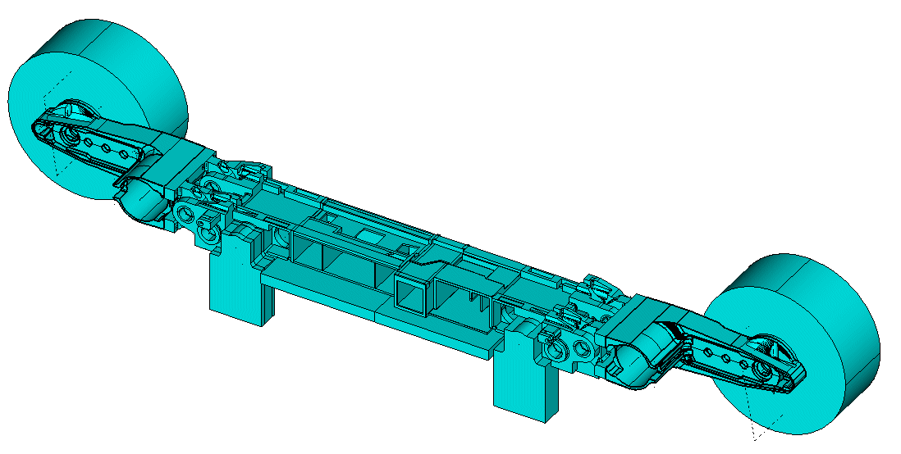
Figure 1: Milling machine. Assembly view.

The 3D model of each part was done using the I-DEAS soft and was based on the technical sketches made after the designing step. There were considered for each part all details as: holes, gaps, and caves. Each part was designed step by step using different small components and then joining all of them in a whole. The structure of the I-DEAS soft allow to visualise all steps and, if is necessary, to modify dimensions or geometry and to update the entire part. Some of the parts there are presented in Figure 2.

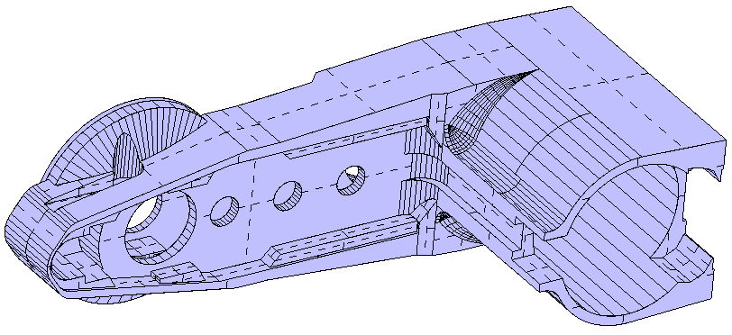  a) |  | 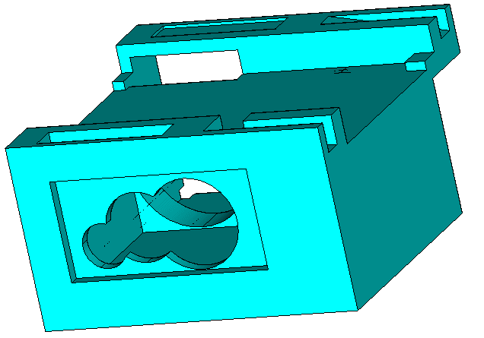  b)
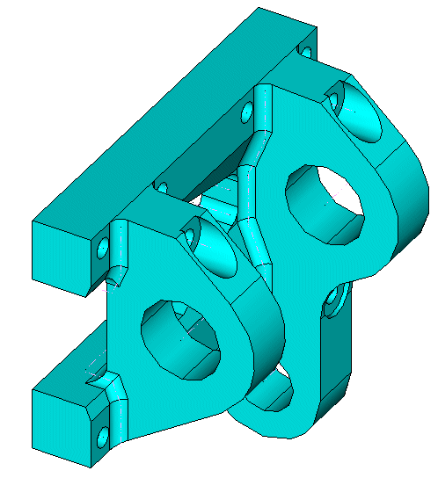  c) | 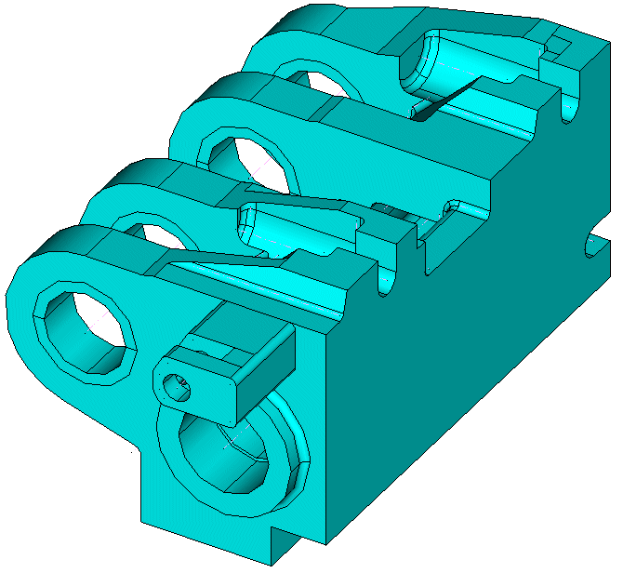  d)
Figure 2: Parts of the milling machine: a) milling machine arm; b) gearbox; c) plate; d) rotating system base.
2.2. Model meshing

The finite element model was made in two distinct steps: mapped solid mesh for the parts that allow this method and surface combined mapped and free mesh for the parts that had a complex geometry. Both of this mesh generation activities were done using the facilities offered by I-DEAS.
From the first category it is presented the box of hydraulic commands (Figure 3,a). The part was divided in some small component by the partition command used in I-DEAS to divide a solid body in different volumes. The partition length was made for each volume taking into consideration the geometry and length of the finite element – brick of the first order. The maximum length of the element was established to be about 25 mm.
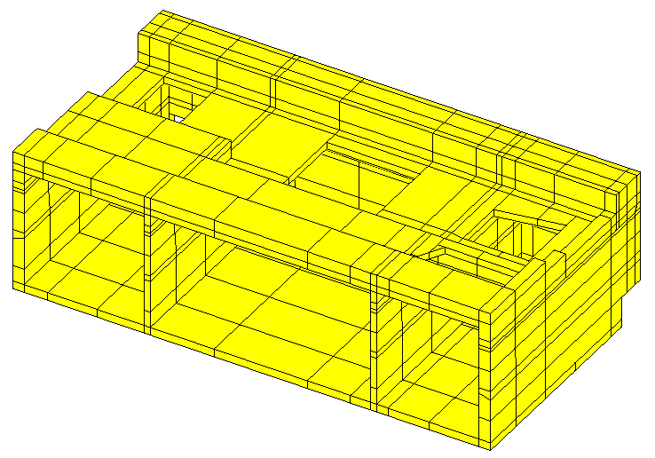  a) | 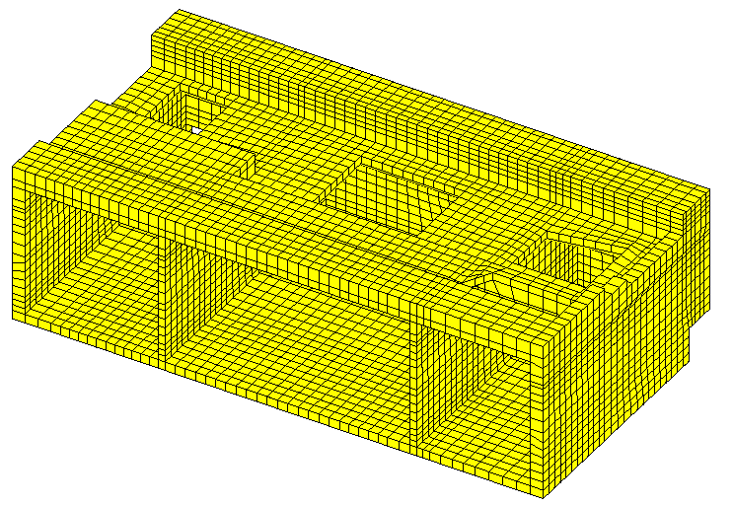  b)
Figure 3: Hydraulic commands box, a) partition of the part; b) solid mesh definition.
This method is very useful in case of parts with straight walls and non-complex geometric structure. Such solid mesh offer the possibility to realise a controlled network of elements and the calculation is cheaper than in case of a free mesh. In the same time it is obtained a control of the finite elements from all points of view.
From the second category there are presented the mesh generation for the arm (Figure 4) and for the engine box (Figure 5).
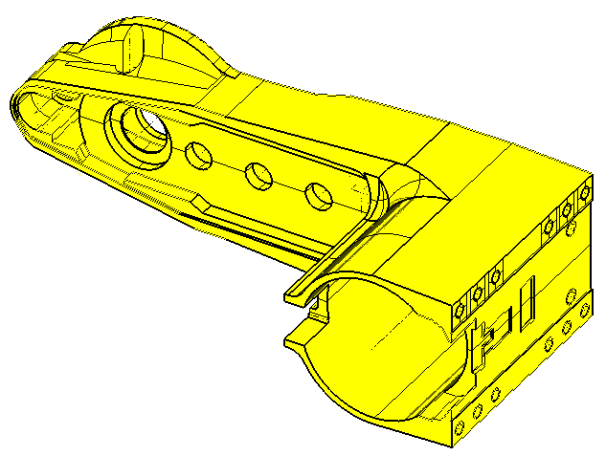  a) | 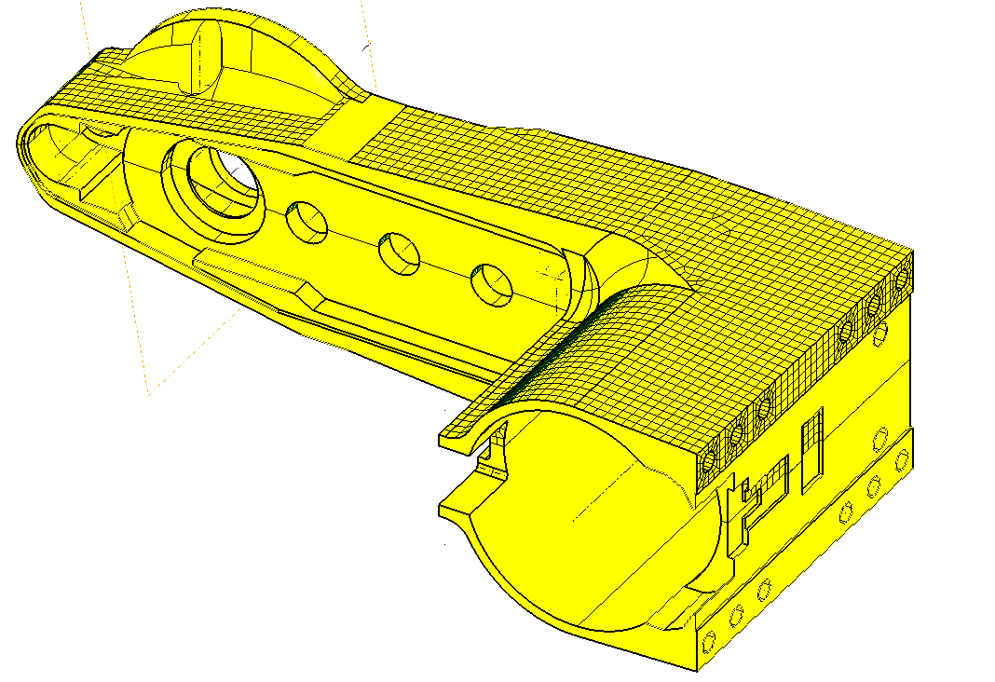  b)
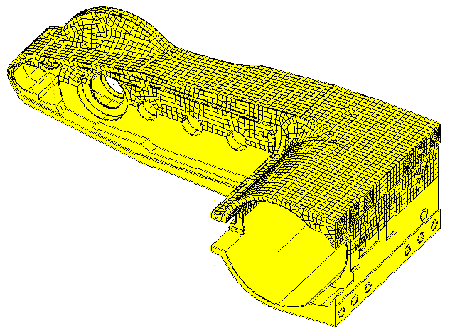  c) | 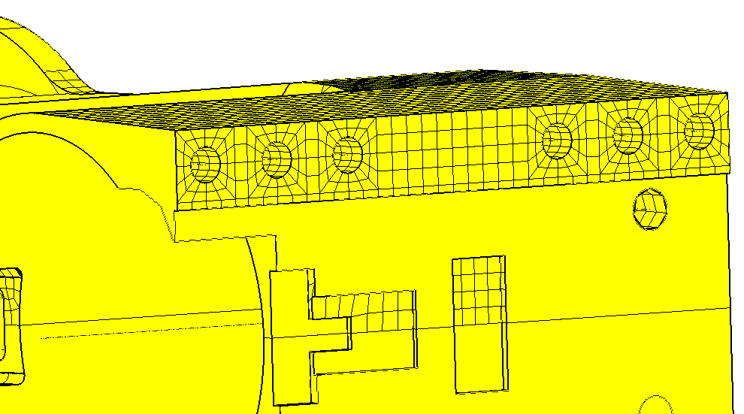  d)
Figure 4: Milling machine arm: a) the 3D model with splited surfaces; b) surface mapped mesh; c) surface mesh (mapped and free); d) detail with mapped mesh needed for screws connections.
The milling machine arm represents the most complex part of the assembly. As it can be seen in Figure 4,a this part consists of many holes, openings, cavities, and straight walls that forced to be made in the first step a surface mesh. Considering he symmetry plane the arm was meshed only on a half of its surfaces (Figure 4,b and c). In the same time it was considered a surface mapped mesh where the geometry allowed this (Figure 4,b) and the rest of surfaces were meshed with free option mesh (Figure 4,c). One of the most important technical aspects that had to be considered was tied of the screws connections and other links that are presented in the assembly. This obliged to be created a specific mapped mesh (Figure 4,d) useful for linear constraint equations definition. The solid mesh was made in ALGOR (Figure 5,a) and then was duplicated using the mirror possibility (Figure 5,b).

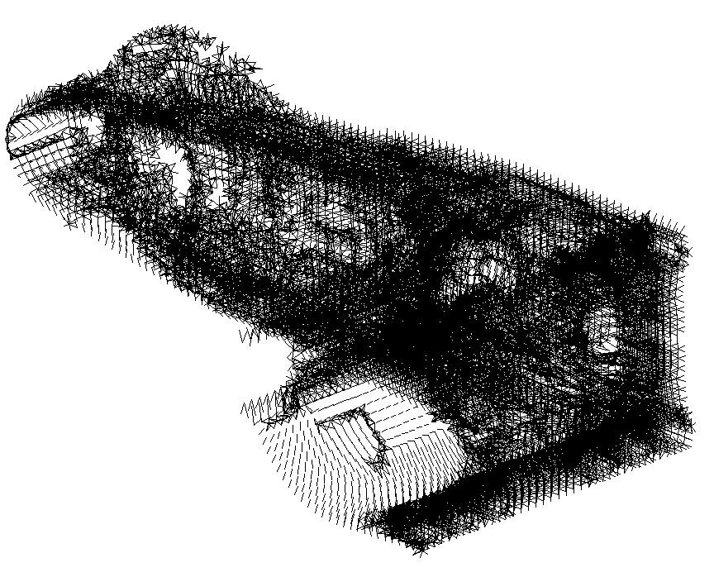  a) | 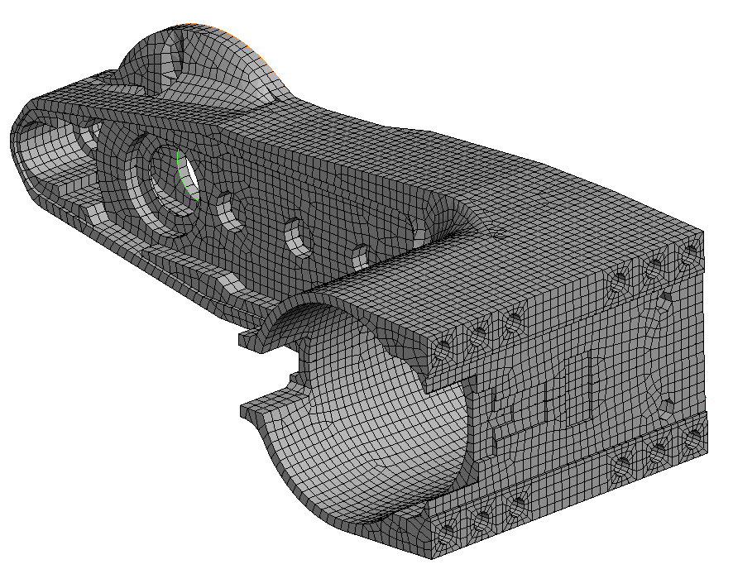  b)
Figure 5: Milling machine arm: a) solid mesh made in ALGOR; b) entire arm obtained by mirror option.
Another complex part is the main gearbox (Figure 5,a). The mesh of this part was entirely made using surface meshing possibilities offered by I-DEAS soft.
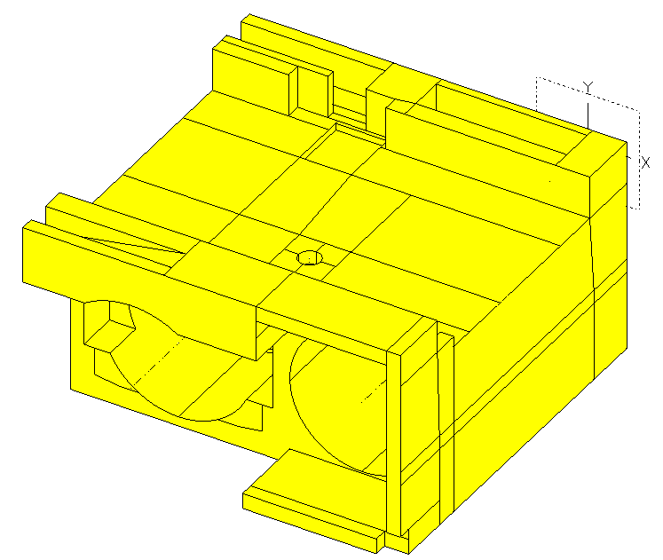  a) | 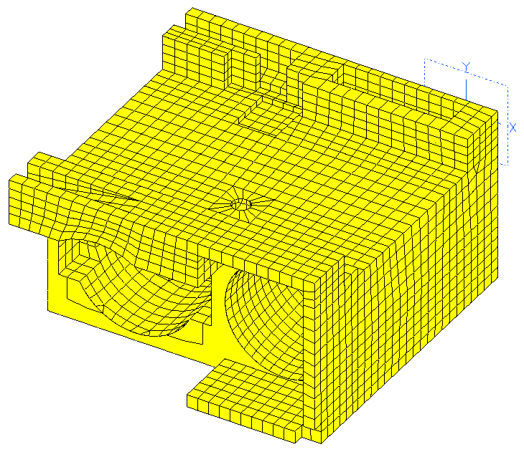  b)
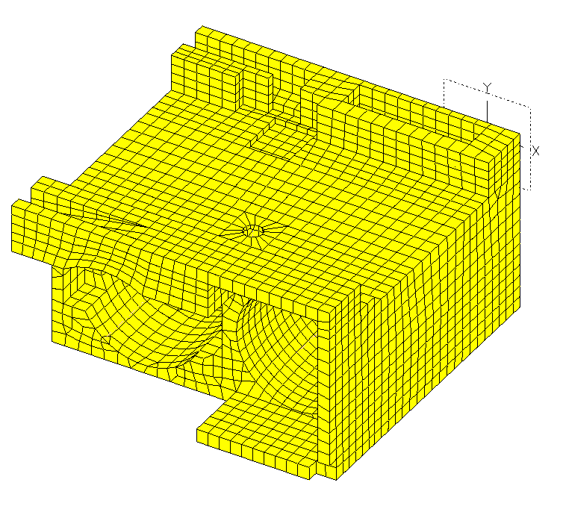  c) | Figure 5: Surface mesh methodology: a) split surfaces for defining areas of mapped surface mesh and free mesh surface; b) mapped mesh surfaces; c) surface mesh (mapped and free).

As in the case of milling machine arm, first time it was realised a split of the surfaces (Figure 5,a) and then was done mapped mesh (Figure 5,b) and a free surface mesh (Figure 5,c). The surface elements that were used are of the first order.

2.3. finite element model of the assembly

After all parts were meshed with solid or surface mesh they were exported in ALGOR. In the next step, in ALGOR all parts were arranged on their position in the assembly. As reference system of the milling machine was considered the rotation axe of the arm.
Then, all components that were meshed only with surface elements were re-meshed with solid element of the first order. This was realised using the facilities offered by ALGOR. At the end the assembly consists of approximately 260,000 elements.
Considering the complexity of the milling machine parts, the diversity of the connecting elements and the large number of contact surfaces the assembly was analysed using as finite element program ABAQUS. This involved the export of the assembly as a text file that is an input file in ABAQUS. This input file can be divided in some distinguish parts: in the first one there are defined the nodes and the elements with materials characteristics. Each element is numbered with the number of the part and the code number that is given in ABAQUS. Then there are defined all additional elements, as beams or gaps for contact, the contact pairs and definition for contact problem, constrain equations, loads and boundary conditions, etc.
The finite element model was prepared in ALGOR (Figure 6). After each part was put on its right place there were separated the contact surfaces. This was made using the facilities offered by ALGOR that is working on layers.
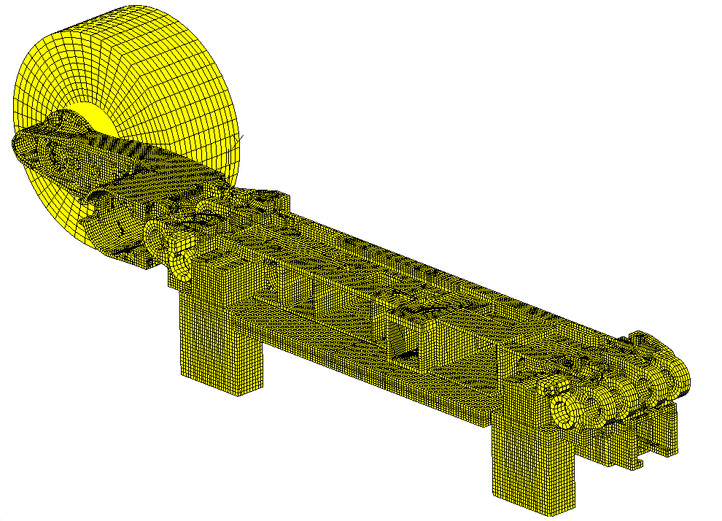
Figure 6: Milling machine assembly realised in ALGOR.

The next step was to define the screws, keys, and pegs that are used as connecting elements between parts. There were identified the nodes that mark the limits of the screws, keys, and pegs and for each node there were defined distinguish nodal temperatures. These nodes formed node sets when the model was exported in ABAQUS. The models of connecting elements were simulated using constrain equations according with the role of each link as machine part. The screws were modelled considering beam elements with the cross section equal with the real cross section. This model was considered for the screws because they are used as support of force flow transmission from the milling cutter to each part of the assembly.
Another important part of the milling machine is the planet gear that is situated inside of the milling tool assembly. To simulate the planet gear, taking into consideration that through this mechanism are transmitted the cutting forces, it was considered a beam system with a high stiffness and with gap elements that simulated the contact between the cogs wheel.
The export in ABAQUS was made after it was realised the assembly in ALGOR (Figure 6). The assembly was generated step by step combining each part and creating some subassemblies, 20 at all. At each subassembly was added a new part and so on. Each part was considered with its finite element model: elements, material characteristics, nodal temperatures, contact surfaces, etc.

3. conclusions

The finite element model of the milling machine has a multiple complexity that can divide on different layers as:
- a geometric one taking into the consideration the number of the parts and the particular geometry of each one;
- a constructive one according with the components that generate the links in the assembly: screws, keys, pegs, and planet gear;
- the mesh of each part that involve on a hand a solid mesh made after a complex partition and on the other hand surfaces mesh in I-DEAS followed by a solid one realised in ALGOR;
- the construction of the assembly that was realised using the ALGOR soft were each part can be place were easy on its position in the assembly;
As was presented above to realise a proper model involve a very large amount of modelling activity on a hand to create the 3D model and on the other hand to realise the mesh for each part. In the same time there were used three different specialised programs: I-DEAS, ALGOR and ABAQUS.

The present work is part of the activity done in the frame of the research project “Teilautomatisierte Generierung von 3D-CAD-Modellen”, developed at the Institut für Bergwerks –und Hüttenmaschinenkunde, Rheinisch-Westfälische Technische Hochschule, Aachen, Germany.

references

[1] Constantinescu N. Ioan; Dăneţ V. Georgeta: Metode noi pentru calculul de rezistenţă, Editura Tehnică, Bucureşti, ISBN 973-31-0094-3, 1989.
[2] Pascariu Ioan: Elemente-Finite. Concepte-Aplicaţii, Editura militară, Bucureşti, 1985.
[3] Rao, S., S.: The Finite Element Method in Engineering, Second Edition, Pergamon Press, ISBN 0-08-033419-9, 1989.
[4] ***: ABAQUS Reference books. User guides.
[5] ***: ALGOR Reference books. User guides.
[6] ***: I-DEAS Reference books. User guides.

