1st International Conference
″Computational Mechanics and Virtual Engineering ″
COMEC 2005
20 – 22 October 2005, Brasov, Romania

Modeling of working process at corn harvesting equipment endowed with a single corn cob detachment roll and simultaneous stem chopping

of MS. Eng. Stanciu Lucian1, math. Cârdei Petru1, Prf. Ph. Ing. Cândea loan2,
¹INMA, Bucuresti, ROMANIA, icsit @sunu. rnc.ro
²University Transilvania, Braşov, ROMANIA, candmec @unitbv.ro

Summary
The aim of the paper casuists in mathematical by modeling the working process of the roll, taking into account both the geometrical and kinematics features of the harvesting process and the corn crop characteristics (witch is to be picked up) .The mathematical model defines a condition of an appropriate feeding system, colligating the driving speed of the harvesting machine with the roll rotational speed and with the average distance between the plants of a row, the roll radius and the average choppable length of the corn stem.
The paper refers to the use of this model in order to optimize the working process by simulation, aiming the option of a proper feeding regime an of an optimum driving system of rolls, meaningly in a general wag. The model is intended to be used to the improving of equipment performances, in design process, through the calculus off disturbing frequencies or of the feeding regime, which are comparable with the own roll frequencies, this way resonances and the knockings being avoided.

1. General formulae.

This chapter is presents the kinematics and dynamic frame of the problem. The physical magnitudes, appearing during the process are are showed in the table 1.
The table 1 Meaning of Variables of Dynamic Models.
Nr. | Symbol | Meaning | Measurement unit
1 | l_{t} | average length of the haulm | m
2 | n_{c} | number of knifes on circumference | -
3 | d | distance between plants of a row | m
4 | v | equipment driving speed | m/s
5 | g | local gravitational acceleration | m/s²
6 | L | roll length | m
7 | α | roll banking angle of the degrees | grade
8 | ω | roll rotational speed | m/s
9 | c | coefficient of viscous friction | m
10 | t | time | s
11 | M_{s} | detachment moment | Nm
12 | M_{t} | chopping moment | Nm
13 | M_{c} | engine moment | Nm
14 | M_{c0} | engine moment | Nm
15 | M_{c1} | engine moment | Nm
16 | M_{f} | friction moment | Nm
17 | φ_{s} | detachment frequents | -
18 | φ_{t} | chopping frequency | -
19 | p_{s} | puling act pulsation | rad/s
20 | p_{r} | chopping pulsation | rad/s
21 | r | roll radius | m

The roll of the detachment equipment is regarded as a rigid solid in movement around a fix axle passing throng its mass centre. The rotational angle is $θ$ and ;$\overset{˙}{θ}$ and $\overset{¨}{θ}$ are respectively the velocity and the angular acceleration. The hypotheses of the most simple model, are represented by the following forms of excitations belonging to the system:
(1.1)
which is the detachment moment:
(1.2)
which is is the chopping moment and
(1.3)

which is the engine moment, the amplitude of resisting moments ( 1. 1) and ( 1. 2) being given in ( 1. 4)
(1.4)
The detachment pulsation is:

(1.5)
The cutting pulsation is:

(1.6)
The hypothesis of sinusoidal moments is a good approximation for the opening study of the model, stage in which the correction of the mathematic model with the real one is emphasized. The main model results being confirmed we can take into account other forms too ,for the excitation moments: engine moment and resisting moments. A term without of which the model don't burn can cohere is global fiction moment, assimilated for the beginning to the viscous friction moment, proportionally shaped ( 1. 7), with the mass supported on the rollbearings.
(1.7)

In the circumstances the roll motion equation coupling to 1 or 2, he is giver of( 1. 8).

(1.8)

2. The feeding correct condition.
In temporally during of the distance d of to equipment a plant of length l_{t} must be processed and be t_{d} – the time fof displacement of the equipment between two consecutive plants on the same row, t_{pp} - the time movement of the stem during the pulling drawing of the roll. Then it result offspring cases: 1) If t_{d} <t_{pp} overcrowd, 2) if it t_{d}=t_{pp} ideal feeding and 3) if it t_{d}> t_{pp} underfeeding. The correlation variables are v (working a driving velocity) and ω (angular velocity of the roll):

(2.1)

the proper condition of operation t_{d}>t_{pp}
(2.2)

(2.3)

(2.4)

In figures 2.1 and 2.2 are given the graphical representations of the suitable feeding correct condition( 2. 2) or( 2. 3). we can notice the fields of proper feeding ( light underfed) in the system(ω; v) but also the evolution of this feeding when the distance between the plants an the row varis ( the figure 2.2)
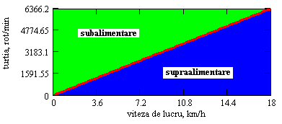
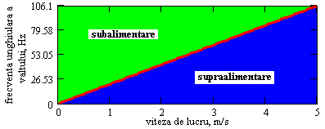

Fig. 2.1 Feeding Condition on the red diagonal the ideal feeding takes place.

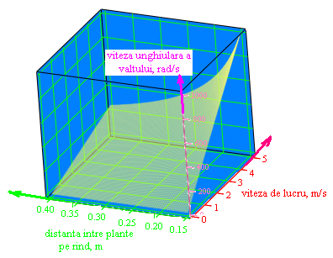
Fig. 2. 2 Surface ω =ω( v, d). Zoned among even the speed of thing - distance between plants on row ( plan of the base of the cube) and the surface is the zone of supercharge, and the overhead zone surface is the zone of malnutrition. On the surface found out the feeder points idealist

Conclusions

C1) In order to obtain a suitable feeding, for the stem length that is going to be chopped well consider its maximum minced, The value this maxim value and not the average one when the overfeeding phenomenon could appear.
C2) The suitable feeding condition varies from a crop to an other depending on the distance between the plants an the row( which is before on sowing categories), and on the length of the choppable stem part, which can fortuitously vary
C3) The geometry of the roll being set, it isn’t alterable, and the rotational angular velocity is for the unknown element of the problem so that the single control parameter ( at command the camera-man) is the driving velocity of advance, v. accept the driving velocity, a function of the control is given by the engine moment, whose value can change.

3. Study of Differential Equation of the roll Motion.
In order to obtained a process simulator the mathematic model must be tested. As the chopping frequency depends of the roll frequent rotational frequency, the motion equation is not linear, presenting a non-linearity with doesn’t allow the obtaining of analytical solution, expressible by elementary functions, not approximately . Consequently the solutions will be given through the numerical methods. The initial conditions will be putted depending on the studied phenomenon.
3. 1. Study of Material Processing Model the model in the apparatus of the harvester-thresher.

The simulation function of operation of the material processing unit has, as we have previously shun, multiple applications. Amongst all the models constants which can interfere, the only one which hasn’t been experimentally is the overall friction coefficient, c. This one has been indirectly, determined through the condition of obeying the parameters idle running. More precisely, at a certain measured value of the moment, the roll running no load has a certain rotative speed which is also measured. From experimental date it has resulted that the average engine moment idle running has the value Mg= 29. 705 Nm, what corresponds to a rotational speed of the roll of 1120 rot./min( 117. 286 rad/s). Introducing in the formula of the moment of subpoena (the motive moment), the constant value, and taking for the friction coefficient in bearing the value of 0. 003975, the regulation of rotational speed moment is performed at 1122 rot /min( 117. 5 rad/s.)

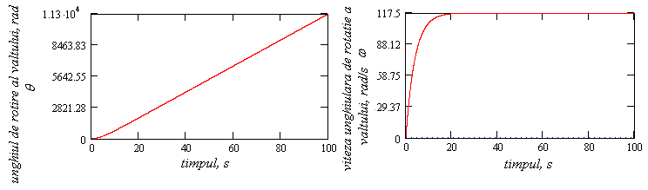
Fig. 3. 1 Motion of Roll at Motionless Starting until the Idle Running Recalling

In fig. 3. 1 are given the variations in time of the roll rotational angle (left) and of angular rotational speed of the roll. It can be noticed that the rotational angle incases al neat in linear manner temporally of the of and the angular speed of rotation. Noticed The angle of rotation breeds near linear( except a little period of time when the process is transitory). In transiently process is better visualized on the occasion of the angular velocity diagram to graphic the variation of speed, observation the stabilization to the value of regime is done in a aisle of approximate 20 s. The rapidity of the reeling the steady working regime when the equipment from idle running is influenced not only by the intensity but also by the from of the friction term, the problem being very difficult and not representing the subject of this model.

3. 2 Working Regime-Control.
In order to control the model, a certain working regime will be performed, the geometry of the culture plantation(distance between plants on row, d= 0. 15 m and the length minced the maxim of the plants, l_{t}= 2. 5 m), propriety appearances the plants(force minimum of hash, F_{t}= 40 and minimum pulling force, F_{s} = 90 ). The first checked case is the case when the working rate (considered as a constant in this model), has a steady value v= 3. 62 Km/h, corresponding to a driving moment regime 40. 7 Nm, according to the field menstruations. For these values, the critical angular velocity is of ω _{cr}= 111. 73 rad/ s( 1066. 93 rot/min). The harvesting machine starts working at the above mentioned velocity and with an idle running rotational speed, raising its rotational sped to the new regime rotational speed.

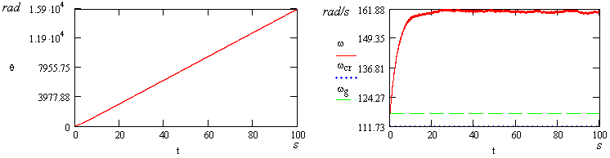
Fig. 3. 2 Roll Movement at 3. 62 Km/h. Working Rate
.
The graphical representation of this working rate movement has shown that with the entrance under construction, which can produce since the initial moment, t= 0 (because the rev of the roll in empty is superior the critical rev for the which culture is harvested and the speed of thing of regime), within the roll angular speed variation appear little variations slightly visible in fig. 3. 2. These oscillations are due to chopping and detaching process which the roll itself notices A regime snapshot in which the transitory phase doesn’t appear is presented in figure. 3. 3. The oscillation of a higher frequency, determined by the chopping (a higher frequency) and pulling out processes(a less frequent). The amplitude of this oscillations is less, being under 1 rad/s.

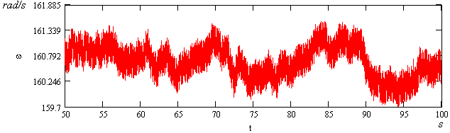

Fig. 3. 3 Detail of Regime Oscillation Determined by The Roll Motion during The Chopping and Ruling Out Processes.

An interesting ting is, in this particular case given by the influence of an oscillations during the moment transmission from the engine to the roll. If the engine moment has itself its oscillations, even of little amplitude, depending on the rotational frequency of the roll, then can appear some composition phenomena of guys resonance, which can be dangerous for the equipment operation .this kind of oscillations can be determined by the engine by the transmission or by engagement elements etc. In figure. 3. 4 is represented the consequence of such oscillations appearance an 3 Hz and of 0. 2 Hz frequency (identification on diagrams), with amplitudes of only 2% and 3% from the average moment permanently programmed. The main effect consists in raising the amplitude of oscillations belaying to roll rotational speed. The oscillations of roll rotational speed produce them too rotational undesirable during the process. On diagrams containing the measurement results have been also found oscillations presenting a double amplitude of the average value. The process itself is in fact, more complex including the interaction between the propulsion system and the consumption elements, from which one is represented by the plant processing system which our present subject.
For a speed of elder thing 6. 24 Km/h, during the process dynamics no important qualitative changes (variations)interfere excepting the energetic aspects. The variation in time of the roll rotational angle and the variation in time of roll angular speed are given in fig. 3. 5 and 3. 6. We can notice that the roll angular speed is superior to the critical speed, which assures the underfeeding condition and the operation without any possible over feedings.
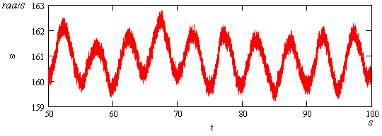
Fig. 3. 4 Oscillations of Angular Speed of Roll Amplified by The Engine Moment Oscillations at a Speed of 3.62 Km/h.
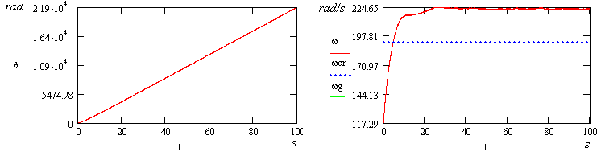

Fig. 3. 5 Roll Motion at A Working Speed 6. 24 Km/h.

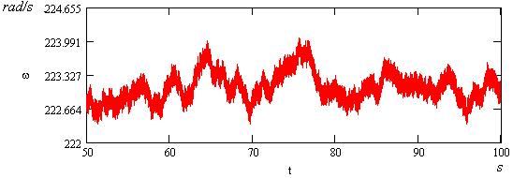

Fig. 3. 6 Oscillations of Angular Speed Amplified by the Engine Moment Oscillations at A Working Speed 6.24Km/h.

3.3 Conclusions.
The studies performed on the model of harvesting process allow to draw the following conclusions:
C1) The building drove of the model has determined the obtaining of the appropriate and sufficient condition for a suitable operation, meaning the light underfeeding condition, which establishes the connection between the harvesting machine and roll kinematics parameters ( driving speed and roll angular speed) and the geometrical parameters of the harvested corn crop: The distance between plants of a row and the stern choppable length This proper operation can be also used in the optimum setting of working regime, even to the operation automation;
C2) The mathematic model has been checked an real working regime and the obtained results were in accordance
C3) The mathematic model whide has been built can be used as simulator for corn harvesting t process, in order to energetically optimize, to avoid the resonant regimes or same permanent wear, produced by the disturbances for the interring exterior of the system.
As the mathematic model reflects satisfactorily the reality, it can be turned in to a simulator designed at solving the following problems:
Process study during disturbances of working process;
Effect of engine moment perturbations on the process, possible resonances or knockings;
Possibility of same oscillations appearance having the appropriate fundamentally frequency of the roll;
Study of intensity of roll vibrations, depending the amplitude of feeding condition being used

These issues are a few from the main applications of this model and which can by used in order to improve ( even optimize) the working process.

Bibliography
1 Caius Iacob: Theoretical Mechanic, Editura Didactică si pedagogică, Bucureşti, 1980;
2 Lazăr Dragoş: Principles Of Analytical Mechanics, Editura Tehnică, Bucureşti, 1976.

